**Fostering Social Worker Checklist for Foster Carers Supervision - To be completed for all foster carers.**

Foster Carers Name and Liberi ID number:

Fostering Social Worker

Date of Supervision Visit:

|  |  |
| --- | --- |
|  | Notes/Date |
| Has the foster carer completed the mandatory PREVENT Training? Do they need to refresh their knowledge? |  |
| If the foster carer has not completed PREVENT training, this must be completed within 2 weeks of the date of this supervision – Record agreed date for completion? |  |
| If the foster carer is caring for unaccompanied asylum young people (UASC), what additional training have they completed on this? Are they booked onto the Save the Children training “Supporting Unaccompanied Asylum Children”? |  |
| Does the foster carer know how to make a referral if they have concerns for extremism or radicalisation? Using the PREVENT guidance for discussion, have there been any changes in behaviour/concerns with any member of the fostering household, that require a referral? (Any changes in a young person’s asylum status, could be a potential vulnarbility or recent media activity – local or global). |  |
| What does the foster carer have in place to monitor use of social media/internet use? Are parental controls set up and does the foster carer regularly view internet history to monitor use? Does the carer undertand what is being said e.g. Do they use Google translate? |  |
| Where children/young people are vulnerable to extremism or radicalisation is this recorded in the Safe Care Plan and Placement Plan Arrangements? |  |

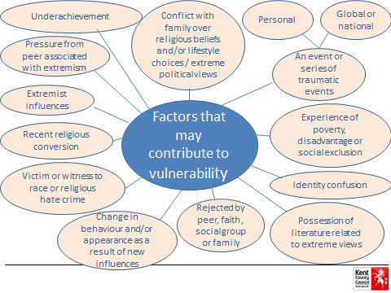

|  |  |
| --- | --- |
| What is working well? |  |
| What are we worried about? |  |
| What needs to happen next? (Safety Plan) |  |
| On a scale of 0 – 10 where 10 means you are confident that you have been provided with the advice and support and have the understanding to spot signs of radicalisation or extremism within your fostering household and community, where do you rate this today?  0 10 | |

Fostering Social Workers should refer to the PREVENT training they have completed, to ensure foster carers follow the guidance and referral process. This checklist must be completed and signed by the foster carer during supervision and attached to supervision notes/uploaded onto the carers Liberi file. **Signed:**

Foster Carer(s):

Fostering Social Worker: