Permanency Planning Meeting
Permanency Planning Meeting
Date of Meeting | Calendar Field
Attendees | 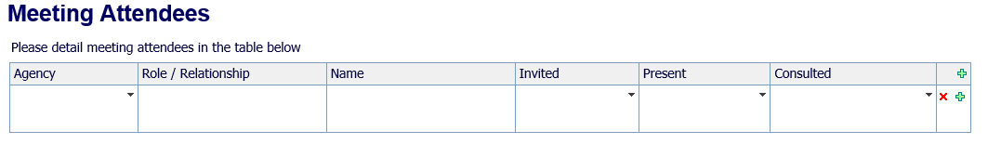  Table:
Type of Meeting | Drop down answers:  - Early Permanency Planning  - Permanency Planning for a Child/Young Person in Care
If Option 2 above selected, can these questions display:  Is the child in their Permanent Placement?  I  Has the Placement been matched at Panel? | Y/N options  If No - question ‘Is a change of Placement required? Y/N options  If Y to Is a change of Placement required? – question – Target Date of planned move? Calendar field for answer  Y/N options  If this question answered ‘Y’ can additional question display:  Date of Panel with Calendar field for answer  If this question answered ‘N’ can additional question display:  Proposed Date of Panel – with Calendar field for answer
Why is this Permanency Planning Meeting being held? Prompt text: (include short background history, legal context and any risk factors. Please include intended outcomes for the child/young person) |  | Free Text Box
What’s working well? |  | Free Text Box
What are we worried about? |  | Free Text Box

Permanency Plan
What options for Permanency are being sought – early  (question to display if option 1 at beginning selected) |  | Special Guardianship Order  Child arrangement order  Care Order  Adoption order  Placement Order  Long Term Foster Care  Residential  Supervision Order  Stabilise Family environment  Initiate Legal Proceedings  No further Action  Further Permanency Planning Meeting (Date field)
What options for Permanency are being sought CLA  (question to display if option 2 at beginning selected) |  | 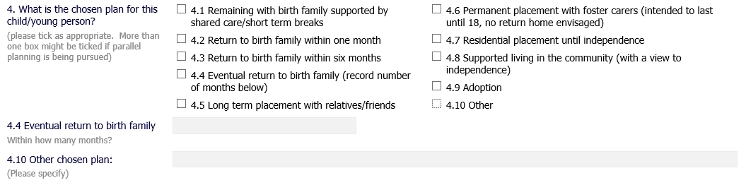
What other options have been considered? |  | Free Text box
Actions
Actions (please include dates of Adoption panel, Area Resource Panel, Fostering Panel, ADM) | 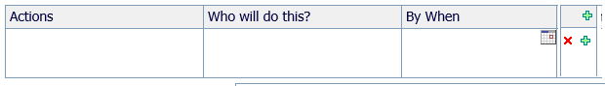  Table:
Proposed Date of next Permanency Planning Meeting (if appropriate) | Calendar field

