NEGLECT

TOOLKIT JANUARY 2021

Kent
County
Council
kent.gov.uk

Introduction – How to use this Neglect Tool Kit
Table of Contents

Contents | Page
Introduction | 3
Change | 4
Managing Ambivalence | 7
Tools to establish Baseline and Review | 8
Care Consideration Tool | 9
Assessment Checklist | 26
Routine – A Day in the Life of a Baby (0-18m approximately) | 31
A Day in the Life of a Child | 33
Identifying Concerns | 34
Identifying Parenting Tasks, Knowledge, Skills and Attributes | 35
Voice of the Child | 38
Tools for Direct Work with Children and Young People | 40
Multi Agency Working | 41
Involving the Wider Support Network | 46
Conversational Tools | 48
Safety Circles | 49
Facilitating Family Network Meetings | 50
Common Problems and How to Overcome Them | 51
Interaction Observation Chart | 53
Further Reading | 56
References | 57

This Neglect Tool Kit is intended to be used in partnership with the Neglect Guidance, supporting practitioners with tools to engage families to build an understanding and therefore identify, assess and intervene in a timely manner where there is childhood neglect.

There are a variety of tools with different interventions to support your work in addressing neglect, they can be used flexibly and take account that neglect can be complex, cumulative and often alongside other forms of abuse. Furthermore, the tools and web links are designed to prompt practitioners to reflect, interpret and understand the impact of neglect on the child’s health and development.

All of the tools link with Kent’s Practice Framework and centre on systemic and strengths- based approaches to enable the family with the practitioner to develop their own solutions. There is a deliberate emphasis in the first section on motivation and ability to change with tools that enable thorough assessment and review of neglect in families. The next section is understanding the child’s lived experience, these activities may also be complimented by the Core Skills Workbook. Access the Core Skills Resource Book on the Academy. The next sections are based around relationships both formal and informal. There are Multi – Agency working prompts to support a coordinated understanding and response when working with a family and tools related to social connectivity to support and sustain change. The final section centres on common problems practitioners may experience when working with families where neglect is present, there are useful suggested actions.

Change

This is based on “Assessment of Parental motivation to change” by Jan Horwath and Tony Morrison in: Jan Horwath (ed.) (2001): The Child’s World. London: Jessica Kingsley.
The Assessment Framework guides professionals to assess the child’s developmental needs, as well as the parent’s capacity to meet these needs. If an assessment suggests that a child’s health and development are impaired or likely to be impaired, the assessment needs to identify the changes needed, both in terms of parenting and support services. Parental capacity to change should be considered as a dynamic process in which strengths and weaknesses are identified, targets set and agreed, effective interventions identified and implemented, and progress monitored over a specific time period. Capacity to change is made up of motivation and ability, and the authors suggest that if either of these is missing, the parent in question will lack the ability to change.
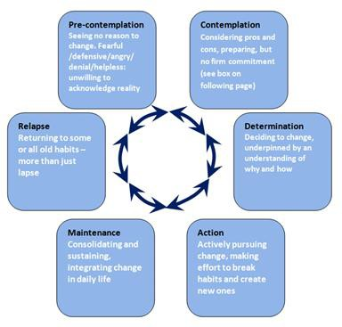
Stages of Change incorporating Seven Steps of Contemplation (based on Prochaska and DiClemente, 1982 and Morrison, 2010)

When considering addressing initial neglect worries it is important assessments gather information and understand motivation, change and to engage parents / carers in that process. This cycle can be used with parents / carers.
- Change is a matter of balance. If the motivational forces are greater than the status quo forces, change will be likely to happen.
- For the process to work, professionals need to assess and work with parents in terms of their readiness to accept or deny the need for change.

The blocks to change in terms of the model above are pre-contemplation and relapse.

Pre-contemplation:
Most families are at this stage at the start of contact with the agencies. They may have a vague notion of wanting change, but not that they need to change. Parents at this stage are unable to make a full psychological commitment, as they have not yet come to terms with the need to change. The implications for this are that early contracts need to be reviewed as (if) the parents move into the change cycle.

Contemplation:
At this stage, the parents consider that there is a problem, and can explore how to tackle it. Effective intervention will depend on whether external motivation can be transformed into internal motivation. This means that workers need to be able to combine external sanctions with engagement with parents in order to effect change.
Parents may need time to:
  - Look at themselves and come to terms with what they see.
  - Appreciate the child’s needs.
  - Count the cost of change.
  - Identify the benefit of change.
  - Identify goals which are meaningful to them. The professional task is to assess sources of motivation:
  - Recognise the parents’ ambivalence, compliance, genuine commitment and capacity to change.
  - Recognise that each parent may be at a different stage of the change process.
  - Recognise that different changes may be required from each parent.
  - Assess the motivational/status-quo sources in the extended family. Seven stages of contemplation as follows:
- Accept that there is a problem.
- Accept some responsibility for the problem.
- Have some discomfort about the problem.
- Believe things must change.
- See yourself as part of the problem.
- Make a choice to change.
- See the next steps towards change.

Determination:
At this stage, parents should be able to express:
  - Real problems and their effect on the child.
  - Changes they wish to/should make.
  - Specific goals to achieve.
  - How parents and professionals will co-operate to achieve the goals.
  - The rewards of meeting the goals.
  - Consequences if change is not achieved.

Professionals need to be clear about agreed plans, which should be detailed and specific. Plans should be for incremental change, as motivation to change is more likely if there is early support and clear expectations.

Action:
This is the point of change, where parents use themselves and services. There can be a danger of confusion and parents feeling overwhelmed (and consequently disengaging) at this stage, so clarity of aims and objectives is essential. Any agreement which was made at the pre-contemplation stage needs to be reviewed to see if it is still valid.

Maintenance:
This stage is about consolidating changes made, rehearsal and testing of new skills and coping strategies over time and in different conditions.
Professionals need to pay attention to prevent relapse, essentially work to anticipating stresses and triggers which might arise.
This can be the stage where one parent may be able to change, and the other not thus causing stress in the relationship. If this is due to professionals concentrating their efforts on one parent, this sets up failure, so including both parents is important. The assessment task is to ascertain if parents are able to internalise changes if external motivators are relaxed.

Lapse and relapse:
Change is cyclical, and most of us do not succeed the first time. Change comes from repeated efforts, re-evaluation, renewal of commitments and incremental successes. A lapse can usually be dealt with, but a relapse, such as a return of their abusive behaviour is not so easy to deal with.
Overall, the task for professionals is to increase the weight of the factors which promote change, whilst decreasing the forces for the status quo. Motivation is interactional, so look to the wider network (partners / professionals /family / friends and community) for sources of motivation, stresses and weaknesses.

Managing Ambivalence

Ambivalence is an ordinary response to change, so the assessment of parent’s real commitment is important. The response to change model is useful. It identifies four possible types of response to change, depending on effort and commitment to change:
Dissent and/or avoidance.
  - Tokenism.
  - Genuine commitment.
  - Compliance.

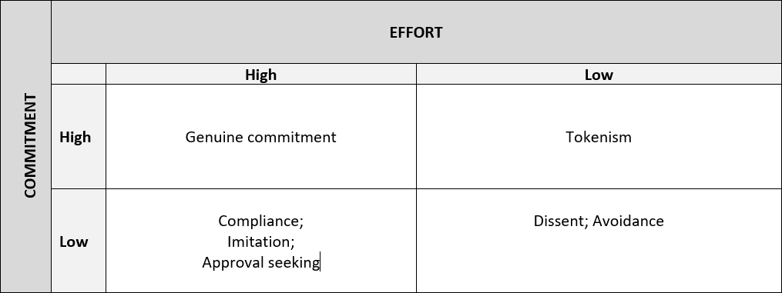
The professional task is to be aware of ambivalence and assess how parents manage ambivalence.

Main messages:
  - Assess both parents.
  - Be child centred, especially on the timing of change, can children wait?
  - Being forced to engage heightens parents’ sense of failure and uncertainty.
  - If parents are unsure, they are likely to respond negatively.

(Adapted from Northamptonshire and Essex Safeguarding Children’s Board)

Tools to Establish Baseline and Review

Maslow's hierarchy of needs is a motivational theory in psychology comprising a model of human needs, often depicted as hierarchical levels within a pyramid. The needs lower down in the hierarchy must be satisfied before individuals can attend to needs higher up.
The hierarchy of needs (shown in the diagram) has five stages which are:
- Physiological needs - these are biological requirements for human survival, e.g. air, food, drink, shelter, clothing, warmth, sex, sleep.
If these needs are not satisfied the human body cannot function optimally. Maslow considered physiological needs the most important as all the other needs become secondary until these needs are met.
- Safety needs - protection from elements, security, order, law, stability, freedom from fear.
- Love and belongingness needs - after physiological and safety needs have been fulfilled, the third level of human needs is social and involves feelings of belongingness. The need for interpersonal relationships motivates behaviour. For example, this includes friendship, intimacy, trust, and acceptance, receiving and giving affection and love.
- Esteem needs - which Maslow classified into two categories: (i) esteem for oneself (dignity, achievement, mastery, independence) and (ii) the desire for reputation or respect from others (e.g., status, prestige). Maslow indicated that the need for respect or reputation is most important for children and adolescents and precedes real self-esteem or dignity.
- Self-actualization needs - realising personal potential, self-fulfilment, seeking personal growth and peak experiences. A desire “to become everything one is capable of becoming”.
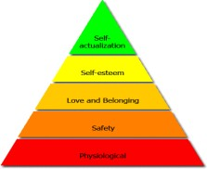

Care Consideration Tool
This tool is designed to be practical and give practitioners the opportunity to collaborate with parents/carers and families to explore what care is like in the home, allowing for a more interactive and reflective approach. Whilst providing the opportunity to ascertain strengths and areas for improvement when initially working with a family and can later be used at review stages. The tool is not a tick box approach; however, it can be used in conjunction with the Signs of Safety scaling.

Discuss with parents/carers you would like to talk to them about the care they provide their child/children. Go through the process with parents/carers and once you are sure they have understood, begin completing the tool.

Methods: It is necessary to do a home visit to make observations. You need to be familiar with the area headings to be sure everything is covered during one or more visits. This document can be shared with the family during the visit, or you can fill it in afterwards. The tool is designed to be use as a whole tool or specific areas of the tool. Each area of care is broken down into sub-areas with comment boxes for observations. Using the Neglect summary analysis sheet specify target areas for improvement with timescales and at review stage gather evidence of what’s changed. The purpose of this is building on current strengths to enable change, by listing actions or tasks to reach goals for better care. Once completed, share a copy with the parents / carers with whom you have completed and discuss your observations.

Please note:
  - As far as possible, use the usual state of the home environment and don’t worry about any short term, smaller upsets e.g. no sleep the night before.
  - Don’t take into account any external factors on the environment (e.g. house refurbished by welfare agency) unless carers have positively contributed in some way by keeping it clean, adding their own bits in the interest of the child like a safe garden, outdoor or indoor play equipment or safety features etc.
  - Allowances should be made for background factors, e.g. bereavement, recent loss of job, illness in parents. It may be necessary to revisit and score at another time.

  - If the carer is trying to mislead deliberately by giving the wrong impression or information in order to make one believe otherwise. Consider information the Neglect Guidance regarding disguised compliance, practitioner prompts in this Neglect Tool Kit and discuss within supervision.

Practitioner prompts when using the Care Consideration Tool:

Physical
Nutritional: When thinking about nutrition consider quality, quantity, preparation and organisation.
Take a history about the meals provided including nutritional contents (milk, fruits etc.), preparation, set mealtimes, routine and organisation. Discuss the parent / carer’s knowledge around nutrition, how do they respond if you offer advice or suggestions? Are they keen to know more and accepting or are they dismissive? Observe for evidence of provision, Does the parent / carer have the utensils necessary to provide healthy food for their child? Such as appliances, pots and pans etc. It is important not to lead as far as possible but to observe the responses carefully for honesty. Observation at a mealtime in the natural setting (without special preparation) is particularly useful. Consider amount offered and the parent / carer’s intention to feed younger children rather than actual amount consumed as some children may have eating/feeding problems.

Housing: When thinking about the condition of housing inspect maintenance, décor and facilities.
Observe different rooms. If lacking, ask to see if effort has been made to improve, ask yourself if the parent / carer is capable of doing them him/herself or who else could do the work? When considering décor it is not in relation to taste but standard of décor, is the wall paper peeling? Are there holes in walls?

Clothing: When thinking about clothing consider insulation, fit, look. Observe. See if effort has been made towards repairing, cleaning and ironing.

Hygiene: When thinking about hygiene contemplate the child’s appearance (hair, skin, behind ears and face, nails, rashes due to long term neglect of cleanliness, teeth).
Ask about daily routines.
Neglect Tool Kit 2021

Neglect Tool Kit 2021

Health: When thinking about health consider if opinion sought, follow-up attended, health checks and immunisation and disability or chronic illness.
Ask who is consulted on matters of health, and who decides when health care is needed. Check about immunisation uptake, reasons for non- attendance if any, see if reasons are valid. Check with relevant professionals. Distinguish genuine difference of opinion between carer and professional from non-genuine misleading reasons. Beware of being over sympathetic with carer if the child has a disability or chronic illness. Remain objective.
Safety
In Presence: This means how safely the home environment is organised and when the parent / carer is present in the home caring for the children. It includes safety features and parent / carer’s behaviour regarding safety (e.g. lit cigarettes, drugs or medication left lying in the vicinity of child) in everyday activity. Awareness may be assumed from the presence and appropriate use of safety fixtures and equipment in and around the house or in the car (child safety seat etc.) by observing parent / carers handling of young babies and supervision of toddlers. Also observe how parent / carer instinctively reacts to the child being exposed to danger. If observation not possible, then ask about the awareness. Observe or ask about child being allowed to cross the road, play outdoors etc. along the lines in this manual. If possible, check answers out with other sources.
In Absence: This covers childcare arrangements where the parent / carer is away, taking account of reasons and period of absence and age of the minder. This itself could be a matter for concern in some cases. Check answers out with other sources.
Love
When thinking about love consider the parent / Carer in terms of sensitivity, timing of response, reciprocation (quality of response).
This mainly relates to the parent / carer’s relationship with the child. Sensitivity means where parent/carer shows awareness of any signal from the child. Parent / Carer may become aware yet respond a little later in certain circumstances. Note the timing of the parent / carer’s response in the form of appropriate action in relation to the signal from the child. Reciprocation means the emotional quality of the response.

Mutual Engagement: When thinking about mutual engagement contemplate initiation of interactions and the quality of interaction.

Observing what goes on between the parent / carer and child during feeding, playing and other activities gives you a sense of whether both are actively engaged. Observe what happens when the parent / carer and the child talk, touch, seek each other out for comfort and play, babies reaching out to touch while feeding or stop feeding to look and smile at the carer.

Esteem
Stimulation: Observe or enquire how the child is encouraged to learn. Talking and making noises, interactive play, nursery rhymes or joint story reading, learning social rules, providing fun play equipment are such examples with infants (0 – 2 years). If lacking, try to note if it was due to parent/carer being occupied by other essential chores.
Approval: Find out how child’s achievement is rewarded or neglected. It can be assessed by asking how the child is doing or simply by praising the child and noting the parent/carer’s response (agrees with delight or child’s successes rejected or put down)
Disapproval: If opportunity presents, observe how the child is told off, otherwise enquire carefully (Does the child throw tantrums? How do you deal with it if it happens when you are tired yourself?) Beware of any difference between what is said and what is done. Any observation is better in such situations than the parent/carer’s description e.g., child being ridiculed or shouted at. Try and ask more if parent/carer is consistent.
Acceptance: Observe or ask how parent/carer generally feels after she/he has told the child off, or when the child has been told off by others (e.g., teacher), when child is not doing well, or feeling sad for various reasons. See if the child is rejected (put down) or accepted at these times with warm and supportive behaviour.

The information gathered can feed into assessments and plans within Integrated Children’s Services.

Physical - Nutrition |  |  |  |  |  | Comments &  Observations
Quality | Aware and thinks ahead; provides excellent quality food and drink. | Aware and manages to provide reasonable quality food and drink. | Provision of reasonable quality food inconsistent through lack of awareness or effort. | Provision of poor-quality food through lack of effort; only occasionally of reasonable quality if  pressurised. | Quality not a consideration at all or lies about quality.
Quantity | Ample | Adequate | Adequate to Variable | Variable to Low | Mostly low or starved
Preparation | Freshly cooked/ prepared for the child. | Well prepared for the family. Always thinking of the  child’s needs. | Preparation infrequent and mainly for the adults, child sometimes thought about. | More often no preparation. If there is, child’s need or taste not thought about. | Hardly ever any preparation. Child lives on snacks, cereals or takeaways.
Organisation | Meals carefully organised – child’s seating, timing & manners. | Well organised- child often seated, regular timing. | Poorly organised - irregular timing, child not encouraged to sit down to eat. | Ill organised- no clear mealtime. | Chaotic – eat when and what one can.

Physical – Housing |  |  |  |  |  | Comments &  Observations
Maintenance | Additional features | No additional features but | State of repair | In disrepair- but could | Dangerous disrepair-

 | benefiting child- safe, warm and clean | well maintained. | adequate. | be repaired easily | but could be repaired easily (exposed nails, live wires).
Décor | Excellent, child’s taste specially considered. | Good, child’s taste considered | In need of decoration but reasonably clean. | Dirty, cluttered and unhygienic | Long term engrained dirt. (Bad odour/ no clear spaces).
Facilities  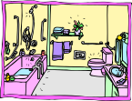 | Essential and additional fixtures and fittings- good heating, shower or bath, play and learning facilities. | All essential fixtures and fittings; effort to consider the child. If lacking, due to practical constraints (child comes first). | Essential to bare  – child’s needs overlooked. | Adults needs for safety, warmth and entertainment come first. | Child dangerously exposed or not provided for.
NOTE: Consider if the parent/carer has taken steps to improve home conditions like speaking to the Housing Association / Owner or spent a loan or a grant on the house or had made any other personal effort towards house improvement.

Physical - Clothing |  |  |  |  |  | Comments &  Observations
Insulation | Well protected and dressed appropriately for weather. | Well protected, adequate for the weather. | Adequate to variable weather protection. | Inadequate weather protection. | Dangerously exposed.
Fitting | Appropriate fitting and design. | Adequate fitting even if handed down. | Clothes a little too large or too small. | Clothes clearly too large or too small. | Grossly improper fitting.
Look- age 0-  5 | Good condition and clean. | Effort to restore any wear and clean. | Repair lacking, usually not quite clean. | Worn, somewhat dirty and crumpled. | Dirty, badly worn and crumpled, odour.
Look- age 5+ | As above | As above, odour if bed wetter, not otherwise. | Worse than above, unless child does own washing. | Same as above unless child does own washing. | Child unable to help him/herself therefore same as above

Physical - Hygiene |  |  |  |  |  | Comments &  Observations
Age 0 to  4 | Cleaned, bathed and teeth brushed more  than once a day | Regular bathing and teeth brushed daily. | No routine.  Sometimes bathed and teeth brushed. | Occasionally bathed, poor dental hygiene and occasional odour | Seldom bathed or clean. Bad dental hygiene  and strong odour.
Age 5 to  7 | Some independence at above tasks but always helped and supervised. | Reminded and products provided for regularly. Watched and helped if needed. | Irregularly reminded and products provided. Sometimes watched. | Reminded only now and then, minimum supervision. | No supervision or encouragement. No products provided.
Age 7+ | Reminded, followed, helped regularly. | Reminded regularly and encouraged if lapses. | Irregularly reminded, Products not provided consistently. | Left to their own initiatives. Provision minimum and  inconsistent. | No encouragement. No products provided.

Physical - Health  Compliance = accepting professional advice at any venue and carrying out advice given. |  |  |  |  |  | Comments &  Observations
Opinion sought | Not only on illnesses but also other genuine health matters thought about in advance and  with sincerity. | From professionals/ experienced adults on matters of genuine and immediate concern about  child health. | On illness of any severity. Or frequent unnecessary consultation and/ or medication. | Only when illness becomes moderately severe (delayed consultation). | When illness becomes critical (emergencies).
Follow up | All appointments kept. Rearranges if problems. | Fails one in two appointments due usefulness or due to pressing practical constraints. | Fails one in two appointments even if it of clear benefit for reasons of personal inconvenience | Attends third time after reminder. Doubts its usefulness even if it is of clear benefit to the child | Fails to keep appointments despite reminders. Misleading/ inconsistent explanations for not  attending.
Health checks and immunisation | Visits in addition to the scheduled health checks, up to date with immunisation unless genuine reservations. | Up to date with scheduled health checks and immunisation unless exceptional or practical problems. Plans in place  to address this. | Omission for reasons of personal inconvenience, takes up if persuaded. | Omissions because of carelessness, accepts if accessed at home. | Clear disregard of  child’s welfare. Blocks home visits.
Disability/ chronic illness (3 months after diagnosis) | Compliance excellent, any lack of compliance is due to pressing practical reason.  Compassion for child’s needs. | Any lack of compliance is due to difference of opinion, or pressing practical reason.  Compassion for child’s needs. | Compliance is lacking from time to time for no pressing reason (excuses). Shows some compassion for child’s needs. | Compliance frequently lacking for trivial reasons, very little affection, if at all. shows little  compassion for child’s needs. | Serious non- compliance, medication not given. Can lie, inexplicable deterioration. Shows no compassion for  child’s needs.

Safety - In Presence and Absence |  |  |  |  | Comments &  Observations
Awareness | Excellent awareness of safety issues however  remote the risk. | Excellent awareness of safety issues. | Poor awareness and perception except for  immediate danger. | Inadequate response to safety risks. | Oblivious to safety risks.
Safety Features | Excellent safety features- gate, guards, drug lockers, electrical safety devices, intercom to listen to the baby, safety with garden pond and pool etc. | Good safety features- secure doors, windows and any heavy furniture item. Safe gas and electrical appliances, drugs and toxic chemicals out of reach, smoke alarm.  Improvisation and DIY if  cannot afford. | Lacking in essential safety features, very little improvisation or DIY (done too causally to be effective). | No safety features. Some possible hazards due to disrepair (tripping hazard due to uneven floor, unsteady heavy fixtures, unsafe appliances). | Definite hazards exposed electric wires and sockets, unsafe windows (broken glass), dangerous chemicals carelessly lying around.
Pre- mobility age | Very careful with handling and laying down. Seldom unattended | Careful whilst handling and laying down. Frequent checks if unattended | Handling careless.  Frequently unattended. | Handling unsafe.  Unattended even during care chores (bottle left in mouth) | Dangerous handling, left dangerously unattended during care chores like bath
Acquisition of mobility | Constant attention to safety and effective measures against any perceived dangers when mobile. | Effective measures against any danger about to happen. | Inconsistent measures taken against danger. | Ineffective measures if at all. Improvement from mishaps soon lapses. | Inadvertently exposes to dangers (dangerously hot iron near by).
Infant school | Close supervision indoors and outdoors. | Adequate supervision indoors and outdoors. | Little supervision indoors or outdoors. Acts if in noticeable danger. | No supervision, intervenes after mishaps which soon lapses again. | Minor mishaps ignored or the child is blamed; intervenes casually after major mishaps

Junior & | Allows out in known | Knows where child is, | Not always aware of | Not bothered about | No boundaries despite
senior | safe surroundings within | appropriate boundaries. | whereabouts | daytime outings, | knowledge of dangers
school | appointed time. Checks | Reasonable time limit. | outdoors believing it | concerned about late | outdoors. Staying away
 | if goes beyond set boundaries. | Checks if worried. | is safe as long as they return in time. | nights in case of child younger than 13. | until late evening/nights.
In absence | Child is left in care of a | Out of necessity a child aged | For recreational | For recreational reason | For recreational reason a
 | vetted adult. Never in sole care of an under 16. | 1-12 is left with a young person over 13 who is familiar and has no significant  problem, for no longer than | reason leaves a 0-9 year old with a child aged 10-13 or a  person known to be | a 0-7 year old is left with an 8-10 year old or an unsuitable person. | 0-7 year old is left alone or in the company of a relatively older but less  than 8 year old child or an
 |  | necessary. | unsuitable. |  | unsuitable person.
 |  | Above arrangement applies
 |  | to a baby only in an urgent
 |  | situation.
Note: Other safety provisions which are not a fixture like a bicycle helmet/safety car seat etc, can be commented on as a strength or a change needed.

Love - Parent / Carer |  |  |  |  |  | Comments &  Observations
Sensitivity | Looks for or picks up very subtle signals- verbal or nonverbal expression or mood. | Understands clear signals – distinct verbal or clear nonverbal expression. | Not sensitive enough – messages and signals have to be intense to make an impact e.g. crying. | Quite insensitive  – needs repeated or prolonged intense signals. | Insensitive to even sustained intense signals or dislikes child.
Timing of response | Responds at time of signals or even before in anticipation | Responds mostly at time of signals except when occupied by essential chores. | Does not respond at time of signals if during own leisure activity. Responds at time of signals if fully unoccupied or child in  distress. | Even when child in distress responses delayed. | No responses unless a clear mishap for fear of being accused.
Reciprocation (quality) | Responses fit with the signal from the child, both emotionally (warmth) and materially (food, nappy change). Can get over stressed by distress signals from child. Warm. | Material responses (treats etc.) lacking, but emotional responses warm and reassuring. | Emotions warm towards child if in good mood (not burdened by strictly personal problem), otherwise flat. | Emotional response brisk and flat.  Annoyance if child in moderate distress but attentive if in  severe distress. | Disliking and blaming even if child in distress, acts after a serious mishap mainly to avoid being accused, any warmth/guilt not genuine.

Love - Mutual Engagement |  |  |  |  |  | Comments &  Observations
Beginning interactions | Carer starts interactions with child. Child starts interactions with carer. Carer does this more often. | Carer starts interactions with child. Child starts interactions with carer.  Equal frequency. Positive attempt by carer even if child is defiant. | Child mainly starts interactions.  Sometimes the carer.  Carer negative if child’s behaviour is  defiant. | Child mainly starts interactions. Not very often the carer. | Child does not attempt to start interaction with carer.  Carer does not start interactions with child. Child appears resigned or apprehensive.
Quality | Frequent pleasure of engagement, both enjoy it. | Quite often and both enjoy equally. | Less often engaged for pleasure, child enjoys more. Carer passively joins in getting some enjoyment at times. | Engagement mainly for a practical purpose.  Indifferent when child attempts to engage for pleasure. Child can get some pleasure (attempts to sit on knees, tries to show a toy). | Dislikes it when child tries to enjoy interactions, if any. Child resigned or plays on own. Carer’s engagement for practical reasons only (dressing, feeding).
Note: If Parent/Carer, child or young person has any underlying reasons they may struggle with interaction then ensure these are considered and any comments noted. I.E Autism Spectrum Condition or Previous experience of trauma

Esteem - Stimulation |  |  |  |  |  | Comments &  Observations
Age 0-2 years | Plenty of appropriate stimulation (talking, touching, looking).  Plenty of equipment | Enough and appropriate intuitive  stimulation. | Inadequate and inappropriate- baby left alone while carer  pursues own | Little stimulation. Baby left alone while adult gets on with pursuing  own amusements unless | Absent- even mobility restricted (confined in chair  /pram) for carer’s
 |  | Appropriate toys, | amusements; | strongly sought out by | convenience.
 |  | gadgets, outings | sometimes interacts | the baby. | Inappropriate
 |  | and celebrations | with baby. |  | response if baby
 |  |  |  |  | demands attention.
Age 2-5 years | Interactive stimulation (talking  to, playing with, reading stories | Sufficient and of  satisfactory quality. | Variable – adequate if  usually doing own | Scarce – even if doing  nothing else. | Nil.  Nil, unless provided
 | and topics) plenty and good | Provides all that is | thing. | Lacking on essentials. | by other sources-
 | quality.  Toys and gadgets (items of uniform, sports equipment, books etc.) – Plenty and good | necessary and tries for more.  Enough visits to  child centred places | Essentials only. No effort to make do if unaffordable.  Child accompanies | Child simply accompanies carer.  . Only seasonal – low key  to keep up with the rest | gifts or grants. No outings for the child, may play in  the street.
 | quality | locally (e.g. parks) | carer wherever carer |  | Even seasonal
 | Outings (taking the child out for | and occasionally | decides, usually child |  | festivities absent or
 | recreational purposes) – | away | friendly places. |  | dampened.
 | frequent visits to child centred | (e.g. zoos). | Mainly seasonal
 | places locally and away. | Equally keen and | (Christmas) low key
 | Celebrations– both seasonal and | eager. | personal (birthday)
 | personal, child made to feel
 | special

Stimulation cont. |  |  |  |  |  | Comments &  Observations
Age 5+ years | Education– active interest  in schooling and support | Active interest in  schooling, support at | Maintains schooling  but little support at | Little effort to maintain  schooling or mainly for | Not interested or can  even be discouraging.
 | at home. | home when can. | home. | other reasons like free | Not bothered even
 | Sports and leisure well organised outside school hours e.g. swimming, | All affordable support.  Carer offers some | little effort in finding out but takes up opportunities at | meals etc.  Child makes all the effort, carer not | if child is doing unsafe/ unhealthy activity.  Not bothered.
 | clubs etc. | help. | doorstep. | interested.
 | Friendships encouraged |  | Accepts | Child finds own friends, | No provision.
 | and checked out | Adequate |  | no help from carer
 |  |  | Poorly provided | unless reported to be
 | Provision– plentiful |  |  | bullied.
 |  |  |  | Under provided.
2. | Talks about the child with | Talks fondly about | Agrees with other’s | Indifferent if child | If the child is praised by
Approval | delight/ praise without | the child when | praise of the child, | praised by others, | someone else, successes
 | being asked; material and | asked, generous | low-key praise and | indifferent to child’s | rejected. Achievements not
 | generous emotional | praise and emotional | damp emotional | achievement, which is | acknowledged, lack of
 | reward for any | reward, less of | reward. | quietly acknowledged. | reprimand or ridicule is the
 | achievement. | material reward. |  |  | only reward if at all.

Stimulation cont. |  |  |  |  |  | Comments & Observations
3. | Mild verbal and | Consistent terse verbal, | Inconsistent boundaries or | Inconsistent, shouts/ | Terrorised. Ridicule,
Disapproval | consistent | mild physical, mild | methods terse/shouts or | harsh verbal, moderate | severe physical or
 | disapproval if any limit is crossed. | sanctions if any set limits are crossed. | ignores for own convenience, mild physical and moderate other sanctions. | physical, or severe other sanctions. | cruel other sanctions.
4. | Unconditional | Unconditional acceptance, | Annoyance at child’s | Unsupportive and/or | Indifferent if child is
Acceptance | acceptance. Always warm and supportive even if child is failing. | even if temporarily upset by child’s behavioural demand but always warm  and supportive. | failure, behavioural demands less well tolerated. | rejecting if child is failing or if behavioural demands are high.  Accepts if child is not | achieving but rejects if makes mistakes or fails. Exaggerates  child’s mistakes
 |  |  |  | failing.
NOTE: If the style of parenting or type of values instilled is of concern, please make a note in the corresponding comment box.

Neglect Analysis Sheet
Once you have completed the Care Consideration Tool use this Neglect Analysis Sheet to specify target areas for improvement with timescales and at review stage gather evidence of what’s changed. Alternatively, you could use the Signs of Safety Mapping Tool

Date of analysis: | Family Name:

 | Targeted Areas | Time Scales | Review comments
1
2
3
4
5
6

(Adapted from Dorset Safeguarding Board)

Assessment Checklist

At each section consider whether there is anything that seems likely to have an impact on the child.

Nutrition and Feeding
- Is the child regularly fed?
- Does the child eat enough food?
- Does the child eat appropriate food?
- Is the child patiently handled during feeding?
- Does the parent/carer seek help regarding nutrition/feeding problems?
- Is the child punished for not eating?
- Is the child encouraged to eat?
- Is the child encouraged to develop appropriate skills?
- Are there flexible routines?
- Is the parent/carer aware of the child being over or under weight?
- Is there evidence that the child is thriving?

Physical Warmth
- Is the child appropriately dressed for the weather?
- Is the bedroom appropriately heated?
- Is the house in general appropriately heated?

Physical Health (includes dental)
- Are physical health needs anticipated by parent?
- Do physical health needs get an appropriate and timely response from parents/carers?
- Is expert advice sought appropriately regarding non-emergencies?
- Is expert advice sought appropriately regarding emergencies?
- Is expert advice acted upon?
- Are any additional needs of the child understood and appropriately responded to?
- Does the parent/carer ignore or not recognise the need for diagnosis and/or treatment of physical health needs?
- Does the parent/carer act in a way that increases the likelihood of poor outcomes for physical health?
- Is there appropriate and active management of any head lice?

Mental and Emotional Health
- Does the parent/carer ignore or not recognise the need for diagnosis and/or treatment of mental and emotional health needs?
- Does the parent/carer refuse to allow or provide or facilitate diagnosis and/or treatment of mental and emotional health needs?
- Does the parent/carer act in a way that increases the likelihood of poor mental and emotional health? (This may include not taking known appropriate measures and/or not acting on advice in this respect).

Safety and Protection
- Is the child left alone inappropriately?
- Are all babysitters of an appropriate age and capability? And known to the child? And are adults or young people without obvious problems that may affect their ability to care for the child?
- Are there safe physical boundaries? For example, not allowed/able to wander from home; parents have clear ideas of limits of play areas
- Is there safety equipment, for example, stairgates and fireguards? Is the equipment in use?
- Can the windows and doors be opened by a child if unsafe for them to do so?
- Are dangerous household substances (e.g. bleach and cleaners) kept safely?
- Are dangerous personal items (e.g. medication, needles and drugs) kept safely?
- Is dangerous household equipment (e.g. knives, lighters, electrical appliances) accessible to children?
- Is there effective supervision in potentially dangerous situations in and outside of the home?
- Is the child expected/allowed to do inappropriate dangerous tasks, e.g. cooking, lighting fires, supervising very young siblings etc.?
- a history of fire setting, in or outside of the home, by any member of the family?
- Is the area immediately around the home safe? E.g. are there accessible dangerous objects, balconies, stairwells etc.?

Cleanliness
- Is general hygiene in the home reasonable?
- Is animal mess cleaned up promptly? Or is it left within reach of the child?
- Is old food cleared away?
- Is rubbish disposed of safely?
- Does the child have clean clothing available?
- Does the child smell? If they do, are they teased/rejected by peers?
- Is there bedding available? If so, is it clean and dry?
- Is food stored hygienically?
- Is the toilet cleaned on a regular basis?
- Are there facilities for washing and bathing? Are they used regularly?
- Does the house have an unclean smell?

Possessions and Personal Space
- Does the child have his/her own clothing?
- Does the child play with age appropriate toys?
- Does the child have toys of his/her own?
- Does the child have personal space (e.g. bedroom), including personal privacy?
- Does the child have appropriate personal possessions?

Animals and Pets
- Are the pets appropriately cared for?
- Are the needs of the pet(s) prioritised over those of the child?
- Are pets safe in terms of harm to the child?
- Do the parents/carers ensure the child learns to behave appropriately with pets, and take appropriate responsibility for them (if age appropriate)?
- Is a significant proportion of family income being spent on the pets(s)? To the detriment of the child?
- Is access to, or ill-treatment of a pet, being used to control or punish the child?
- Are animals harmed by any member of or visitors to the household?

Visitors to the Household
- Is the child’s home often frequented by ‘visitors’, i.e. adults or young people who have no significant relationship with them?
- Is the child left in the care of ‘visitors’?
- Does the presence of ‘visitors’ disrupt the child’s normal routines or result in inappropriate routines?
- Do the needs of the ‘visitors’ take priority over those of the child?
- Do ‘visitors’ stay overnight?
- Are ‘visitors’ genuinely friends of a parent, or are they exploiting or abusing a parent?

Parent/carer’s Emotional Involvement with the Child
- Is the child comforted when distressed?
- Does the parent expect comfort from the child when the parent is distressed?
- Is the child denigrated?
- Is the child praised/rewarded for achievements?
- Does the parent/carer emphasise or punish failure?
- Does the parent/carer have limited physical and emotional contact with the child?
- Is affection shown and expressed?
- Do the parents/carers have a negative attitude towards the child?
- Do the parents lack emotional maturity?
- Is there a sense of belonging and security in the family? i.e. a sense of the parents/carers commitment to the child and to protect the child?
- Is the child free to express themselves?

Routines
- Are routines regarding meals, bedtimes, access to television, school attendance, homework, age appropriate?
- Are routines consistent and consistently applied?

Controls
- Is the child locked or shut in rooms or a cupboard etc.?

- Is the child subject to punishment or sanctions that cause damage or pain?
- Is the parent able to instigate/ maintain appropriate controls and/or maintain structure/routines and/or ensure safety and protection?

Parent’s/Carer’s Expectations of the Child
- Are the parent’s/carer’s expectations age appropriate?
- Are the parent’s/carer’s expectations of ability appropriate?
- Is there awareness of the child’s needs?
- Is there awareness of the child’s developmental progress?
- Are the parent’s/carer’s expectations realistic?
- Are the parent’s/carer’s expectations consistent?
- Is the child expected or allowed to act as a carer for the parent/carer or sibling?

Domestic Violence and Abuse
- Does the child experience domestic violence and abuse as a part of family life? (‘Experience’ means being aware of, not just being actually involved in it or seeing it)

Parent’s/Carer’s Behaviour
- Is the parent/carer able to instigate and maintain basic routines?
- Is the parent’s/carer’s behaviour chaotic and/or unpredictable and/or inconsistent?
- Does the parent/carer allow multiple carers? Do they have a relationship with the child?
- Does the parent/carer allow age/gender appropriate carers?
- Does the parent/carer leave the child unattended?
- Does the parent/carer provide reactive rather than proactive care?
- Does the parent/carer treat animals better than the child?
- Does the parent/carer acquire possessions for themselves, but markedly less so for child?
- Does the parent/carer provide better living conditions for themselves than for the child? (For example, bedrooms).
- Does the parent/carer help the child to know right from wrong?
- Does the parent/carer involve the child in criminal/drug related/anti-social behaviour?
- Does the parent/carer attempt to address child’s inappropriate behaviour? For example, committing offences, causing damage, being abusive and/or threatening, not attending school and so on.
- Does the parent/carer allow, encourage, or fail to prevent bullying by siblings?

Leisure Activity
- Does the child have access to age inappropriate video, DVD, computer games etc.?
- Does the child have access to adult pornography?
- Does the child have uncontrolled access to the internet?
- Does the child have unrestricted access to late-night television?
- Is the child supervised by a responsible person during potentially dangerous leisure activities?
- Is the child allowed to take part in age inappropriate activities?

Self-Harming
- Self-harming may include using drugs or alcohol or deliberate exposure to danger.

- Does the child experience self-harming, or threats of self-harming by a parent/carer or sibling as part of family life?
- Is the child self-harming, or threatening self-harm?

Educational Needs
- Does the parent/carer ensure the child receives an appropriate education?
- Does the parent/carer allow and/or recognise the need for treatment and/or services regarding serious educational problems or needs? Is the parent/carer involved in the child’s education? (E.g. assisting with homework, ensuring child has equipment, engaging with teachers as appropriate, and so on)
- Is the child unable to access the curriculum or fully benefit from the educational experience? (E.g. because of their or others behaviour in class, relationships with peers and/or adults in school, ability to concentrate and/or learn, punctuality and/or attendance, social skills and/or acceptability and so on).

Parents/Carers Attitudes to Professionals
- Are parents/carers likely to refuse (actually or effectively) to be involved with professionals?
- Is there any history of disguised or noncompliance?
- Do parents/carers accept that professional involvement is appropriate?
- Do parents/carers accept that professional involvement is necessary?

History and Context
- Is there a history or context of current concerns in terms of?
- Abuse or neglect?
- Mental ill health?
- Learning disability?
- Drug or alcohol misuse?
- Poverty or financial problems?
- Homelessness?
- Frequent changes of home and/or school?
- Child going missing, with or without parents/ carers?
- Addictive behaviour by parents/carers?

The Child
- Is the child seen as being ‘difficult’? (Crying, refusing to engage with parents or in play and so on)
- Is the child ‘passive’? (i.e. vacant facial expression, failing to respond to adults, reluctant to play)
- Is the child able to enjoy social intercourse, take turns, and respond to adult interest and so on?
- Does the child have a secure attachment to parent/carer?
- Does the child have strong feelings of self worth and self-confidence?

Routine – A Day in the Life of a Baby (0-18m approximately)

What is the Baby’s Daily Routine? Prompts for observation and suggested questions for Assessment and Review for parent/carer.
Waking
What time do they wake up? What happens next? Who gets them up? Does the same thing happen every day?
Feeding
Is the baby breastfed? Are there any difficulties? What time does this happen? Where does this happen? If bottles are used, are they sterilised? Who does this? How often does this happen? Where are the sterilised bottles kept? Who bottle feeds the baby? Is the baby held while feeding? If not, then what happens? E.g. prop feeding, in their cot etc. How well does the baby feed? Is the baby ‘burped’ during and at the end of feeding? Is eye contact made with the baby? Does the baby
settle well after the feed? What is happening regarding weaning?
Dressing
Who dresses them? Where are they dressed? Are they washed? Is the nappy changed? Are there clean clothes? How are they dressed (considering weather / planned activity)? Does the same person dress them/change their nappy every day? Are the carers gentle when they dress the baby?
Do they interact with the baby during dressing?
Getting to School (if there are school age children in the house)
What happens to the baby? Do they go as well? If so, how do they get there (e.g. in a pushchair,
car, carried in car‐seat)? If they stay at home, who is looking after them? What is happening at this time? Are feeds being missed or rushed due to the school run? How are they dressed (taking into account the weather)? Where are they whilst parents/carers take the older children into school?
E.g. are they left in the car?
During the Day
What happens during the day? Who is spending time with them? What do they do with the baby? What toys and books are available? What happens about sleeping during the day? What time are they sleeping? Where do they sleep? Do they go out of the house? Where do they go? Who goes with them? What equipment goes with them? Does the same thing happen every day? What happens about feeding? What time does this happen? If bottles are used, are they sterilised? When does this happen? Who does this? What happens about nappy changes? Who does this? Is there a good supply of nappies? How often are nappies changed? If there are pets, where are they? Are they spending long periods of time sat in front of television or sat in a car seat and/or pushchair for long periods? If they are beginning to explore their environment, what safety measures are being
put into place, e.g. safety gates, plug socket covers, supervision by an appropriate person?
Socialising (Communication)
The baby will start to enjoy socialising within the first few weeks of life, and this will increase over time with smiling and eye to eye contact. Is the mother/father/carer able to cue into the baby’s need to communicate initially through fleeting face to face communication? Does the
mother/father/carer support this communication by holding the baby’s head up if needs be? Is the mother/father/carer aware of the baby’s state and able to cue into when the baby feels sleepy, hungry or in pain and either doesn’t want to start an engagement or has had enough of interacting for the time being? The baby gradually communicates more by moving and changing the shape of their mouth and tongue. This socialisation gradually turns onto play and babbling. Does the
mother/father/carer mirror and respond to the baby’s efforts to communicate i.e. promoting attunement? How does the baby respond to this communication? How does the baby respond to facial expression when they are being calmed, talked to or played with? This is the voice of the child which is one of the most important considerations when carrying out an assessment.

After School (if there is a school age child in the house)
Does the baby go with anyone to meet the other child(ren) at school? What happens when the other child(ren) are home from school? Do they engage with the baby? Is there an adult present if this happens? What happens during mealtimes? What about during the school holidays?
Evenings
What happens about feeding? Who does this? What happens at bath time? Who does this? How often does the baby have a bath? Where do they have a bath? Does the same person bath the baby? What do the parents/carers do in the evenings? Does the baby spend time with parents/carers in the evening? If so, what happens? What is on the television when the baby is
around?
Bedtime
Do they have a set time to go to bed? Who decides when it is time for bed? Where do they sleep? What does their bed look like? What is their bedding like (take account of temperature)? Are they changed for bed? What happens before they are put to bed? Do they have anything in with them
e.g. bedtime toy? Does anyone read them a story? How are they settled? What happens if they do not settle? Is there a baby monitor? Who else is in the house at night? Is anyone put in charge of them at bedtime? What position do they sleep in? What is the environment like, e.g. regarding
temperature?
Overnight
How often do they wake? What happens when they wake? Who goes to them when they wake? Does the same person go to them when they wake? Are they fed when they wake? Is their nappy changed when they wake? If there are pets, where do the pets sleep? Is the baby left to cry for long
periods of time?

A Day in the Life of a Child

What is the Child’s Daily Routine? Suggested questions for Assessment and review for both child and parent / carer.
Waking
Do they use a clock to get up? Does someone get them up? Do they have to get anyone else up? Does anyone else get up with them? Does the same thing happen every day? What time does this happen?
Breakfast
Do they have breakfast? What sort of food do they have? Do they have a choice? Who makes breakfast?
Dressing
Do they dress themselves? Do they help anyone else get dressed? Do they wash and clean their teeth before getting dressed? Who makes sure they are doing this? Is there hot water? Do they have correct and
clean uniform / clothes?
Equipment
Do they pack their bag or does someone help them? Do they have a drink? Is the temperature considered; do they have a coat / is there sunscreen / sun hat in their bag? If they wear glasses are these remembered? Have they got hygiene products they may need? Is prescribed / required medication at school?
Getting to School
How do they get there? Does someone take them? Do they walk with someone else? Do they have to take
anyone else? Do they cross busy roads? Who helps them do this? Do they get to school on time?
In School
What do they like about school? What don’t they like about school? Who are their friends? What do they do with their friends? What do they like to do at break times? What do they eat at lunchtime? Do they have a favourite teacher or subject? Are they experiencing bullying? Do they receive pupil / student support?
After School
How do they get home from school? Does someone meet them at school? If so, who is this? If not, then is there anyone at home to meet them? What do they do after school? Do they look after anyone else? Do they have anything to eat? What do they have? Who makes it for them? Do they prepare food for anyone else? Do they go out and play? Do they do homework? Are there any issues around doing homework?
Evenings
Do they have an evening meal? What time is this? Who prepares the meal? What is their favourite food? Do they have this often? Do they eat with their parents/carers/other family members? If not, where do they eat? Who do they tell if they are hungry and what happens about this? Do they watch TV? If so, what do they watch? Do they use the internet/social networking sites? Is this supervised? Who do they communicate with online? What do they talk about? Do they go out? If so, who are they with and where do they go? Do they communicate this information to anyone? Do they have to be in at a particular time? Do they like toys and games? Do they have any? What do their parents/carers do in the evenings? Do they spend time with
parents/carers in the evening? If so, what do they do?
Bedtime
Do they have a set time to go to bed? Who decides when it is time for bed? Where do they sleep? Do they like where they sleep? What is there bedding like? Do they wash and brush their teeth at bedtime? Do they change for bed? Who else is in the house at night? Are they put in charge of anyone else at bedtime?
School holidays/weekends
Do they look after anyone? Do they have chores/jobs to do? If so, what are they and who are they for? How else do they spend their time? Do they see friends? Who do they tell where they are going? Do their parents
/ carers know their friends? Do they go to clubs? Who looks after them when they are not in school? Who
supervises mealtimes?

Identifying Concerns

The starting point of any assessment is to get the parents / carers to understand and acknowledge concerns from practitioners. They will have possibly been involved in a meeting, or some other kind of multi-agency meeting, but what understanding do they have of what was discussed and what the priorities are? The aim of this activity is to make sure the parents/carers understand what the concerns are and to determine the potential for change.
Tools: make some cards labelled with identified concerns or points from the action plan e.g.

George’s bedtime

Ifemelu missing her doctor’s appointment

Bedding is unsuitable

Method: Read through the action plan going over each point with the parent/carer, then using the cards, ask the parent/carer to place the cards into two piles – “High Concern” and “Low Concern”. Encourage them to say why they feel this way.

Further Ideas: It would also be useful to do this activity separately with the child/young person (if appropriate) to establish whether there are any differences of opinion as to what the priorities are, or whether there is agreement within the family. This information can then be used to further the assessment/action plan.

Accessibility: If it is not appropriate to use labelled cards, using picture cards, drawing pictures on paper/flipchart, cutting out pictures from magazines etc. could be more visual ways of engaging children/young people/parents/carers in identifying concerns.

Identifying Parenting / Caring Tasks, Knowledge, Skills and Attributes

The table below provides a focus for discussions with parents/carers regarding expectations about basic care and the skills and knowledge they may already have or might need to develop in order to provide good enough care.
Parenting / Caring Tasks | What do I already know? What do I need to develop?
Basic care  Meeting child’s physical needs  Providing appropriate health care and medical attention  Ensuring child has nutritious diet, warmth, shelter  Giving clean and appropriate clothing and ensuring adequate personal hygiene | Knowledge of:  Healthy diet and the food and drink requirements of a child at different ages  A comfortable temperature for a baby and small child  Toileting requirements of baby or child  How to bath a baby and hygiene requirements of child  Common ailments and how to cope with accidents  How to access GP, dentist, optician etc Particular medical requirements of the child  Skill in being able to:  Provide a diet that enables child to thrive Recognise if a child is uncomfortable because they are too cold or hot  Identify and respond to child’s toileting needs Keep a young child clean and teach a child to take increasing responsibility for their own hygiene  Identify and respond to child’s health care needs Meet the particular needs of the child related to  their disability or health issues
Ensuring Safety  Ensuring child is adequately protected from harm and danger  Protecting children from possible significant harm  Avoiding contact with unsafe adults/children Protecting children from self-harm  Recognising hazards and dangers both at home and elsewhere | Knowledge of:  Sources of potential harm such as hazards in home, need for supervision, risk posed by unsafe adults and other children  Ways in which child can become involved in anti- social behaviours and indicators of this involvement  Particular vulnerabilities of a disabled child  Skill in being able to:  Provide a safe environment for the child both within the home and elsewhere  Identify the signs and indicators that the child is at possible risk of harm
Stimulation | Knowledge of:

Promoting the child’s learning and intellectual development  Encouraging, stimulating cognitive development Providing social opportunities  Talking and responding to the child Encouraging and joining in play Enabling the child to experience success Ensuring school/nursery attendance  Facilitating child to meet the challenges of life - | The education system and resources available to promote child’s intellectual development within the community  The way in which a child develops cognitive and language skills  Impact of child’s disability on their cognitive development  Skill in being able to:  Engage with the child in play activities Stimulate the child through verbal  communication or child’s particular communication method, reading, play materials etc  Access and use educational resources in the community  Prepare child for preschool and school activities and support child enabling them to maximise the opportunities provided by these activities  Have appropriate expectations of child when encouraging them to take on the challenges of  life
Emotional Warmth  Ensuring the child’s emotional needs are met Giving the child a sense of being valued and a positive sense of own race and cultural identity Ensuring the child has secure, stable and affectionate relationships with significant others Demonstrating sensitivity and responsiveness to the child’s emotional needs  Providing appropriate physical contact, comfort and cuddling sufficient to demonstrate warm regard, praise and encouragement | Knowledge of:  The child’s cultural background The emotional needs of children  Skills in being able to:  Offer child love and acceptance and being able to respond sensitively to their needs  Foster a sense of identity  Have confidence in the child’s worth and abilities Provide appropriate physical contact in light of age and ability  Demonstrating consistency, reliability and dependability, providing a stable environment
Guidance and Boundaries  Enabling the child to regulate their own emotions and behaviours  Demonstrating and modelling appropriate behaviour and control of emotions and interactions with others  Providing guidance involving the setting of boundaries enabling child to develop values, a conscience and appropriate social behaviours Enabling the child to grow into an autonomous adult acting appropriately with others Allowing child to explore and learn  Enabling child to manage anger, consider others Use effective methods of discipline to shape behaviour | Knowledge of:  Appropriate behaviour for age and ability Effective methods for disciplining child  Skills in being able to: Understand how their values and attitudes impact upon others  Be authoritative, rather than overprotective, permissive or authoritarian  Offer a secure environment where rules are clear and consistent  Set appropriate boundaries, providing adequate supervision and encouraging children to set their own boundaries  Avoid harsh punishments but reinforce good  behaviour

Model effective methods of dealing with conflict, demonstration of emotions and interactions with others
Have confidence in child
Have appropriate expectations of child
Stability  Provide a sufficiently stable family environment to enable the child to develop and maintain a secure attachment to the primary caregiver Ensure secure attachments are not disrupted Provide consistent emotional warmth  Respond in a similar way to the same behaviour Recognise and respond to the child’s changing needs  Ensure child keeps in contact with family members and significant others | Knowledge of:  What a child needs to develop a secure relationship with a care giver  Their own upbringing and its effect on their ability to parent  Skills in being able to:  Maintain relationships with significant people in the child’s life  Recognise the changing needs of the child as they mature and develop  Create a stable home environment

Voice of the Child

A neglected child/young person has suffered significant harm and Gardner (2008) concludes that the damage caused can affect all areas of development and last a lifetime, long after the neglect has stopped. When working with neglect, practitioners need to maintain focus on the child/ren. It is important to capture the voice of each individual child and to understand their lived experience (see Neglect Guidance on ‘Invisible Children’).
The following are examples of tools you can use with children to gain an understanding of their world.

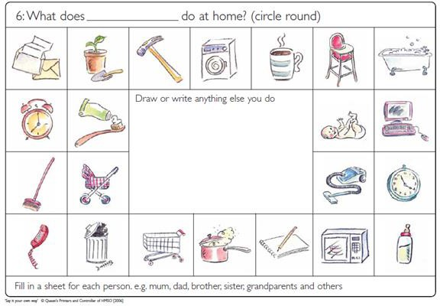

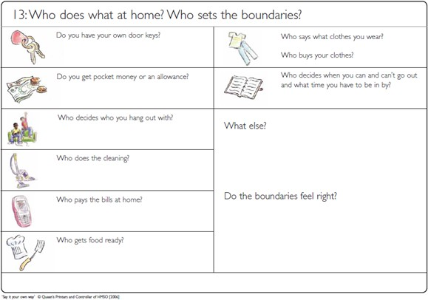
taken
from ‘How it Looks to Me’, see references

Some other useful and well-known tools can be used to consider risks, strengths, hopes and dreams, such as the ‘Three Houses’ and the ‘Wizard and Fairy tool’ - See ‘Child’s Voice’ section of Core skills Workbook Access the Core Skills Resource Book on the Academy.

Understanding the lived experience through observation
When working with non-verbal babies/children, it is important to observe them with their parent/carer, to understand their stage of development, their needs, and how they might be experiencing their world. See link in Neglect Guidance: Summary of Stages of Child Development. There is also further training available via the Early Years Development Programme, which contains learning specifically linked to the Early Years Foundation Stage, with a focus on the importance of child observation (see further reading)

Below is a particularly useful tool to support with observation.

Interaction Observation Chart

Parent/Carer Details:

Child’s Details:

Date and Venue:

 | Child | Parent | Reaction
Playing
Talking
Touch/Affection
Reassurance
Boundaries
Guidance
Praise
Criticism/Negative Comments

(Taken from the South Gloucestershire Safeguarding Children’s Board Neglect Tool Kit)

Tools for Direct Work with Children and Young People

There are a variety of resources that you can use with children and young people to identify their network as follows:
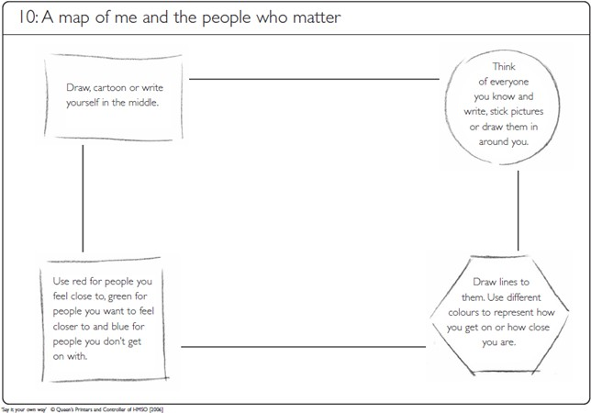

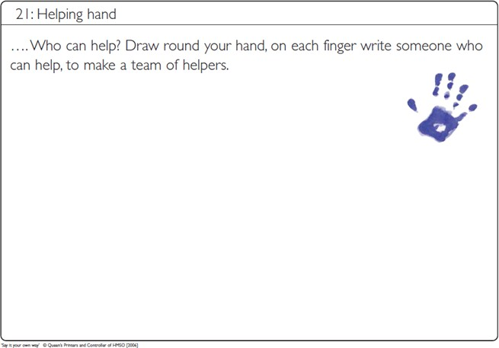
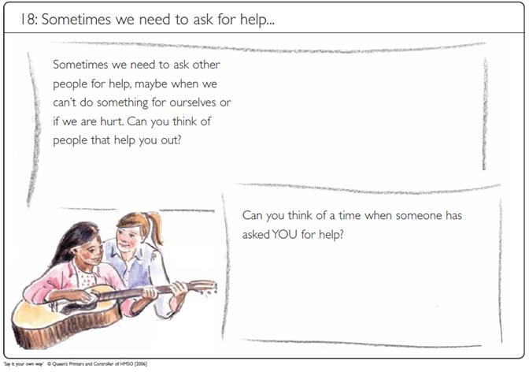
‘Say it your own way’ (DFE/Barnados) see reference

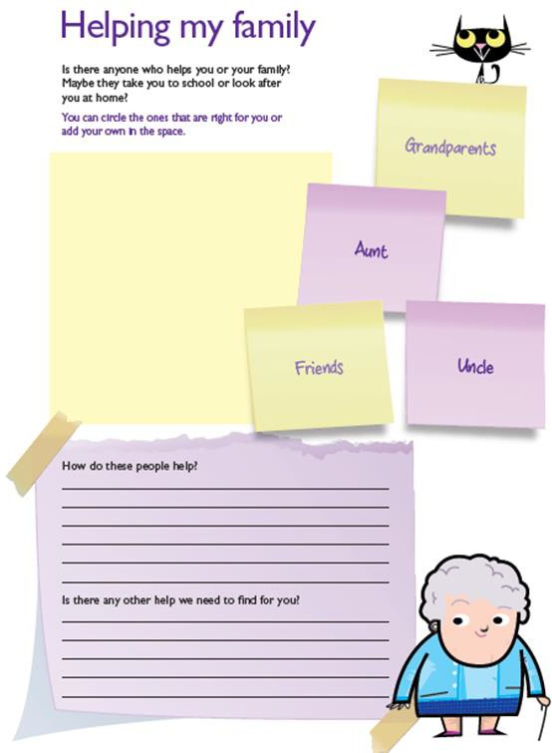

‘How it looks to me’ (Cafcass) see references

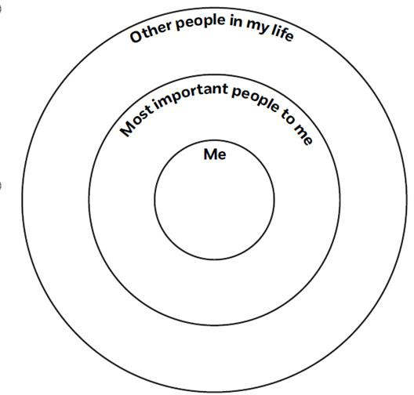

Solution Focussed Practice Toolkit (NSPCC) see reference

Sometimes parents/carers will find it difficult to identify their network, and/or they might identify their family members as their primary support, which can often bring concern due to the trans-generational nature of neglect that is often seen. However, careful assessment is needed in this situation, and practitioners must be careful of unconscious bias. When trying to elicit information from the parent/carer, you should also explore friends, neighbours, and the community and ‘family’ in the widest possible sense.

Multi Agency Working

When neglect is a presenting worry in families, research illustrates that those families are often isolated or perceive themselves to be lacking in support (Brandon 2014). When working with neglect it is important to consider Multi Agency working and to create an environment where discussion is welcome and does not lead to ‘Group Think’. This is a phenomenon where people tend to conform with group decisions to avoid feeling outcast, and this can lead to ignoring alternatives and taking irrational actions (See Neglect Guidance).

Mapping the professional network
This is your first step; using the information you know, and by asking the family and those already involved. You may then want to consider if there are agencies/professionals you feel are missing? Who has the best relationship with the family? Think about your own Social Graaaaces (See Core Skills Resource Book on the Academy) and what may lead to bias?
Consider:
  - What are your previous experiences with the agencies or individuals involved?
  - What is your relationship like with partner agencies? Is there a culture of multi- agency working?
  - Is there a shared understanding of risk? Is there a shared Framework?
  - How do you think your team is perceived by other professionals? What were the worries before you became involved? What has already been tried?

Working effectively
It is important to use a restorative approach when working with others (see section on Facilitating Family Network Meetings). You can do this by:
  - Introducing everyone to each other: Individual professionals may have consulted each other in the past, but not yet come together as a network. This can be an opportunity for everyone to know who is involved and will support information sharing. You could do this in a number of ways (via a group email, a virtual meeting etc)
  - Set out how you want to work and test out hypotheses and ideas to pre-empt potential issues in working together
  - Invite views and create a sense of collaboration as you would be when working with a family
  - Take time to think and prepare. Time for in-depth thinking about the position of each professional will support you to consider each perspective.
  - Consider and utilise the strengths of each professional Who is best placed to support the child/young person or parent/carer, and with what tasks. Ensure work is joined up, but not overlapped, and the family do not feel overwhelmed.

  - Focus on the shared goal There may be differences of opinion, but use solution focussed questions to remind everyone of their shared goals, which will be to improve the outcomes for the child/young person.

Involving the Wider Support Network

Social isolation and limited networks can impede the ability to address change. In this instance, Family Finding Tools can be useful to help a family naturally develop and identify their support network, which is important for families to feel empowered, enable change and build resilience.

There are a number of tools that you can use with a family to map their network of support to feed into assessments, plans, reviews and chronologies thereby maximising the effectiveness of the practitioner's interventions. All of the following can be found in the Core Skills Resource Book on the Academy
  - Genogram – Page 10
  - Eco Map - Page 34
  - Family Tree Tools – Page 49
  - Mobility mapping – Page 56

Note that all of these tools can be completed with a parent/carer, or a child/young person. You need to carefully consider which tool to use. You can often use the same tool with the parent/carer and with the child/young person and you might get a different response regarding whom is identified.

Conversational Tools
There are a number of strength-based ‘family finding questions’ from Turnell (2012) (see references). You can ask parents/carers or the child/young person to broaden your conversations with them, and elicit more information about their network, especially if they feel isolated.
Not all questions are applicable in all circumstances, but you can choose the questions most appropriate for the person you are talking to:

Past
  - Who are the people that have stuck with you at your best and worst moments in life?
  - Can you tell me about someone in your life who has really understood you? Really appreciated you?
  - What has been the most important day in your life and who was there to share it with you?
  - Who has been the person that surprised you the most when you needed help caring for your child?
  - When you think about your past, who has been most supportive of you in the choices you have made regarding your children?
  - Can you find a photo on (social media/phone etc) that reminds you of a happy time? Who are you with? Who has responded to the photo in a positive way? (eg. a ‘like’)

Present
  - Who is someone in your life that you can call on or depend on in a time of need or crisis?
  - Who is someone in your life that you would tell exciting/good news to?
  - If today was the last day you could ever communicate something to your child what would you say to them? Who would you tell them to go to for help?
  - If you had a power cut tonight who would you call? Where would you stay?
  - Who sent you a birthday/Christmas card? Who did you send them to?
  - Who is last person on your phone that text you and made you smile?

Future
  - If you could fast forward 5 years from now, who would be your support network and who would rely on you?
  - If you found yourself homeless who would you call?
  - You wake up tomorrow and its two years from now. Who are the people you hope are in your life?
  - Its several years from now and your children have grown up. Who are the important people in their life?

Safety Circles

Developed by Susie Essex (Cited by Turnell 2012). This can be done by asking the parent/carer to list everyone they know and ask them to categorise those people within the following three circles. This encourages the parent/carer to think about whether some people are more appropriate and helpful than others. The parent/carer is also supported to consider who in their network might share the worries of the practitioner.
Safety Circles’
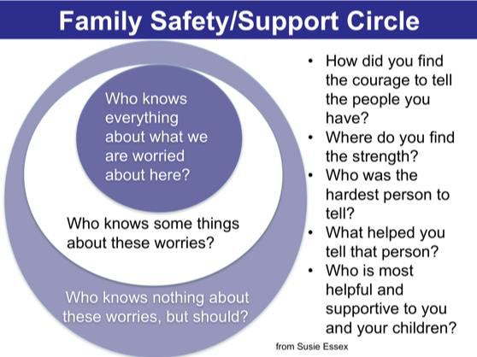

Facilitating Family Network Meetings

Facilitating a solution focussed ‘Family and Friends Meeting’ can result in a robust family plan that takes a restorative approach, building self-efficacy and resilience. These meetings have the following features:
  - A Family led approach
  - Family friendly language
  - The family are encouraged / supported to share their views
  - A neutral venue
  - Child or Young person taking the lead
  - Family taking responsibility (owning their feelings)
  - Family making suggestions
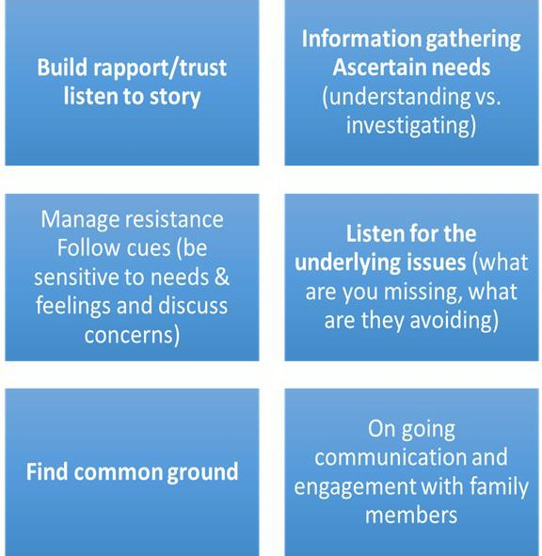
  - Family making their own resolutions The restorative practitioner's role is as follows:

Prior to holding a ‘Family and Friends meeting’, there are a number of questions to consider in your preparation:
  - Network mapping – Have you used the tools in this Neglect Tool Book? Have you fully explored with the parent/carer/child/young person who is in the network? Have you discussed with the parent/carer anyone who might be considered unsafe and/or most useful to involve?
  - Absent parents – Have you explored involving absent parents/carers? Those with parental responsibility? Some members of the network may wish to give their views or have their voice heard, or may not be able to attend but wish to be consulted
  - Conflict and Risk Assessment – Do you understand the dynamics within the family? Do you know of any conflict? How will you manage any conflict that might arise? Do you have a risk assessment in place?
  - Practicalities– Have you considered the best location, time and day for the meeting? Does it suit the family? What impact might venue/online/time/place have on the meeting itself? How will people be invited? By the parent/carer or you? Consider the balance of power and how you might address this
  - Voice of the child/young person - How are you going to include the voice of the child? Will they attend? If so, how will you support them, or who else can? If not, how can you creatively ensure their voice is heard? How will you record it?
  - Information for the family – What information will you present at the meeting? How might everyone respond? Will there be new information for the family? If so, how might they respond? Are the family likely to understand the information?
  - Family Plan – How will this be formulated? Do you have a template? How will it draw on the strengths? How will it be relevant and workable for the family? How will it be related to your worries? How will it be written – by you or the family? How can you make sure it is SMART? How will it be measured moving forwards? How will you know it is working? What would the plan need to look like for you to close or feel less worried? See Neglect Guidance.

Common Problems and How to Overcome Them

Issue: I can’t seem to get the family to understand what I am concerned about…
Try the following:
- Seek support at an early opportunity from your manager. Talk through your worries and agree whether there are any different techniques that could be used.
- Think of creative ways to discuss the issues you are concerned about with the family. – Perhaps produce concern strips with your worries written on each one. Ask the family to reflect and prioritise them.
- Ask the family why they think you are visiting and use their response to talk about issues.
- If you have been involved with the family for a long time and you feel that when you talk about issues you are no longer making an impact, try and visit with a colleague to produce a new way of talking about the same things.
- •Be mindful of level of cognitive ability of the family and adjust your language accordingly (particularly relevant with families with significant learning disabilities).
- Use case progression to share your thoughts and reflect on the family’s circumstances as a group
Issue: It’s hard to effect change with issues of neglect with this family
Try the following:
- Review the case with your manager.
- Share chronologies between agencies who are working with the child / family.
- Review the plan.
- Establish whether there is any pattern to decline or triggers that can be identified.
- Consider the likely long-term outcome for the children without change and the impact of this. Use this to inform the plan or discussions with the family.
- Be clear about the desired outcomes and timescales with the family, extended informal network and multi-agency partners
- Be mindful that children with disabilities and / or additional needs, and their families, are likely to require additional support.
Issue: The family had shown that they do know and understand what good parenting is……. But they don’t do it consistently…
Try the following:
- Look for and require consistency; it is common for parents who have received support and services such as parenting skills programmes to have knowledge of what good
parenting is. Often parents can talk about what they should be doing with their children and a lot of the time they demonstrate an ability to provide good enough care, however

they are not always able to do this consistently.

- Consider involving individuals who can act as role models to parents, preferably in the home. There may be resources within the extended family for this. The aim of this exercise would be to have someone who is able to spend significant periods of time in the home assisting and guiding parenting. It might mean helping a young mother or father to safely bath a baby. Or helping a family to understand the necessity for good hygiene in the kitchen.
- Keep the needs of the children in focus. Talk to the children and find out what their experiences are, e.g. what a day in their life is like (there are some examples included within this toolkit).
- When you know that parents can care adequately some of the time it becomes harder to remain objective and there could be a tendency to err on the side of optimism. Record carefully when the dips in parenting occur and compile chronologies of accidents and issues around poor supervision.
- Be mindful that children with disabilities and / or additional needs, and their families, are likely to require additional support.
Issue: There is a plan in place, but I remain concerned for the child’s safety. I can’t seem to get the family to understand what I am concerned about….
Try the following:
- Discuss your concerns with your manager or, where the child is subject to a Child Protection Plan, the Chair of the Child Protection Conference.
- Ask for the review to be brought forward.
- Produce a multi-agency chronology.
- Reflect on concerns in relation to the child and parent and the effectiveness of the current plan.
- Be mindful of level of cognitive ability of the family and adjust your language accordingly (particularly relevant with families with significant learning disabilities).
- Use tools/resources to consolidate concerns.
- Seek legal advice about commencing the Public Law Outline (Social Care staff only).
Issue: The plan doesn’t seem to be working, the family isn’t co-operating – I feel ‘stuck’
Try the following:
- Review what you have done so far to engage the family – what has been most successful? What has been least successful and why?
- Discuss with your manager.
- If there are practical issues blocking progress attempt to resolve these. It may be that the home environment is so chaotic when you visit that you are unable to complete any assessment. If this is the case, plan carefully how you can assess the family in these circumstances.
- Resolve some of these practical issues that may be distracting the family (although be aware to the possibility that they are not being used as excuses to distract you).
- Think about what the family most likes to talk about, for example, the children,

themselves, housing issues. Structure your visit and allow them 10 minutes at the beginning of the session to let off steam and then spend the remaining time looking at issues that you want to cover.
- Plan your visits. Think carefully about what time you will visit, what you want to achieve from the visit and how you will do it.
- Think carefully about how you are going to monitor and measure the issues of neglect. It is not acceptable to see this as ongoing activity that you cast your eyes over when visiting the family home. Use resources and tools to review change and feedback to the family what you perceive the situation to be.
- Consider using creative ways to engage the family e.g. DVD, games.
- Consider using a written agreement with the family.
- Use observation as a method of gaining information and then feedback the issues to the family and engage in discussion about this.
- Consider discussing your family within your team, possibly at a team meeting. Your colleagues may think of new ways of engaging the family or support to offer.
- Consider having a colleague co-work with you. This will provide you with support and may also help to provide a fresh approach to the case.
Issue: There is no network of support for this family – family members are unsuitable
Try the following:
- Consider what you know about the extended family and friends/network. Is your information based on an effective assessment or just what you have been told? Consider any unconscious bias and reflect on this with your manager
- What makes the family members/network unsuitable? If there is trans-generational neglect, do the family members understand the concerns? Consider speaking to extended family (with consent) to help them understand your worries and your assessment, and the next steps if things don’t improve. If appropriate, it might be possible to involve them in your work and discussions with parents/carers to fully engage them in the process of change.
- Try the strength based questions with the family to explore when things have gone well, who has helped them? How? Try supporting the family to visualise a future where things have improved. What would this look like? Who would be helping them?
- Are there people that can give the parent/carer moral support, reminders or emotional support? Support from the network does not mean others ‘doing it for them’
- Think creatively about what the support network might look like – it does not have to be direct family members. Try using the strength-based questions, safety circles and other tools with the family to fully explore their network and who can be most helpful. Try to focus on what can be done by an individual, not what can’t (eg. they might not be able to provide respite care, but they might be able to text a parent and remind them of appointments)
- Complete direct work with the child/young person to explore who they feel can help – sometimes they will identify different people to their parent/carer

Further Reading

General Neglect Resources Research in Practice Community Care Inform KCSPM – Neglect Strategy
Department for Education - This link takes you to the safeguarding children pages of the website where there are numerous articles, reviews and research papers related to child neglect as well as wider safeguarding concerns.
NSPCC - Spotlight on preventing child neglect; an overview of learning and research. Early Years Development programme on Kent Academy

Home Conditions
The tools and links below provide a method to assess physical aspects of home conditions and their impact on the children who live there.
https://www.cafcass.gov.uk - Home conditions assessment Home Conditions Oberservation / Record Framework https://www.hoardinguk.org/

Domestic Abuse
Tools for assessing Domestic abuse impact on children CAFCASS https://www.womensaid.org.uk/
Womens Aid – How you can help your children http://www.oasisdaservice.org/home

Mental Health
Kent Enablement and Recovery Service for mental health Kent Enablement and Recovery Service (KERS) works with people experiencing mental health difficulties to address social care needs over a short period of time (up to 12 weeks).
MIND

Substance Misuse https://www.changegrowlive.org/ https://www.alcoholics-anonymous.org.uk/#
https://www.al-anonuk.org.uk/ - Al-Anon Family Groups UK & Eire is there for anyone whose life is or has been affected by someone else's drinking.

Parents/carers with Learning Disabilities
Community Learning Disability Team

Family Assessment Centre and online Community Support - Symbol - The service exists to provide specialist assessment and support services for clients with special needs and/or vulnerabilities. The service provides residential and community based care for families who have special needs, this includes assessment, support, teaching and developing communication skills and independence within the community
References
Brandon, M. et al., (2014) Missed opportunities: indicators of neglect-what is ignored, why, and what can be done? London: Department for Education, DFE-RR404

Cambell, K & Turnell, A, (2012) Family Finding/Signs of Safety Residency - Questions for Finding Naturally Connected Networks. (www.familyfinding.org)

Children and Family Court Advisory and Support Service (CAFCASS), (2013) How it Looks to Me (www.cafcass.gov.uk)

Department for Education, Barnardo’s, (2006) Say it your own way – Children’s participation in assessment: resources. London: Her Majesty’s Stationary Office (HMSO).

Turnell, A, (2012) The Signs of Safety Workbook. Resolutions Consultancy, (www.signsofsafety.net)

NSPCC (2014) Solution-focused practice – A toolkit for working with children and young people (www.nspcc.org.uk)

Gardner, R (2008) Developing an effective response to neglect and emotional harm to children. University of East Anglia and NSPCC

Prochaska, J.O. and DiClemente, C.C. (1982) ‘Trans-theoretical therapy: toward a more integrative model of change.’ Psychotherapy: Theory, Research, and Practice 19, 3, 276– 288.

Morrison, T. (2010) ‘Assessing parental motivation for change.’ In J. Horwath (ed) The Child’s World: The Comprehensive Guide to Assessing Children in Need. London: Jessica Kingsley Publishers.
Some tools adapted from: Dorset Safeguarding Board, South Gloucestershire Safeguarding Board, Essex Safeguarding Board and East Sussex County Council

