- Every effort should be made to resolve issues informally. Where this is not possible, in order to discharge their responsibilities in relation to the child, the CP Chair following discussions with their line manager, should initiate the formal Practice Alert process.

- In some cases, it may be appropriate to begin the process at a different stage e.g. if the social worker or the team manager do not have the authority/ remit to implement the decision, the process should start with the manger with the appropriate authority/responsibility.

- Practice Alerts may be raised either prior or following a conference i.e. following a CP Chair mid- way monitoring.

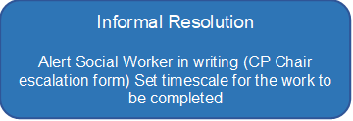
Not resolved
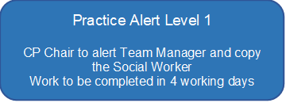
Not resolved

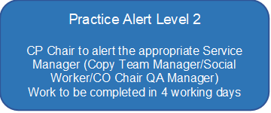
Not resolved
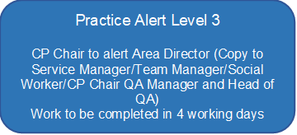
Not resolved
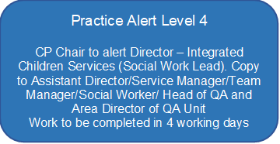

- The timescales at each stage of the Practice Alert process is guidance. In exceptional cases, where it would be beneficial to a successful resolution, CP Chair’s in agreement with their line manager can call a ‘time out’ from the formal alert process. This might involve waiting until a required person becomes involved to undertake work or the child and/or the family need time to make a decision. The key issue is applying the Practice Alert process to make this as effective as possible in resolving an issue that is getting in the way of the child’s needs being met and their care plan progressed in a timely manner.

