Safeguarding Adults
Tell us your concern (formerly referred to as alerting)

You can report concerns by completing this form: Send by secure email to: ASTeam@gov.im

You can speak to us via the single point of referral (Mon to Friday - office hours) 01624 686179

If a crime has occurred & police help is needed, please call 01624 631212, (or 999 in an emergency)

Please complete this form with as much information as possible.
We cannot progress without key details; you must complete domains marked with a *

Date Safeguarding Concern Raised:

1. Who is the person at risk? *

Title:  Mr/Mrs/Ms/Other | First Name(s): * |  | Surname: * |  | Date of Birth:  Age:
Address:  Post Code:  Tel: |  |  | URN: (if known)
 |  |  | Gender:
 |  |  | Language spoken:
 |  |  | Communication needs:
 |  |  | Ethnicity:
 |  |  | Religion:
 |  |  | Other:
Primary Support Reason:
Physical support needs  (exc. Sensory support needs) |  | Mental health support needs  (excluding dementia) |  | Support for learning disability
 |  |  |  | Support for substance misuse
Sensory support needs |  | Support with memory / cognition (including dementia) |  | Other (please specify below)
Carer support needs

2. What existing professional/care/support services is the person receiving (if any)?

3. Details of the safeguarding concern *
(A) Describe what has happened, when and where.
(B) What are the person at risk’s views about this incident
(C) Describe the risks or any injuries or harm experienced by the person at risk
(D) Please explain why the person at risk is not able to keep themselves safe?

Please tick here if a Body Map has been completed (only to be completed by a health care worker or carer)
Type(s) of abuse *
Physical |  | Domestic abuse |  | Financial / Material
Neglect / Acts of omission |  | Discriminatory |  | Organisational
Psychological |  | Sexual abuse |  | Self-Neglect
Modern slavery |  | Hate Crime (mate) |  | FGM |
EMOTIONAL |  | OTHER

4. What does the person at risk want to happen now?
What are the desired outcomes of the person at risk? (That is, what do they wish to achieve from the support they might receive, such as feeling safe at home or having no contact with certain individuals)
Has the person at risk given consent for these concerns to be raised?  (The person at risk should be advised about the referral) | Yes No
Did the person give informed consent (capacity) to the referral being made? | Yes No  (If no please explain why below)
If you have marked no above to consent, then you must explain you’re rational as to why the person consent was not sort or given.
Can you justify why consent was not ascertained | Complete in part 7 *

5. Actions already taken in relation to the safeguarding concerns?
Details of action taken:

If a crime has been committed, or believed to have been committed Have the police been informed? | Yes No | Crime Ref. Number:
Is medical intervention required and if so, has this been sought? | Yes No | From where/whom?

6. Details of the person or organisation alleged to be responsible for the abuse or neglect (PATCH- person alleged to have caused harm)
Name: |  | Date of Birth:
Address:  Post Code: |  | Gender:
Does the person/organisation know that a safeguarding concern has been raised?

Yes No Not Sure
What is their relationship to person at risk?  Are they known to the person at risk? Yes No |  | Is this person also an adult at risk? Yes No
Additional information, such as previous concerns (consider if the MASM process is appropriate):

7. Any other relevant information
Include any safety or confidentiality issues that may impact on how the concern is acted upon and why consent needs to be overridden *

8. Details of the person completing this form *
Name: |  | Job Title:

Address:

Post Code:
Tel: |  | Date:

Please send by secure email to Adult Safeguarding Team – ASTeam@gov.im
Appendix 1
Body Map
Where appropriate, and only in a health/carer capacity use this form to provide further information to support a safeguarding concern.
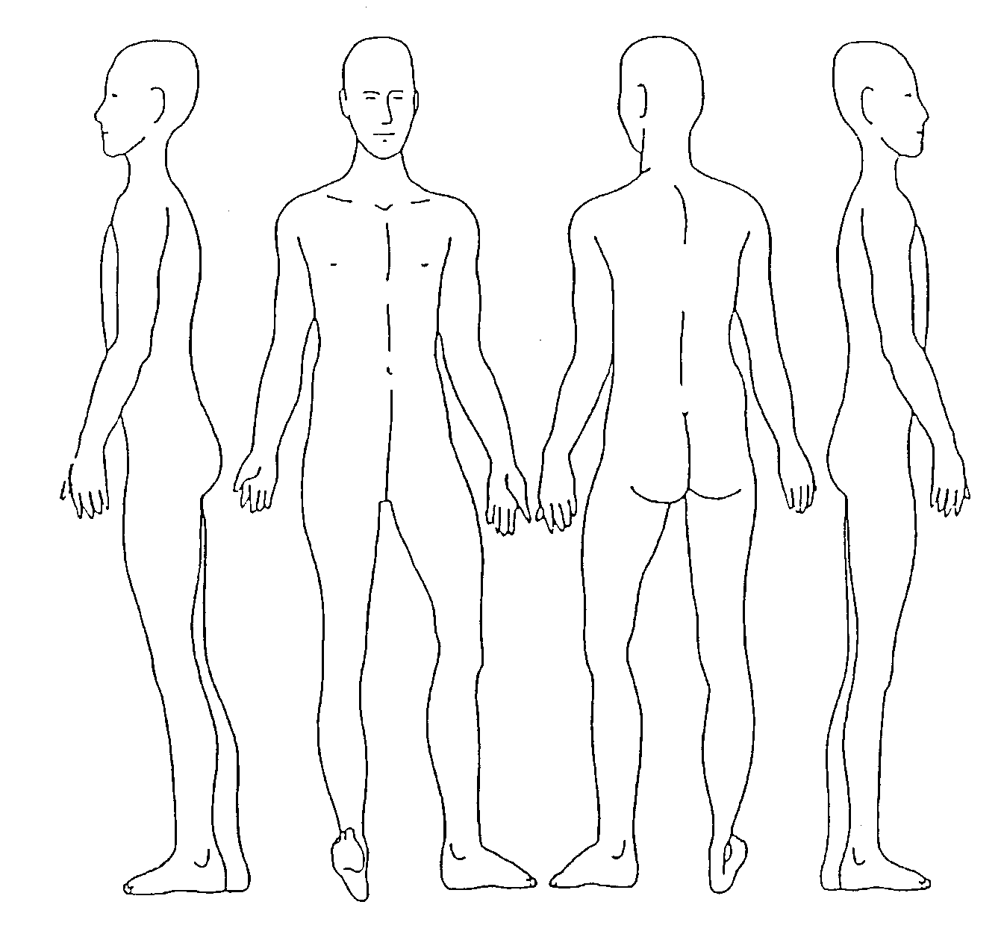
Date when the injury happened (if known) |  | Date injury below was first observed (if this is different) to the original date
Record the area/site of any injury, marks, bruising, etc. Please also indicate the rough size in centimetres or use a comparison, for example, the same size as a 10p coin. Record details such as the colour of bruising, etc.
A – Pressure trauma B – skin excoriation/grazing/reddening
C – burns D – bruising E – wounds

