Children’s Continuing Care Team
Riverside House
2nd Floor
Goldcrest Way
Newburn Riverside
Newcastle upon Tyne
NE15 8NY
Telephone: 0191 2236551
E-mail: necsu.chtadmin@nhs.net
www.necsu.nhs.uk
To whom it may concern

22nd November 2018

Dear Sir/Madam

Re: Incomplete Referrals

We are sorry to inform you that there has been a decline in the quality of the referrals received recently by the Children’s Continuing Care Team which has been and is resulting in delays in processing the Referrals as a significant amount of time is spent chasing up the required information.

From 1st December 2018 we would ask that all referrals sent to the Children’s Continuing Care team are fully complete and contain the information as stated below. This is necessary as The Children’s Continuing Care Team must adhere to the strict timelines to process Referrals as set out in the National Framework.

Please Note:

- All sections in the referral form must be fully completed.
- The consent to share form must be completed and signed (verbal consent is not acceptable). The Referral will be returned immediately to the Referrer and closed if the consent form is incomplete/unsigned and it will be necessary to re submit the Referral.
- The EHC Plan and C&F Assessment must also be sent with the referral along with any other supporting reports and assessments. If any of this information is not included seven days will be given to submit the information requested, failure to do so will result in closure of the Referral and the Commissioner for Children will be informed.
- The details of professionals involved with the child must be fully completed including, name, contact tel. number, address, email, involvement of care and report attached.

If you have any queries or questions please do not hesitate to contact a member of the Children’s Continuing Care Team on 0191 2236551.

Yours faithfully
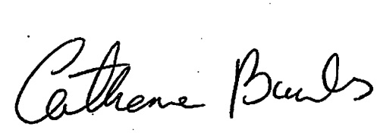

Catherine Banks
Senior Administration Officer
Children’s Continuing Care

