Incident Report

Guidance : To ensure Family Fostering meets the requirements of Standard 29 and Regulation 36. Please notify Family Fostering in the first instance and complete an incident report for the following:
- Any incident necessitating the police visiting the foster home
- Any measure of control or restraint in respect of a child placed
- Any allegation that a child placed has committed a serious offence
- Involvement or suspected involvement of a child placed being a victim of sexual exploitation
- Death or serious injury/ accident/ illness of a child placed
- Any episode of a child missing/ absent without permission
- Any concerns, complaints, allegations, disclosures or safeguarding issue
- Outbreak at the foster home of any infectious disease deemed serious by a GP
Fax or email to the Family Fostering Office as soon as is practicable following the incident.

Name of Child/YP |  |  | D.O.B
Name of Foster Carer(s)
Date of Incident |  |  | Time
Description of Incident: See Above

Name of persons witnessing/involved in the incident (use initials for other children/young people) |  | Relationship to the Child/Young Person:
Brief summary of events leading up to the Incident:

Full details of the Incident including duration:
Action taken by the Foster Carer(s)

De-escalation Strategies Attempted – Only to be completed in event of acting out behaviour: Please highlight or put in bold the strategies you have tried:
Distraction / Change Subject Offer comfort Empathic listening

Humour Offer of time out Planned ignoring Spoke calmly

Removal of audience Non verbal signs Reverse psychology

Other Please detail below:

Physical Intervention Used- Only to be completed in the event of physical intervention

Escort

Hold/Restraint Duration of Restraint:

Details of any injury sustained and/or medical attention required :

Details of all professionals/Agencies contacted/involved. |  |  | Date/Time
Outcome:

Foster Carer’s view of why the incident arose and what intervention may prevent a similar incident arising in the future:

Foster Carer’s signature |  | Date
Name of person completing the form (if different from the above)
Signature |  | Date
Office Use:

Classification of Incident:
Supervising Social Worker’s Review of Incident – including action to be taken to prevent further incidents:
Managers Review of incident – including action to be taken to prevent further incidents – To be completed within one month of incident:
Does this require a Schedule 7 Notification
Date of Notification
Final Outcome
Name of Supervising Social Worker:
Date & Time informed:
Name of Local Authority Social Worker:
Date & Time informed:
Date Incident report sent to Child’s LA:
Signature of Registered Manager/Fostering Manager

Body Map

Name of Child/Y P |  | D.O.B

Body Map Notes

Please draw on the body map in black ink, using the following key to indicate the different types of injury (alphabetic code), shade in the body map to show the size of the affected area and provide brief details for each injury.
A – Bruising B - Cuts & Wounds C - Scalds, Burns D- Other (specify)
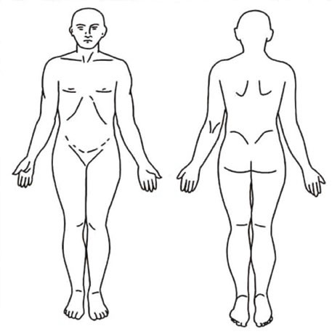

Once completed please return to the Family Fostering Office

