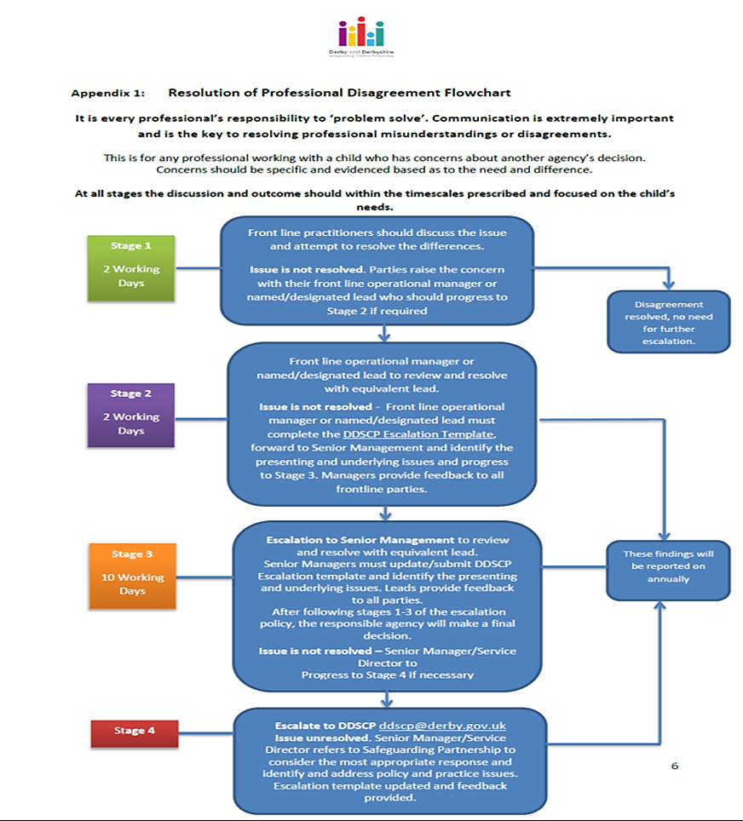

Please see the following pages for the contact details for Stages 3 and 4

**Escalation contacts Derby & Derbyshire**

**Stage 1** E.g. Front line health professional tries to resolve the issue with e.g. Front line Social Worker, if this cannot be resolved their respective managers should be contacted and progress to **stage 2.**

*If the case progresses to* **Stage 2**

* **E.g. Named Nurse or the front-line professionals’ manager to discuss the case with the Team Manager or relevant Deputy Head of Service (HOS)**

 

*If the case progresses to* **Stage 3**

* **Team Manager/Named Professional to complete Escalation Form and send to** Designated Nurse / Doctor who should discuss the case with the relevant Head of Service/Assistant Director

** **

If issue is still not resolved at **Stage 3** the case will need to escalate to Director Level.

If no resolution escalation to **Stage 4 -Derby and Derbyshire Safeguarding Children Partnership (DDSCP)**

[alison.noble@derbyshire.gov.uk](mailto:alison.noble@derbyshire.gov.uk)                    01629 532005

[linda.dale@derbyshire.gov.uk](mailto:linda.dale@derbyshire.gov.uk)                        01629 532456

[suanne.lim@derby.gov.uk](mailto:suanne.lim@derby.gov.uk) 01332 642641

Derby & Derbyshire Safeguarding Children Partnership Email for **Stage 4**: [ddscp@derby.gov.uk](mailto:ddscp@derby.gov.uk)