Prevention of Non Accidental Head Injury in Infancy Guidance

Contents
- Introduction
- Aim
- Background
- Parental Education Programme (PEP)
- Health Staff Guidance on delivering the Parental Education Programme
- Governance and Assurance of the Parental Education Programme
- Multi-agency Staff Guidance on the promotion of reducing non accidental head injury in babies across Derby and Derbyshire
- References

This document is a multi-agency guidance document and it replaces all other previously published documents, including those within health.
Version | Author/s | Signed off by | Date | Review Date
1. | Consultant/Designated Nurse Safeguarding Children and Children in Care – Derbyshire County | DSCB Policy and Procedures Group | February 2014 | February 2016
2. | Guidance reviewed by Keeping Babies Safe in Derby and Derbyshire Group: no amendments required. | DSCB Policy and Procedures Group | January 2016 | February 2019
3. | Guidance reviewed by Keeping Babies Safe in Derby and Derbyshire Group | DDSCP Policy and Procedures Group | November 2019 | February 2021

- Introduction

Non accidental head injury involving injury to the brain is the most serious form of physical abuse and can have serious consequences for a child’s future development and wellbeing. Non accidental head injury is the leading cause of death among children who have been abused.
Non accidental head injury occurs most commonly in children less than two years of age with an estimated prevalence of 1:3,000 in babies less than six months old. Boys appear to be affected more commonly than girls. Non accidental head trauma involves inflicted injury to the brain or bleeding within the structures around the brain. The consequences can lead to significant long-term disabilities including cerebral palsy, visual problems, epilepsy, learning and behaviour problems. (CORE INFO and NSPCC 2014).

This form of child abuse differs in a number of ways from other more common and more visible forms of abuse;

  - A single event may cause catastrophic outcome
  - Often there are no visible sign of injury
  - There is frequently no intent to harm the child
  - The immediate and follow on outcome is worse than with other cause of head injury in childhood (Bruce & Zimmerman, 1989)

Shaking events do not appear to be related to race, class or family circumstance (Sinal et al., 2000) although risk does increase in families where there are more stressors and fewer resources (Sanders et al.,2003).

Aim

To deliver a health education initiative with the aim to reduce the incidence of shaken baby syndrome in Derby City and Derbyshire. This will be achieved by delivering a Parental Education Programme (PEP). This programme will:-
- increase parents and carers awareness of the risks of shaking a baby
- support and educate parents and carers by sharing some strategies for managing crying babies and stressful situations. .

Background

Following the learning from previous serious case reviews Safeguarding partners continue to promote Parental Education Programme (PEP), which was re-launched in 2013. Both Safeguarding Children’s Boards and the new Safeguarding Partnership Arrangements remain committed to preventing non accidental head injury and support the Parental Education Programme.

- Parental Education Programme

The aim of the PEP is to prevent and reduce the numbers of babies living in Derby and Derbyshire who are injured by shaking and non- accidental head trauma. The DVD will help parents, and prospective parents and carers, to understand the dangerous consequence of shaking a baby. The programme provides them with consistent information about strategies for managing a crying baby and managing the personal stress of caring for a baby. The PEP consists of:-

- An educational DVD (3 minutes long);
- An information leaflet;
- A signed commitment statement which confirms the parent’s commitment to keeping their baby’s head safe.

The DVD is evidence-based and has been modified from a successful Australian campaign (University of Sydney). The DVD is approximately 3 minutes long and provides education on;

- Reassurance that crying in babies is normal;
- How to cope with a crying baby;
- The dangers of shaking a baby;
- Where to get help and advice; and
- That shaking the baby is just not the deal!

The process for the PEP was adopted from a parental educational programme which is described in an American research paper (Ref: Preventing Abusive Head Trauma Amongst Infants and Young Children, Dias et. al; 2005) where the incidence of shaken babies has been reduced by 47% over a four year period.

A recent study by Coster (2017) has concluded that for many parents a crying baby can lead to elevated levels of frustration, anger and distress and as such can be a common trigger for shaking which can lead to non-accidental head injuries. The study concluded that a psycho-educational film can be an effective tool in helping parents cope with crying and gives parents simple practical strategies to use which are memorable.
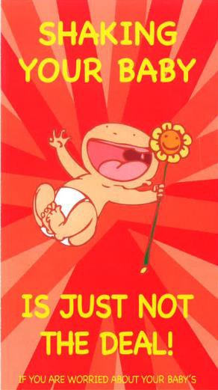
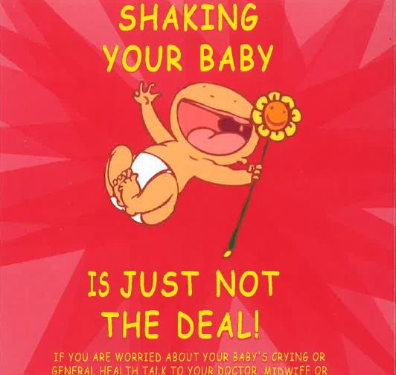

5. Health staff guidance on delivering the Parental Education Programme

PEP is delivered by the Midwifery Services in Derby and Derbyshire as follows:

In Hospital

- Optimal time for the delivery of PEP is in Hospital following the birth of the baby and prior to discharge.
- It is the responsibility of the Hospital Midwife discharging mother and baby to ensure that the PEP takes place. When a baby is being discharged from the Neonatal Unit it is the responsibility of the Neonatal Nurse discharging the baby.
- Both parents should see the 3 minute DVD and be given an opportunity to ask any questions and both should sign the Commitment Statement a copy of which will be placed in the Red Book (Child Health Record) and maternity record for audit purposes.
- In cases where the baby is to be cared for by anyone other than the parent e.g. Foster Carer or extended family then there is an expectation that they undertake the PEP if possible prior to discharge
- A “Shaking your baby is just not deal” information leaflet should be given to the parents / cares as a reminder of the details seen on the DVD.
- Parents and carers should be shown how to hold baby and how to handle their baby’s head with care.
- Where English is not the first language of the parents or carers the PEP should be delivered by showing the DVD and supporting this with a leaflet in the language of the parents or carers with support and advice from a practitioner. The leaflets in alternative languages can be obtained from the Midwife.

In Community

- In cases where baby is born at home or in a Hospital outside Derbyshire, the PEP should take place in the home or local community base.
- It is the responsibility of the Community Midwife discharging the mother and baby into the care of the Health Visitor to ensure that the PEP has taken place and that both parents have seen the DVD.
- The Midwife must confirm that the PEP has taken place on the Handover of Care to the Health Visitor
- If the baby is being cared for by foster carers or extended family there is an expectation that the PEP is completed as soon as possible at home or at a local community base.
- Whilst this is primarily a Midwifery initiative, it is the Health Visitor’s responsibility to check that the PEP has taken place.
- Where English is not the first language of the parents or carers the PEP should be delivered by showing the DVD and supporting this with a leaflet in the language of the parents or carers with support and advice from a practitioner. The leaflets in alternative languages can be obtained from the Midwife.
Helpful tips and advice can also be found on the NSPCC’s Baby & toddler safety page

- Governance and Assurance of the Parental Education Programme

- The overall delivery and outcomes of the programme will be monitored through the Keeping Babies Safe in Derby and Derbyshire which is a sub group of the Child Death Overview Panel.
- An audit of the programme will be completed at least every two years to gain assurance of the delivery and effectiveness
- If there are any concerns regarding the ability to deliver the programme this should be raised with the Designated Nurse Safeguarding Children and to the Keeping Babies Safe in Derby and Derbyshire group.

- Multi-agency Staff Guidance on the promotion of reducing non accidental head injury in babies across Derby and Derbyshire

- All those who come into contact with babies, parents and prospective parents and carers should be mindful of the need to reinforce the messages around the importance of keeping babies safe.
- The PEP version or condensed version of “Shaking your baby is just not the deal” DVD should be shown at any relevant pre parenting course or any area where the public may be receptive to the messages contained in the DVD e.g. GP waiting rooms, ante natal waiting areas, Children Centres, Probation Offices, youth projects and schools.
- Families with babies under 6 months old should be asked if they have seen the DVD. In cases where it is identified that families with babies have not seen the DVD or been subject to the PEP (may be due to moving in from a different area) these should be referred to the Midwife or Health Visitor for their attention.

Everyone is responsible for conveying the following messages to the general public:

- IT IS DANGEROUS TO SHAKE A BABY – because a baby’s head is big and heavy compared to the rest of their body, and their necks relatively weak. Shaking makes the head accelerate back and forward and can result in bleeding in or around the brain and / or damage the blood supply to the brain, and may result in;
  - Blindness
  - Deafness
  - Fits
  - Learning Difficulties
  - Brain Damage including cerebral palsy
  - Death

- SHAKING CAN HARM OLDER CHILDREN – whilst the harm is greatest in babies under 12 months, shaking can cause serious harm to older babies and toddlers.
- OTHER KINDS OF ABUSIVE HANDLING CAN CAUSE INJURIES – in particular hitting a baby on the head.
- BABIES ARE OFTEN SHAKEN WHEN A PARENT LOSES CONTROL – a parent or carer may lose control and shake the baby in a moment of anger or frustration especially if the baby cries a lot or has a problem whilst feeding. Many people don’t understand the serious damage that shaking can cause.

- ALWAYS PROTECT A BABYIES HEAD EVEN IN AN EMERGENCY – even if the baby appears to have stopped breathing, don’t shake them. Doctors advise flicking the soles of the feet and picking up the baby with the head and neck well supported.

HOW TO MANAGE A CRYING BABY

Step one - Understanding why babies cry

- The baby is uncomfortable – too hot or too cold, needs a nappy change
- Hungry
- Upset or scared
- Unwell – teething, wind or running a temperature
- Lonely – sometimes babies just want to be comforted
- Remember it is not uncommon for babies to cry for up to two hours a day

Step two - Once all the checks have been made and action taken to alleviate baby’s discomfort and baby is still crying try;

- Another feed – to check baby is not still hungry
  - Sing or talk to baby
  - Try to make close eye contact with the baby
  - Take baby for a walk in the fresh air
  - Rock baby gently close to the chest
  - Gently rub or massage baby
  - Offer a dummy (if the parent chooses to use one)
  - If all else fails loosely wrap baby in a small soft sheet so baby feels secure and try to settle in a safe and quiet place being mindful to check baby regularly

- HOW TO MANAGE PARENTS/CARERS STRESS – when baby is still crying, or parents/carers feel stressed for other reasons. Advise parents and carers:-

Crying will not harm a baby
- Loosely wrap baby in a small soft sheet and place on his/her back in the cot and then leave the room. Do something which will take a break from the sound of baby crying for 5-10 minutes. Be mindful to check baby regularly once crying has stopped.
- Listen to music or watch TV
- Have a quick shower
- Walk out in the garden
- Call a relative or friend and let someone know how you are feeling
- If worried call the GP, Midwife or Health Visitor

REMEMBER: BABIES CRY TO COMMUNICATE

Babies are fully dependent on the person who is caring for them. That person should provide food, warmth and comfort which all babies need. When a baby cries it is he/she way of communicating those needs and asking for attention and care.

IT IS NEVER ACCEPTABLE TO SHAKE OR SMACK A BABY

- References
Dias, Mark, Smith, Kim, deGuehery, Kathy, Mazur, Paula., Li, Veetai and Shaffer, Michele, Preventing Abusive Head Trauma Amongst Infants and Young Children. Paediatrics official journal of the American Academy of Paediatrics, Volume 115, No 4, pp 470-477.

Derek A Bruce and Robert A Zimmerman – Shaken Impact Syndrome, Paediatric Annals, American Journal,18:8, August 1989, pp 482 – 489

Sinal. S.H; Petree, A.R., Herman – Giddens, M., Rogers, M.K., Enand, C. and Durrant, R.h.,2000 Is Race or Ethnicity a Predictive Factor in Shaken Baby Syndrome?
Child Abuse and Neglect 24. 9: pp 1241-1246

Sander,T,. Cobley. C., Coles, L and Kemp, A., 2003. Factors Affecting Clinical Referral of Young Children with Subdural Haemorrhage to Child Protection Agencies, Child Abuse Review, 12: pp 359-373

Coster, D, 2017 . Changing Parents’ Behaviour Using a Psycho-Educational Film as a Preventative Measure to Reduce the Risk of Non-Accidental Head Injury. Child Abuse Review vol 26: 465-476.

CORE INFO/NSPCC (2014) Head and spinal injuries in children

