Appendix 1a – Clinical pathway for a Derby & Derbyshire CCG child or young person requiring a
Female Genital Mutilation (FGM) medical examination at the Queen’s Medical Centre SARC service, Nottingham

See Appendix 1 Multi-agency FGM Risk Assessment, Decision Making and Action Flowchart
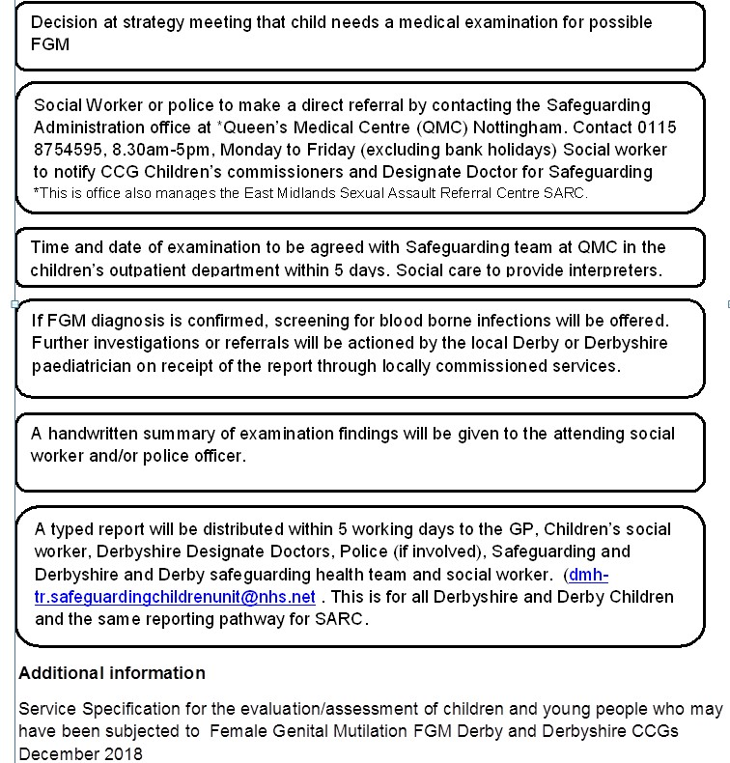

Also refer to the following DDSCP procedures:
Making a referral to Childrens Social Care
Safeguarding Children at Risk of Abuse through Female Genital Mutilation (FGM)
Child Protection Section 47 Enquiries
Child Protection Medicals
Honour Based Abuse and Violence

