SDQ Process and Interpreting SDQ Scores – Social Worker Guide
Introduction

The SDQ provides information to help social workers form a view about the emotional well-being of individual children who are looked after. The annual completion of the SDQ by a carer is a statutory requirement for children aged 4-17 years who have been in care for one year or more (DOH, DOE 2015). It is a clinically validated behavioural screening questionnaire which is used to identify children who are at risk of developing emotional and behavioural difficulties and who are likely to benefit from early intervention. It comprises a series of statements that require a judgement on how well it describes the child. The form has separate sub scales for different aspects of problems or behaviours some positive others negative: emotional problems; conduct/behaviour problems; inattention/ hyperactivity; relationship with peers; pro-social behaviour. There is also a section on impact for the child, young person, carer/s and school.

The NSPCC (2015), highlights that too often the emotional wellbeing and mental health of looked after children is thought of as something that is the responsibility of specialist mental health services alone. However, if the local authority and health services work together they can address the needs of children looked after both at an individual and strategic level. The SDQ will inform social care, education and health plans and will assist professionals when considering child and adolescent mental health (CAMHS) referrals.

Process for SDQ Collation
Baseline SDQ
LAC business support sends out a baseline SDQ to carers prior to the 2nd LAC statutory review. Young people aged 11yrs and over are also sent an SDQ to complete. When returned LAC business support scores them and scans into TED. You will then receive an email alerting you to the fact that the SDQ’s have been completed and are available to view. You are also informed if the carer does not return the SDQ, as it will be necessary for you to chase this up. The non-return of SDQ’s is not acceptable. Please note - The SDQ is not suitable for children and young people with complex needs. However, as LAC business support will be unaware of whom these children are, please inform them so the reason for non-returns is recorded accurately.

Check the score and level of impact (see overleaf) so this can inform your ongoing assessment of emotional health, the carer’s ability to manage any difficulties and the support you give them.

Annual SDQ
Once you have returned the consent forms for a Review Health Assessment (RHA), which is sent to you by LAC business support, they will send out an SDQ & Carers Report to carers – completion of the SDQ is compulsory. Young people aged 11yrs and over are also sent an SDQ to complete – this is voluntary. When carers return these to LAC business support they score them and scan into TED along with the completed health assessment. You will be sent an email to alert you to this. You are also informed if the carer does not return the SDQ, as it will be necessary for you to chase this up. The non-return of SDQ’s is not acceptable.

Check the score and level of impact (see overleaf) so this can inform your ongoing assessment of emotional health, the carer’s ability to manage any difficulties and the support you give them.

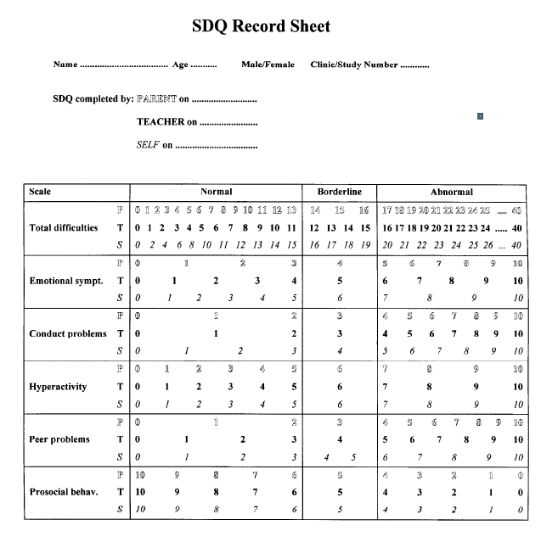
The score sheet looks like this. It will have the details filled in and the scores will be circled.

Interpreting Scores
Scores in the Normal column – usually indicates low risk of a disorder and usually no action is needed

Scores in the Borderline column - usually indicates a medium to high risk and needs careful consideration within the wider assessment of emotional health and wellbeing. Consider repeating the SDQ in 6 months.

Scores in the Abnormal column- usually indicates high risk and requires careful consideration within the wider assessment. It is most likely that a referral to CAMHS is required and should be considered, discussed and made as appropriate in order that emotional wellbeing needs can be met. A copy of the SDQ should be sent with referrals to CAMHS and social workers should attend the CAMHS consultation clinic.

Schools will also commence completing an SDQ this summer term (2019) and every year thereafter. The scores will be available on the TPEP. These will be useful to triangulate with the carer and young person scores giving a more rounded view.

Some other considerations

Is there a discrepancy in the carer and young person score – what could this mean/indicate? What about the school score? Is how the child/YP presented at the time of completing the SDQ normal for them, or are there particular short term circumstances impacting on them that are affecting the score?
Do they have a diagnosed disorder or special need that can impact on the score (ADHD, Autism)? If so even if the score hasn’t decreased has the impact lessened or does the carer feel more confident and skilled?
What was the previous score (if available), is this score better or worse?
Are they already receiving therapy or has a referral already been made?
Are carers receiving any support?
Is the score complimentary or at odds with your wider assessment?
Is a carer score complimentary to their carer report (if available)?

