Appendix B: Body Map [LTEEBAY OCT2020]
a wider range of electronic body maps

Name: d.o.b NHS No:
Date / time of documentation: Documentation by: print name signature
Other comments (e.g date marks first noted, by whom)

in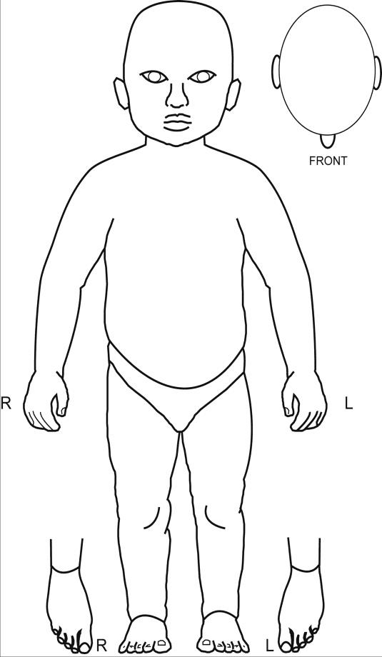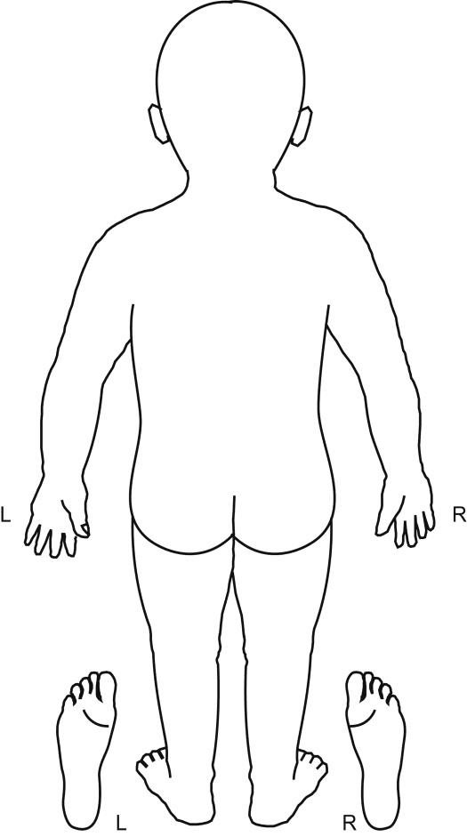sert face

