**Pan Berkshire LSCB Child Protection Procedures**

**Child Exploitation (CE) Indicator and Analysis Tool**



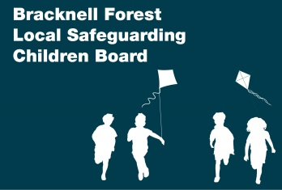 



**Guidance**

This Child Exploitation Indicator and Analysis Tool aims to help practitioners focus on the specific child exploitation (CE) evidence, indicators, and vulnerabilities, and determine whether further investigations are needed by Children’s Social Care and Thames Valley Police. This tool therefore informs both assessment of need and referrals to Children’s Social Care. Where applicable, this tool should be attached to your Children’s Social Care referral regarding a potential CE case.

The CE Indicator and Analysis Tool is intended for use by lead professionals working with children under the age of 18 where concerns of CE have been identified. Boys as well as girls are abused through child exploitation. Often, children themselves do not recognise they are victims, or that they are being groomed, and as a result disclosures of such abuse can be unlikely. Therefore, this tool aids the identification of CE.

These are the Home Office definitions of child sexual exploitation (CSE) and child criminal exploitation (CCE):

*Child sexual exploitation is a form of child sexual abuse. It occurs where an individual or group takes advantage of an imbalance of power to coerce, manipulate or deceive a child or young person under the age of 18 into sexual activity (a) in exchange for something the victim needs or wants, and/or (b) for the financial advantage or increased status of the perpetrator or facilitator. The victim may have been sexually exploited even if the sexual activity appears consensual. Child sexual exploitation does not always involve physical contact; it can also occur through the use of technology.*

*Child Criminal Exploitation occurs where an individual or group takes advantage of an imbalance of power to coerce, control, manipulate or deceive a child or young person under the age of 18 into any criminal activity (a) in exchange for something the victim needs or wants, and/or (b) for the financial or other advantage of the perpetrator or facilitator and/or (c) through violence or the threat of violence. The victim may have been criminally exploited even if the activity appears consensual. Child Criminal Exploitation does not always involve physical contact; it can also occur through the use of technology.*

*Exploitation of children can also include Forced Labour: Employing a child to undertake some form of employment to pay off any ‘debts’ or pay them minimal amounts. Engaging in work that is illegal for their age. This exploitation can also include domestic servitude in the home.*

Practitioners need to exercise their own **professional judgment** when completing this tool because factors such as the child’s age, any additional vulnerabilities, their history etc. may mean that they are more vulnerable to CE. Professional judgment also includes capturing concerns about which they have some evidence **AND** concerns based on ‘their gut feeling’. Staff should differentiate between the two and explain this in the ‘comments/evidence/description’ sections.

Once completed, where CE is identified or suspected, the worker should follow local safeguarding procedures. Remember, Children’s Social Care is responsible for assessing the level of risk to children. Should the referral not meet Children’s Social Care’s threshold, other support options will be considered including Early Help and referrals to appropriate services.

When considering child exploitation the following domains are helpful to consider:

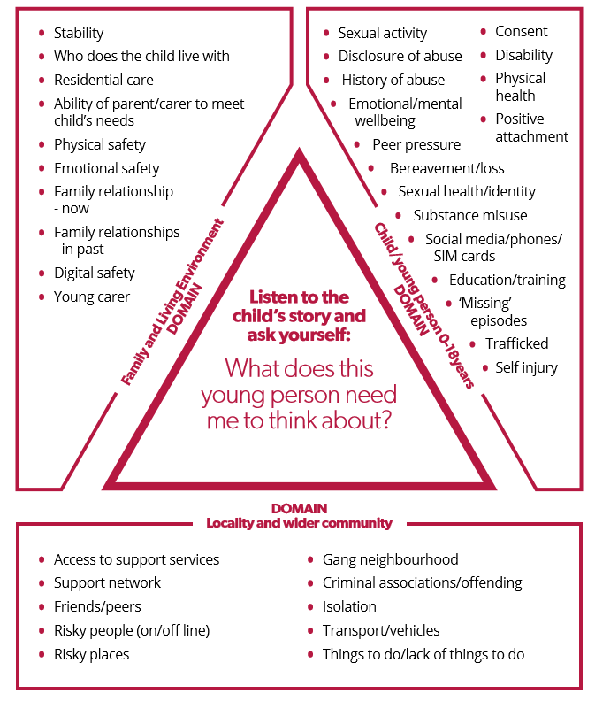

|  |  |
| --- | --- |
| **1. Child Details** | |
| **Child’s name:** |  |
| **Date of birth:** |  |
| **Ethnicity:** |  |
| **School / College:** |  |
| **Is this child looked after?** | Yes ⬜ No ⬜ |
| **Do they live in residential care?** | Yes ⬜ No ⬜ |
| **Are they placed at a distance?** | Yes ⬜ No ⬜ |

|  |  |
| --- | --- |
| **2. Your Details** | |
| **Your name:** |  |
| **Job title:** |  |
| **Contact details:** |  |
| **Date completed:** |  |

|  |  |
| --- | --- |
| **3. Information Sharing and Disclosure** | |
| **Is child aware that this tool has been completed?** | Yes ⬜ No ⬜ |
| **Are Parents/Carers aware that this tool has been completed?** | Yes ⬜ No ⬜ |
| **Has the child made a disclosure of exploitation (abuse)?** | |
| Current ⬜ Yes ⬜ No ⬜ If ‘Yes’ you must refer to Children’s Social Care immediately | |
| Historic ⬜ Yes ⬜ No ⬜ If ‘Yes’ you must refer to Children’s Social Care to determine current risk | |
| **Are the people who may be grooming or exploiting the child:** | |
| **Known to the child?** | Yes ⬜ No ⬜ Unknown ⬜ |
| **A family member?** | Yes ⬜ No ⬜ Unknown ⬜ |
| **(if you answer Yes to either of the above questions please state who this person is)** | |
| **Names of the child/child’s friends/family who you think are or might be affected by Child Criminal Exploitation also:** | |

|  |  |  |
| --- | --- | --- |
| **4. Evidence**  The following is evidence of child exploitation or activities of a comparable level requiring rapid and rigorous response. If you identify any of the following please make an immediate child protection referral. | **Yes (Y) / No (N)** | **Current (C) / Previous (P)** |
| Child under the age of 13 engaged in penetrative sex (rape) or sexual activity with any other person. |  |  |
| Child aged 13 years or over meeting with different adults and/or peers and exchanging or ‘selling’ sexual activities. |  |  |
| Child receiving money, goods or status for forcing or coercing other children into Child exploitation. |  |  |
| Being taken to/trafficked to an area/place for the purposes of exploitation, e.g. to sell drugs or engage in sexual activity |  |  |
| Abduction and/or false imprisonment. |  |  |
| Being groomed online for exploitation. |  |  |
| Unexplained marks/scars/physical injuries and attempts to conceal these. |  |  |
| Attendance at a hospital / surgery with a stab wound |  |  |
| **Comments/description/evidence of concerns marked ‘Yes’** | | |
| **5. Risk Indicators**  Children are groomed and exploited in different ways. Below are some signs that may signify if the child is being groomed for exploitation or actually being exploited. | **Yes (Y) / No (N)** | **Current (C) / Previous (P)** |
| Frequenting areas known for on/off street sex work and/or drug supply |  |  |
| Disclosure of sexual/physical assault followed by withdrawal of allegation. |  |  |
| Entering/leaving vehicles driven by unknown adults. |  |  |
| Knowledge of/connection to town or cities child has no previous connection with. |  |  |
| Association with taxi firms/takeaway owners/nighttime economy. |  |  |
| Evidence of unexplained / suspicious public transport - rail / bus tickets to places where they have no trusted association |  |  |
| Seen in or known to frequent CSE hotspots/places of concerns. |  |  |
| Change in behaviour – being more secretive/ withdrawn/ isolated from peers and not mixing with usual friends. |  |  |
| Increasingly disruptive, hostile or physically aggressive at home or school, including to animals, and the use of sexualised language. |  |  |
| Association/relationship with older person(s) online/offline, who encourage emotional dependence, loyalty and isolation. |  |  |
| Physical/emotional abuse from a partner, controlling adult or peer, including use of manipulation, violence and/or threats. |  |  |
| Possession of keys to unknown premises and/or hotel key cards. |  |  |
| Phone calls, texts, letters from unknown adults. |  |  |
| Persistently missing from home/care/school for different periods including overnight, including episodes that aren’t reported to Police. |  |  |
| Returning home after long intervals appearing well cared for or dirty/disheveled. |  |  |
| Change in physical appearance (more/new clothes, more/less make up, weight gain/loss). |  |  |
| Marks/scars/physical injuries and attempts to conceal these. |  |  |
| Expression of despair (depression, mental health, self-harm, suicidal thoughts/attempts, eating disorder). |  |  |
| Repeat/unplanned pregnancy(s) and/or seeking termination/emergency contraception. |  |  |
| Accessing contraception outside of ‘normal’ amounts. |  |  |
| Adults/unexplained person(s) loitering outside the child/young person’s usual place of residence or school. |  |  |
| Sexually transmitted infections (STI’s) and/or repeat visits to the sexual health clinic. |  |  |
| Concealed/concerning use of the internet and/or mobile phone, including during the night (webcam, online gaming, web chat, social media, online dating apps/websites). |  |  |
| Concern that an online relationship has developed into an offline relationship. |  |  |
| Involvement in offending. |  |  |
| Exclusion from school, disengaged from education, unexplained absences from school. |  |  |
| Failing to respond to attempts from workers/carers to keep in touch/disengagement from professionals. |  |  |
| Sexualised behaviour, including on the phone and internet, e.g. sexting. |  |  |
| Young gay/bisexual exploring sexuality in an unsupported way. |  |  |
| Association with gangs/fear of victimisation from gangs. |  |  |
| Increasing use of drugs/alcohol or misuse of drugs/alcohol. |  |  |
| Evidence of sexual bullying and/or vulnerability through the internet, including sharing of indecent images. |  |  |
| Concern that the child/young person is being coerced/bribed/threatened to provide sexually explicit images/engage in inappropriate online activity. |  |  |
| Unexplained money/clothing/goods/activities. |  |  |
| Possessing multiple mobile phones, sim cards, or concerning use of a phone, i.e. multiple callers, frequent messages, phone answered by adult/unknown person. |  |  |
| Harmful sexual behavior. |  |  |
| Becoming angry/hostile if any suspicions or concerns are expressed about their activities |  |  |
| **Comments/description/evidence of concerns marked ‘Yes’** | | |

|  |  |  |
| --- | --- | --- |
| **6. Vulnerabilities**  These are things which may make a child more at risk of being targeted for exploitation. The absence of these vulnerabilities does not preclude children being targeted; **evidence shows victims can come from any background and without any prior vulnerability.** | **Yes (Y) / No (N)** | **Current (C) / Previous (P)** |
| Associating with other exploited children. |  |  |
| Migrant/refugee/asylum seeker/trafficked status. |  |  |
| Currently/previously known to Children’s social care. |  |  |
| Physical/learning disability(s)/communication disorder(s). |  |  |
| Living in a chaotic or dysfunctional household. |  |  |
| History of emotional/physical/sexual abuse and/or neglect. |  |  |
| Living in residential care/hostel/B&B/sofa surfing/homeless. |  |  |
| Gang affected through family/friends/neighbourhood. |  |  |
| Unsure about sexual orientation or unable to disclose sexual orientation. |  |  |
| Parental difficulties; drug and alcohol misuse, mental health problems, physical or learning difficulty. Child or young person is a young carer. |  |  |
| Recent bereavement or loss. |  |  |
| Low self-esteem/self-confidence. |  |  |
| Exploitation previously identified as a concern for the child. |  |  |
| Poverty or deprivation. |  |  |
| Current/historical exposure to domestic abuse. |  |  |
| Breakdown of family relationships and/or conflict around boundaries, e.g. staying out late. |  |  |
| Family involvement in the adult sex trade. |  |  |
| Lacking friends of their own age. |  |  |
| **Comments/description/evidence of concerns marked ‘Yes’** | | |

|  |  |  |  |
| --- | --- | --- | --- |
| **7. Summary of Concerns**  *Please note scoring of the below is not prescriptive of risk* | | | |
|  | **Evidence** | **Indicators** | **Vulnerabilities** |
| **Number of concerns marked as ‘Yes’ and ‘Current’** |  |  |  |
| **Number of concerns marked as ‘yes’ and ‘Previous’** |  |  |  |
| **Total** |  |  |  |
| **What type of exploitation has been identified through completion of the assessment tool;**  Child Exploitation currently not a factor at this time/concerns relate to age appropriate behaviours  Evidenceof vulnerability to child criminal exploitation  Evidence of vulnerability to child sexual exploitation  Evidenceof child being groomed (including online)or targeted for the purposes of sexual exploitation  Evidence of child being groomed into membership of a criminally active gang  Evidencethat child is being sexually exploited  Evidencethat the child is being criminally exploited  Evidenceof other child exploitation / modern day slavery  *Please note that the threshold for referral to National Referral Mechanism (*[*NRM*](http://www.nationalcrimeagency.gov.uk/about-us/what-we-do/specialist-capabilities/uk-human-trafficking-centre/national-referral-mechanism)*) is that there are reasonable grounds to believe the individual is a potential victim of human trafficking and modern slavery and if this tool has identified reasonable grounds then a referral should be made to the NRM.* | | | |
| What information has this indicator tool identified about other children, including siblings and friends, who may be at risk of, or are, being exploited? This is really important for early intervention. | | | |
| Specific planned or completed actions as result of tool completion: | | | |

|  |
| --- |
| **Date assessment completed:** |
| **Date for next review:** |