Children’s Residential Placement Request Form – Initial System Process

- Where to find the Referral Form

- Completion of the Template

- How to set up the notification to Commissioning

The Referral form should be sourced from the documents tab:
Category: Children in Care
Type: Children’s Residential Placement Request Form (Practitioner component)
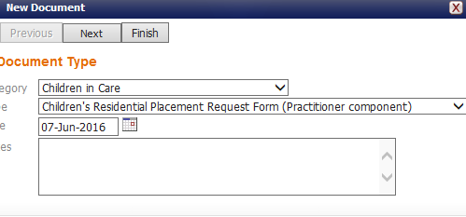
Next step is to download the document:
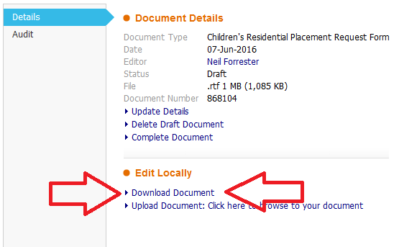
……….followed by
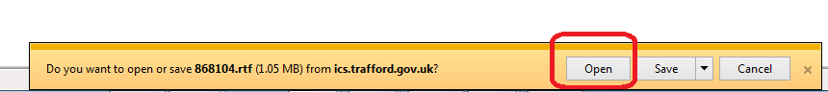

The word document shall open and present with an amount of pre-populated data:
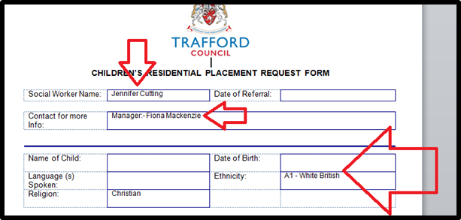
n.b. At this point, you should save the document in the normal fashion (File: save as etc etc)………and continue the completion of the document.

Further point of note:
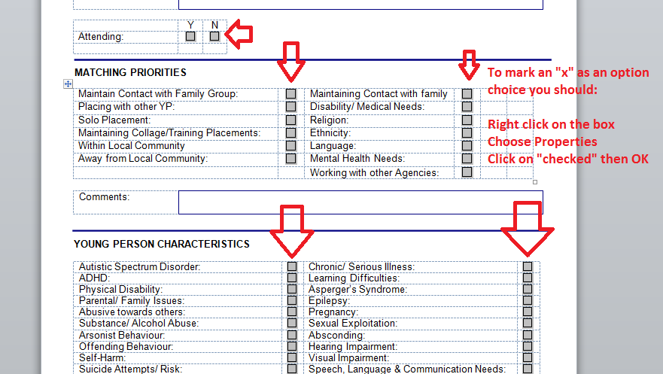
When you have completed the form and saved, you need to upload the finished article and notify the Commissioning Team. To do this, simply:

Update the notification section: (once complete, this shall send the alert to the Commissioning Team)
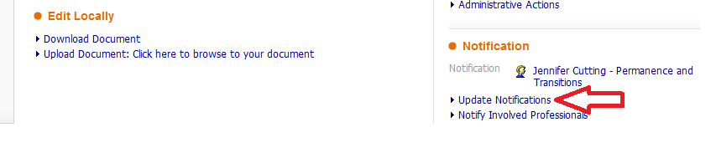

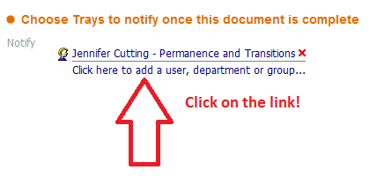

Choose the following sequence then confirm
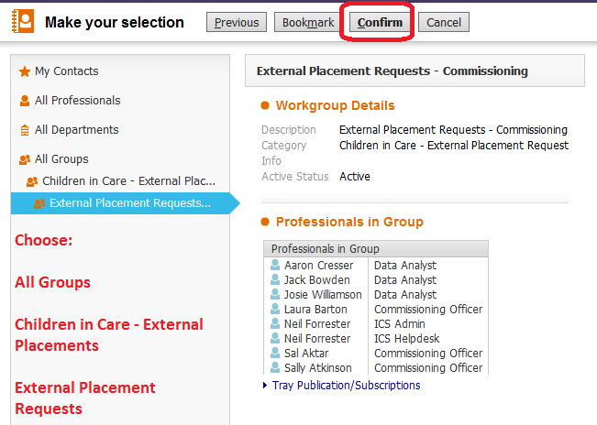
n.b You can “bookmark” this group within your Address Book!!
