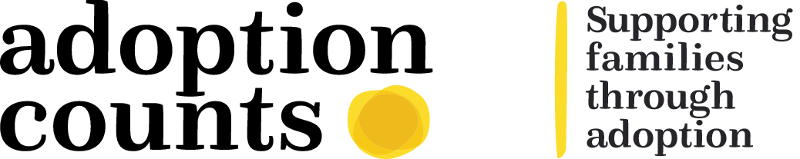

PRACTICE GUIDELINES

ADOPTER RECRUITMENT
Stage 1
The registration of interest will be received by the recruitment staff in the hub and the spoke team manager will be notified the same day or within 24 hours. The spoke team manager will make a decision whether to accept the ROI within 5 working days of the hub receiving it. Unless additional or previously unknown information is on the ROI the ROI should be accepted based on the previous assessments / decisions following initial assessment visit.
If accepting the ROI the spoke manager will allocate to a social worker and notify the hub staff of this decision along with the name of the allocated social worker within 24 hours. On receipt of this information the hub recruitment staff will communicate with business support to initiate statutory / other checks and medicals (Appendix)
Contact will be made with the prospective adopter(s) to advise them of the online system for completing a DBS check or if they are unable to complete this on line a form will be posted to them to complete prior to the first social worker visit.
The allocated social worker will contact the adopters within a further 24 hours and arrange a stage 1 agreement meeting. In this meeting agreements will be made between the prospective adopter(s) and the social worker about the way they will be working together, the adopters preferred learning style and methods of communication. The meeting will follow the format of the stage 1 agreement meeting template and this will be signed by both parties and kept on the adopter record. The social worker will explain the process for stage 1 and provide an overview of the range of checks and learning materials available (Appendix). This discussion and the process as a whole should assist the prospective adopters and the agency in making an informed decision about pursuing adoption further on the basis of the qualities they have to offer a child.
At the first stage 1 meeting the prospective adopters will provide required evidence of identity and the social worker will record this on CHARMS following the visit. The prospective adopters will be asked to arrange for a medical appointment with their General Practitioner within the required timescale. They will also be asked to notify their referees that they will receive a request for an initial report.
If the prospective adopters have ex partners this will discussed and decisions made by the social worker’s manager following the visit as to whether they need to be contacted.
The social worker should explain the significance of the DBS checks as well as the range of other checks undertaken and make it clear to the prospective adopters that if any of the checks undertaken reveal information that raises concerns about their suitability to adopt they may not be invited to progress to stage 2 of the process.
The stage 1 agreement form will be uploaded on CHARMS along with a record of the visit.
There will be a minimum of 3 face to face contacts with prospective adopters during stage 1 and these can be at the prospective adopter’s home or in the office. At least one of them should be at the prospective adopter’s home given the need to complete a health and safety assessment. In addition communication will take place via email and telephone to offer the prospective adopters advice and support.
Where the prospective adopters have a birth child or previously adopted child they should be given a clear explanation of the work that will be done with the child in stage 2 of the process, taking into account the child’s age and other characteristics. It should also be explained that where the child is of sufficient age and understanding they will need to undertake reasonable preparation work with them during stage 1. This would not involve the social worker undertaking any direct work.
Where the applicants have a dog it should be explained to them that an authorised dog assessor will undertake an assessment of the animal during the stage 1 process and that they will be required to cover the cost of this.
The prospective adopters will also attend 3 days of preparation training during stage 1. The worker will receive feedback from the social workers undertaking the training and if there are any issues / concerns these will be discussed with the prospective adopters with input from the social worker who undertook the training.
The prospective adopters will also need to complete a self-assessment form and carry out online learning through First4adoption (appendix).
Once the prospective adopters have made sufficient progress and once checks have been received a stage 1 report will be written by the social worker. The report will follow the agreed format, contain a summary of the activity undertaken and the social workers recommendation. A separate section will contain the prospective adopter’s views and a summary of their learning from the process. The report will contain a section completed by the manager together with their decision as to whether the prospective adopters should proceed to stage 2 of the process. If the decision is not to proceed to stage 2 the prospective adopters must be sent a letter advising them of this and reasons why.
The stage 1 process should be completed within 2 months of the agency receiving the registration of interest.
If the prospective adopters wish to take a break from the process or the agency recommends a break between stage 1 and 2 this should be discussed with them and if agreed should be no longer than 6 months. If they require a break of longer than 6 months they will need to repeat stage 1. If they contact the agency within 6 months of going on a break they should be offed a re-entry interview with a view to establishing their suitability to proceed to stage 2 based on any changes in their circumstances.

Appendix:
Summary of stage 1 checks / activity
Statutory Checks / DBS (from Hub)
Medicals / GP medical (from Hub)
Inter country check
Preparation Group Training format
Programme of learning material
Preparation / assessment of birth children with adopters (not by social worker)
Referees agreed with written reports / questionnaires (From Hub) (do interviews in stage 2)
Employer’s references stage 1 or 2 (adopter choice). Same for education checks (birth/adopted child)
Ex partners – agreed with adopters / written reports (from Hub) (if interviewed in Stage 2)
Financial information – verify income and outgoings
Pet Assessments (Mandatory Dog assessments paid for by adopters)
Health and Safety questionnaire (Tasks requiring actions by adopters identified)
Individual work by adopters – self assessment questionnaire, family tree / Eco Map

Appendices / Documents to be attached
Stage 1 resources list
Zip folder with all forms/resources
Stage 1 tasks – key responsibilities
Stage 1 checklist for social workers

