Uturn Prenoxad Injection Protocol May 2016

This protocol aims to provide guidance on the use of Prenoxad injection within Restorative Youth Services.

Introduction

Prenoxad Injection contains the medicine Naloxone Hydrochloride. Naloxone Hydrochloride reverses the action of opioid drugs such as Morphine, Diamorphine (Heroin), Methadone, Codeine and Dihydrocodeine and Dextropropoxyphene. Prenoxad will also partially reverse the effects of Buprenorphine.

If someone has accidentally overdosed, and an opioid drug such as those mentioned above is involved, Prenoxad injection can be used to reverse the action of the drug. Prenoxad injection is designed to be used as an emergency rescue treatment so you should still get medical attention as soon as possible by calling for an ambulance.

Prenoxad injection does not remove opioids from the body and does not last indefinitely, it wears off after around 20-30 minutes so the opioids will still be in the body and the person may go back into overdose. It will not have any effect unless the person had opioids in their system.

Prenoxad injection is a prescription only medicine (POM) which means that is can only be prescribed to someone who has a prescription for it. It is normally prescribed to people who may be at risk of opioid or opioid-related overdose.

Although Prenoxad injection is a POM, the law allows anyone to administer it for the purpose of saving a life. This means that a representative or other people can inject Prenoxad injection.

Prenoxad injection pack

The Prenoxad injection pack contains a glass 2ml syringe containing Naloxone. The pack also contains two 1 ¼ inch needles. Two needles are included in case one breaks, gets contaminated (e.g. if it gets dropped) or if it becomes blunt after being used through clothing. The Prenoxad injection pack is stored as a prepared kit that is ready to use. It is kept in a zip lock bag with gloves, this will have everything you need. Normal infection and prevention control protocols should underpin this process.

The pack will also have a patient information leaflet supplied by the manufacturer which gives instructions on how to assemble and use Prenoxad injection.

How to store Prenoxad injection

Prenoxad injection should be stored safely and in the original box to protect from light. It should NOT be stored above 25 degrees centigrade.

If the injection is discoloured it SHOULD NOT be used.

How to dispose of Prenoxad injection

After you have used Prenoxad injection, any leftover product, including used and unused needles, should be given to the attending ambulance crew.

If this does not happen the used Prenoxad injection can be disposed of in the yellow sharps bin and PHS will need to be contacted to do a one of collection for this.

If this is not possible, the used Prenoxad injection can also be disposed of by handing the pack to a pharmacy or needle exchange service.

CGL should be informed once the Prenoxad injection has been used and they will be able to issue a new Prenoxad injection.

Signs and symptoms of an opioid overdose

- Pinpoint pupils (indicates opioid use)
- Pale skin colour
- Bluish tinge to lips, tip of the nose, eye bags, fingertips or nails
- No response to noise (where shouting at the casualty gets no response)
- No response to touch (shoulder shake)
- Loss on consciousness i.e. the suspected overdose casualty cannot be woken
- Breathing problems
- Slow/shallow or infrequent breaths
- Snoring/rasping sounds
- Not breathing at all
When someone has overdose they can look and sound like they are just asleep. Always check when you hear snoring as the person may actually be asleep and not in an overdose situation. Snoring/rasping can be an indication of breathing difficulties.

The time gap between a person taking (e.g. injecting) drugs and slipping into an overdose can vary from a few minutes to several hours)

When to use Prenoxad injection

When accidental opioid or opioid-related overdoses occur, please follow the following process

- Approach the young person with caution and care watching out for anything that might be dangerous to you or the young person. These dangers may vary depending on where the young person has been found. Other potential dangers could be present, such as injecting equipment (needles/syringes etc.). If you see a needle or syringe near the young person and it may pose a threat to you or the young person if you need to move the (for example) into the recovery position, then you may need to move the injection equipment safely.

MAKE SURE IT IS SAFE FOR YOU TO APPROACH THE YOUNG PERSON BEFORE YOU DO SO.

- You should begin by speaking to the young person from a safe distance encouraging them to open their eyes and asking them to wake up. If there is no response to this, start to use a louder voice (shout) making the same statements to the young person. As you continue to approach keep looking out for dangers and shouting at them.
- Once you are next to the young person try to get a response from them by shaking their shoulders and shouting ‘open your eyes’ or ‘wake up’ into each ear. If they don’t wake or respond, you may need to move them from whatever position they are in to lying flat preferably on the floor. Once they are lying on a flat surface, make sure you open their airway by gently tilting their head back and opening their mouth. Look, listen and feel for signs of breathing for no more than 10 seconds.

What you do next will depend on whether the person is breathing or not.

If the young person ISN’T breathing normally (i.e. you have not detected 1 or 2 breaths/breathing in the young person during the 10 second assessment.

- Call 999 immediately and ask for an ambulance, explaining that the young person is UNCONCIOUS AND NOT BREATHING NORMALLY – tell the emergency call handler that you believe the young person has had an opioid overdose and that you have a Prenoxad pen
- Give basic life support by giving 30 chest compressions and attempting 2 rescue breaths if possible
- Give 0.4ml Prenoxad injection:
- Open and assemble Prenoxad injection

- Hold the syringe like a pen
- Inject the young person with Prenoxad injection. The needle should be inserted into the young person’s outer thigh or upper arm muscle at a right angle to the surface of the skin, straight through clothing if required
- Push the plunger to the first black line
- Withdraw the needle from the young person’s thigh or upper arm muscle and out the syringe (with needle still attached) back in the ‘cradle’ in the Prenoxad injection case. It will fit into the cradle even with the needle attained
- DO NOT ATTEMPT TO REMOVE OR RE-SHEATH THE NEEDLE
- If the young person is still not breathing normally give 3 more sets of 30 chest compressions and 2 rescue breaths followed by one dose of 0.4ml Prenoxad injection. Inject Prenoxad injection following the same process and using the same needle as before. Repeat this as many times as necessary until:
- The young person starts breathing normally
- The ambulance arrives
- If the young person begins to breathe normally, move them to the recovery position, lying on their side, mouth open and pointing towards the ground. Stay with them and continue to monitor their breathing

If the young person IS breathing normally (i.e. you have detected 1 or 2 breaths/breathing in the young person during the 10 second assessment) but is unconscious or not rousable (i.e. can’t be woken)

- Move the young person to the recovery position, lying on their side, mouth open and pointing towards the ground
- Call 999 and ask for an ambulance explaining the you have a young person who is UNCONCIOUS BUT APPEARS TO BE BREATHING – tell the emergency call handler that you believe the young person has had an opioid overdose and that you have a Prenoxad injection

- Give 0.4ml Prenoxad injection:
- Open and assemble Prenoxad injection
- Hold the syringe like a pen
- Inject the young person with Prenoxad injection. The needle should be inserted into the young person’s outer thigh or upper arm muscle at a right angle to the surface of the skin, straight through clothing if required
- Push the plunger to the first black line
- Withdraw the needle from the young person’s thigh or upper arm muscle and out the syringe (with needle still attached) back in the ‘cradle’ in the Prenoxad injection case. It will fit into the cradle even with the needle attained
- DO NOT ATTEMPT TO REMOVE OR RE-SHEATH THE NEEDLE

- If the young person does not wake up/regain consciousness, keep them in the recovery position and given further doses of Prenoxad Injection every 2 – 3 minutes. Inject Prenoxad injections following the same process and using the same needles as before i.e. hold the syringe like a pen, inject at a right angle to the surface of the skin and push the plunger down to the next black line. Repeat this as many times as necessary until:
- The young person regain consciousness
- The ambulance arrives

- Stay with the young person and continue to monitor breathing. If there is a decrease in breathing give 0.4ml Prenoxad injection solution every 2-3 minutes (if you have some left). If the young person’s breathing becomes less frequent or if it stops, you may need to give basic life support.

The young person will NOT KNOW that they have been rescued from and overdose state once they regain consciousness and may therefore be unaware of the on-going danger to them. The young person may become agitated or even aggressive. The young person may also want to use drugs to overcome the (almost inevitable, but temporary) withdrawal symptoms they are feeling. The young person may also want to leave the scene BEFORE the ambulance arrives.

If the young person regains consciousness/wakes up BEFORE the ambulance arrives, the helper should:
- Explain to the young person what has happened. Tell the young person what they overdosed, could not be woken/were having breathing problems etc.
- Offer reassurance, explaining that they have been given Prenoxad injection to help restore their breathing and to save their life.
- Explain to the young person that the withdrawal symptoms they are experiencing (if this the case) are temporary and will gradually ease within the next hour or so. Also explain that this is because the Prenoxad injection will wear off and that they are in danger of going back into overdose at this time
- The young person should be told not to use and drugs, including alcohol
- Tell the young person that it is extremely important that they are seen by the ambulance crew when they attend

How to put someone in the recovery position.

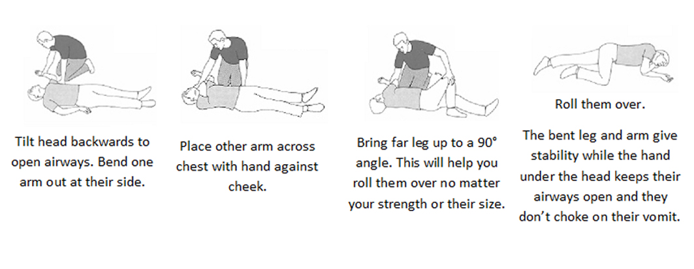

How to give chest compressions and rescue breaths

Hands only CPR: To carry out a chest compression:
- Place the heel of your hand on the breastbone at the centre of the person’s chest. Place your other hand on top of your first hand and interlock your fingers.
- Position yourself with your shoulders above your hands.
- Using your body weight (not just your arms), press straight down by 5-6cm (2-2.5 inches) on their chest.
- Keeping your hands on their chest, release the compression and allow the chest to return to its original position.
- Repeat these compressions at a rate of 100 to 120 times per minute until an ambulance arrives or you become exhausted..

CPR with rescue breaths: If you’ve been trained in CPR, including rescue breaths, and feel confident using your skills, you should give chest compressions with rescue breaths. If you're not completely confident, attempt hands-only CPR instead (see above).
- Place the heel of your hand on the centre of the person's chest, then place the other hand on top and press down by 5-6cm (2-2.5 inches) at a steady rate of 100 to 120 compressions per minute.
- After every 30 chest compressions, give two rescue breaths.
- Tilt the young person's head gently and lift the chin up with two fingers. Pinch the person’s nose. Seal your mouth over their mouth and blow steadily and firmly into their mouth for about one second. Check that their chest rises. Give two rescue breaths.
- Continue with cycles of 30 chest compressions and two rescue breaths until they begin to recover or emergency help arrives.

Recording: a record of the incident should be recorded in the client file and should also be reported and logged in the Restorative Youth Service incident book.

Guidance from Prenoxad injection training manual, Martindale Pharma. http://www.prenoxadinjection.com/downloads/training_guide.pdf
19th May 2016, version 1.

