**This information sheet is available to order in other languages and formats. If you would like a copy, please contact us on 01793 604031 or email** [**gwh.pals@nhs.net**](mailto:gwh.pals@nhs.net)

**Document Control**

Division:

Department:

Approved Date:

Next Review Date:

Document Number:

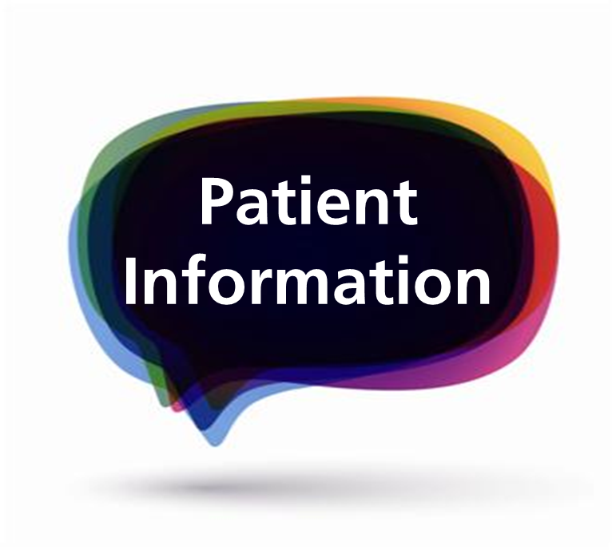

**Paediatric Continence Care:**

**Information for parents/carers**

**Statement of need**:

All children and young people can get help to develop a healthy bladder and healthy bowels, regardless of their age, culture and ability. This is called ‘Paediatric Continence Care’.

**The Team**:

Paediatric Continence Care for children and young people living in the Swindon Clinical Commissioning Group area is offered by a variety of health care professionals including; Health visitors; school nurses; learning disability nurses and the paediatric continence nurse.

Parents/carers can access support for children and young people through their GP, or by contacting any of the professionals listed above.

**What happens then:**

The health care professional will assess your child or young person to identify the

correct support and advice needed. This will include asking questions about the type and amounts of fluid and food your child eats and drinks, their general health and family health history.

On completion of this assessment, the most appropriate support and care can be discussed and offered.

This will usually involve a number of appointments. It is essential that all appointments are attended, or cancelled and rearranged at a convenient time.

Appointments may be offered in the family home, at the health centre or in the children’s outpatient department at GWH.

The overall aim of support is to help your child/ young person to achieve the best possible healthy function of their bladder and bowels.

**Paediatric Policy on continence product provision:**

In line with most other NHS health providers this Trust may provide a limited number of continence products from the age of four for those children with a physical or learning disability that impacts directly on their ability to achieve a healthy bladder and/ or bowel.

For some children and young people, there may be exceptional circumstances, the products required will be assessed on an individual basis, for example children receiving liquid feeds, or who have profound disabilities.

Nappies and pads will not be supplied to those children who have a treatable condition, where a healthy bladder and/ or bowels can be achieved; this includes constipation and night time wetting.

**Useful links for support:**

**ERIC:** Education and Resources for Improving Childhood Continence

Tel: 0845 370 8008

Website: [www.eric.org.uk](http://www.eric.org.uk)

**Bladder and Bowel UK:**

Tel: 0161 607 8219

Website: [bladderandboweluk@disabledliving.co.uk](mailto:bladderandboweluk@disabledliving.co.uk) .

**My Care My Support:**

Website:

[www.mycaremysupport.co.uk](http://www.mycaremysupport.co.uk) .

**Tena:**

Tel: 0845 3080 803

Website: [www.tena.co.uk](http://www.tena.co.uk)

**Fledglings:** A national charity that finds and sells products that improve the lives of disabled children and their families.

[Tel:](Tel:01799)  01799 541807

Website: [www.fledglings.org.uk](http://www.fledglings.org.uk)

**References:**

‘Guidance for the provision of continence containment products for children and young people’, A consensus document’ Copyright 2016 PromoCon.

(Now known as ‘bladder and bowel uk’.)

‘Paediatric assessment of toilet training readiness and issuing of products’, RCN (2006).