LETS TALK ABOUT 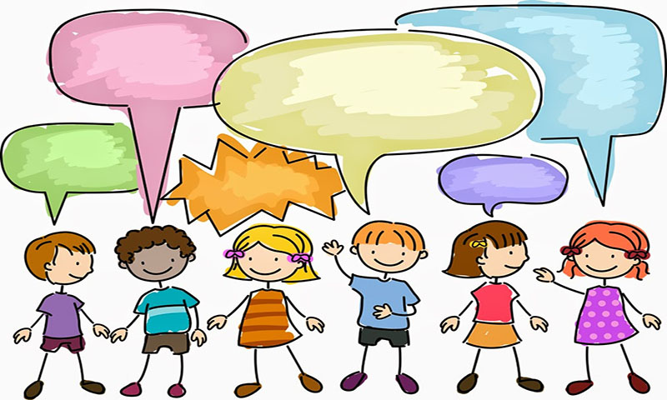
ANGER -

PART 4 – ANGER
THESE PAGES HAVE BEEN PUT TOGETHER TO HELP CHILDREN TALK ABOUT ANGER,-
- HOW IT FEELS,
- WHAT HAPPENS
- WHAT CAN THEY DO DIFFERENTLY
THEY CAN ALSO BE USED AS A TOOL TO TALK ABOUT ANGER IN OTHER PEOPLE AND WHAT THIS LOOKS LIKE & HOW IT MAKES THEM FEEL. – REFER TO WHAT DIFFERENT PEOPLE DO WHEN THEY ARE ANGRY AND WHAT IS OK VERSUS NOT OK.
USING A MIRROR TO MAKE ANGRY FACES IS A SAFE WAY TO START TALKING ABOUT WHAT ANGER LOOKS LIKE AND WHAT IT DOES TO THE BODY.
IT CAN BE FUN TO ACT OUT ANGER AS LONG AS THE CHILD FEELS SAFE TO DO SO.
ANGER IS AN EMOTION THAT IS OK, IT IS WHAT WE DO WITH IT THAT IS OFTEN NOT OK

