[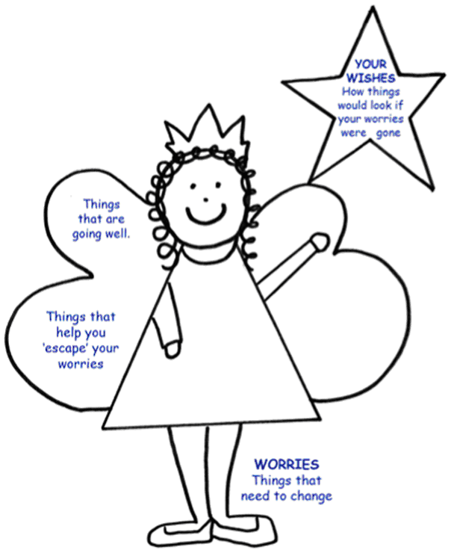](https://www.google.co.uk/url?sa=i&rct=j&q=&esrc=s&source=images&cd=&cad=rja&uact=8&ved=2ahUKEwiE9qGEh6neAhVRaVAKHXkmAloQjRx6BAgBEAU&url=https://www.norfolklscb.org/children-young-people/signs-safety/&psig=AOvVaw1X0PNutBk7qknDIIUWWc-m&ust=1540813048477964) [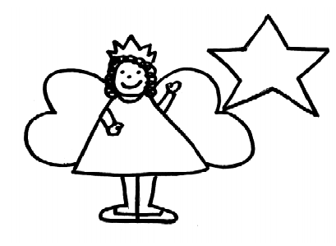](http://www.google.co.uk/url?sa=i&rct=j&q=&esrc=s&source=images&cd=&cad=rja&uact=8&ved=2ahUKEwiE9qGEh6neAhVRaVAKHXkmAloQjRx6BAgBEAU&url=http://sites.southglos.gov.uk/safeguarding/news/signs-safety-briefing-note-3/&psig=AOvVaw1X0PNutBk7qknDIIUWWc-m&ust=1540813048477964)