This is a Words and Picture Story to explain to XXX, XXX and XXXX why the Judge has told them that they are not allowed to see their daddy anymore.
XXXX, XXXX and XXXX live in a house in XXXX with their mummy and their pets Snow the hamster, Charlie the hamster and Misty the hamster. Mummy loves all of her children very much.

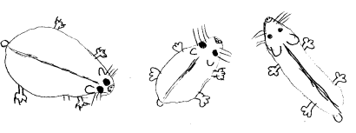
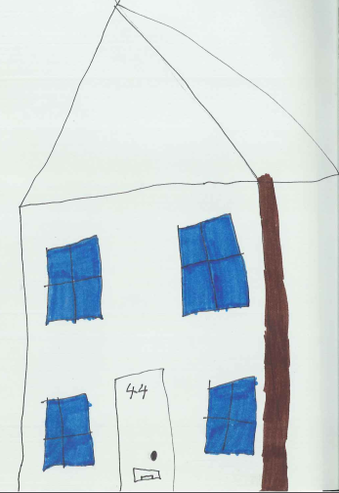

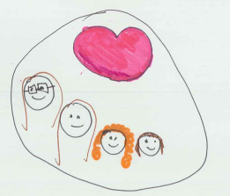

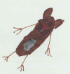

XXXX is 12 years old and goes to Secondary school and she really enjoys arts and crafts and baking!
XXXX is 8 years old and she goes to Primary School and she really enjoys going to choir, looking after her animals and drawing.
XXXX is 7 years old and she also goes to Primary School. XXXX really enjoys drawing and writing, reading her Rainbow Magic books and loom bands.
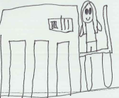
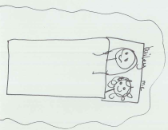

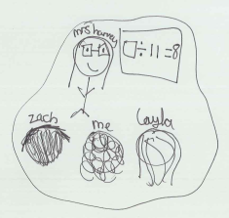
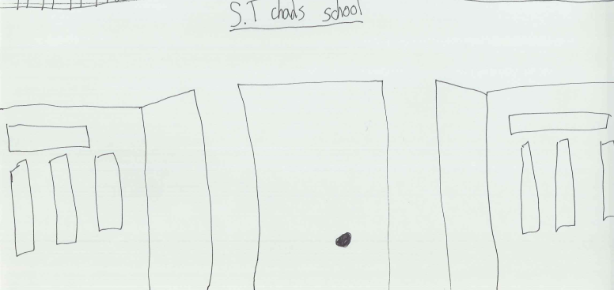
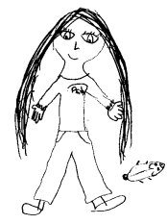
XXXX, XXXX and XXXX’s daddy used to live in the house with them and mummy. The girls have some good memories of when daddy lived with them, like going on holiday to Devon Cliffs, day trips to Clevedon and sometimes they would all do cooking together.

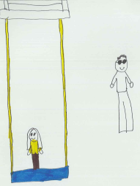
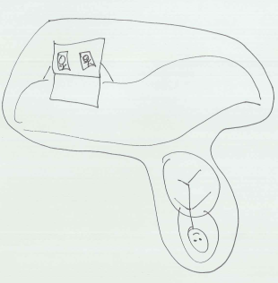

After a few years Daddy started spending lots of time in his office and he and mummy started arguing lots. Mummy was worried that XXXX, XXXX and XXXX were hearing daddy say nasty and threatening things to mummy which would make mummy cry. Daddy also started to say mean and hurtful things to XXXX and XXXX which made them cry too. Because mummy loves her children very much and didn’t like seeing them sad, mummy decided she didn’t want to be with daddy anymore.

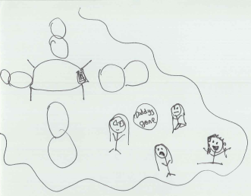

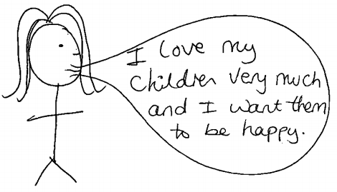

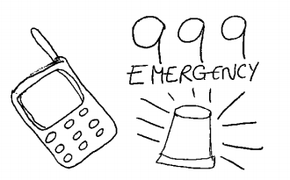
Even though mummy and daddy were no longer together and daddy no longer lived in the house, daddy would still come round and try and say more mean and hurtful things and there was more shouting. Sometimes, this made mummy, XXXX, XXXX and XXXX really scared so the police had to be called. XXXX told mummy that because daddy was mean to her, she didn’t want to see daddy anymore.

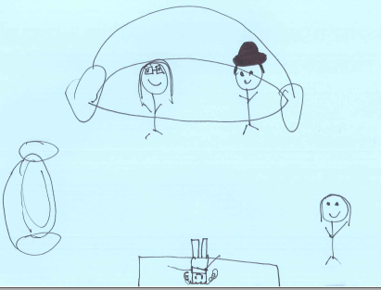
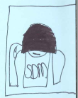

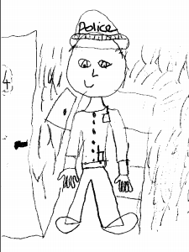

Because daddy kept coming round to the house even though mummy and the girls didn’t want him to, mummy had to go to court and speak to a judge. A judge’s job is to make sure that children are safe and make decisions that are best for them in the long run. The judge decided that because daddy had been so mean and made the girls scared that it wasn’t safe for them to see daddy anymore. Because mummy loves XXXX, XXXX and XXXX very much and wants to protect and look after them, mummy has listened to the judge and not let the girls see daddy.
I would like these children to be safe and happy.

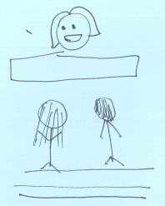
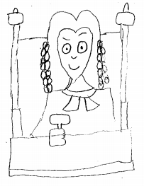

Mummy, nanny, grandad, Uncle Stu and Mary want XXXX, XXXX and XXXX to feel safe and happy, so everyone has come up with some ideas to help XXXX, XXXX and XXXX to feel safe. Some of these are:
- Mummy doesn’t answer the door when she thinks it might be daddy and she checks out the window to see if his car is outside.

- If the girls and mummy see daddy in the street then the judge has said that mummy and the girls need to cross the road and keep walking and not speak to daddy.

- Mummy needs to call the police if daddy does come to the house.
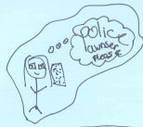
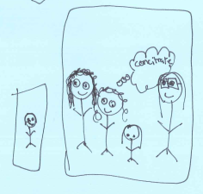
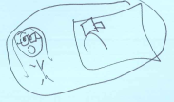

The girls might feel angry towards daddy because of the nasty and hurtful things daddy said and the way that he made them feel and this is okay. They might also feel angry towards mummy or the judge for not letting them see daddy anymore and this is also okay.
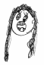
If XXXX, XXXX or XXXX feel angry, upset or worried then there are some things that they can do to help them. Mummy, Mary, Miss Parsons, Mrs Harvey, Mrs Rogers and Mr Bressington will help XXXX, XXXX and XXXX to remember these things.
Use the chat box in Mrs Harvey’s classroom.
Use the room 4 pass.
Watch favourite show on Netflix.
Take deep breaths and count to 10.
Play with teddies.
Play with the hamsters.
Watch funny videos on YouTube.
Draw a picture.
Do some singing.
Ignore the person who is making you angry and walk away.
Go to a quiet space.
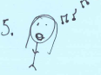
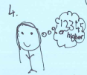
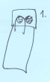

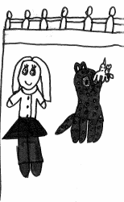
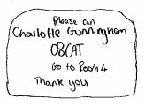
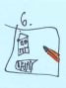
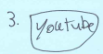
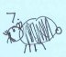

The girls can still love daddy and miss him and this is okay too. If the girls miss daddy then there are some things they can do to help them.

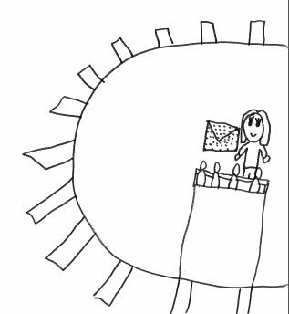
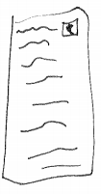

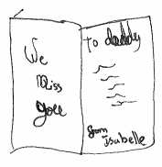

Mummy wants XXXX, XXXX and XXXX to remember that she loves them very much and she wants them to be safe and happy. Mummy wants all 3 girls to know that there are lots of people that they can talk to if they ever feel sad, scared, upset or worried.
These people are:
*Childminder *Mary *Friends *Mummy *Nanny and grandad
* Teachers at school
