Core Purpose of Preventative Services
Preventative Services support families with children from pre-birth to 18, with multiple and/or complex needs which have not been able to be addressed by universal services. The aim is to work with families to help them improve their resilience, achieve positive outcomes and reduce the chance of problems getting worse. Preventative Services work alongside colleagues from universal services, such as schools and early years’ settings, health providers, and sometimes in partnership with specialist teams from health or social care, working with the whole family.

Structure of Preventative Services
Preventative Services are part of South Gloucestershire Council’s Integrated Children’s Services (ICS), specifically contribute to the vision and priorities of South Gloucestershire’s Early Help Partnership Strategy 2019-24 and include the following:
Teams
- Compass (previously known as the Early Help Partnership Team)
- Families Plus 0-5 (previously known as Children Centre teams)
- Families Plus 5-18 (previously known as FYPS)
- Young Peoples Support (YPS) team (new)
- Youth Offending Team (YOT).

Functions

- Coordination of the national Troubled Families Initiative, known locally as Families in Focus
- Commissioned Youth Activities Offer (YAO) Youth work provision, delivered by partners across South Gloucestershire.
- Statutory function to track the employment, education and training destinations of all 16-18 year olds, in line with NCCIS Management Information Requirements.
- Provision of evidence-based, targeted parenting programmes across the age range (alongside one to one work)
- Support for young people to achieve recognition of learning outside formal education (e.g. Duke of Edinburgh Award, ASDAN Award).

The Preventative Services approach
- Whole family work - exploring the issues and dynamics within families which may be impacting on the presenting issues eg. the impact of poor housing, unemployment, mental health etc
- Conversations with families to identify their needs, strengths and best hopes, using a strength-based, ‘Signs of Safety’ approach.
- Families are supported to drive the work themselves
- Trained workers facilitate, coordinate and use evidence-based interventions to support families
- Keyworkers identify and enhance the wider support network of family, friends, community and professionals to sustain progress.
- The teams only work with families who want to work with Preventative Services (except where a statutory Youth Justice order applies) and who give consent.

When do Preventative Services work with families?
Preventative Services are targeted, with some specialist functions (notably the statutory work undertaken by the Youth Offending Team). The key aspects of targeted work are described in the Early Help Partnership Strategy.
Teams may become involved with families at different stages. For example:
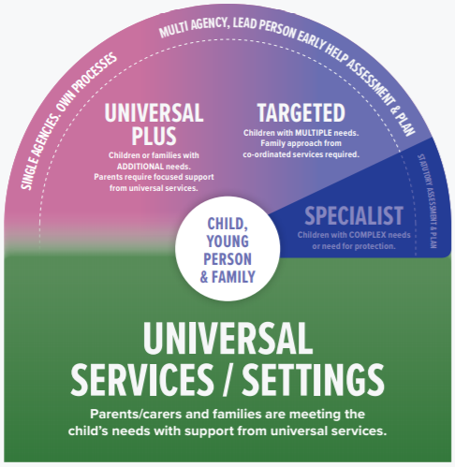
- Compass provide advice and support to services who are working with families and/or who are leading on an Early Help Assessment and Plan (EHAP)
- Compass provide advice and signposting directly to families
- YPS and Families Plus and teams (0-5 and 5-18) work alongside other agencies and/or directly with families whose needs are more complex
- All teams can work with families who have ‘stepped down’ from statutory services to support them sustain positive changes.
- YPS and Families Plus 0-5 teams may contribute to an existing Child in Need or Child Protection plan, for a specific piece of work
- YOT support young people to reduce the risk of offending or re-offending
- As part of a parenting programme

Requesting support from Preventative Services (other than YOT)
A ‘Request for Help’ form can be completed by a family or, with the family’s consent, by a professional or other person on their behalf and sent to accessandresponse@southglos.gov.uk. If there are no significant safeguarding concerns the Compass team will explore how to link the family to the most appropriate level of support. This could be by directly providing advice, through the wider early help partnership or Preventative Services.
For requests from Social Care
- If the Social Worker has assessed that the family would benefit from a contribution to the Child in Need or Child Protection plan, they can request this directly from YPS and from Families Plus 0-5 (Families Plus 5-18 workers do not undertake these contributions). This contribution will explicitly support the family to meet the safety goals identified within the statutory plan.
- If a social worker is closing their involvement with a family they can ‘step-down’ to Preventative Services with the family’s consent. This would be to support the family sustain progress.

Further details for Preventative Services can be found in the embedded documents:
Compass |  | Families in Focus
Families Plus (0-5)
Families Plus (5-18)
Young People’s Support

