LET’S TALK ABOUT
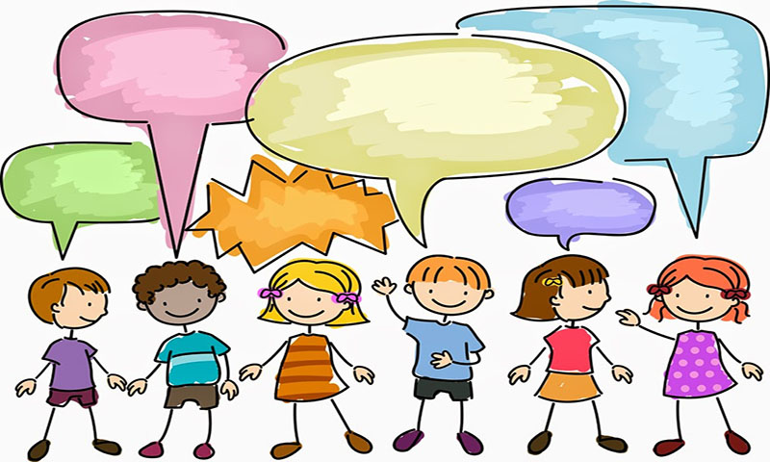
MY SAFE HOUSE

MY HOME
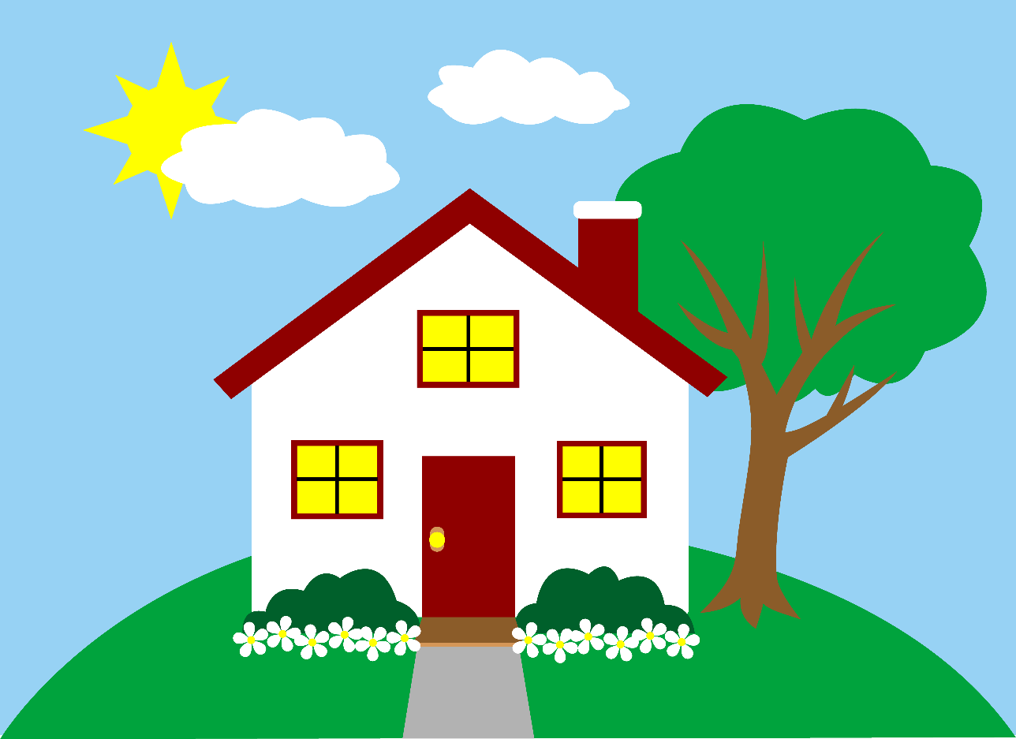
Here are some things that I Need in my house to Feel and Keep safe -
……………………………………………………………………………………………………………………………………………………………
……………………………………………………………………………………………………………………………………………………………
……………………………………………………………………………………………………………………………………………………………
……………………………………………………………………………………………………………………………………………………………
……………………………………………………………………………………………………………………………………………………………
……………………………………………………………………………………………………………………………………………………………

Sometimes my house does not feel very safe and it makes me feel ………………………………………..

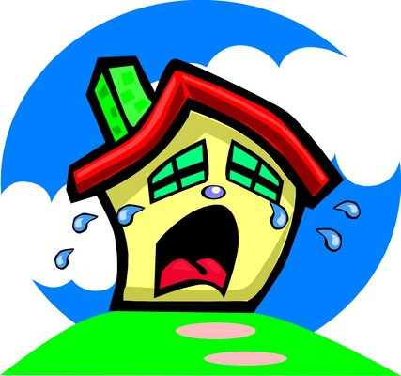

I feel unsafe when ……………..………..………………………………………………………………………………………………. ……………………………………………………………………………………………………………………………
I don’t like it when ……………………………………………………………………………..
………………………………………………………………
I feel ………………………………………………….. when …………………………. happens

These are the people that can help me

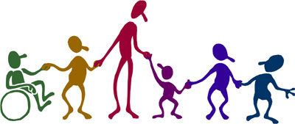
They are called …………………………………………………………………………….
They help me by ……………………………………………………………………………………
…………………………………………………………………………………………………………………….
I like it when they do ……………………………………………………………………………..
They help my family by ……………………………………………………………………………
………………………………………………………………………………………………………………………
If I need help I would tell ……………………………..
I can contact them by ……………………………………………

I know I need to be safe and people can help me.

March 2019

