**LETS TALK ABOUT**

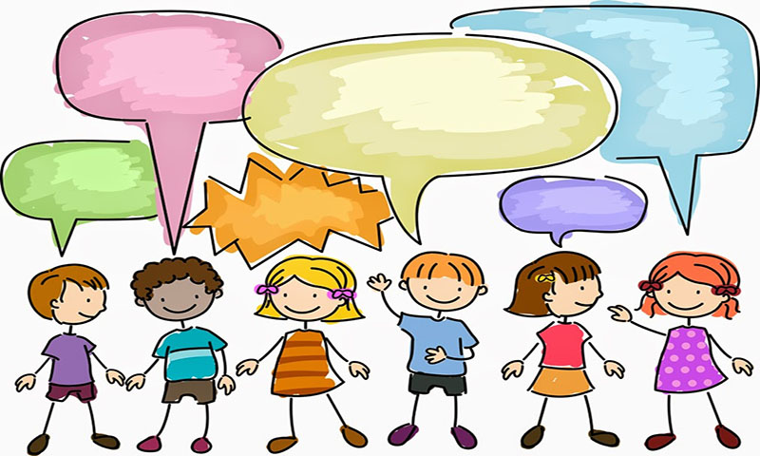

**DIFFERENT FEELINGS AND EMOTIONS**

THESE PAGES HAVE BEEN COMPILED TO HELP YOU TALK TO CHILDREN ABOUT HOW THEY FEEL.

GATHERING A CHILDS WISHES AND FEELINGS CAN BE DIFFICULT DUE TO FEAR OF SAYING THE WRONG THING, BUT ALSO BECAUSE OFTEN CHILDREN DO NOT HAVE THE LANGUAGE TO EXPRESS THEMSELVES. – THESE TOOLS CAN HELP TO PROVIDE A VOICE AND THE WORDS THEY ARE TRYING TO SAY.

THESE PAGES ARE A SELECTION OF SIMPLE IDEAS, THE SECRET IS TO BE MINDFUL OF THE CHILDS AGE & ABILITY AND EXPERIENCES THEY HAVE YET TO TALK ABOUT.

THE CHILD NEEDS TO FEEL THEY CAN TRUST YOU, THEY ARE VALUED AND SAFE. THESE TOOLS CAN HELP YOU TO BUILD A RELATIONSHIP WHERE THE CHILD CAN ALSO LEARN A LITTLE ABOUT YOU. IE WHAT YOU LIKE

SO……GET READY, TO LISTEN, SEE AND DO – HAVE FUN

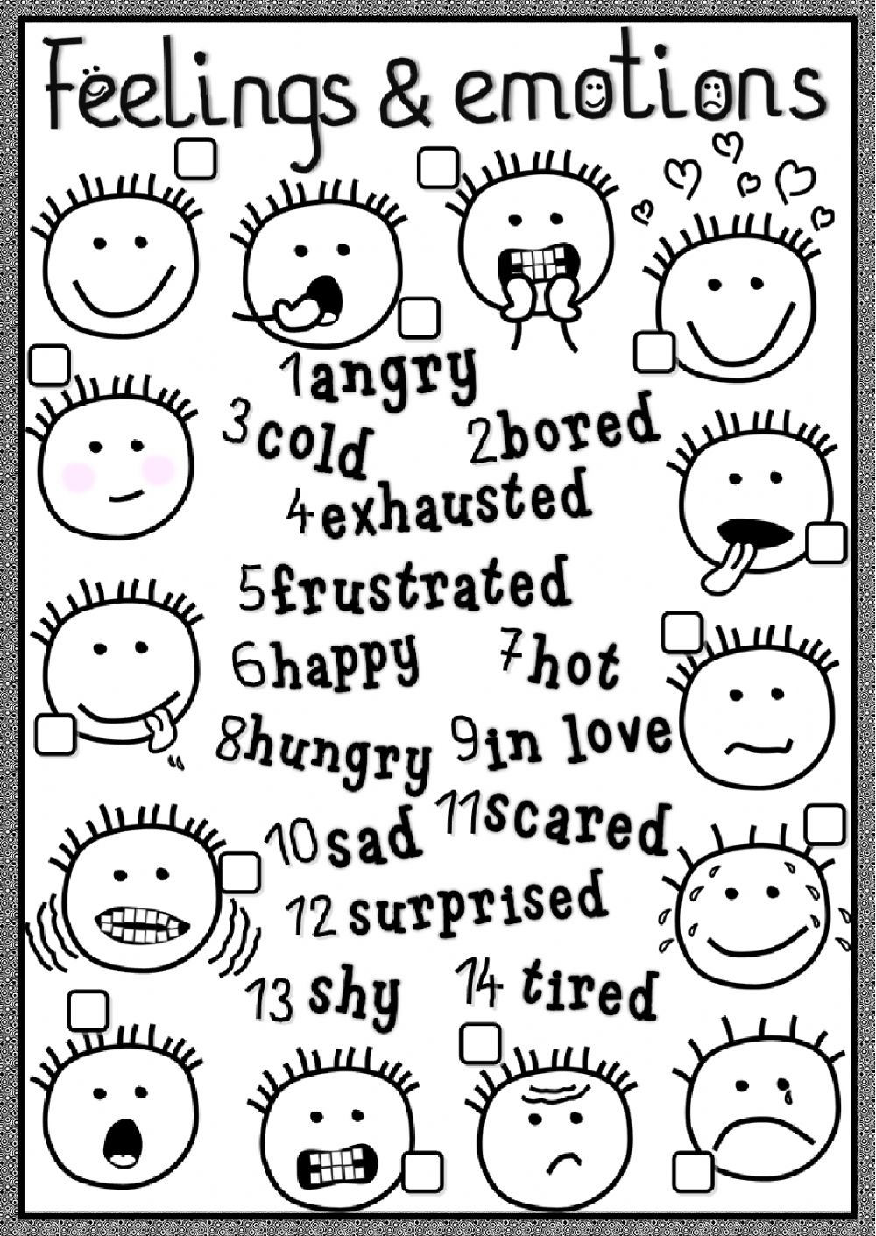

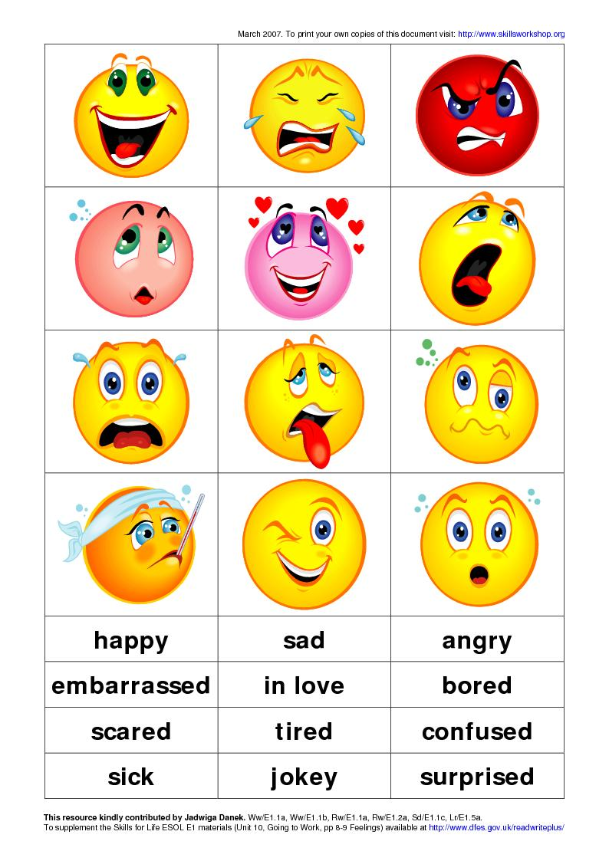

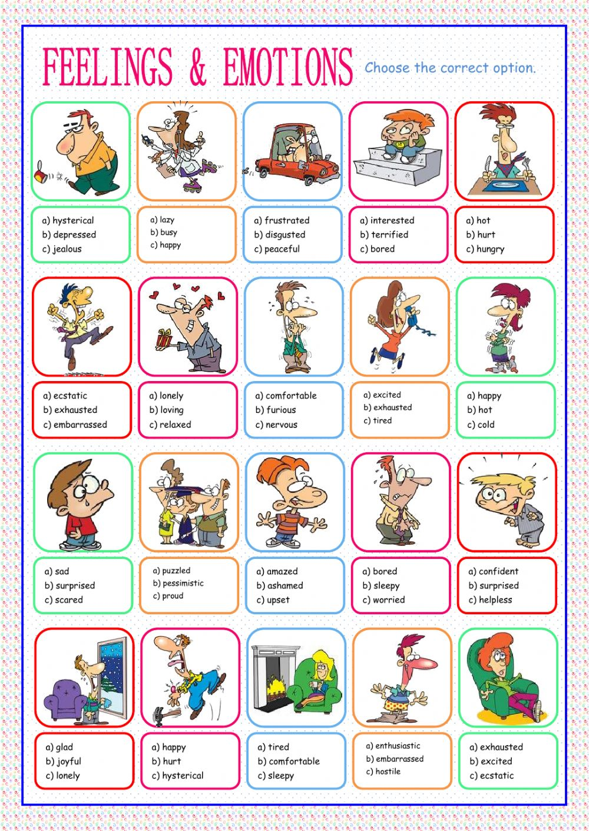

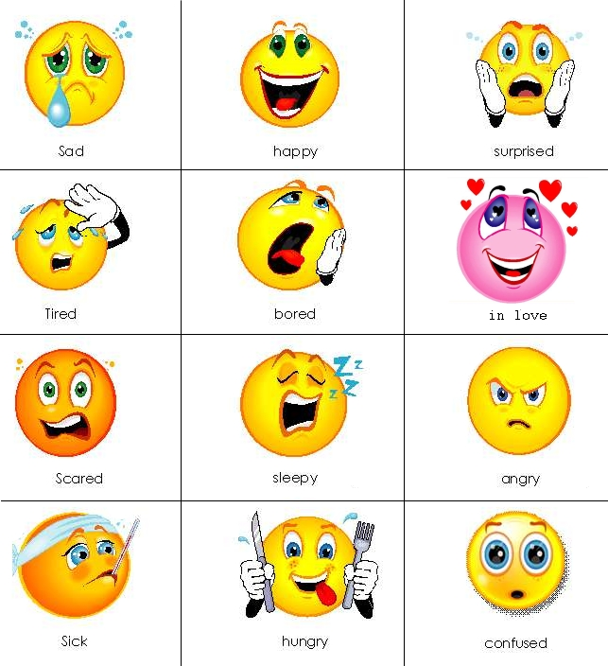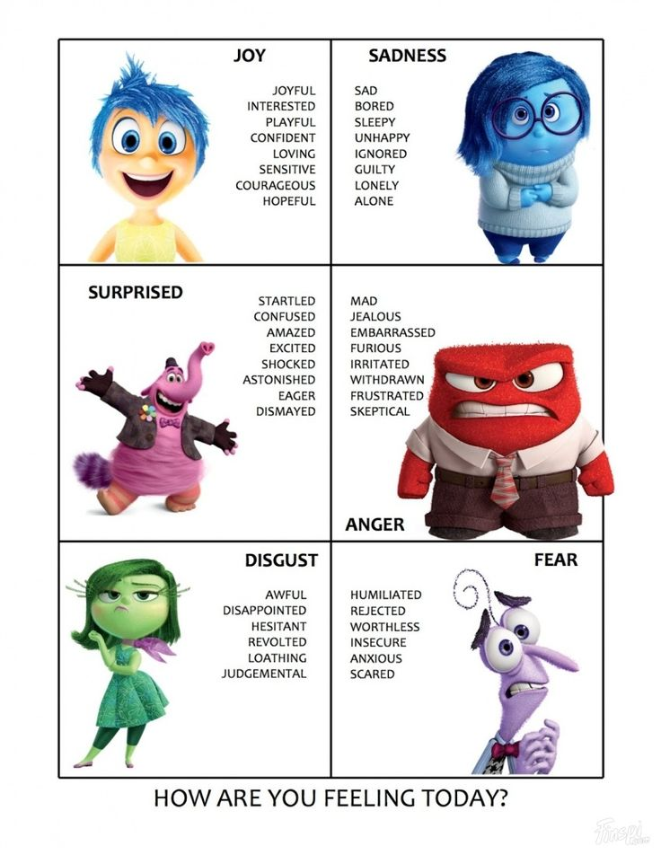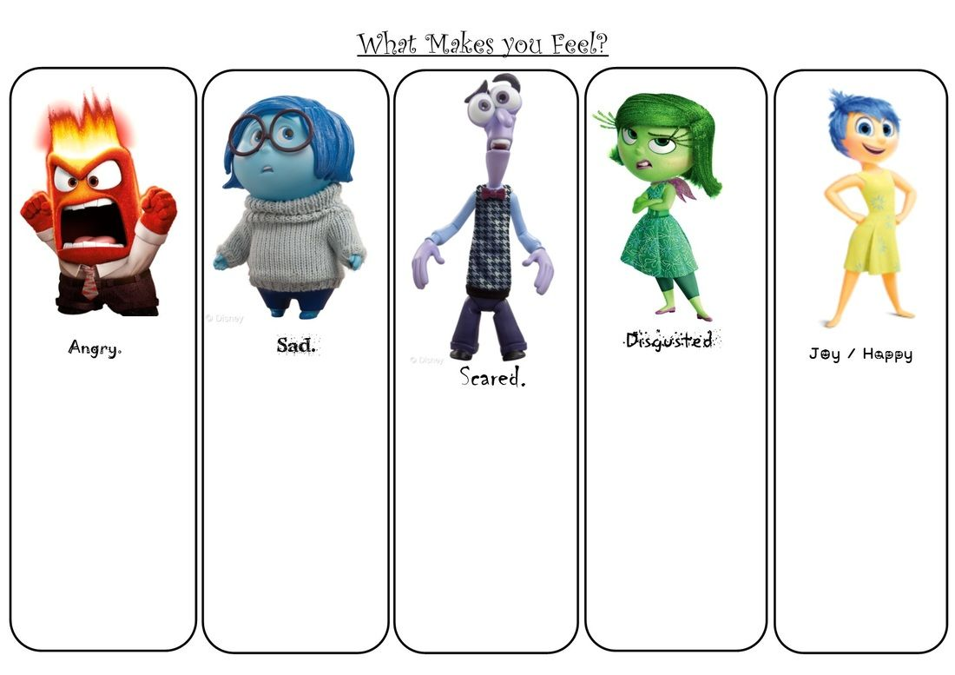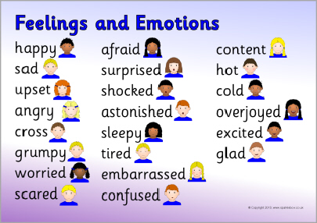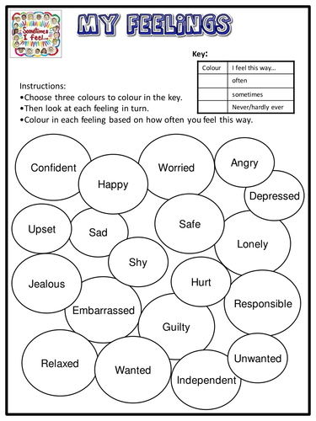 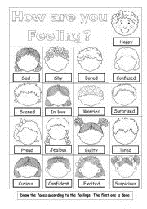

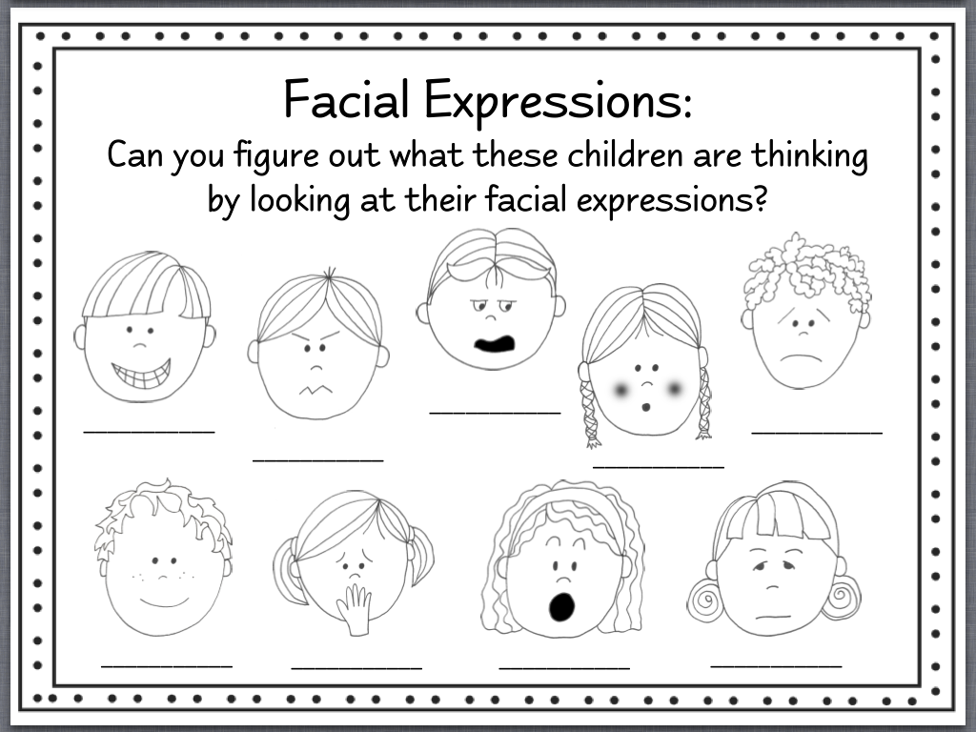

**[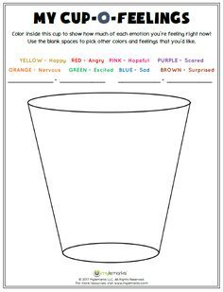](http://www.mylemarks.com/store/p210/My_Cup-O-Feelings.html)**

THE EMOTIONAL BAROMETER

TT

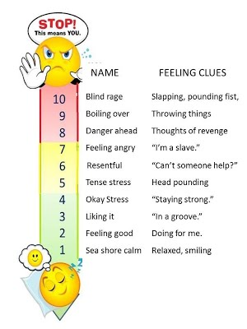

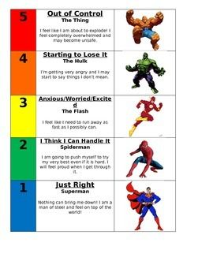

OTHER IDEAS –

USE A MIRROR TO MAKE FACES AND DESCRIBE WHAT IS SEEN

MAKE PAPER PLATE PUPPETS AND THEY CAN ACT OUT AN EMOTION OR SITUATION

DRESS UP ALLOWS THE CHILD TO BECOME SOMEONE ELSE

WORRY BOX – MAKE A BOX/CHEST/ SPECIAL ENVELOPPE AND USE IT TO PUT WORRIES IN IT, WHEN YOU VISIT THE CHILD YOU SEE IF THERE ARE ANY WORRIES YOU CAN TAKE AWAY FOR THEM

PLAYDOH FACES ARE GREAT BECAUSE THEY CAN BE SQUISHED IF THE CHILD DOESN’T LIKE THE FEELING

EMOTION WHEEL – SPIN AN EMOTION AND TALK OR ACT IT OUT

OPEN ENDED QUESTIONS - WHAT IF …. HOW ……. I WONDER WHAT….?

28/10/18

UPDATED 25/3/19