LETS TALK ABOUT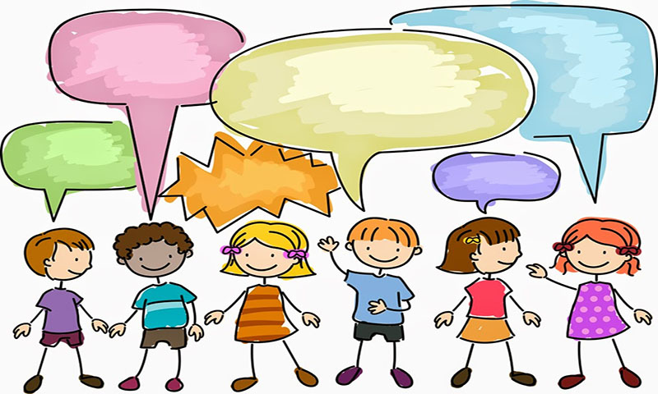
SELF ESTEEM

WHAT DOES SELF ESTEEM MEAN? -
SIMPLY PUT IT MEANS WHAT WE THINK AND FEEL ABOUT OURSELVES.
POSITIVE SELF ESTEEM COMES FROM BELIEVING YOU ARE LOVED, VALUED, APPRECIATED, GOOD, CLEVER, HELPFUL ETC
NEGATIVE OR LOW SELF ESTEEM COMES FROM BELIEVING YOU ARE WORTHLESS, RUBBISH, NOT VERY GOOD AT ANYTHING, HAVE NO FRIENDS, BAD ETC
SELF ESTEEM DEVELOPS FROM THE MESSAGES WE RECEIVE. OFTEN CHILDREN RECEIVE NEGATIVE OR FEW POSITIVE MESSAGES AND THEREFORE THEY FEEL THEY ARE OF NO VALUE, AND SO NOTHING IS IMPORTANT OR IS BASED ON’ WHATEVER’. – THIS AMBIVALENCE ACTS AS A PROTECTIVE LAYER
THESE PAGES HAVE BEEN PUT TOGETHER TO HELP RAISE SELF ESTEEM AND DEVELOP SAFE COPING STRATEGIES.

CHILDREN NEED TO FEEL WANTED AND VALUED
THEY NEED PRAISE AND REASSURANCE
THEY NEED BOUNDARIES AND THE ABILITY TO ASK FOR HELP
THEY NEED TO KNOW FAILURE IS OK
THEY NEED COMFORT AND WARMTH
THEY NEED OPPORTUNITIES TO TRY, EXPLORE AND EXPERIMENT
THEY NEED TO SEE, HEAR, TOUCH AND FEEL THEY ARE IMPORTANT – YOUR JOB IS TO HELP REBALANCE THE MESSSAGES SO THE CHILD CAN –
- BE SAFE.
- BE HEALTHY
- BE HAPPY
- BE EMOTIONALLY CONFIDENT AND SECURE
- TRY AND SUCCEED
- ACHIEVE AND HAVE A FUTURE

This Photo by Unknown Author is licensed under CC BY

