**LETS TALK ABOUT**



**WORRIES**

CHILDREN HAVE ALL TYPES OF WORRIES FROM BIG TO SMALL.

TO ENTER THEIR WORLD, YOU NEED TO KNOW WHAT IS IMPORTANT TO THEM AND THE THINGS THEY WORRY ABOUT.

PROVIDING A SPACE TO TALK ABOUT WORRIES ALLOWS THEM TO FEEL SAFE, OFF LOAD AND FIND SOLUTIONS TO PROBLEMS WHEREVER POSSIBLE.

SHARING A WORRY IS ABOUT FEELING SAFE THAT THEY WONT BE JUDGED OR IGNORED, YOUR ROLE IS TO LISTEN AND HELP THE CHILD IDENTIFY A SOLUTION.

SHARING A WORRY IS ABOUT TRUST – HELPING TO IDENTIFY WHO CAN HELP WITH WORRIES, ENABLES THE CHILD TO UNDERSTAND THAT OTHER PEOPLE MAY BE ABLE TO HELP THEM, AND THEY ARE NOT ON THEIR OWN.

DEVELOPING A SAFE SYSTEM FOR THE CHILD TO TALK CAN PROMOTE DISCLOSURE – SO BE PREPARED FOR THE UNEXPECTED.

IF A CHILD FINDS TALKING ABOUT WORRIES DIFFICULT, TRY OTHER MEANS OF COMMUNICATION LIKE USE OF TOYS, A BOOK, OR WHAT MIGHT A FRIEND SAY IF ……….

OPENING UP AND LETTING YOU INTO THEIR WORLD REQUIRES A BIG ELEMENT OF TRUST , SO BE PATIENT, BE RELIABLE, BE SYMPATHETIC, BE HONEST, BE FUN.

ALWAYS END THE SESSION WITH SOMETHING FUN - A SONG, A DANCE, A STICKER, A WHATEVER, BUT DO NOT LEAVE THE CHILD FEELING UNCONTAINED WITH THEWORRIES EXPOSED AND NOT KNOWING WHAT WILL HAPPEN NEXT.

ALWAYS DISCUSS WITH THE CHILD WHAT YOU ARE GOING TO DO WITH THE INFORMATION YOU HAVE TALKED ABOUT AND GATHER ANY ANXIETIES ABOUT THIS.



**[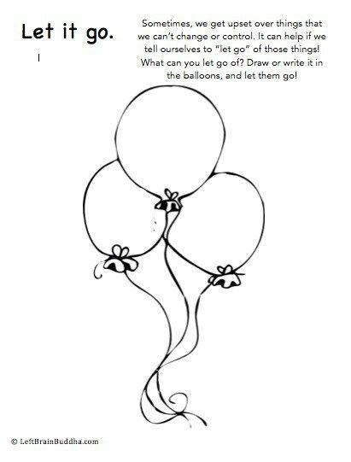](http://leftbrainbuddha.com/mindful-mantras-for-kids/)**

**[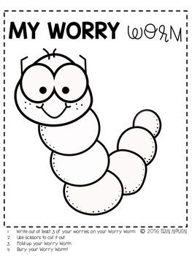](https://www.teacherspayteachers.com/Product/Worries-Anxiety-Group-596603?utm_medium=social&utm_source=pinterest&utm_campaign=tailwind_tribes&utm_content=tribes)**

**[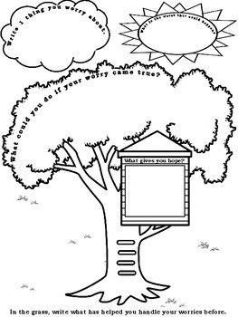](https://www.teacherspayteachers.com/Product/No-Prep-Individual-and-Group-Counseling-CBT-Problem-Solving-Worksheets-2981116)**

**[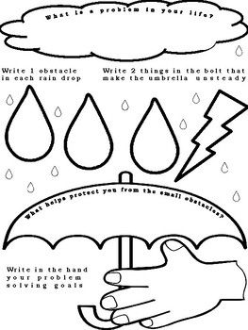](https://www.teacherspayteachers.com/Product/No-Prep-Individual-and-Group-Counseling-CBT-Problem-Solving-Worksheets-2981116)**

**[](http://creativityintherapy.com/2017/04/tree-strength-art-directive/tree-of-strength-second/)**

Tree of strength – what makes you strong?



**[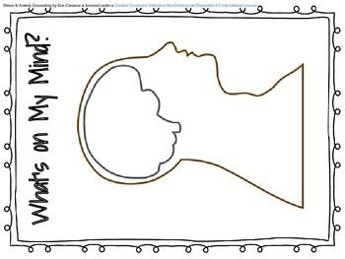](http://www.teacherspayteachers.com/Product/Stress-Anxiety-Counseling-Graphic-Organizers-2092419)**

**[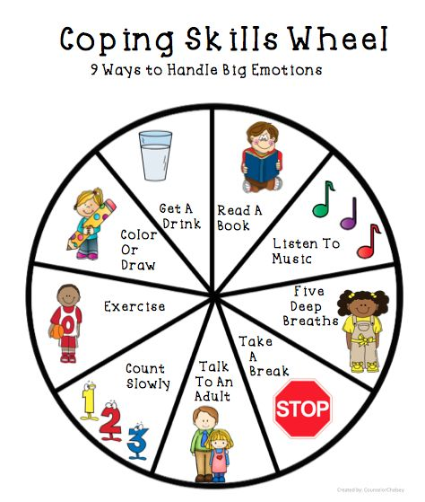](https://www.teacherspayteachers.com/Product/Coping-Skills-Activities-2205798)**

[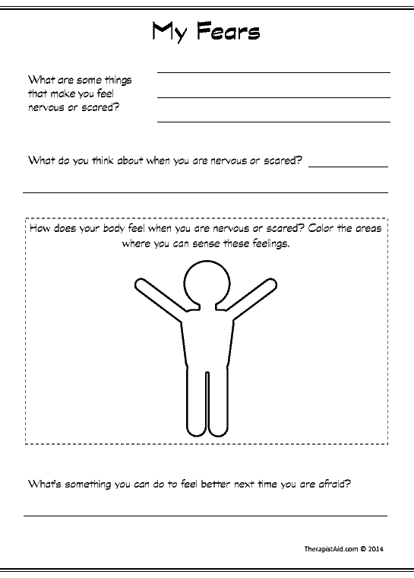](https://www.therapistaid.com/worksheets/my-fears.pdf)

**[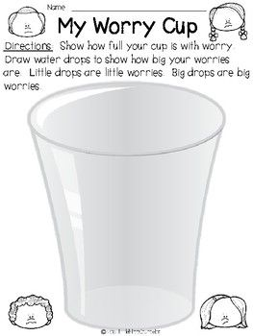](http://www.teacherspayteachers.com/Product/My-Worry-Cup-Worksheet-2925023)**

**[](http://www.elementaryschoolcounseling.org/marissas-blog/recent-additions)**

The iceberg – is what you see really the whole person and experience?

