Use of Social Media during assessments or investigations
To assist with various assessments or investigations carried out by the council, from time to time council officers may need to make use of information made publically available through social media sites such as Facebook, Twitter, and LinkedIn etc. To better facilitate and control the use of Facebook, the council has created this guidance to ensure we take a lawful, consistent and safe approach when using Facebook.
The use of any other social media sites is not permitted by this policy.
If use of another social media site is considered necessary and proportionate, you are required to contact Mike Hawke Information Governance Compliance Officer (mike.hawke@southglos.gov.uk)
It is acknowledged that in certain rare circumstances it may be necessary and proportionate to obtain information from Facebook. This should be determined on a case by case basis and only following consultation and the written approval of your line manager.
Individuals are not permitted to create Facebook accounts for any purpose connected to their work, neither are they permitted to use their personal Facebook accounts to access any information relating to their work.
Accounts can be created once they have obtained specific written approval from line managers. The process for opening an account is as follows:
- Complete a ‘facebook account form’ (please see appendix 1) by:
- Obtain written agreement to create an account from your line manager. This confirmation must include the following information:
  - The proposed name of the account
  - Contact details to be used on the account
  - The reasons for using
  - Expected period of use
- The completed and signed facebook account form must be retained with the relevant investigation / assessment work file and a copy sent to the Information Governance Compliance Officer (mike.hawke@southglos.gov.uk) prior to opening the account.

- Details of the account will be recorded in a central register of our use of Facebook to demonstrate our controlled use of the facility, for audit purposes. This register will be inspected by the regulatory body (Office of Surveillance Commissioners).

Opening an Account
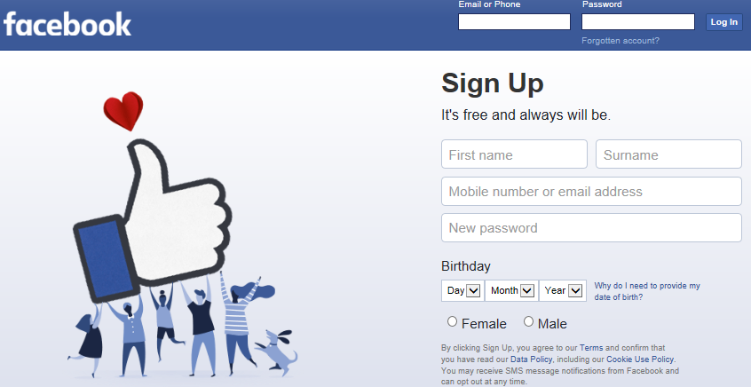
As you will see above, in order to create an account the following will need to entered:
- Name
- SGC email address
- Password
- DoB
- Sex
You must use your details.
Facebook demands your everyday name and will block / reject names that it thinks are fake. So please enter your normal first and second name. Please note that unlike ‘LinkedIn’ Facebook does not inform the user who has accessed their account. However, accesses are used to suggest friends, but your name should not feature in their ‘possible friends list’ from a single viewing.
You will need to choose a password, please use a work related password and Facebook will prompt you to include enough characters etc.
Then you will be asked to enter a mobile number (a SGC phone number – it is assumed that the officer or their line manager will have a SGC mobile phone).
Facebook will then verify the account set-up by texting a number to the phone that you will need to enter into the Facebook page.
Once this is completed open the security setting pages (top right of the home page) and minimise all the settings to either only ‘me’ or only ‘friends’.
Do not use your own personal Facebook account for this purpose.

The number of accounts must be kept to a minimum, so initially there is an expectation that only the following service areas of the council will need to utilise Facebook accounts as a resource for the following:
- Childrens Social Care
- Adult Social Care
- Environmental Health Enforcement
- Trading Standards
- Housing Eligibility
You may only collect openly available information viewable by any Facebook user – you are not allowed to seek to befriend anyone through Facebook. To do so would require the compliance with a law known as RIPA (Regulation of Investigator Powers Act). There are rigorous requirements to be met and approval needs to be sought from a Magistrates’ Court. Therefore, in the unlikely event that you feel ‘befriending’ anyone is necessary, you must first seek advice on a case by case basis from your line manager and the council’s Information Governance Compliance Officer.
Also be aware that repeated viewing, even of openly available information viewable by any Facebook user, for intelligence gathering and data collection may also trigger RIPA because it may amount to covert surveillance. Repeated viewing will not only require RIPA authorisation but will also drive Facebook to suggest you as a ‘possible friend’. So your assessment / investigation must be considered on a case by case basis.
You may not use the account to message anyone, post information, ‘like’ or follow any groups – i.e. you may only use the account as a passive observer of ‘open’ information available to any Facebook user.
Unless your work requires the regular use of Facebook for different cases, e.g. Envirocrime and Noise officers, the account must be deleted once the assessment or investigation (and any subsequent legal processes, such as prosecutions) have been completed.

Appendix 1:
Facebook Account Form
Proposed details of required account:
Name
Contact e-mail address

Verification mobile phone number

Please concisely state the reasons why this account is required

Live date
What is the expected period of use?

Requestor details:
Name

Job title

Authorisation:
Line manager name

