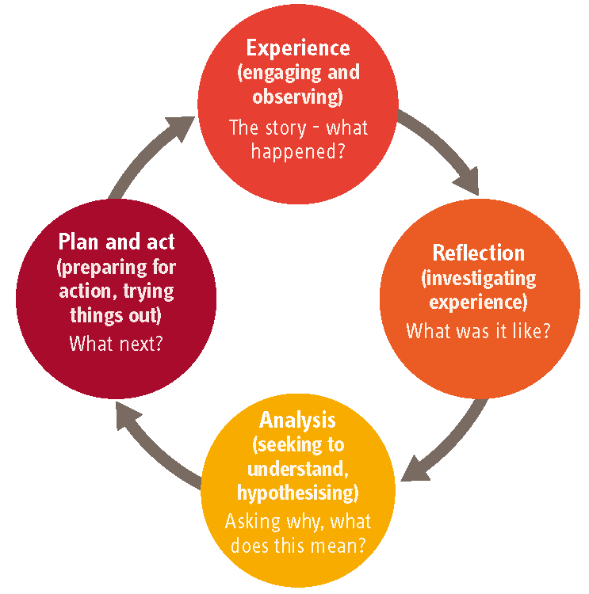
Guide for Residential Carers Supervision

This is a guide to give guidance and example questions and topics for residential carers supervision. This list of topics and questions below are not exhaustive and are not designed to be prescriptive. Other questions, issues and topics will naturally be talked about in supervision

Agenda Items:  Anything the supervisee wants to ensure is discussed | Actions from Previous Supervision:  Agreed actions should be taken from previous supervision and discussed
- Carer Welfare

- How are you?
- Is there anything that we should be aware about that is affecting your welfare?
- Is there anything more we can do to support your welfare?
- Are there any Health and Safety Issues?
- Stress related issues
- Work/Life Balance
- Offer Support –Access to Health and Wellbeing (incl NOSS) or Occupational Health
- Any absence from work
- Annual Leave
- Rota’s/Shifts

- Reflect on what’s gone well

- What’s gone well?
- For you
- For our children
- For the team

Use the reflective cycle (Experience>Reflection>Analysis>Plan – see image in top right) to aid discussion and help to generate actions for future

- Reflect on areas that have been difficult

- What’s been difficult?
- For you
- For our children
- For the team

Use the reflective cycle (Experience>Reflection>Analysis>Plan – see image in top right) to aid discussion and help to generate actions for future

- Professional Development and Feedback

- Discussion of recent training you may have attended
- Review of Training Matrix
- What training do you have booked?
- Do you feel you have any more training needs?
- Is there anything your supervisor or management can do to help support your development?
- Review Personal Development Plan (PDP) and Appraisal
- Are they up to date with all paperwork? (Read and signed all Risk Assessments, Key Work Sessions, Placement Plans etc.)
- Are there areas regarding paperwork that you want more support with?
- Supervisor to provide any professional feedback given about the supervisee
- Ask a question about their knowledge of regulations, e.g.
- What is Regulation 5?
- What is a Section 31?
- What are the timings involved if there has been a physical intervention in terms of recording in the Behaviour Management Regulation (Reg 35)?

If applicable:
- Completion of Induction and Workbook
- Review of Qualification progress

- Our children’s progress

- Discuss relationships between the carer and each of the children
- How is your work supporting their outcomes for our children?
- Discuss the progress children have made since they have been in the home
- Discuss any barriers that have hindered this and what they can do to support the children
- Impact of child’s behaviour on others/self/practice

- Adoption of Three Pillars and Vision, Mission and Values (PARENTAL)

- How are you using de-escalation techniques (Team Teach’s 95%) to manage the child’s behaviours that challenge?
- Discussion of any incidents they’ve been involved with
- Name the 3 elements of the Solihull Approach (Containment, Reciprocity, Behaviour Management)
- One of you pick one of the elements to ask them to consider how this has underpinned their practice?
- Could you share a conversation that you have had in a restorative way?
- Pick a Core Value (PARENTAL) and discuss how you have shown/considered it in your practice?
- Consider our vision and mission and how we are showing these in your practice

- Safeguarding (Concerns, Complaints, Whistleblowing)

- Do you have any concerns about the children you work with?
- Do you know what the safeguarding procedure is?
- Do you have any concerns about where you have been with work – education, contact visits, out in the community?
- Do you have any concerns with who you work with?
- Has there been any concerns or complaints made that require discussion?

- Any Other Business

- Is there anything else you want to raise?

Agreed Actions

- Actions should be agreed throughout the supervision, but also discussed at the end to ensure you both have agreed them.
- Actions should be SMART, or if not recorded with a review date

Date of Next Supervision

