Children Social care and Safeguarding
Shropshire Council
Shropshire children’s social care workforce strategy 2016-17 (Draft)

Contents

Our Vision
The aim of this strategy
Our Aspirations
Who does this strategy apply to?
The national context
The local context
Setting Standards and measuring achievement
Learning and development offer
Strategy sign off and Review
Appendix 1 ASYE programme plan
Appendix 2 Social work training plan
Appendix 3 Children’s social care practitioner training plan
Appendix 4 Residential training plan
Appendix 5 Foster carers training plan
Appendix 6 Action plan

Children’s Social Care in Shropshire – Our Vision
The vision of Shropshire’s Children’s Trust, as set out in the Children, Young People
and Families Plan is that:
All children and young people will be happy, healthy, and safe and reach their full potential, supported by their families, friends and the wider community.

Excellence in children’s social care is our key objective and our Workforce Development Strategy aims to give our staff the competencies, skills and knowledge needed to achieve this resulting in improving outcomes for children and families.

Our workforce is our greatest asset and the workforce development strategy has been developed to ensure we deliver first class professional development opportunities and career pathways for our staff. Our improvement plan focuses on the importance of excellence in social work practice through workforce development and this strategy not only aims to support that improvement but ensures Shropshire is an innovative and challenging place to progress professionally, making us the very best learning organisation and employer of choice.

The aim of this strategy

This strategy sets out the aspirations for the workforce and professional development programme to achieve this, linking closely to a number of key documents, which provide focus and form the framework for our vision and aspirations for the workforce and service as a whole.
- Shared vision and values Children’s Social Care – Business Plan 2016-2018
- Strengthening families through Early Help 2016-18
- Social Work Health Check report 2015/16
- Shropshire Quality Assurance Framework
- Shropshire Quality Standards
- Shropshire’s Theoretical Framework: Relationship Based Practice
- Working Together 2015
- Children’s Social Care A Vision for Change 2016 DFE
The key to the success of this strategy is ensuring quality and performance and learning and development are closely linked, providing a culture of continuous learning, reflection and improvement. Staffing data informing this strategy will provide evidence of achievements against the priorities and direct the strategy in the years to come.
The vision for this strategy is to improve recruitment and retention through the development of career pathways and to support and develop a skilled permanent social care workforce. We will aim to do this by embedding our revised supervision policy, embedding a model of reflective supervision, developing the way we deliver training and development opportunities, forging links with Higher Education Institutes, Teaching Partnerships and responding positively to National and regional drivers for the progression of the Social Care profession.

All Social Work professional development in Shropshire is linked to the Professional Capabilities Framework and reflects the Knowledge and Skills Statement for Child and Family Social Work, ensuring our workforce is well equipped to deal with the local and national context.
The Early Help Training Plan will be clearly aligned to the Vision for Strengthening Families through Early Help in Shropshire.
This vision for children and families sits within the wider Shropshire Council and Partnership approach to focus on prevention and well-being. Through the offer of advice, support and assistance to the people and communities of Shropshire it seeks to enable people and communities to help themselves. It puts the home and community at the centre for enabling care and support. This includes promoting engagement of the community and the voluntary sector to identify and meet the needs within their local communities.
Our Aspirations

Our aspirations in Shropshire are high and in return we offer excellent opportunities for our workforce. These include a varied and challenging Learning and Development Programme, a recognised ASYE Programme, an annual Social Work Health Check, regular Supervision and Personal Development Plan’s through our Appraisal Process. Shropshire’s continuous improvement cycle gathers information and data which is then analysed and informs and contributes to future plans, in turn ensuring we are delivering the best services for children and families in Shropshire.
Workforce objectives are to:
- Safeguard children, young people and their families
- Develop a knowledgeable, dedicated professional workforce
- Recruit and retain a workforce of proud, skilled, competent professionals
- Embed effective partnership working
- Strengthen and empower Leadership and Management
- Link learning & development to Professional Capabilities Framework (PCF) and Knowledge and Skills Statement (KSS) for child and family social work
- Develop a learning culture that respects, challenges and supports
- Use performance and quality assurance data to measure impact, evaluate and shape the plan
- Develop a clear career pathway that offers opportunities for future managers as well as practice consultants
- Individual feel valued for their contributions and understand the vital role it plays in achieving the best possible outcomes for children, young people and families
- Provide equal access to opportunities for employment, training and development appropriate to each person’s role regardless of age, gender, disability, ethnicity, race, sexual orientation or religion
Whilst these objectives are not exhaustive they reflect the key areas we think will make a real difference to the children and families in Shropshire.

Other issues that have workforce development implications have just as much importance and will feed into the overall programme such as promoting equality and diversity and ensuring the participation of children, young people and families.

Who does this strategy apply to?
The workforce consists of 296 employees who work directly with children and families or oversee this work, supported by 66 administration colleagues, working across all levels of help, support and intervention, including Early Help, Targeted Help, Acute and more Specialist Help, in many differing roles: Social Workers, Parenting Co-ordinators, Children’s Centre workers, Family Information Service Officers, Targeted Youth Support, Family Group Conferencing Co-ordinators to name but a few, all within Children’s Social Care. Here in Shropshire we have a single point of referral for professionals and the public seeking advice or assistance with a concern for the welfare or protection of a child or young person. This is known as Compass - Shropshire’s Multi-Agency Safeguarding Hub.

The children’s social care workforce consists of employees at each level of the system including, Service Managers, Team Managers, Senior Social Workers, Advanced Practitioners, Social Workers, Newly Qualified Social workers in the Assessed and Supported Year of Employment (ASYE) Independent reviewing Officers (IRO’s) and other Children’s Social Care staff, who may be in Specialist or Support Roles. The chart below shows this in more detail:
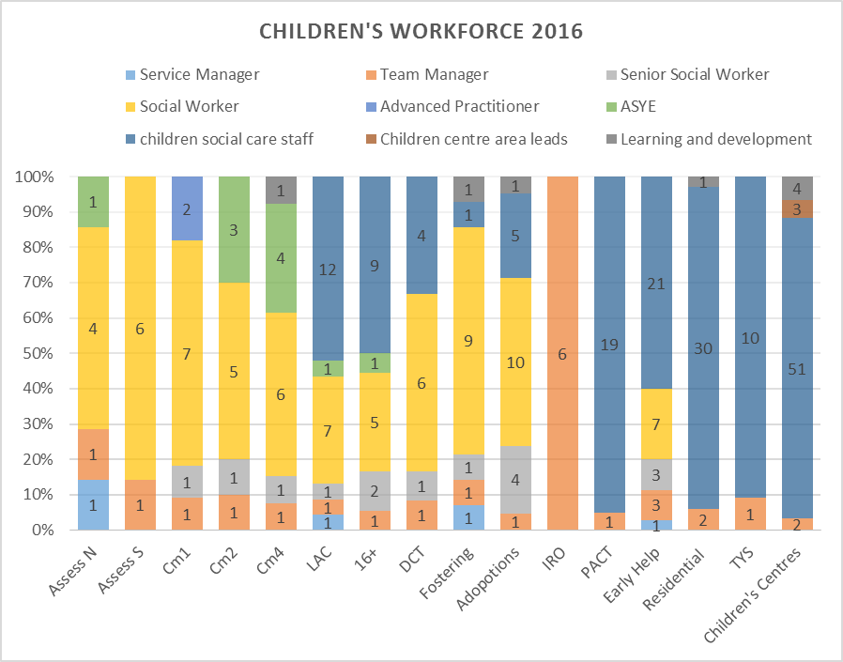
The chart demonstrates Shropshire offers a number of opportunities to enter and progress internally as either a newly qualified social worker or as an employee of the children’s workforce as a support worker, children’s centre worker, residential worker, parenting co-ordinator, family information co-ordinator or targeted youth support worker but to name a few.

Looking at the workforce at a glance shows that we are employing a variety of workers with a wide range of skills and knowledge across the workforce to ensure we can offer the right services at the right time.
Agency social work rates are a key area of focus and we strive to keep these as low as possible, covering maternity and sickness where necersary. At the time of writing this strategy our agency rates stood at 12%, which is particularly high for Shropshire and is as a result of high levels of maternity cover, movement of staff following a restructure and providing additional capacity where needed. Shropshire are working regionally to agree The Joint Agency Protocol, to ensure where we do need agency workers, they are of the highest quality. The aim is to attract the right people to Shropshire, to develop a permanent settled workforce who can provide the best service to Children, Young people and Families.

National Context
The Children Act 2004 remains in force, advocating ‘a highly skilled and competent children’s workforce, which is supported by effective shared systems and processes.’ But is now strengthened by a number of reforms put forward by the Department for Education (DfE) and Chief Social Worker.
The Department for Education (DfE) has been challenging and innovating in its approach to requirements and frameworks for professionalised job roles. This now includes The Departments for Education’s, Children’s social care reform, A vision for Change, published in January 2016.
The DfE vision is clear:
Children’s social care is about changing lives. It has the ability not just to improve the circumstances of vulnerable children but to transform them completely.
We want every child in the country, whatever their background, whatever their age, whatever their ethnicity or gender, to have the opportunity to fulfil their potential. Children’s social care services have an essential role to play – whether by keeping children safe from harm, finding the best possible care when children cannot live at home, or creating the conditions that enable children to thrive and achieve. To make that happen, it is essential that everybody working within children’s social care has the knowledge and skills to do their jobs well, and the organisational leadership and culture to support and challenge them to keep improving.
DfE 2016
The Chief Social Worker for Children and Families has published the Knowledge and Skills Statements for Children’s Social Work, clearly setting out the expectations for high standards for social work. These now needed to be embedded through a reformed system for creating and maintaining rigorously high standards of professional excellence.
The DfE has also shared its commitment to a national system of assessment and accreditation to guarantee the practice skill of every practitioner, at every level of seniority. This will include creating and implementing a coherent and rigorous career pathway for social workers, from practitioner to practice supervisor to practice leader ensuring the necessary specialist knowledge and skills at every stage.
Against this context, Strengthening Families in Shropshire faces both a significant challenge and a huge opportunities to transform children’s services across Shropshire. The process has already started and will be a dynamic one. This strategy will support that journey and will be amended as government policy, national guidance and regional partnerships as they are developed.
To implement these reforms a new Regulatory Body for social work will be set up. Shropshire wish to be at the table when this occurs and wish to react to these national reforms and challenges embracing these challenges and new ways of developing the profession.
The local context
Shropshire has been on its own journey of improvement and development over the last 2 years. Co-locating COMPASS the Multi-agency Safeguarding Hub and the Social Work workforce in one building has strengthened communication and integrated working across the multi-disciplinary teams in Shropshire. Ensuring Shropshire is offering the best support for partner agencies, where needed through The COMPASS has effectively strengthened our ability to safeguard children and families and identify the risk of significant harm. This was supported further by the development of the Early Help Social Worker role and publication of the Shropshire Safeguarding Children Board’s Threshold document ‘Getting the right help at the right time’.
Shropshire recognised through feedback from the LGA Peer Review Findings and Recommendations 2015, there was a need to re-focus on developing smaller teams and building the capacity of managers by recruiting the best leaders and supporting those we have through creating opportunities through learning and development.

This also led to the refocus of roles within the social work teams, the creation of two assessment teams, 3 case management teams and a looked after children’s permanence team. These teams are supported by two advanced practitioners, one as an ASYE Advanced Practitioner, whose remit is to support and mentor newly qualified social workers, in their first year of employment here in Shropshire. The other as an AP for legal work, whose role it is to offer support, guidance and mentoring when legal case work is required.

Shropshire has delivered a successful Assessed and Supported Year in Employment Programme (ASYE) since 2013. This work has been driven and influenced by National developments and resulted most recently in the development of all ASYE’s candidates being assessed against the Knowledge and Skills Statement for Children’s Social Work at commencement on to the programme and again at the end, to evidence their proficiency and capabilities. Shropshire is very proud of its internal verification process, involving Team Managers, Principal Social Worker, Universities and Service Users, who form a Standardisation Panel across both Children’s and Adults Social Care. Regional work is currently being developed with Skills for Care to develop External Moderation processes for Standardisation and Verification.

Shropshire have identified and begun to embed our Theoretical Framework for Relationship based practice. This has provided the workforce with a refocus on what’s important when working with children and their families and offered a framework for recognising excellent practice in Shropshire.

The recent appointment of a Principle Social Worker (PSW) at Assistant Director level demonstrates the commitment of Shropshire give this post the ability to influence at the highest level, enabling the PSW to lead and oversee excellent social work practice, to support and develop the arrangements for excellent practice and to lead on the development of excellent social workers. The PSW reports directly to the Director of Children’s Services and also has regular contact with the Chief Executive and the lead member for Children’s Services. The PSW is part of the West Midlands PSW Network, which is an established network, looking at how the PSW’s can support practice locally and regionally, seeking to address priority areas that have been identified by the Association of Directors of Children’s Services.

The Association of Directors of Children’s Services (ADCS) was also formed for the West Midlands and more regional work on driving up the performance and excellence of social work practice began. This lead to the commissioning of the successful commissioning of the Team Managers Leadership Programme, delivered by sector leaders C4EO.

Regionally Shropshire is engaged with Improvement West Midlands to plan and prepare the Social Work Workforce for Accreditation for the Approved Child and family Practitioner Status.
Shropshire is working as part of an established Teaching Partnership, working jointly with a local University and other local authorities as part of the North West Midlands Teaching Partnership to ensure we provide the best opportunities for our Workforce. This has provided opportunities for training and development opportunities for our workforce, bringing university teaching into the Local Authority. Going forward we are considering how Shropshire will engage with the expansion of both Front line and Step Up Programmes, to bring excellent practitioners to Shropshire.
Setting Standards and measuring achievement
As a social work employer there are specific standards we must meet. All aspects of the Standards are equally important, just as the Professional Capabilities Framework is holistic in nature in order to effectively set out the expectations of social workers themselves.
The Standards for Employers at a glance
1 | Clear Social Work Accountability Framework  Employers should have in place a clear social work accountability framework informed by knowledge of good social work practice and the experience and expertise of service users, carers and practitioners.
2 | Effective Workforce Planning  Employers should use effective workforce planning systems to make sure that the right number of social workers, with the right level of skills and experience, are available to meet current and future service demands.
3 | Safe Workloads and Case Allocation  Employers should ensure social workers have safe and manageable workloads.
4 | Managing Risks and Resources  Employers should ensure that social workers can do their jobs safely and have the practical tools and resources they need to practice effectively. Assess risks and take action to minimise and prevent them.
5 | Effective and Appropriate Supervision  Employers should ensure that social workers have regular and appropriate social work supervision.
6 | Continuing Professional Development  Employers should provide opportunities for effective continuing professional development, as well as access to research and-relevant knowledge.
7 | Professional Registration  Employers should ensure social workers can maintain their professional registration.
8 | Effective Partnerships  Employers should establish effective partnerships with higher education institutions and other organisations to support the delivery of social work education and continuing professional development.
(LGA, 2014)
Our aim will be to measure that we are effective in every area of these standards. There will be a number of measures which will indicate to us that we are achieving across the 8 standards. The Social work health check is one mechanism by which we check we are meeting these standards.
Good social work can transform people’s lives and protect them from harm. In order to achieve consistently high quality outcomes for service users and their carers, social workers must have and maintain the skills and knowledge to establish effective relationships with children, adults and families, professionals in a range of agencies and settings, and members of the public. (LGA, 2014)

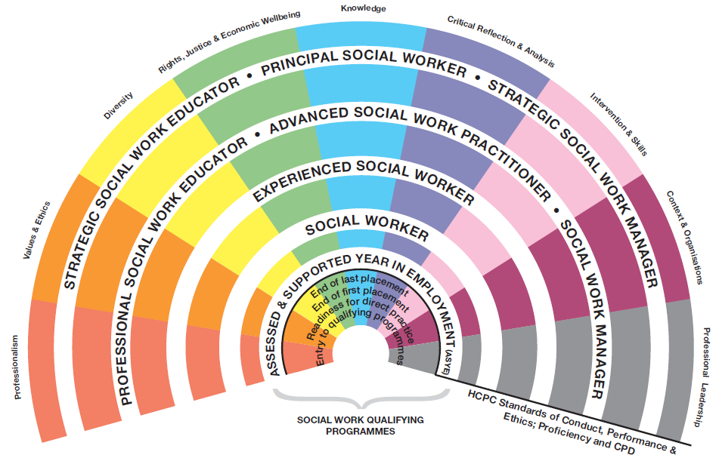
Shropshire adheres to the College for Social Work’s Framework for Continuing Professional Development (CPD). CPD is essential to ensure that social workers remain up-to-date with professional developments, and can adjust their practice in line with new evidence. The Framework recognises learning can, and does, take place in a range of different ways and circumstances. It is not always associated with a ‘course’ and the development need may be met through a range of different activities.
Outcomes of learning and career development routes are identified within the professional capabilities framework (PCF) which will act as a ‘scaffold’ to inform the CPD requirements of any individual social worker. It is used in conjunction with Performance development and supervision structures which help identify learning requirements to support the social worker in meeting organisational as well as personal and professional needs.
Social Workers in Shropshire will be supported by Shropshire Council and expected to take professional responsibility for developing their skills to a high professional level, through undertaking learning and development activities over and above the core standards required for Registration with HCPC.
Social Workers are expected to be proactive in identifying and meeting their individual professional needs. Learning activities will arise from everyday work, as well as any other requirements imposed by external circumstances or organisational needs.
A wide range of learning and development activities are promoted in Shropshire Council. Space for critical reflection, learning from others and opportunities for access to research should be valued alongside more structured training.
In line with the recommendations from the Narey review, Chief Social Worker Isabelle Trowler produced the knowledge and skills statement on 31 July 2014.
All Learning and development is mapped against the knowledge and skills statement, which clarifies that a child and family social worker should be able to do the following, to ensure we have a skilled and competent social work workforce.

1) Relationships and effective direct work
Build effective relationships with children, young people and families, which form the bedrock of all support and child protection responses. Be both authoritative and empathic and work in partnership with children, families and professionals, enabling full participation in assessment, planning, review and decision making. Ensure child protection is always privileged.
Provide support based on best evidence, which is tailored to meet individual child and family needs, and which addresses relevant and significant risks. Secure access to services, negotiating and challenging other professionals and organisations to provide the help required. Ensure children and families, including children in public care, receive the support to which they are entitled.
Support children and families in transition, including children and young people moving to and between placements, those returning home, those being adopted or moving through to independence. Help children to separate from, and sustain, multiple relationships recognising the impact of loss and change.
2) Communication
Communicate clearly and sensitively with children of different ages and abilities, their families and in a range of settings and circumstances. Use methods based on best evidence. Create immediate rapport with people not previously known which facilitates engagement and motivation to participate in child protection enquiries, assessments and services.
Act respectfully even when people are angry, hostile and resistant to change. Manage tensions between parents, carers and family members, in ways that show persistence, determination and professional confidence.
Listen to the views, wishes and feelings of children and families and help parents and carers understand the ways in which their children communicate through their behaviour. Help them to understand how they might communicate more effectively with their children.
Promote speech, language and communication support, identifying those children and adults who are experiencing difficulties expressing themselves. Produce written case notes and reports, which are well argued, focused, and jargon free. Present a clear analysis and a sound rationale for actions as well as any conclusions reached, so that all parties are well informed.

3) Child development
Observe and talk to children in their environment including at home, at school, with parents, carers, friends and peers to help understand the physical and emotional world in which the child lives, including the quality of child and parent/carer interaction and other key relationships. Establish the pattern of development for the child, promote optimal child development and be alert to signs that may indicate that the child is not meeting key developmental milestones, has been harmed or is at risk of harm.
Take account of typical age-related physical, cognitive, social, emotional and behavioural development over time, accepting that normative developmental tasks are different for each child depending on the interaction for that child between health, environmental and genetic factors. Assess the influence of cultural and social factors on child development, the effect of different parenting styles, and the effect of loss, change and uncertainty in the development of resilience.
Explore the extent to which behavioural and emotional development may also be a result of communication difficulties, ill health or disability, adjusting practice to take account of these differences. Seek further advice from relevant professionals to fully understand a child’s development and behaviour.
4) Adult mental ill health, substance misuse, domestic abuse, physical ill health and disability
Identify the impact of adult mental ill health, substance misuse, domestic abuse, physical ill health and disability on family functioning and social circumstances and in particular the effect on children, including those who are young carers. Access the help and assistance of other professionals in the identification and prevention of adult social need and risk, including mental health and learning disability assessment.
Coordinate emergency and routine services and synthesise multi-disciplinary judgements as part of ongoing social work assessment. Use a range of strategies to help families facing these difficulties.
Identify concerning adult behaviours that may indicate risk or increasing risk to children. Assess the likely impact on, and inter-relationship between, parenting and child development. Recognise and act upon escalating social needs and risks, helping to ensure that vulnerable adults are safeguarded and that a child is protected and their best interests always prioritised.
5) Abuse and neglect of children
Exchange information with partner agencies about children and adults where there is concern about the safety and welfare of children. Triangulate evidence to ensure robust conclusions are drawn. Recognise harm and the risk indicators of different forms of harm to children relating to sexual, physical, emotional abuse and neglect. Take into account the long-term effects of cumulative harm, particularly in relation to early indicators of neglect.
Consider the possibility of child sexual exploitation, grooming (on and offline), female genital mutilation and enforced marriage and the range of adult behaviours which pose a risk to children, recognising too the potential for children to be perpetrators of abuse.
Lead the investigation of allegations of significant harm to children in consultation with other professionals and practice supervisors. Draw one’s own conclusions about the likelihood of, for example, sexual abuse or non-accidental injury having occurred and the extent to which any injury is consistent with the explanation offered. Commission a second professional opinion and take legal advice where necessary.
6) Child and family assessment
Carry out in-depth and ongoing family assessment of social need and risk to children, with particular emphasis on parental capacity and capability to change. Use professional curiosity and authority while maintaining a position of partnership, involving all key family members, including fathers. Acknowledge any conflict between parental and children’s interests, prioritising the protection of children as set out in legislation.
Use child observation skills, genograms, ecomaps, chronologies and other evidence based tools ensuring active child and family participation in the process. Incorporate the contributions that other professional disciplines make to social work assessments.
Hold an empathic position about difficult social circumstances experienced by children and families, taking account of the relationship between poverty and social deprivation, and the effect of stress on family functioning, providing help and support. Take into account individual child and family history and how this might affect the ability of adults and children to engage with services.
Recognise and address behaviour that may indicate resistance to change, ambivalent or selective cooperation with services, and recognise when there is a need for immediate action, and what other steps can be taken to protect children.
7) Analysis, decision-making, planning and review
Establish the seriousness that different risks present and any harm already suffered by a child, balanced with family strengths and potential solutions. Set out the best options for resolving difficulties facing the family and each child, considering the risk of future harm and its consequences and the likelihood of successful change.
Prioritise children’s need for emotional warmth, stability and sense of belonging, particularly those in public care, as well as identity development, health and education, ensuring active participation and positive engagement of the child and family. Test multiple hypotheses about what is happening in families and to children, using evidence and professional judgement to reach timely conclusions. Challenge any prevailing professional conclusions in the light of new evidence or practice reflection.
Make realistic, child centred, plans within a review timeline, which will manage and reduce identified risks and meet the needs of the child. Ensure sufficient multi-disciplinary input into the process at all stages. Apply twin and triple track planning to minimise chances of drift or delay, being alert to the effectiveness or otherwise of current support plans.
8) The law and the family and youth justice systems
Navigate the family and youth justice systems in England using legal powers and duties to support families, to protect children and to look after children in the public care system, including the regulatory frameworks that support the full range of permanence options. Participate in decisions about whether to make an application to the family court, the order to be applied for, and the preparation and presentation of evidence.
Seek advice and second opinion as required in relation to the wide range of legal issues which frequently face children and families involved with statutory services including immigration, housing, welfare benefits, mental health and learning disability assessment, education and support for children with learning difficulties.
Use the law, regulatory and statutory guidance to inform practice decisions. Take into account the complex relationship between professional ethics, the application of the law and the impact of social policy on both.

9) The role of supervision
Recognise one’s own professional limitations and how and when to seek advice from a range of sources, including practice supervisors, senior practice leaders and other clinical practitioners from a range of disciplines such as psychiatry, paediatrics and psychology. Discuss, debate, reflect upon and test hypotheses about what is happening within families, and with children.
Explore the potential for bias in decision-making and resolve tensions emerging from, for example, ethical dilemmas, conflicting information or differing professional positions. Identify which methods will be of help for a specific child or family and the limitations of different approaches. Make use of the best evidence from research to inform the complex judgements and decisions needed to support families and protect children.
Reflect on the emotional experience of working relationships with parents, carers and children, and consciously identify where personal triggers are affecting the quality of analysis or help. Identify strategies to build professional resilience and management of self.

10) Organisational context
Operate successfully in a wide range of organisational contexts complying with the checks and balances within local and national systems which are a condition of employment. Maintain personal and professional credibility through effective working relationships with peers, managers and leaders both within the profession, throughout multi-agency partnerships and public bodies, including the family courts.
Act in ways that protect the reputation of the employer organisation and the social work profession, whilst always privileging the best interests of children. Manage the specific set of organisational tasks relating to lead responsibility for children with the support of an appropriately qualified supervisor and use of the multi-agency support network.
Contribute to the organisation’s role as corporate parent to children in public care, encouraging and advocating for organisational focus, resource and support so that children and young people can thrive and enjoy their childhood and move into independence with confidence in and ambition for their futures.

(Education, 2014)

Career Pathways
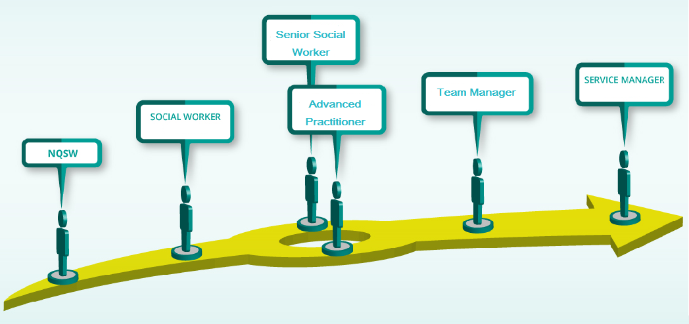
At every stage of the career pathway Shropshire will provide support, challenge and learning opportunities through regular supervision and a robust learning and development plan linking this closely to Performance, Audit and Appraisal Information. We want every social worker who joins Shropshire to have a long and varied career here.

Student Social Work Placements and links with Universities and Teaching Partnerships
Shropshire Council have worked with and provided placements for Wolverhampton University, Staffordshire University, Keele University and occasionally The Open University. Shropshire are part of the North West Midlands Social Work Teaching Partnership (NWMSWTP).
Shropshire hope to develop relationships further with Universities to explore the fast track graduate routes in to social work. This will further enhance our recruitment and retention opportunities.

Newly qualified social workers
Shropshire provide a structured induction programme followed by an Assessed and Supported Year in Employment (ASYE) Programme. This crucial first year is about providing you the support and experience needed to develop. Each ASYE social worker will keep a critical refection log, develop a professional development plan with protected time, a protected caseload and reflective supervision. All ASYE’s build portfolios of evidence to support evidencing their development through the first year. This includes regular development sessions which focus on elements of the Knowledge and skill statement for child and family social work.
The ASYE portfolio is internally moderated and verified at a standarisation panel, which is jointly chaired by both the principal social workers for Adult social care and Children’s social care. The panel consists of representatives from: service user feedback specialist from HUSK, Team managers from both adult and children’s services, University teaching fellows, and the advanced practitioner for ASYE.
External moderation processes are currently being developed with Skills for care in a Reginal Alliance to include: Telford and Wrekin Council, Staffordshire Council, Walsall Council, Stoke Council and Wolverhampton Council. This will regional external moderation will prove to test and challenge the quality and consistency of social work practice across all areas, Sharing good practice and innovative ways of working. Approval is acknowledged by the Director of Children’s Services, letters and certificates are awarded and achievements recognised with a pay enhancement.

Social Workers
Following the completion of the ASYE program, social workers have the opportunity to develop further in their roles. Social workers will continue to receive Reflective Supervision, to access Learning and development opportunities structured around the KSS and be supported to work creatively with new ideas and innovation. Our theoretical framework Relationship based practice which was introduced at induction and through the ASYE program offers a model in which to develop practice further

Senior Social Workers
Senior social workers will be given the opportunity to work with more complex cases, enhancing and growing the experience and skills of the worker with continued reflective supervision. Senior social workers will have the opportunity to mentor Social workers in their first year and those in need of support. Senior social workers will also have the opportunity to be considered for Practice education training, to develop their role. This can lead to senior social workers supporting our excellent Student Social work offer.

Advanced Practitioner Social Workers
Advanced practitioners are non-case holding social workers in Shropshire. The role has been developed to provide consultative advice, support and guidance to Social Workers in their teams. Like the Senior Social Worker, advanced practitioners can and will be expected to take advantage of the practice educator route, to support and assess students in placement. In Shropshire there are currently two AP roles, a Legal role and an ASYE role. As part of the role AP’s develop and deliver learning opportunities for the workforce, which are flexible and can responsive to the outcomes of quality assurance and performance activity. Learning opportunities can also be developed through regular communication with Team Managers. This post is an excellent stepping stone for those interested in becoming managers in the future.

Team Manager
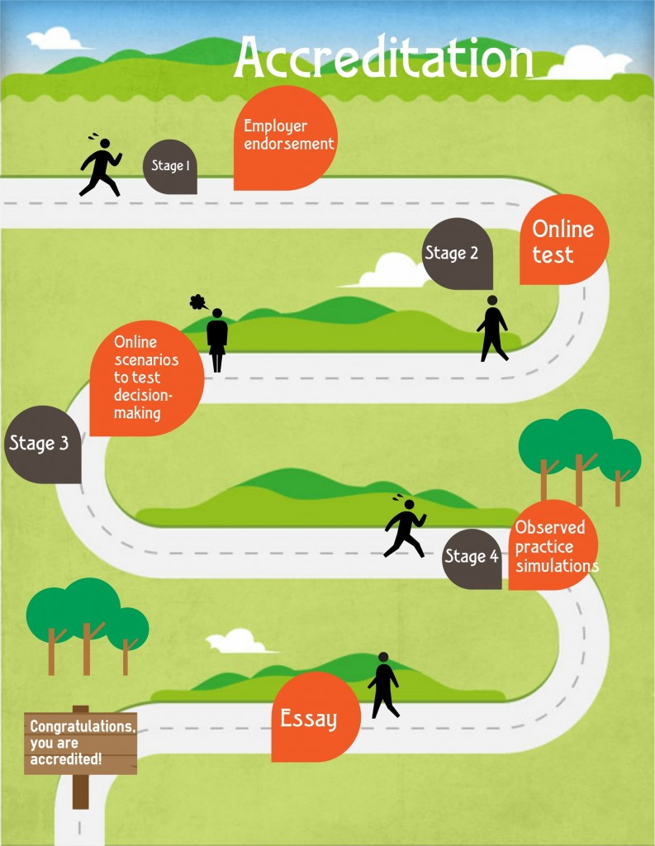
Team managers are non-case holding social workers in Shropshire, who are able to demonstrate confidence and an ability to lead and inspire social workers at every level. Team managers will provide case supervision and managerial oversight of their teams case load. Team managers will carry out observations of practice, quality and performance audits, case file audits and provide appraisals for their team. In return team managers will receive reflective supervision training and the opportunity to take advantage of the C4EO Leadership Program.
Accreditation
At the time of writing this strategy Shropshire is still developing the Employer endorsement pathway, however we do know this will be closely linked the ASYE Program and internal moderation process for passing the Assessed and Supported Year in Employment.
We know that we will be working closely with our University Teaching Partnership and the West Midlands Principle Social Worker Network to develop a robust process for the Local Authority Accreditation of Social Workers and Leaders which will include the Head of Children’s Social Care and Safeguarding. Through this process we will be providing workforce development opportunities which will stretch and challenge social workers and managers at every level of the system from Social work leaders to those who are new to practice. Providing up to date access to emerging academic theories, research and new ways of working to ensure Shropshire continues to grow and develop proactively seeking creative and innovative ways of working with children, young people and families using the principals of our Theoretical model ‘Relationship Based Practice’.
Shropshire’s aspirations for the future include wishing to be an employer of choice by offering the best experience possible, by consulting with, listening and responding to what we hear about what it is like to work in Shropshire, and offering the best career pathways we can for all who live and want to work here.

Learning and Development

The wider children’s social care workforce includes a wide ranging group of practitioners and specialists, the learning and development offer aims to meet training needs of this wide ranging group of staff. All dates for training can be found by following the link: www.shropshire.gov.uk/childrens-social-care-workforce
In our most recent Social Work Health Check 89% of participants reported that they believed that Shropshire had a learning culture. This strategy looks to develop this further.

We recognise that it is not always possible to meet the needs of every member of staff by internally delivered training programmes, with this in mind we encourage all staff to explore learning and training opportunities with their line manager in supervision and to complete the mangers forms, to request more bespoke training if required.

A Mandatory Induction Programme provides the best possible introduction to Shropshire. Our aspiration is to recruit and arrange start dates in line with recruitments schedules and the Induction Programmed. The Principal Social Worker will meet and greet all new starters and key documents, policies, procedures and training plans will be shared, Including The Children’s Manual which can be accessed by following this link: http://shropshirechildcare.proceduresonline.com/chapters/contents.html

A professional development plan addressing specific training needs is developed with Line Managers for every member of staff, in line with the Supervision Policy during your first supervision.

Shropshire Safeguarding Children Board (SSCB) and Children’s Social Care work closely together to design and deliver a wide ranging number of safeguarding and child protection training modules, which can be accessed by the whole workforce and multi-agency partners. The SSCB training schedule can be found on the SSCB website:
Shropshire’s core training programme for the Children’s Social Care Workforce
www.safeguardingshropshireschildren.org.uk
All staff are required to attend Raising Awareness of Child Protection, to ensure they have the knowledge, skills and competence to identify concerns about children, young people and families and know how to respond.

To ensure staff can work effectively with children and young people, Child Development is an integral part of the learning and development offer. This includes the principals of the Solihull Approach, an evidenced based parenting programme, Understanding Your Child.

To ensure our staff can engage successfully with children, young people and families, we offer a one day training course to enhance these skills; Communication with children, young people and families.

The ability to accurately assess, analyse and record information to support children, young people and families is an essential skill, Report Writing and Recording

Children’s Homes Learning & Development
The Shropshire Council Children’s Homes, Learning and Development (L&D) strategy sets out the key learning and the professional qualification requirements which meet requirements of the Children’s Homes Regulations including the quality standards, April 2015.

MANDATORY Training
Attachment
Child Protection – 2 year
COSHH
Driver Assessment – 2 year
Effective Risk Assessment – e-learning
Equality & Diversity
Fire Extinguisher Training – 3 year
Fire Safety e-learning – 3 year
First Aid – 3 year
Food Hygiene e-learning – 3 year
Fraud & Corruption e-learning - annually
Health & Safety – learning session in monthly team meetings (i.e. quiz)
Manual Handling Plus e-learning – 3 year
Safe Handling of Medication e-learning – 2 year
Medication Practical Assessment – annually
Protecting Information e-learning - annually
Team Teach – 18 months
Restorative Practices
Teenage Brain
Understanding Your Child
Carefirst
Carestore
The areas listed as Mandatory training have been agreed by managers and the L&D officer, the list is reviewed annually for its relevance and value for money. Mandatory spend can differ each year depending on the number of staff who require refresher training.

The annual L&D Plan sets out secondary learning events for the forthcoming year, these are agreed between Managers and the L&D Officer and take into consideration the projected spend on mandatory training.
The models practiced in the Children’s Homes are Team Teach, Restorative approaches and Understanding your Child, (Teenage Brain) in addition to the Strengthening Families, Relationship Based Practice.
All residential care workers complete an induction workbook, as part of their introduction to Shropshire, and this is used as evidence of their competence against the

Health & Care Council Standards of Proficiency:
Standard 1: Understand the principles and values essential for working with children and young people
Standard 2: Understand your role as a worker (employed or self-employed)
Standard 3: Understand Health & Safety requirements
Standard 4: Know how to communicate effectively
Standard 5: Understand the development of children and young people
Standard 6: Safeguard children(keep them safe from harm)
Standard 7: Develop yourself

Successful completion of the induction standards will provide evidence towards meeting the knowledge requirements of the core units for the Diploma in Children’s Residential Care. It will not provide all the underpinning knowledge for the whole of your Diploma. Knowledge and skills sets may be undertaken to meet knowledge requirements and/or performance criteria needed to complete the remainder of Diploma. All Residential care workers are supported to achieve the Diploma in Children’s Residential Care.

Foster Carers
Our Foster Carers in Shropshire play a vital professional role as part of the team around the child for our looked after children. Because of this we feel it is important to ensure that they receive support to develop the skills and knowledge needed in order to assist and support them in their role and help Shropshire to provide outstanding quality of care to our looked after population.

Appendix 5 The foster carers training strategy lays out the Learning and Development team’s commitment to this group of carers and provides Shropshire Local Authority Foster Carers with all the information they need to navigate through their Learning and Development journey. This training offer is made to all Foster Carers in Shropshire including Family and Friend Carers and those who are looking to apply for Special Guardianship Orders.

Twice yearly the team will look to develop a specific training day for Friends and Family connected people Foster Carers and those who hold Special Guardianship Orders which will look to support those in these positions.

An Annual conference for all Foster Carers with guest speakers who can provide specific knowledge enhancement for all will also be organised in February/March of each year

Social work learning and development
Induction

Each new social worker will receive a comprehensive induction to Shropshire, the induction programme will ensure each social worker is equip to deliver the best possible service to children, young people and families. The programme will include the following:

- Welcome to Shropshire by the Principal social worker
- Quality assurance framework
- Shropshire quality standards
- The Children’s Manual
- SSCB Multi-agency child protection procedures
- Introduction to COMPASS
- Familiarisation with local services and Partner’s
- Development of an professional development plan – individual to your needs

Social Work Training

The core training programme has been developed with the PCF and KSS in mind and all training is mapped against this, to ensure all social workers have developed the skills and knowledge required to deliver excellent services. In Shropshire we recognise that creating a learning culture is key to delivering excellent services for children, young people and families, therefore we strive to offer a wide range of learning opportunities, including Breakfast Briefings, Workshops, Learning lantern sessions, In house and Commissioned training sessions, including training days and workshops provided through the NWMTP. (Please see the Social Work Training Plan for further details). Social workers are encouraged to access SSCB Multi-agency training as well as specialist training specific to the social work role. Learning and development group meets on a quarterly basis to explore and agree learning priorities, this group includes representation from across the workforce. Workforce leads from around the region meet on a regular basis to explore regional priorities, including strategies for recruitment, retention and workforce development.

Practice Educators Training
Social workers will be encouraged to develop their skills and knowledge further by participating in our Practice education training, to enable them to offer student placements as part of teaching partnership arrangements. It is our intention to increase our pool of active Practice Educators and look to maximise student placements across the whole of our service. Becoming a placement supervisor and a Practice Educators will be a key part of our career pathways developing the necessary skills to go on to be either a Senior Social Worker, Advanced practitioner or Team Manager.

Strategy sign off and Review
This Shropshire Workforce Development Strategy will be signed off by Shropshire’s Director of Children’s Services.

The review date for this Strategy will be June 2017 or sooner, to respond to any changes to legislation, guidance or statutory requirements. At the time of writing this strategy the Assessment and Accreditation of Child and family Social Workers is yet to be finalised, once this is, Shropshire will respond to ensure the workforce is ready.

An action plan to achieve the aims and aspirations set out in this strategy can be found: appendix 6.

