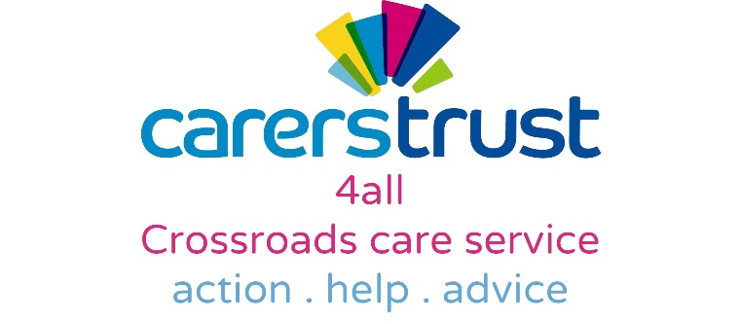

Dear Colleague

I am delighted to announce that as from 1st April 2016, Carers Trust 4all are delivering the new Young Carers Service for Shropshire. Transfer of service, including staff, files and equipment has taken place from British Red Cross and we plan to foster the existing close relationships with schools and other professionals. To this end, I would be happy to attend staff/team meetings in order to promote the new service. I welcome any feedback and will actively seek to make the service as accessible as possible to new referrals.

In addition to Young Carer Services, Carers Trust 4all run a number of adult services for carers in Shropshire. These include the Adult Carer Support Service, providing support, advice, advocacy and signposting to adult carers. This means that we are now able to offer support to carers from age 5 to age 105 (and beyond!), enabling us to facilitate an easy transition from young to adult services.

We recently moved into our new premises at Sutton Farm, on the outskirts of Shrewsbury, from where all our services are now being delivered. Our opening hours are 9am to 5pm Monday – Friday. Please see below our new address and new telephone numbers. Please pass this information on to members of your team.

Our new address is: Carers Trust 4all
Unit 12, Tilstock Crescent
Sutton Farm
Shrewsbury
SY2 6HW

Telephone: 033 33 23 1990

Email: shropshire@carerstrust4all.org.uk

We are keen to accept new referrals. These can be received by phone, email or post via the attached Referral Form.

If you have any queries at all, please do not hesitate to contact me and I hope to meet you all over the coming weeks and months.
Carers Trust 4all
Unit 12, Tilstock Crescent
Sutton Farm Shopping Centre
Shrewsbury
SY2 6HW
T: 033 33 23 1990
E: shropshire@carerstrust4all.org.uk
www.carerstrust4all.org.uk

Offices:
Bury
Congleton
Didsbury
Ellesmere Port
Liverpool
Shrewsbury

With best wishes,

Helen Esslemont

Helen Esslemont
Registered Care Manager

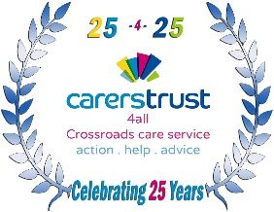
Carers Trust 4all is the trading name of Crossroads Care Cheshire, Manchester and Merseyside Limited. Registered Charity No 1075268. Registered office: Overton House, West Street, Congleton, Cheshire, CW12 1JY. A company limited by guarantee registered in England No. 3554493. Registered with the Care Quality Commission. Patrons: Rt Hon Lord Bradley, Fiona Bruce MP & Sir Nicholas Winterton.

