Havenbrook
STATEMENT OF PURPOSE
February 2023

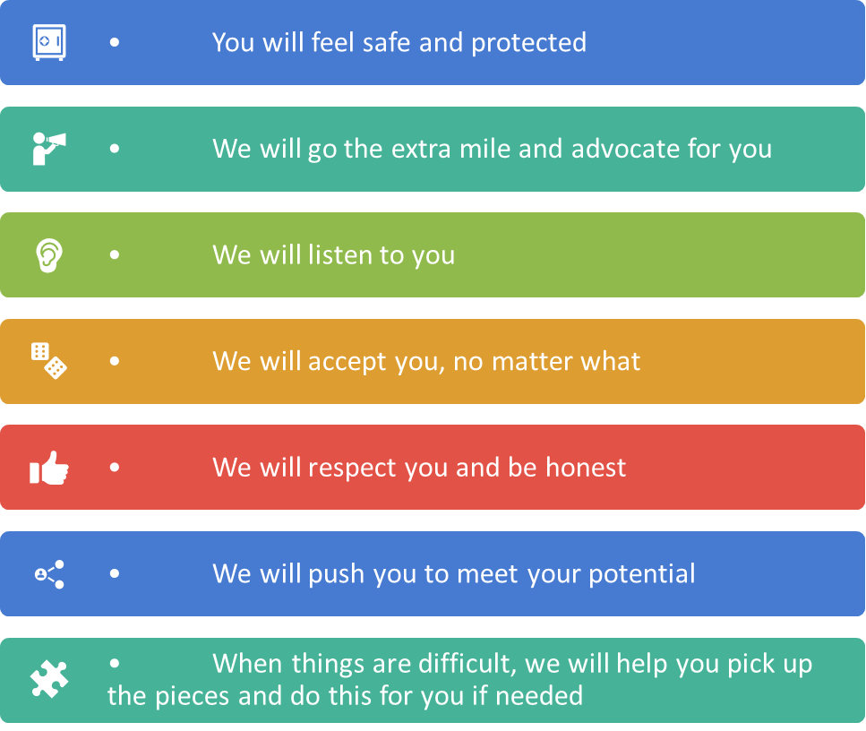
Shropshire Council Residential Services: Our vision and values
Our Values:
Vision for our people and our Children
Vision and Mission
Our Vision:
We aspire to ensure all of our children have the opportunity to live in a home that enables them to achieve their full potential.
Vision For Our People
Vision For Our Children
Our Mission:
To provide our children with nurturing and homely environments where they can thrive with people that care.

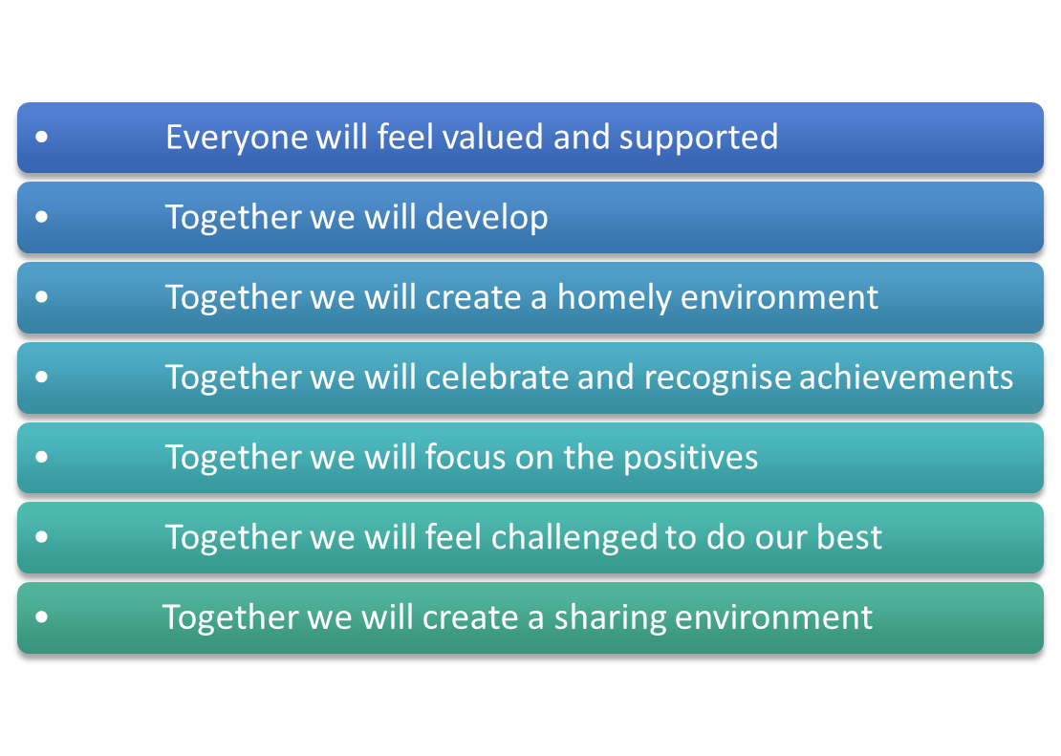

Pride- We take pride in achievements
Acceptance- We care for others unconditionally.
Resolve- We are committed
Empathy- We show compassion
Nurturing- We create growth though support and challenge
Taking responsibility- We take ownership
Adventurous- We find creative and innovative solutions.
Loyalty- We are genuine and honest.

Content

Caring for children – Page 3-7

The range and needs of the children for whom it is intended the home is to provide care
Ethos of the home.
Outcomes seeking to achieve
Approach to achieving outcomes
The arrangements for enabling children to enjoy and achieve, including how we will promote their participation in recreational, sporting and cultural activities.

The arrangements for supporting the cultural, linguistic and religious needs of the children accommodated in the home
The arrangements for promoting contact between children their family and friends
A description of the home’s approach to consulting with children about the quality of care
A description of the home’s policy in relation to (a) Anti-discriminatory practice in respect of children and their families; and (b) Children’s rights
A description of the accommodation offered by the home including (a) How accommodation has been adapted to the needs of children cared for by the home and (b) The age range, number and sex of children for whom it is intended that accommodation is to be provided.
A description of the location of the home
Details of the home’s policies for safeguarding children, preventing bullying and the missing child policy
Any criteria used for admission to the home, including the home’s policy and procedures for emergency admissions
The arrangements for dealing with complaints

Content

Children’s behavior – Page 8

The home’s approach to surveillance and monitoring of children accommodated

The home’s approach to behavioural support, including information about (a) The home’s approach to restraint and (b) How are carers trained in the use of restraint and how are their competence assessed?

Education - Page 11

Health – Page 11

Contact Details – Page 13

Carers Matters – Page 15- 17

The arrangements for supervision, training and development of employees – Page 18

Organizational structure of the home – Page 18

‘Caring for children’

The range and needs of the children for whom it is intended the home is to provide care.

Havenbrook offers up to a maximum of four planned Short Break beds at any one time, a fifth bed is reserved for use as an Immediate Short Break. If all short break beds are not in use a second Immediate Short Break can be offered (see last paragraph for any variation in this arrangement).

The age range for young people accessing Havenbrook is aged 7 – 16 on admission

An Immediate Short Break would be offered where there is an imminent risk of a family breakdown and entry in to care related to the young person’s behavioural difficulties. The care giver’s ability to manage such behaviours are evident, where additional support is needed and where an Immediate Short Break is considered safe and in the best interests of the child to facilitate continued care arrangement in the family.

An Immediate Short Break would also be offered where there is an imminent risk, or actual breakdown of a child’s foster or residential home resulting in that young person not having a place of safety and security to stay in whilst alternative accommodation is found. This will enable a period of stability and safety for a young person and reflection for all involved, also allowing time for an assessment to identify the most appropriate next steps for that young person.

In the event of this happening an immediate individual, and group risk assessment will be undertaken by the Registered Manager in order to determine the compatibility of the existing/future planned group to ensure that Havenbrook remains safe for all young people involved

An Immediate Short Break or planned short break can also be offered to a young person living in Foster Care in order to diffuse an immediate Short Break or provide planned time out reducing increasing pressure within the foster family to prevent placement breakdown.

A social work assessment will have been completed to identify the need for a planned short break.

In the event of an Immediate Short Break short break and where there is no existing social work assessment, initial gathering of information will be completed by a responsible social worker (this might be via EDT) and this early assessment of need will review the options of Immediate Short Break support being provided by family members. EDT will be expected to complete and send an Immediate Short Break referral to Havenbrook with as much information as possible before the child arrives at Havenbrook.

IMMEDIATE SHORT BREAK PROCESS:

All immediate short breaks have a maximum timescale of 17 days as per Havenbrook Statement of Purpose, regulatory requirements, and Ofsted certificate of registration.

An immediate short break will be a child that needs to access Havenbrook with immediate effect, or when appropriate i.e., when Havenbrook is able to facilitate the immediate break with regards to the group dynamics; this includes out of hours.
Referral for an immediate short break can come from a team manager, social work team and EDT.
Any child who attends Havenbrook as an immediate short break will have a review on Day 3, Day 8 and Day 12.

No single Immediate Short Break can last longer than 17 days and should be identified for the minimum period only.

The children that come to stay at Havenbrook come for many reasons.
These may include:
•Family and placement breakdown: including birth and adoptive families, foster placements, and other residential placements.

•Young people with behavioural and/or emotional difficulties that makes it very difficult to live within another setting.

•Young people with learning disabilities and/or learning difficulties, which may
effect the child’s placement stability.

•Young people who have Adverse childhood experiences.

The home will meet the needs of young people with learning difficulties, with support from the Disabled Children’s team and tailored advise from Dr Diane Turner Clinical psychologist in the learning disability team in BeeU. Specific learning disability awareness/ training from our learning and development team.
The home seeks to go above and beyond the minimum standard of care as set out by the Children’s Homes Regulations including the quality standards (April 2015) and strives to achieve the highest level of care possible for the young people.

Where any child is admitted for a short break the registered manager or senior carers member will consider the dynamics and needs of other children either having or planned to have a short break within the same period. Risk to and from each of the young people will be reviewed to determine how each child’s needs can be met and each child safeguarded during their short break.

Where these risks are not manageable, a short break will be refused and where possible re-arranged for another agreed date.

Havenbrook has not been designed with the intention of accommodating children who are disabled. There would have to be an assessment of the building and carers team to determine if we could offer a positive service to a young person assessed as having special needs arising from any disabilities.
We aim to work in partnerships with parents / carers, other agencies, and relevant people to meet the aims stated in the short break plan of individual young people.

Ethos of the home
We recognise the need for young people to be heard and receive timely, positive and proportionate responses to their needs and behaviours.
In addition to using a restorative approach, that focuses on building, nurturing and repairing relationships, all Havenbrook carers work to the above ethos.
We will consult with young people, promote their rights and ensure their views are represented.
Provide stimulation by ensuring young people have the opportunity to take part in education, social activities and have their health needs met.
Promote the interpersonal skills necessary for group living, respecting their rights whilst educating them on their responsibilities in equal measures.

Outcomes seeking to achieve
Children in need and their families are supported with short breaks as part of a range of services provided to them including outreach, Family Group Conference (FCG), and Parenting programmes.
To prevent family breakdown by providing planned or Immediate Short Break short breaks to young people in a residential home who are felt unable to receive such support in an alternative family care arrangement.
To support rehabilitation of a child in care to their birth family care where short breaks are part of a package to achieve sustained positive rehabilitation.
Give young people the opportunity to relate to adults who are able to demonstrate emotional commitment combined with professional integrity and safe boundaries to behaviour.

Approach to achieving outcomes
We will work with young people by the provision of interesting, fun activities to afford parents a break from caring thereby, assisting the repair and maintenance of family relationships.
Young people will be encouraged to value themselves, their family, culture, community, education, and religious beliefs.

We will promote respect for the wider society, including neighbours, as an integral part of the development of young people

The arrangements for enabling children to enjoy and achieve, including how we will promote their participation in recreational, sporting, Spiritual and cultural activities
The linguistic needs, religious, spiritual beliefs and practices of each child will be established at the planning meeting prior to admission. Thereafter, the short break plan will detail how such needs will be addressed.
Young people will be encouraged to respect views, values, needs and interests of others. Young people will be empowered to be morally aware enabling them to distinguish the principles between right and wrong within the code of each other’s cultures.
Social awareness will be continually promoted enabling young people to adjust appropriately and sensitively to living within a diverse community and enrich their social experience.

The arrangements for promoting contact between children and their family and friends
Young People and Parents will be clear that children at Havenbrook are not ordinarily Looked after Children and that parental responsibility remains fully with the parent/carer.
Havenbrook will know how to contact parents, in an emergency and if necessary, maintain such contact as agreed in the short breaks care plan.
Visitors are encouraged to telephone in advance to ensure that young people are available.
If a young person wishes to have telephone contact with their family during their stay, they will be supported to do so.
Where a child’s plan prevents any contact with an individual family member or friend this will be outlined in the short breaks plan and adhered to during the Short Break episode.

A description of the children’s home approach to consulting with children about their quality of care
As far as is practicable, children will be involved in planning their short break.
Consultation with young people will be ongoing during their stay and afterwards, feedback on their experience will be sought and recorded. Also, the views of parents having a break from caring will be obtained.
The registered/ Deputy Manager also make contact with all the children that leave feedback with personalised individual letters with outcomes and responses.
A Statement of the range of needs of the children for whom it is intended that the children’s home is to provide care and accommodation

A description of the home’s policy in relation to –
- Anti-discriminatory practice in respect of children and their families; and
Havenbrook is committed to the Department’s policy on anti-discrimination, which incorporates the B.A.S.W Code of ethics and the professional standards of Social Work England “Anti-Discriminatory Practice is about treating people equally, fairly, recognising that we all have different needs, tastes, experiences and cultures. Practice will be examined so that this recognition is fully taken on board”. It reflects the promotion of equality of opportunity in the way service is offered and delivered within Shropshire.
- Children’s rights
We believe that every young person has the right to a homely, safe environment where care, parenting and choice are provided within a confidential service.
We believe that every young person has the right to be respected as an individual, to express his or her opinions, feelings in a non-destructive, non-abusive manner.
Every young person has the right to be free from oppression and prejudice, the right to education, which enables them to develop their self-esteem, self-control, self-respect and the respect of others.

A Description of the accommodation offered by the children’s home, including –
- How accommodation has been adapted to the needs of children cared for by the home –
Havenbrook provides accommodation for five young people comprising of a large living room area, a dining room, large kitchen and reception area used as activity area and an art/computer/study room and extended garden area to the front and back of the home. These are all shared living spaces. In addition, there are four individual en-suite bedrooms, and a fifth with a shared bathroom
All young people’s bedroom doors have electronic alarms fitted, these are only used with authorisation from family, and social worker and the Registered Manger to safeguard a young person from a specific risk.
Havenbrook also has an external audible Beep, which is activated when any external or internal bedroom doors are opened. This is to ensure that any visitors to the home can be identified immediately.
There is also sleeping accommodation with separate shower facilities for carers.
- The age range, number and sex of children for whom it is intended that accommodation is to be provided;
Havenbrook will provide accommodation for up to five young people of either sex aged 7 to 16 on admission.

A description of the location of the home
Havenbrook is situated in a very remote and rural setting and is located between two small villages approximately 6 miles Southeast outside of Shrewsbury. The home benefits from a semi-rural position without being isolated from neighbors. Since its opening in 2009, young people have benefitted from receiving short breaks in a quiet; safe environment.
A Safe Area and an Environmental Report are in place for Havenbrook

Details of the home’s policies for safeguarding children, preventing bullying and the missing child policy
We recognise the importance of giving reassurance and information to all children and Young People using Havenbrook as to the purpose of the service and especially the use of the Immediate Short Break provision. And whilst maintaining an appropriate level of confidentiality for all children and their families, all Young People being admitted for short breaks will be given basic information as to the other residents and will be given regular opportunity each day to speak to carers about any concern they have about other residents.
Havenbrook conduct Short Break planning meetings. During these meetings, information will be shared at the appropriate level with the Young Person and their Families about the provision and how places are allocated.
Havenbrook will explain how the group dynamics are risk assessed and if after consideration it is deemed that any one group is viewed as an inappropriate mix, then there is the scope to be able to make changes to for example the dates of any planned short break.
Havenbrook also have the provision to offer the facility of one Immediate Short Break short break bed or two if there are only three planned short break beds being accessed at any one time. The group dynamics of the home will be considered, and risk assessed by the Homes Manager or Deputy Manager before any agreement is made to provide a Immediate Short Break short break. To minimise the potential of any disruption towards the other Young People in the home, the Immediate Short Break provisions will whenever possible always be sited in the bedrooms on the ground floor, in the eventuality of an Immediate Short Break being admitted during the early hours.

Where a young person is absent from the home or the supervision of carers without authority, carers will follow the relevant policy and procedure, which will include -
The carers member carrying out a reasonable search of the home and surrounding area to try and locate the young person and confirm their safety.
If the young person has not been found or returned within a time previously specified by the home, the responsible Social worker or the appropriate “out of hours” duty team will be informed, and carers will follow the joint protocol for reporting Missing Young People.
The time for notifying the Police that a young person is missing will be made in consideration of the age and circumstances of each young person and will be identified in their individual Care plan/Risk Assessment.
The Registered Manager will work proactively with the Police to maintain and develop appropriate joint protocols for managing unauthorised absences.
Bullying of any form will not be tolerated in the home; carers will be vigilant and sensitive to the needs of any victim or perpetrator.
Individual risk assessments will reflect a young person’s experience of, reaction to or inclination for aggressive behaviour towards peers or carers.
Young people are given a copy of our anti-bullying policy that sets out the measures that will be taken to encourage respect for others and ensure that everyone is aware that all bullying concerns will be taken seriously and dealt with sensitively and effectively.
We will encourage those responsible for causing harm to become accountable for their actions and responsible for making it right.
All carers are aware of the need to work within statutory requirements and guidelines. The arrangements for child protection are laid out in the Inter Agency Procedures for, Working Together to Safeguard Children, in line with Shropshire Safeguarding Children’s Board.

Any criteria used for admission to the home, including the home’s policy and procedure for emergency admissions
Where there is no existing allocated social worker, a keyworker or lead professional can refer into the provision by contacting COMPASS on 0345 6789021 in the first Instance and request a social work consultation.
Where there is an existing allocated social worker a direct referral can be made to the Registered Manager upon agreement of the Team Manager
Access to the service will be identified through the social work assessment of need. The assessment and recommendation must be signed off by the responsible manager or Early Help social worker.

Social workers need to check Havenbrook’s online diary page for availability, or call the Registered Manager/Deputy Manager, and then complete the referral document; both of which can be found on LCS

On completion these documents need to be sent to:
.Jason.harvey@shropshire.gov.uk or Jessica.love@shropshire.gov.uk

Referrals are only accepted for a maximum of 5 short break period at any one time; with no more than one short break per month unless specifically agreed by Registered Manager and Social Work Team Manager.

As part of the admissions process, the social worker, parents/carers and the young person must attend a short breaks planning meeting with a responsible individual from Havenbrook ideally allowing a minimum of two weeks’ notice.

In exceptional circumstances, social workers can request a back-to-back break with prior agreement from both the Registered Manager and Team Manager.

Havenbrook will look to try and deliver the best bespoke Short Break plans for the children and their families for short breaks, this may enable the child and their families to achieve the opportunity to gain the best outcome for themselves, it may be required that some children would prefer to stay for days only initially, then building this up over time as part of their individual plan, this may also include shorter breaks.

Dates and times of admission are: -

Monday, 3pm until Friday, 9am
(duration of stay—4 nights)
or
Friday, 3pm until Monday, 9am
(duration of stay 3 nights)

It is the responsibility of referrer to ensure arrangements are made for the young person to be transported to Havenbrook.

A member of Havenbrook’s team will provide transport home or to an agreed venue at the end of the short break.

Havenbrook carers will be responsible for ensuring a child attends school, where necessary this will include transporting the child to and from school during their short break.

Any Immediate Short Break request in to Havenbrook should first be agreed with a Social work Team Manager during office hours, outside of office hours EDT will refer in via Havenbrook on call duty Manager.

Should a need arise to cancel a planned Short break following the completion of a risk assessment, and discussions with allocated Social workers, parents will be notified at the earliest possible time to advise them of the cancellation, and offer the earliest alternative planned date

The arrangements for dealing with complaints.
The needs of everyone and their responsibilities within the home are considered.
Parties involved in a specific conflict will be encouraged to resolve collectively how to deal with the complaint and find a mutually acceptable way forward.
All carers at Havenbrook are aware of procedures for dealing with complaints, dependent upon the nature of the complaint
In the event that complaints cannot be dealt with informally, the Directorate has a complaint and representation procedure that complies with the present legislation.
All carers in the home are aware of the procedures for young people and their families.
On admission, young people are given a copy of the procedure and an explanation of how to use it. Young people can contact an Independent Visitor through Coram Voice (VOICE) whom Shropshire Council have an agreement with. Coram Voice is an independent service for Looked After Children which provides advocacy, independent representation, independent persons for complaints representation, alternatively Young People can contact Ofsted.
Alternatively, young people can contact Ofsted, Child line or a number of other independent agencies.
Complaints from neighbours are dealt with promptly according to the home’s policy for neighbourhood comments.
There is guidance for dealing with employee’s complaints. This can be found in the employee Induction Handbook. There is also a Speaking up about Wrong Doing policy for carers working with children and vulnerable adults using the services provided by Shropshire Council.

Children’s behavior
The home’s approach to the surveillance and monitoring of children accommodated.
The carers of the home are committed to encouraging good order and a positive environment through good professional, caring relationships with the young people, and through an established framework of general routines and individual boundaries.
We aim to identify and address the underlying cause behind conflicts or wrongdoing. Where appropriate, consideration will be given to the use of restorative approaches as a way of repairing and maintaining relationships.
Whilst in Havenbrook, children will be supervised according to their ages, development and activities.

Currently Young People’s bedroom doors have an alarm on them, these are only set in the event of Safeguarding concerns for an individual Young person, permission will be required from both Parents and Social Worker should it be felt that alarms are needed. All bedroom doors have a single audible beep when opened, this is so all carers and children are made aware, if anybody should enter their bedroom. This also makes carers aware during the night if any children should leave their bedroom for any reason, medical or other.

Havenbrook CCTV Policy
Review date- October 2023.

Havenbrook has an external securely monitored CCTV surveillance system. The Registered Manager is responsible for the operation of the system for ensuring compliance with this policy
The use of CCTV and the associated images is covered by the Data Protection Act 2018. This policy outlines the appropriate usage use of CCTV and how it complies with the Act and is associated with Havenbrook’s Data Protection policy, the provisions of which should always be adhered to, helping ensure the safety of all the users, carers, children, parents and visitors, consistent with the respect for the individual’s privacy.

Data protection compliance

The use of any CCTV footage will comply with all DATA PROTECTION principles, which are:
a) processed lawfully, fairly and in a transparent manner;
b) collected for specified, explicit and legitimate purposes and not further
processed in a manner that is incompatible with those purposes.
c) adequate, relevant and limited to what is necessary in relation to the purposes
for which they are processed.
d) accurate and, where necessary, kept up to date;
e) kept in a form which permits identification of the data subjects for no longer
than is necessary for the purposes for which the personal data are processed;
f) processed in a manner that ensures appropriate security of the personal data,
including protection against unauthorized or unlawful processing and against
accidental loss, destruction or damage, using an appropriate technical or
organizational measures.

Havenbrook

The System comprises of 4 fixed position cameras, a monitor, digital hard drive recorder and 2 x public information signs. Cameras are located at strategic points on the premises; main carpark directed at the main entrance only, front garden directed at the garden and frontages only which include side views of the front door and windows, Rear Garden gate and side views of the kitchen door and windows. No camera is hidden from view and all will be prevented from focusing on areas of private accommodation. Signs are prominently placed at the entrance and exit points of the site to inform carers, children, parents and visitor that a CCTV installation is installed.

The CCTV system will always be turned off unless there is a significant safeguarding concern that requires the CCTV system to be activated. The CCTV will only be activated with agreement from the Service manager and homes manager, all parents that children are placed at Havenbrook at that specific time and Social Worker.

All parents will be made aware in their child’s Short Breaks meetings that Havenbrook has the facility to use CCTV if there seems to be any safeguarding concerns evident as highlighted below.

•Process for rights requests, If any individual wishes to see any footage about themselves, Please see below link
https://carers.shropshire.gov.uk/how-do-i/information-management-and-governance/what-if-someone-asks-about-personal-information-we-hold-about-them/

Access

Viewing of the recorded images of CCTV will be restricted to the Homes Managers, Jason Harvey (Registered Manager) and Jess Love (Deputy Manager) within the office only, also to those carers who need to have access in accordance with the purpose of the system. This is not a “webcam” facility; parents will not have access to view recordings.

In the absence of both Managers, shift Leaders (Ben Wilson, Ian Maddox or Caron Evans) may be give authorisation to view pre-recordings.

The monitor and recording system will be located, in a ground floor locked carers room.

The system has a Log in and a passcode to enable the activation of the system and another passcode for viewing of recorded information. The passcode for pre-recorded information, is only accessed by Jason Harvey and Jess Love.
Policy written by Jason Harvey

The home’s approach to behavioral support, including information about –
- The homes approach to restraint
The home follows the Children Act 1989 Guidance and Regulations on permissible forms of control in children’s residential care. Young people may be restrained, but only as a last resort to prevent harm to themselves, others or damage to property but never as a punishment.
- How are carers trained in the use of restraint and how are their competence assessed?
All carers trained in the ‘Team Teach’ method of positive handling. Their competence is routinely assessed day by day and formally through a comprehensive refresher training every 18 months

Education

Details of provision to support children with special educational needs.
The education of children on short breaks remains the responsibility of their parents.
If children are identified as having special educational needs, Havenbrook will provide support as detailed in the short breaks plan.
If a child is excluded from education for what ever reason, Havenbrook can contact t LAC education/teachers for support and resources.

Carers at Havenbrook will assess any barriers to learning presented through available paperwork and work to ensure that these are addressed as part of a child’s short break/Immediate Short Break plan. A multi-agency approach is utilized as part of creating plans for the young person’s education, this includes designated LAC Teachers and Shropshire’ s Virtual Head and ensures that everyone is working together to achieve educational outcomes for the young people.

The arrangements for children to attend local schools and the provision made by the home to promote the educational attainment of children.
Every effort will be made to keep children on short breaks in their local schools. Havenbrook fully recognize the importance to young people of having their educational needs promoted and met therefore, carers will actively seek to ensure that young people achieve the goals identified and agreed in their short break plan.
There may be occasions where Details of provision to support children with special educational needs.

Health
Details of health care or therapy provided, including -
- How the home measures the effectiveness of its approach; and
Arrangements for the health of children on short breaks remain the responsibility of their parents, however in the event of a health-related emergency Havenbrook will act in the best interest of the child without delay.
The home ensures during the child’s/Immediate Short Break short break meeting that the children are registered with all required healthcare professionals such as a local GP, opticians and dentist.
Having due consideration to their age and development and understanding, young people will be given advice and encouraged to take responsibility for their health.

- The evidence referred to by the home to demonstrate the effectiveness of its approach and how this information can be assessed.
The evidence to demonstrate the effectiveness of the homes approach to health will be set out in the records of the home and can be accessed by those persons authorized to do so.

A description of the homes policy in relation to smoking.

One of Shropshire council’s aims, and objectives is to improve the health, wellbeing and care of the young people in Shropshire. The Council recognise the need to ensure that Children live in a healthy environment, their health needs are identified, and services are provided to meet them.
All young people who are already smoking and are staying at Havenbrook on a short break or on a Immediate Short Break basis will be actively discouraged from smoking, Where a Young Person already smokes ‘strategies’ will be adopted to support a Young Person to reduce or stop smoking, such strategies may include.
- Handing in of lighters & Cigarettes.
- Health Education
- Focused work via Key Worker Sessions.
- Parental Support to enable the delivery of service.
- Information sharing via leaflets and flyers on ‘Quit Smoking’. Which are available within the home
- All work will be recorded in the Young Person’s Short Breaks Booklet.

Shropshire Council Workplaces and Vehicles are smoke free zones therefore Young People will not be permitted to smoke in any of these establishments, company vehicles or vehicles driven by Shropshire Council employees.
There is a designated area on the perimeter of the grounds which can be used for the purpose of smoking, Young People will be expected to hand the cigarettes & lighters back into the Carers on duty after using them in the Smoking area, cigarettes will be limited as determined by their individual reduction programme
The Carers team at Havenbrook are trained in all aspects of Fire Safety, weekly fire drills and evacuation procedures.

Contacts

The name and address of Registered Provider and the Registered Manager
Registered Provider | Registered Manager
Dan Old  Operations Manager -Acting responsible individual  Service’s and Safeguarding  Mount McKinley Building  Shrewsbury Business Park  Shrewsbury  SY2 6FG  Telephone: 01743 250106 | Jason Harvey  Havenbrook  Cound Stank  Cross Houses Shrewsbury  Shropshire  SY5 6EP  Telephone: 01743 761906  Fax: 01743 761084
The relevant qualifications and experience of the Registered Provider and the Registered Manager

Registered Provider  Dan Old  Level 5 Diploma in Leadership and Management for Residential Childcare (England)  Foundation Degree in Child Therapeutic Studies  NVQ 3 Health and Social Care (Children and Young People)  Daniel Old is employed as an Operations Manager for the Residential Homes across Shropshire Council. He has responsibility for overseeing all the Shropshire Council Residential Children’s homes as well as managing Residential Projects. Daniel is also responsible for ensuring that all managers receive a monthly supervision.  Daniel has been looking after children and young people who display emotional and behavioural difficulties for over 12 years as a Care Practitioner, Deputy Care Manager and Registered Manager. Previous to this Daniel worked in the care sector for 4 years in mental health settings, hospitals and residential care for both young people and adults. | Registered Manager  Jason Harvey  NVQ 3 & NVQ 4 and Completing his Level 5 Health and Social Care.  Jason has over 27 years’ experience working with Children and Young people, in both a Residential setting and also a Maximum secure home for Children and Young people, this was aiming to help rehabilitate young offenders back into the community and supporting young people with extreme self-harming behaviors.  Jason has worked as a Deputy Manager looking after Children and young people that have been Sexually exploited in a residential setting.  Jason has been Deputy Manager at Havenbrook short breaks provision since September 2018  Jason’s hobbies include Football, cycling, keeping fit, and spending time with his family and Isla his Cocker Spaniel.

Registered Manager
Registered Manager  Jason Harvey | NVQ 3 & NVQ 4 in children and young people and currently Completing his Level 5 Health and Social Care.  Jason has 30 years’ experience working with Children and young People, including residential, secure and prison environments.  Jason has 15 years’ experience in a supervisory role within Shropshire Social Services
Deputy Manager
Jess Love | Level 5 Diploma in Leadership and Management for Residential childcare  L2 In Understanding Autism  Jess has been working in social care for 10 years, for the last 7 years, Jess has directly supported young people in Residential care, Jess is experienced in supporting young people presenting trauma behaviours, and experiencing Adverse childhood experiences.  Jess enjoys riding her sports bike, spending time with her little dog, going on camping trips and doing DIY.
Shift Leaders
Ian Maddox  Caron Evans | NVQ 4  Ian has over 18 years’ experience working with young people, both in the private sector and for the Local Authority in the last 10 years. Ian started as Residential Care Worker but has held a supervisory role for the last 20 years.  Ian’s interests include football, gadgets, travelling and dogs.  4 units of Level 5  NVQ Level 3 in Children and Young People’s Services  BA Hon’s History  Caron has worked for Shropshire Council residential services since 2009, where she started as Residential Care Worker at Havenbrook.  Caron enjoys walking, cycling and being outdoors. She likes to spend time in the gym or in the garden at home. Caron likes to watch sports of tv, especially Football, Rugby and American Football. Caron has 2 cats called Penny and Rocky.
Ben Wilson | NVQ 4  Ben has over 26 years’ experience, many of these years in a  Supervisory role with young people in Immediate Short Break.  Ben has recently gained his qualification to teach Forest School.  Ben’s interests include the outdoors and working on his allotment.
Residential Care Workers
Joanne Gibbs | NVQ 3  Jo has been working for Shropshire Council for just over 18 years, initially with adults who have learning difficulties, before coming to Havenbrook in 2008.  Jo’s interests include travelling, arts and crafts, walking her dogs and cookery.
Tom Pritchard | NVQ 3  Before coming to Havenbrook as a Housekeeper Tom was a Residential care worker working for Shropshire council.  Tom recently applied to a vacant Residential care worker role at Havenbrook which he was successful in.  Tom enjoys cooking and going to the gym.
Guy Nisbet | NVQ 4  Guy has worked with young people for approximately 13 years. Prior to this, he worked with adults, where he was the registered manager for a residential home who supported people with visual impairments and additional disabilities. Guy is from Australia and his interests are motor bikes, the outdoors, playing airsoft and supporting his family.
Lesley Mansell | NVQ 3  Lesley has worked in Residential childcare for the last 5 years prior to which she was a catering manager.  Lesley enjoys walking, cooking, gardening and looking after her pets - 2 dogs and 3 cats.
Sophie Powell | NVQ 3 / Currently undertaking Level 4  Sophie has worked in Residential care for about 5 years now and prior to this she worked as a Health Care assistant in the community looking after children in the community. Sophie enjoys watching and playing most sports, especially football.
Steve Quelch | NVQ 3  Steve started working with young people in 2000 at Cruckton Hall in a residential school for boys aged 9-18 diagnosed with ADHD. Steve became a team leader, before moving to The Rowans in March 2004 (at the time, The Rowans was a semi-independent house for young people aged 14-18). In November 2008, Steve transferred to Havenbrook.  Steve’s interests include football, swimming, walking and cycling.
Richard Johnson | Richard is qualified Personal Trainer, Fitness Coach and Football Coach. He played for Liverpool FC and Oldham Athletic FC as a youngster. He has a real passion for the outdoors, especially climbing mountains & anything to do with Fitness &  Health. He has previously worked with young people as a football coach and has worked for New Reflexions as a Residential Care Worker. He has also worked for the NHS in Shropshire before starting his role with the council. He looks forward to sharing his interests and passion, for anything outdoors, with the young people.
Gareth Lewis (part time) | Gareth has several years’ experience working in an educational setting with children/young people. He also has 2 years’ experience working as a member of the bank Residential Care Worker Team.
Phil Wills | NVQ 3  Phil has recently joined the team. Phil has spent 17 years in the Army. After leaving the Army, Phil went into supporting young people. He has now been doing this for 15 years. Phil has supported young people in Immediate Short Break, with Autism and in residential.  Phil loves the outdoors and walking his dog.
Angela Moston | Housekeeper  Angela has been a residential care worker for approximately 20 years working with children, young adults, people with special needs and the elderly. Angela now works at Havenbrook as the housekeeper and is on the list of bank carers to cover leave and sickness.  Angela’s interests are cooking, arts and craft, photography, gardening, and animal studies.
Philippa Ridgway | Team Secretary  Philly has completed a business admin apprenticeship with Shropshire council in 2013. She has worked in customer service and within children services admin posts for 6 years. When she’s not working, Philly spends her time with her 3 year old daughter, and has a house rabbit called Autumn.
Peter Wilder  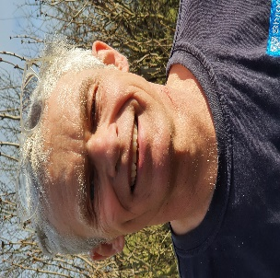 | Maintenance Officer  Facilities Officer or Pete the Handyman to most people in our home, and I have been since November 2020.  I am a trained Graphic Designer and have run a business for the last 20 years working mainly in Educational Publishing, Marketing and Events.  I’ve also had a Handyman and decorating business and worked part-time for the Council as a Caretaker.  Among my interests are making furniture as well as DIY and I’m a keen, though aging road cyclist!
Collectively the carers have acquired many years’ experience working with children and young people. They come from diverse backgrounds/life experiences with knowledge and skills gained from training in for example child protection, child development, equality & diversity, drug/alcohol awareness, Team Teach, health and safety and Restorative Practice in residential care.

The arrangements for the supervision, training and development of employees

Havenbrook has identified 5 key Carers that are known as “Champions”. The champions are trained in key specific areas known as, Exploitation (CSE, CCE), Self-harm, Mental Health/Wellbeing, Positive handling and interventions, Autism and communication needs. The Champions will have links with key agencies and professionals and be able to gather immediate and most recent information available.

Carers will have arrangements for the supervision in accordance with Shropshire Council’s Supervision Policy, in conjunction with Quality Standards for Children’s Homes. The Registered Manager, Deputy Manager and Shift Leaders carry out formal supervision of individuals. There are four weekly team meetings and shift leader meetings in addition to the day-to-day informal supervision.
Everyone will have their performance reviewed annually, enabling learning for the work process and identifying development opportunities, as well as reviewing progress against agreed objectives and the development plans of the home.
All carers will have Individual Learning Log (ITR) and will have regular access to the Children’s Social Care, Learning and Development Officer for Children’s Homes.
The Learning and Development Policy can be found in the Carers Handbook.

The Organizational Structure of the Children’s Home

Registered Manager
Jason Harvey
Deputy Manager
Jess Love
Shift Leaders
Ben Wilson, Ian Maddox, Caron Evans
Residential Care Workers
 | Lesley Mansell  Jo Gibbs  Gareth Lewis |  | Tom Pritchard  Steve Quelch  Richard Johnson | Guy Nisbet  Phil Wills  Sophie Powell
Team Secretary |  | Housekeeper |  | Facilities Officer
Philippa Ridgway |  | Angela Moston |  | Peter Wilder

