CASE TRANSFER (CHILD) WORKFLOW GUIDANCE

Practitioner Guidance

Content

- Purpose

- Workflow

- Documents available

- Completing the episode

- Outcomes

Purpose

The Case Transfer (child) episode records case transfer details. The Case Transfer Form details the Transfer Meeting Request, and records confirmation that relevant documentation has been completed, before the case is accepted for transfer.

The Case Transfer episode is available as an outcome from all episodes where it would be relevant to transfer.

The primary document in this episode is the Case Transfer Form.

Workflow

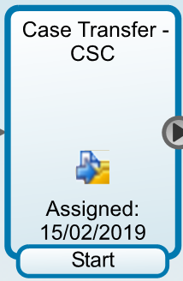

Documents Available

Episode documents | Mandatory? | Purpose
Case Transfer Form | Yes | To record confirmation that relevant documentation has been completed, before the case is accepted for transfer.

People>New Episode
The episode is an outcome from relevant workflows, where it is appropriate to transfer and is assigned to the relevant PM transferring the case.

From Incoming Work, right click, start work on the episode.

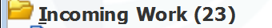
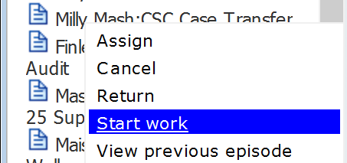

This will take you to the Documents screen.

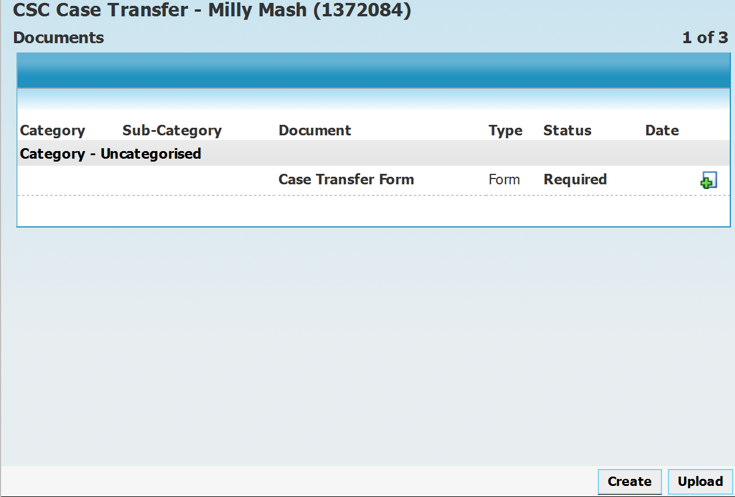

Click on the green cross to activate the document:

The transferring PM will complete Section 1. Transfer Meeting Request:

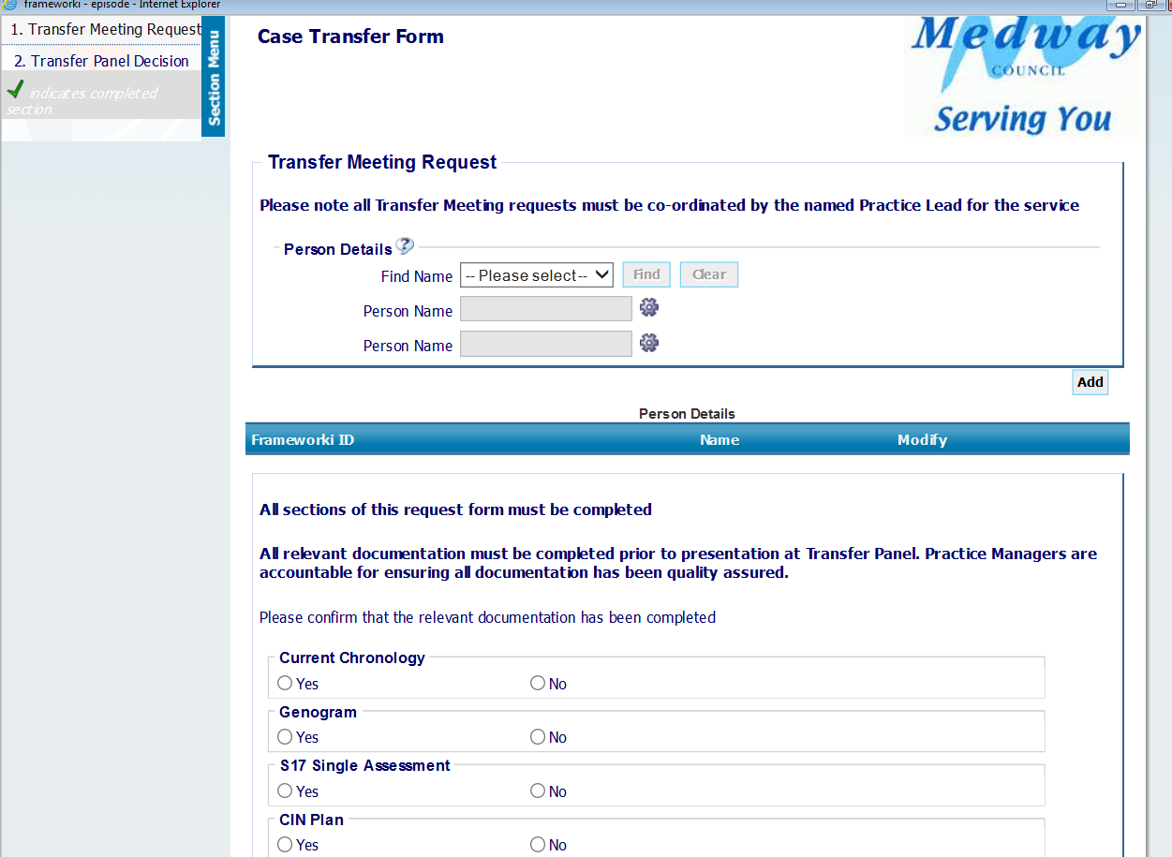
Sections Area
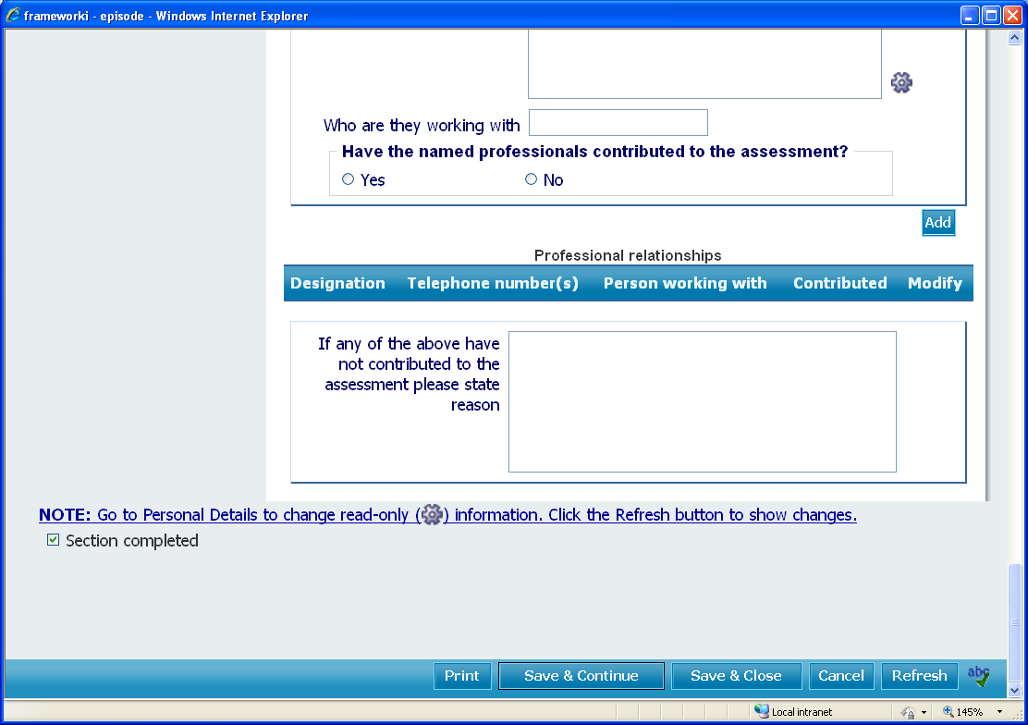
Section completed box
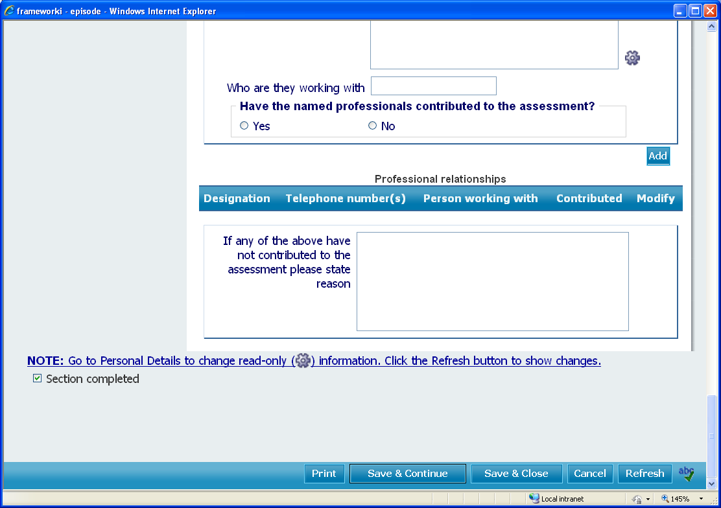
Save & Continue
Save & Close

Once Section 1 of the form has been finished, confirm this by ticking the section completed box and then click “Save and close”.

NB: Always tick Save & Continue when completing the document to ensure information is backed up should the system go off line.

Once you have clicked the “save and close” button you will return to the documents screen below. Note that there are warnings of mandatory fields not completed, as these areas are completed within the Transfer Panel Meeting:

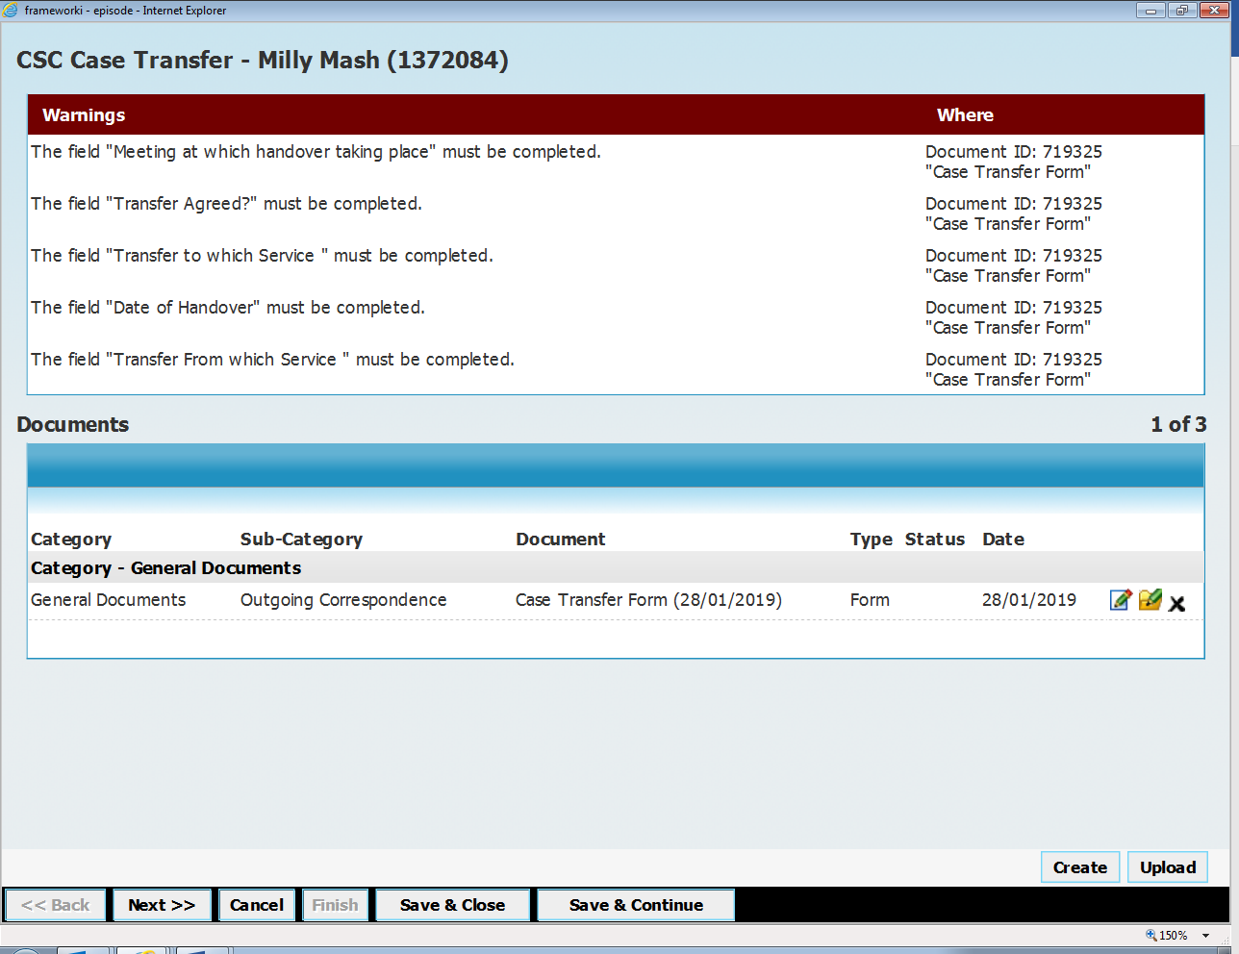

Click Next, this will take you to the Tasks Screen:

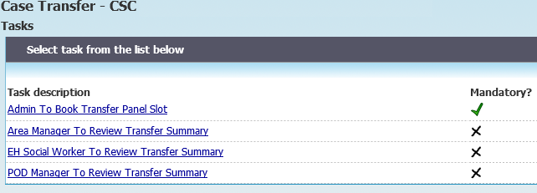

Tasks

Task | Mandatory? | Purpose
Admin to Book Transfer Panel Slot | Yes | Can only be sent to Case Transfer Virtual Worker
Area Manager to Review Transfer Summary | No | Receiving Area Manager to review
EH Social Worker to Review Transfer Summary | No | Receiving EH Social Worker to review
POD Manager to Review Transfer Summary | No | Receiving POD Manager to review

During the Transfer Panel Meeting, Section 2.Transfer Panel Decision will be completed by the Panel Administrator:

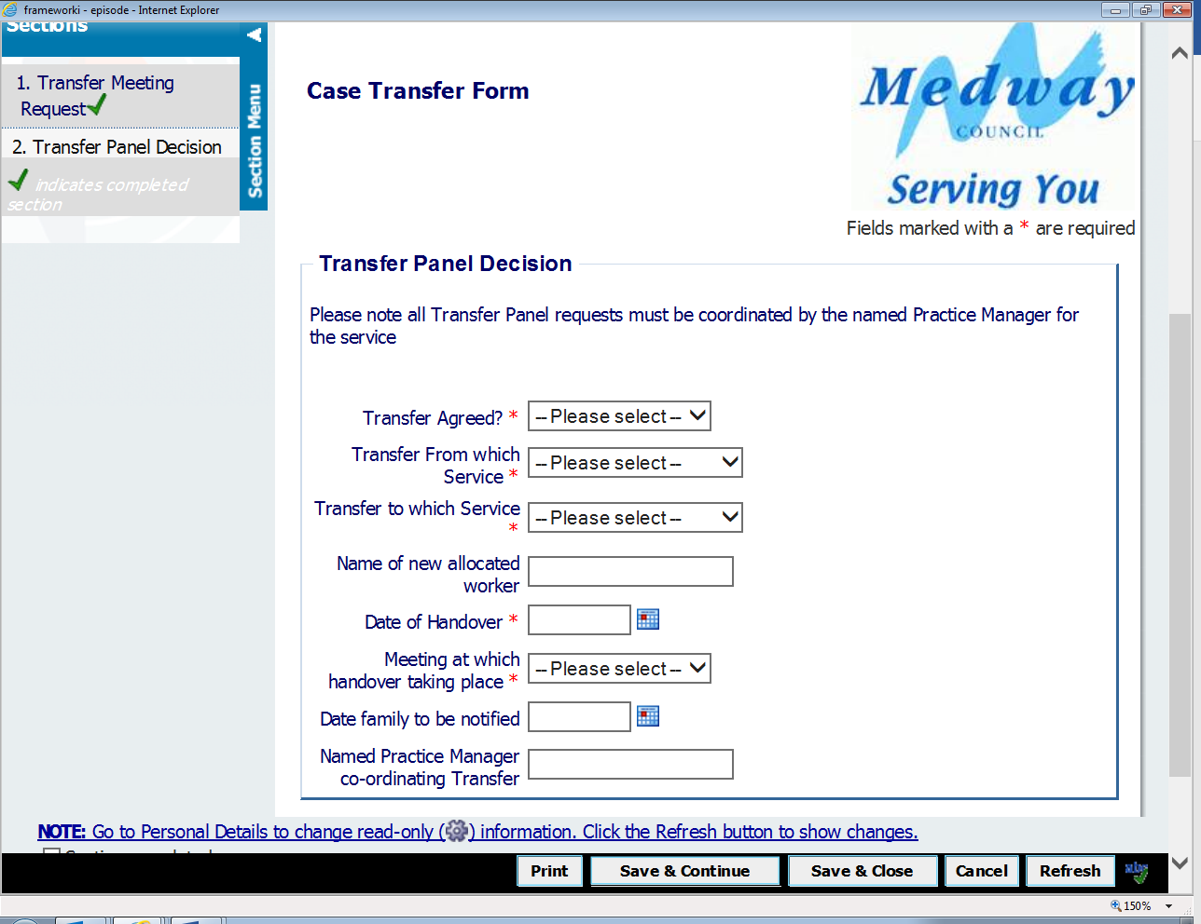

Note: If you have not finished the document and need to revisit it at a later date, click “Save and Close”. The piece of work will move to your “Uncompleted Work” folder. To re-start the work click on the “Uncompleted Work” Folder > select the piece of work you need to work on > right click on the work > choose the start work option.

If you have completely finished the document click the “Next” button to the Outcomes Screen.

This will take you to the Outcomes Screen.

Outcomes

Outcomes | Mandatory? | Purpose
Notification to new Worker Transfer of Case | Yes – Only outcome | To Notify new worker of case transfer

Click on the Dropdown options on the Outcome field to choose the required, relevant outcome.

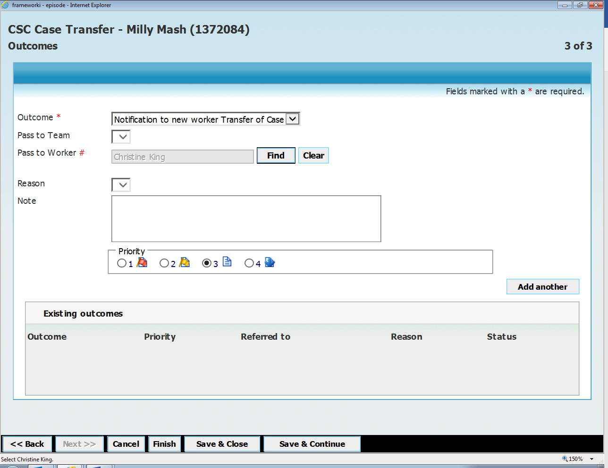

Choose the outcome, and click Find to select the appropriate practitioner:

Click “Add Another” Click “Finish”.

This episode is now complete
The outcome from this episode will appear as a new episode in the Incoming folder of the Practitioner to whom it was sent, but it does not create any work, it has an Acknowledge link that just needs to be clicked.


