Guidance to support completion of Case Summary
- Introduction
The form has been developed to support the consistency and uniformity in completion of case summaries by social workers. The purpose of a case summary is to tell what’s happening for a child at any given time and help managers, new social workers and out-of-hours workers to understand the child’s circumstances and needs. A case summary should be completed on all open cases.
The form allows multiple children to be added and it can be copied across to each child’s record.
- Creating the form on Fwi
The first case summary episode is initiated as ‘standalone’. From the client’s Personal Details screen go to People>New Episode and select Case Summary (CSC): This will open the Case Summary documents screen:
The Case Summary document is in bold and is mandatory. Click on the green cross to open. The document consists of one page. Complete, remembering to Save & Continue as you go along.
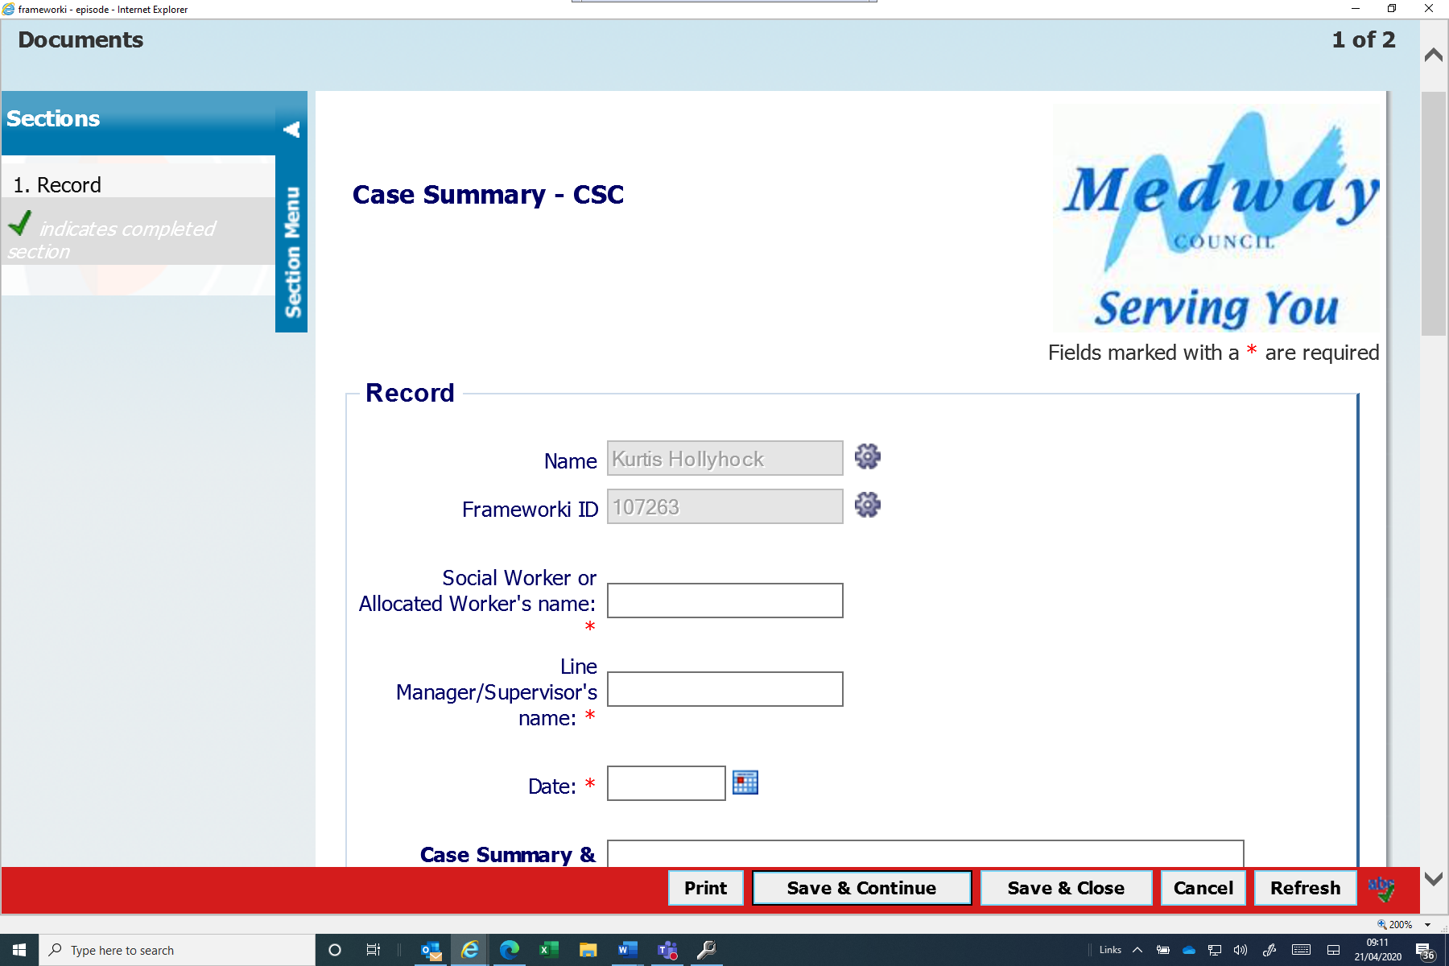
.
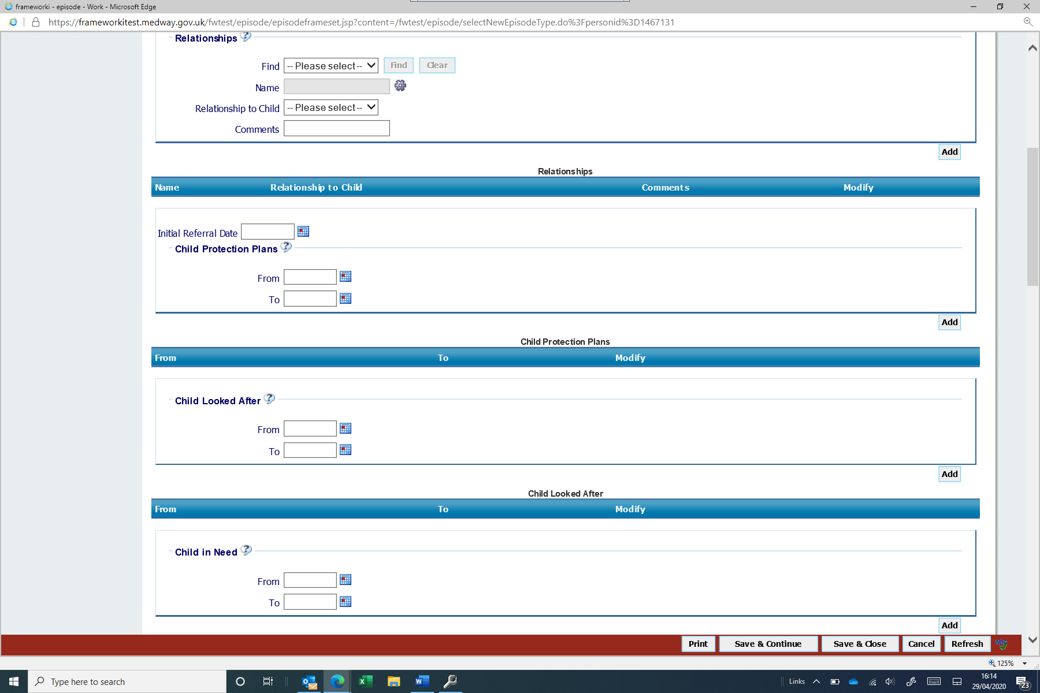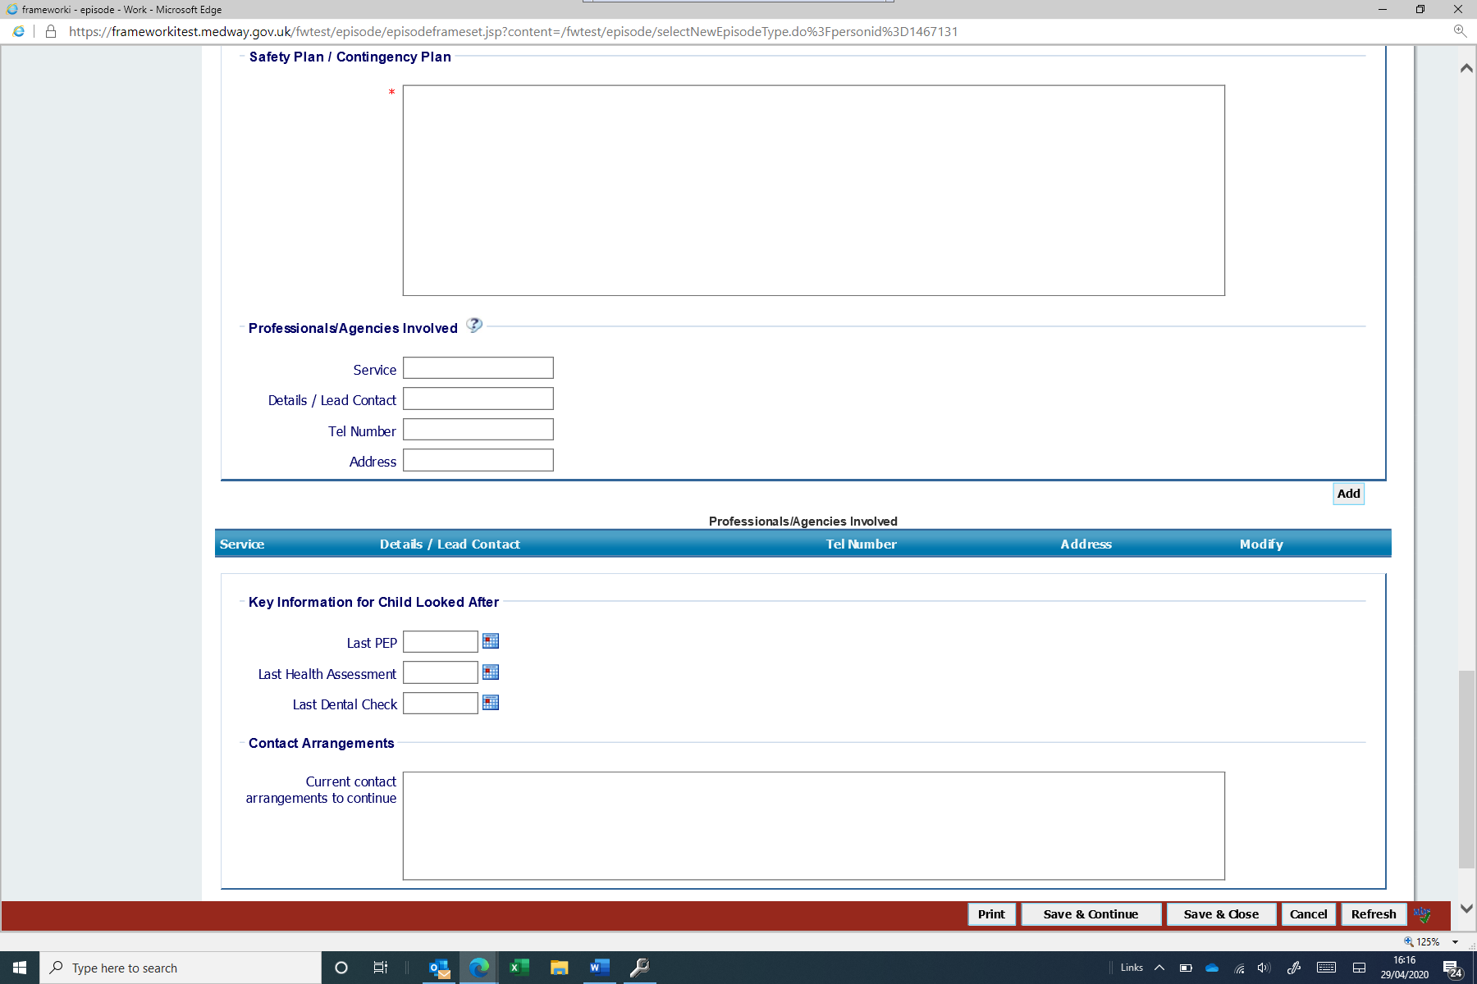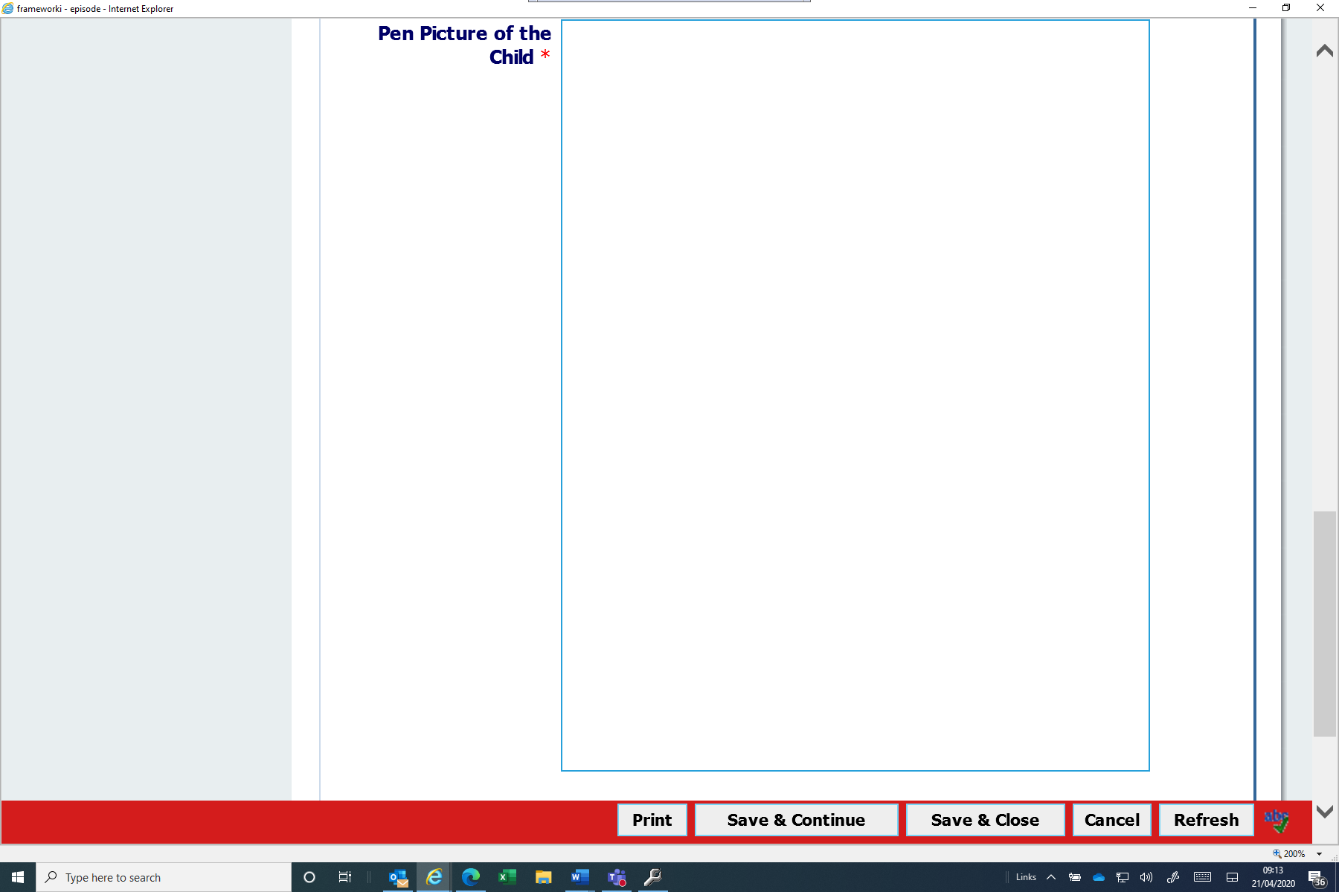

The mandatory fields ‘Social Worker or Allocated Worker’s Name’, ‘Line Manager/Supervisor’s Name’, Date field and all the other date fields WILL NOT prepopulate from any previous Case Summary Episode.
Complete the document, once finished, or if you need to come out of the episode, click Save & Close, if you need to return to it later, and this will go into your uncompleted work folder.
If you have completed the document, click Next to the Outcomes Screen:
There are two options:
- Case Summary to be Reviewed – this will go to your incoming work folder
- No Further Social Work Involvement – this will end the Case Summary workflow

How to Copy Case Summary Episodes to Siblings
As detailed above, you must outcome the Case Summary to ‘Case Summary to be Reviewed’, as the Start Work Copy From option is only available for episodes in your incoming/future work folders.
Once you have completed a Case Summary episode, go to the sibling’s episode in your incoming/future work folder. Right click and select Start Work Copy From:
This will show you which siblings have suitable episodes to copy:

Click on any of the headings to bring up the list of relevant episodes:
When there are more than one options, ensure that you select the correctly dated episode and click on the ID link

This will open the Case Summary episode:
Click on the green cross to open:
Click on Yes within the question prompt. This will open the copied document and you can edit as required. Complete the episode in the normal way with the outcome of Case Summary to be reviewed (unless case is closing).
- The Form
The Short Summary section of the form should include:
- a succinct case history stating the initial referral date,
- brief reasons for involvement with reference to the current risks for children,
- key dates. (i.e. date child became looked after);
- legal status and current case status (i.e. the child is subject to a CP plan);
- for cases in court proceedings, assessments completed, and their outcomes and court dates should be included.
This section should be 12-15 lines long and does not require a detailed description of various events – these will be in the case chronology.
The Pen Picture section of the form should provide the child’s physical description, including any health conditions or disabilities, information about the child’s identity, child’s wishes, observations of the child presentation or personality, communication abilities, likes, dislikes and any difficulties that the child lives with.
The Safety/ Contingency Plan section needs to reflect how we address the current harms or risk of harm to children. Be as specific as possible about any factors which are currently a danger to the child or children and be clear about the different risk for each child in the family (i.e. the risks that apply to older children linked to contextual safeguarding concerns might not be relevant for the baby in the family).
A clear plan of action needs to be recorded if the risk should escalate and if the child is placed at immediate risk of harm i.e. a telephone number for a safe adult where the child could stay (with immediate effect) if it is not safe for them to remain at home.
If a trigger plan has been completed to address risks associated with exploitation and missing episodes, please refer to the plan – there is no need to duplicate the information from that plan into this section.
If the child has a disability and short break provision is offered to them, please include this information in this section.
The Professionals Involved section should include IROs, Children’s Guardians, Advocates, LA solicitors, Health professionals, DSLs etc. If there are different professionals working with different siblings, this section should be completed to reflect the professionals working with each individual child.
Key information to include for children who are looked after are dates for PEP meetings, health assessments, dental and optician checks and other significant health appointments.
The form can be copied across other siblings in the family when completed – but make sure that you update the Pen Picture and the Safety/ Contingency Plan sections to reflect the needs of each individual child in the family.
- Reviews
Case summaries are updated every three months or as and when there is a significant change in the child’s circumstances. It is important that a current and up to date information is maintained for the child to ensure that effective and purposeful interventions are provided.
Case summaries must be updated every time a case transfers between different workers or different parts of the service (i.e. from Assessment teams to Children Social Work Teams).

