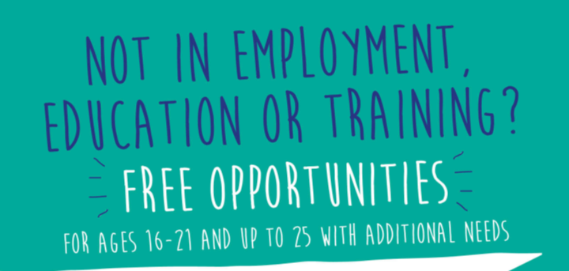
Young people can choose from:

Employability Programming:

Six-week programme
Two hour per session, from 1pm-3pm running from the WREC Room
Young people can sign-up to one or multiple courses.

Mondays - Preparing for work
Tuesdays - Money Management
Wednesdays - Career Planning
Thursdays - Digital Skills

ASDAN Employability Short Course with an Adviser

This consists of a series of activities around employability, including job searching, action planning, health and safety. This can be delivered through weekly one to one sessions with an adviser or a group session depending on individual need.

Professional Workshops:

Boxing, Cooking & Food Hygiene, Coding, Magic and Performance, Music, Photography, and more.
Please register your interest for our next professional workshop.

Special Incentives:

Specialty programming with additional incentives for accreditations, leading them to employment.
Construction Skills Certificate Scheme (CSCS) Revision Course, where young people following completion of their course and test will receive a CSCS card.
Sign-up today and start your course.

Employment Support:

Young people will receive one-to-one and/or group support
- Careers Guidance,
- CV Workshop,
- Online applications Workshops
- Options Workshops

Careers Guidance Support

Every young person will receive a Careers Guidance Interview, to help them identify what their future goals are.
Be Yourself aims to build confidence and resilience to give young people the skills to progress and achieve in their own future choices.

Get Started
For further information please visit:
https://www.medway.gov.uk/info/200215/youth/318/youth_programmes_and_activities_in_medway/8
To download our poster please click here.
For our referral form, please click here.

