Leicester City Council Education and Children’s Services
Reflective Supervision Tool (2017)
The recently updated Leicester City Council Education and Children’s Services Supervision Policy highlights the importance of reflective supervision to achieving good outcomes for children and young people.
Reflective supervision is the activity within the supervision session where the supervisor asks the supervisee to reflect on certain situations that may require a deeper understanding. Reflective supervision allows staff to take a step back from the work and examine it differently, and supports staff and supervisors in building skills that are important to their individual work.
Reflective practice is a key part of effective work with children and young people and the opportunity for reflection is important in the supervision cycle.
- Experiencing: Engaging and observing - the story - what happened?
- Reflecting: Investigating experience - what was it like?
- Analysing: Seeking to understand, hypothesising, and asking why.
- Action Planning: Preparing for action, trying things out - what next?

In all our work with children, young people and families the emphasis must be to build an understanding and collaborative partnership with the children at the centre of the work. A number of research studies emphasise the relationship between worker and client as key in supporting change. It is hard to build relationships without an understanding of the needs, strengths and aspirations of those involved and without an understanding of the parameters and expectations of that relationship.
There are a range of tools available for reflective supervision. We have however developed our bespoke tool to Leicester ‘Reflective Supervision Triad’ to ensure that we can focus on relationships and understanding of a child’s experience. This supervision tool draws upon Robinson’s ‘Triad of Understanding’ developed by Dr Jackie Robinson from De Montfort University and the Aspergers Consultation Group.
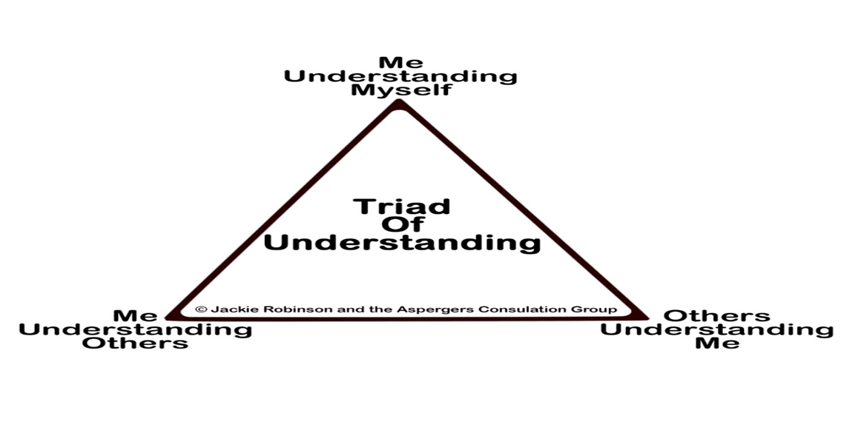
The City Council has worked in partnership with Dr Robinson to further develop the Triad to apply it to work with children, young people and families. We have developed a strengths based model with a focus on the experience of the child. It is aimed at supporting a common understanding of the risks and needs for a child. The tool allows the exploration of the impact of relationships/systems and expectations. Workers are enabled to develop a hypotheses or alternative explanation.
It is based on the premise that if we understand ourselves and the people around us then we are better able to communicate our needs building collaborative understanding and achieve positive outcomes.
In addition to reflective case supervision it can be used in a number of different ways including:

- Directly with a child or young person or family
- A case where there is inertia and a lack of clarity of the direction needed
- Where there is professional conflict or differences of opinion.
- Assessment session
- Potential placement breakdown.

The tool is being updated to be more child friendly with support from the Youth Service and the young advisors.

How to use the Reflective Supervision Triad
The tool starts with an in depth look at the child’s life from their perspective (Me understanding myself), gathers information from significant others (agencies and family / placement members) (Others understanding me) and clarifies the role of the worker involved for the worker, child, family and other agencies (Me understanding others). This aims to build understanding of the child’s day to day experiences, concerns and aspirations, and build relationships and understanding between all involved. Once this information is gathered, cross referenced, strengths and gaps identified then analysis and planning can take place.
The tool starts with the child at the middle a genogram or ecomap of their family.
It is important to always ask ‘so what?’ of the evidence / facts in each of the areas; what does this mean for the child / young person / family?
- Me Understanding myself – what is the child’s view of themselves? /their sense of themselves what do they want to achieve?
- Me Understanding others- this is the young person’s views of what others say about them, what would the child say about you? What is the child’s understanding of your role? Why are you different to the other people involved in their lives? (can help clarify the roles of different agencies involved)
- Others Understanding me? - Agencies/significant others (important to consider who would the young person choose as significant) and their understanding of the young person, what is important, what is working well and what they are worried about.

Actions required
All those who work directly with children, young people and families are being asked to use the tool for 1 case per supervision from April 2017 onwards.

Feedback and monitoring
Use of the tool will be supported by briefings at service area events and team meetings. It will be monitored by audit, dip sampling and reported on by Team Managers and Service Managers.

Thank you and please ask if you need clarification or support.
Kate Wells,
Principal Child and Family Social Worker
Kate.wells@leicester.gov.uk
April 2017

