Recording Covid-19 as a Health Condition and a Hazard in LCS and EHM

System users are now able to record Covid-19 as illustrated here, this needs to be completed on any child or adult who has been identified, including any carers.

Recording the Health Condition

From the Health Tab on the person’s main demographic record they can record Health Conditions.

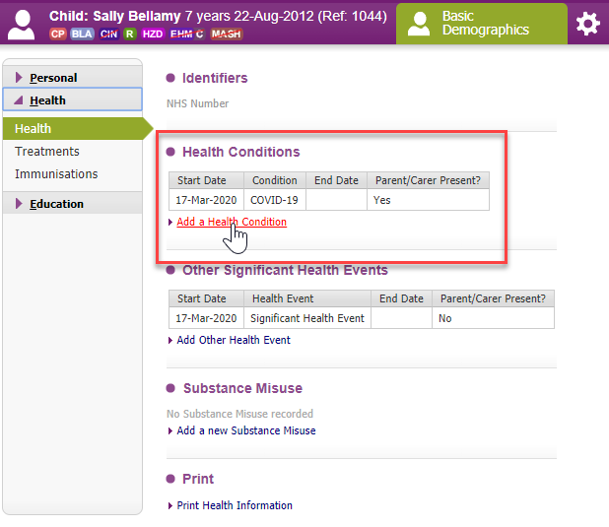

Select Covid-19 from the picklist and they can record if the person has a parent or carer present for support with this condition. When finished click ‘create’.

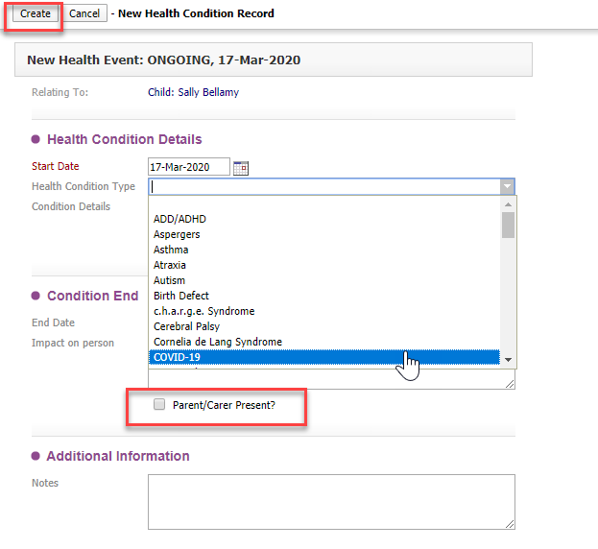

Once complete this is what it will look like on the Health Tab.

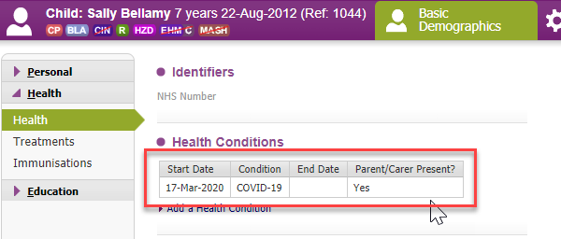

Recording the Hazard

On the person’s demographic record, go to the Risks Tab and click on the ‘Add a Hazard’ link as shown here:

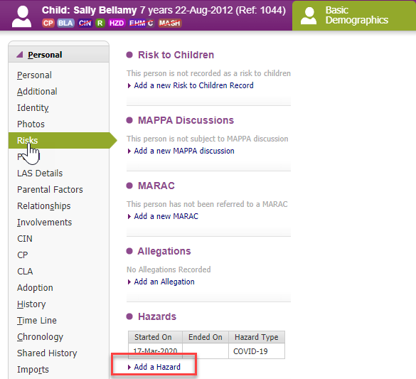

Make sure a start date is recorded and agree what an appropriate review date should be for all Covid-19 cases. When finished click ‘create’.

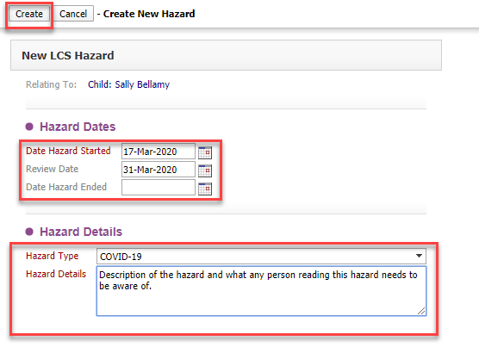

Atom View

Once the hazards are created the user can view these when reviewing the family in Atom as shown below. They can see the ‘HZD’ flag and at a glance they can see who else in the family has this flag and drill into the flag below the person’s name to look at the detail about the hazard.

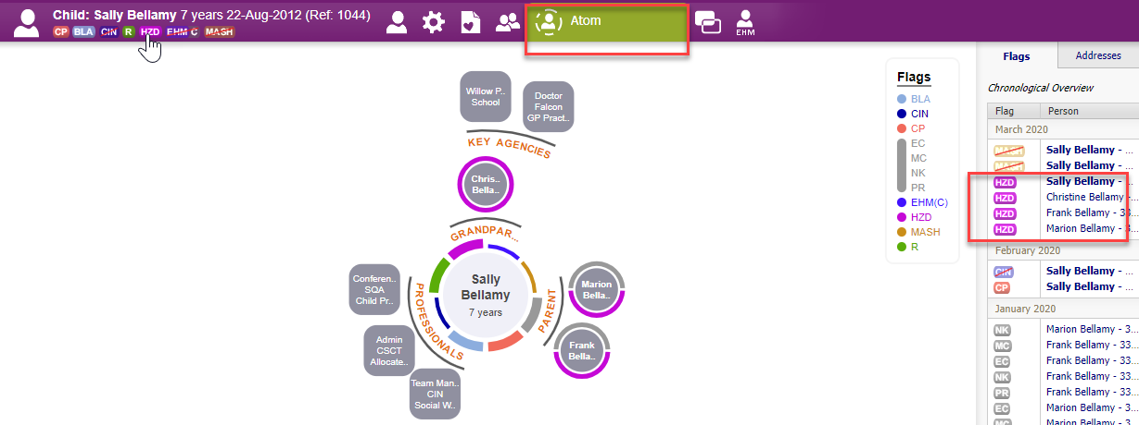

Ending Covid-19 status

When users are informed that a child or adult is no longer suffering from Covid-19, they should return to the health condition and hazard areas and update them to include an end date.

Reports for managers:

If a user has access to the reporting area, they will find the link on the main menu bar as shown here.

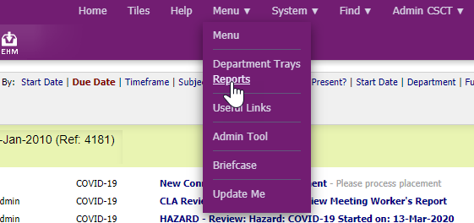

From the available reports, select Risks and follow the screenshots as shown here.
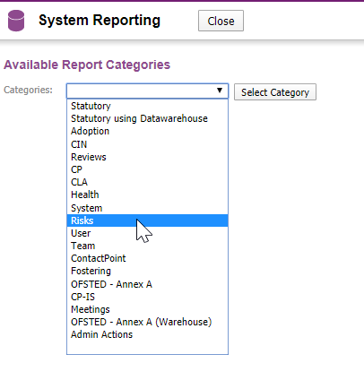

Select LCS Hazards as the focus of the report.

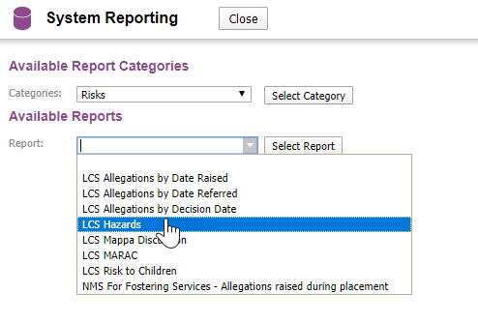

Now select the reporting date parameters (please keep this to a minimum date range) and select ‘run report’.

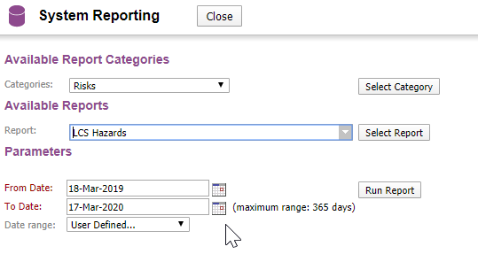

Users will now see a list of all the children and adults recorded with hazards within the database, this means if system admin have followed the same process in EHM this will display a full list across both applications.

From here users can drill into the person record by clicking on the name which is a hyperlink. They can click on the column headings to filter the list, for example by Hazard Type

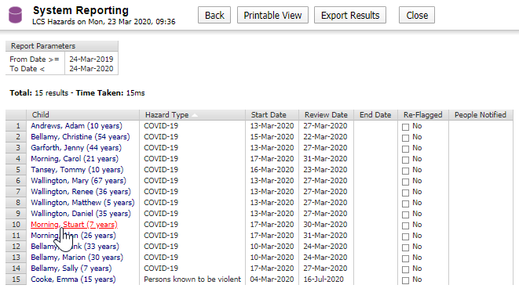

Please note running this report regularly and at peak system usage time, may have adverse effects on system performance particularly given most users are accessing LCC networks remotely currently.

