Creating a CPR
Ideally the decision should be made within the CLA review and the IRO should select that an adoption plan is required. When this does not happen and you need to start the process manually, follow the guidance below
- Within the CLA tab, click on decisions and then click on 'start' next to 'start adoption'. DO NOT SELECT START NEXT TO CREATE CHILD PERMANENCE REPORT

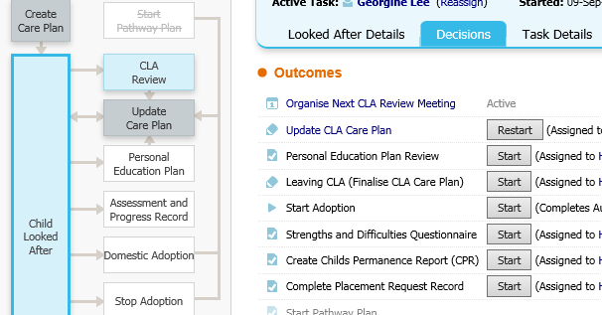

- Then enter the date the decision was made to twin track/complete CPR and select confirm
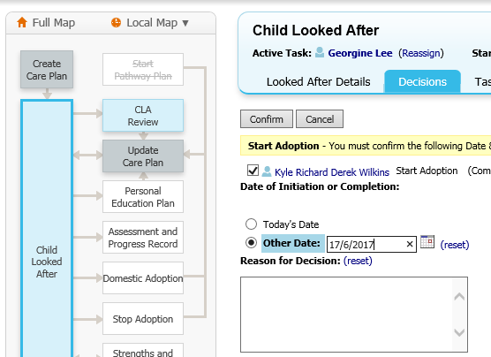

- Click on the blue domestic adoption file down the left hand side of the page
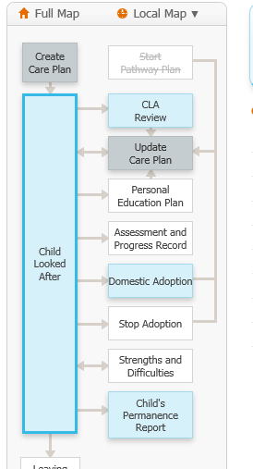

- Then click on 'create CPR'
