User guide for Panel administrators
Your generic panel mailbox will received emails advising that a referral has been received and ready to schedule –
When you follow the link, you will be taken to the referral in the Firmstep system –
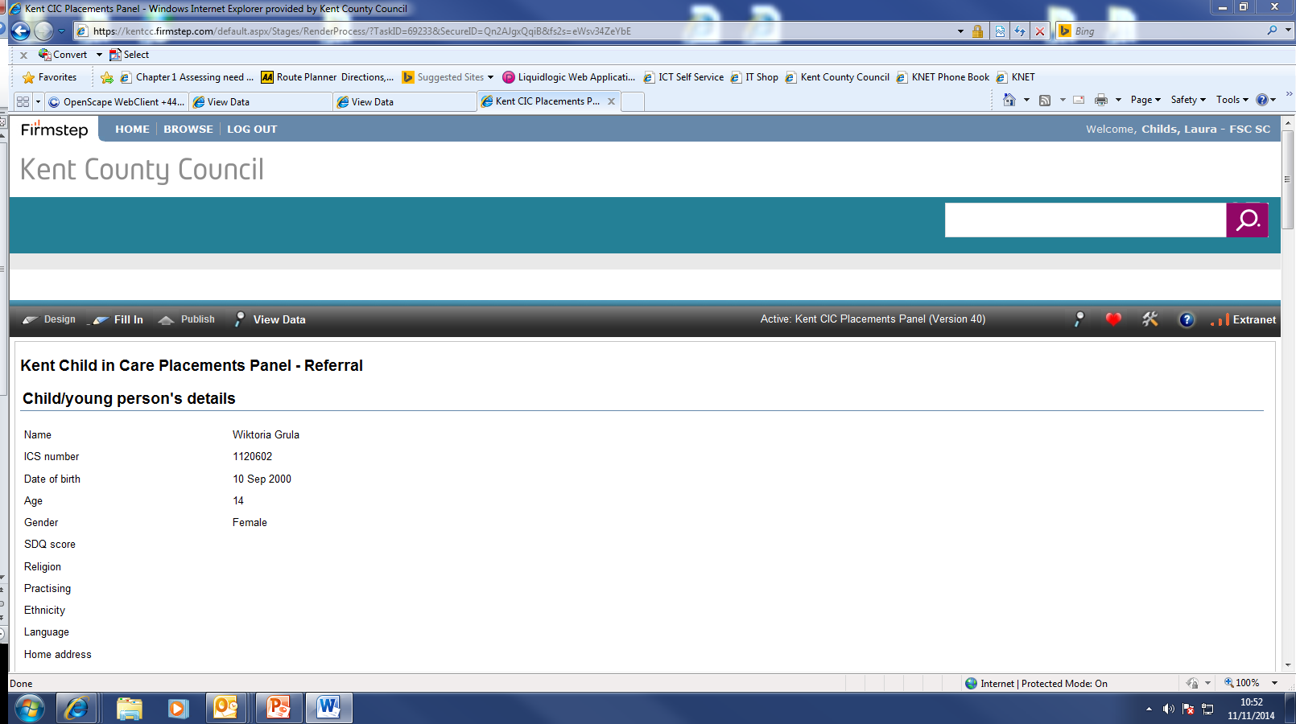

When you have all the referrals for that panel and you have arranged times for them all, the date and time slot can be entered into this form at the bottom, along with the location of where that panel will be held (this isn’t on screenshot below) –
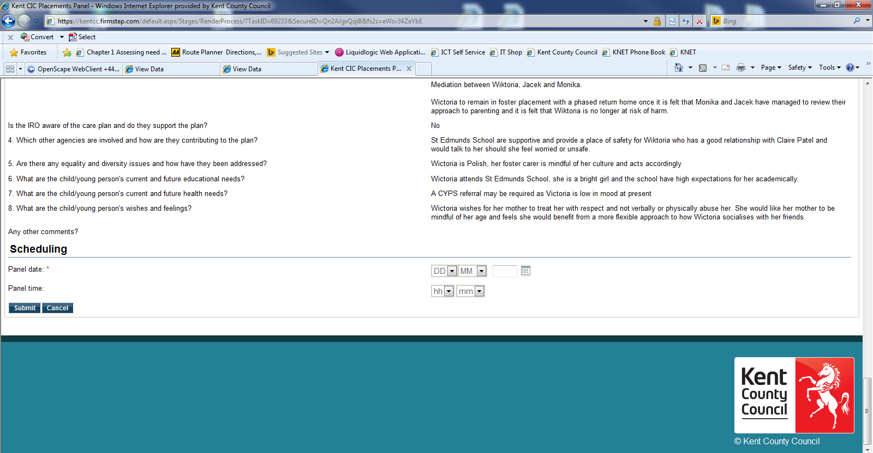

When you submit this, the system will generate an email to the SW who submitted the form advising them of their date / time slot and location of panel. A PDF of the referral will be attached to this email for SW to save.
The system then sends the generic mailbox a PDF of the referral and also an email with the link for submitting the decision after panel has taken place –

When panel have made the decision, the administrator can enter the decision on the form following this link –
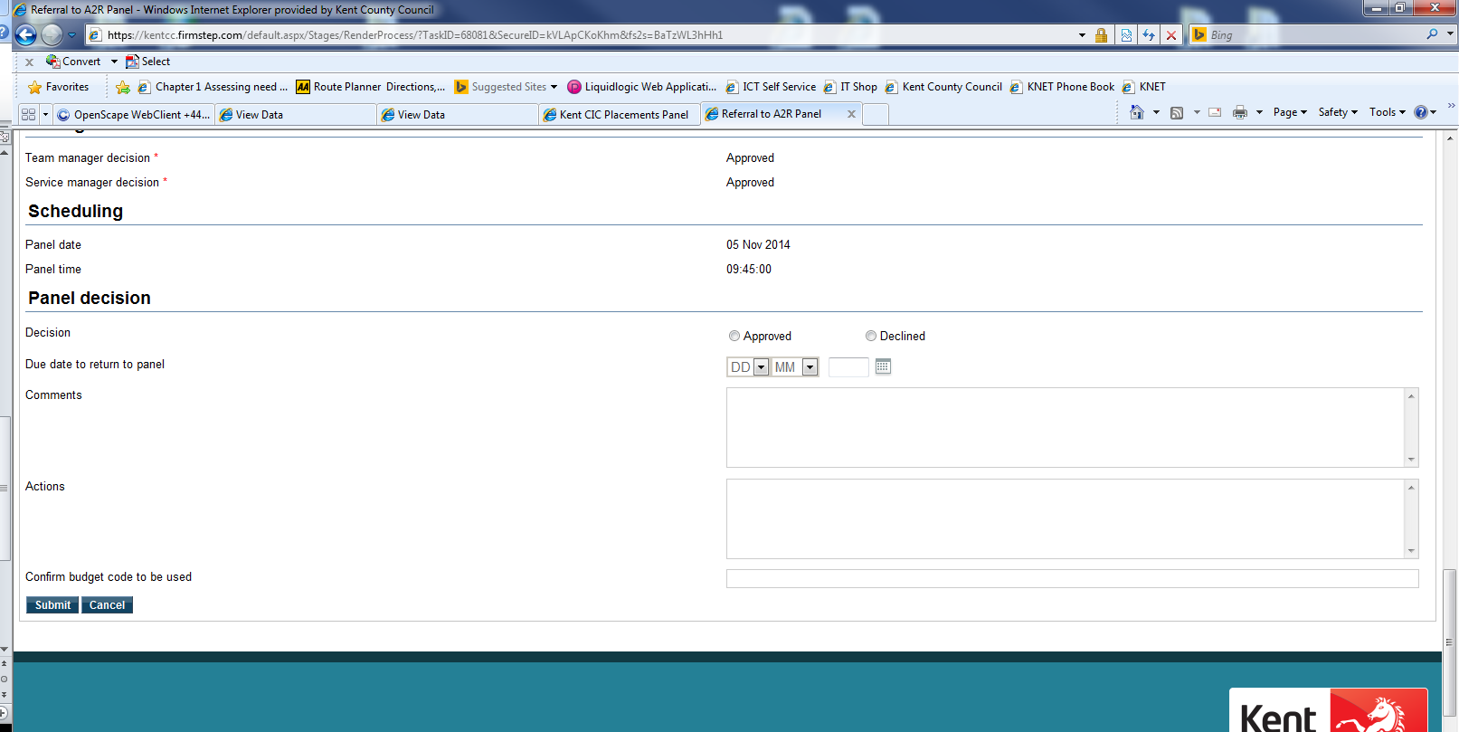
The system then sends the decision on an email to the SW.

Panel administrator also needs to copy the decision onto Liberi *

*if this is the arrangement in your area.

The firmstep system can also be used in the following ways.
The screen you see when you first follow the link is like this:
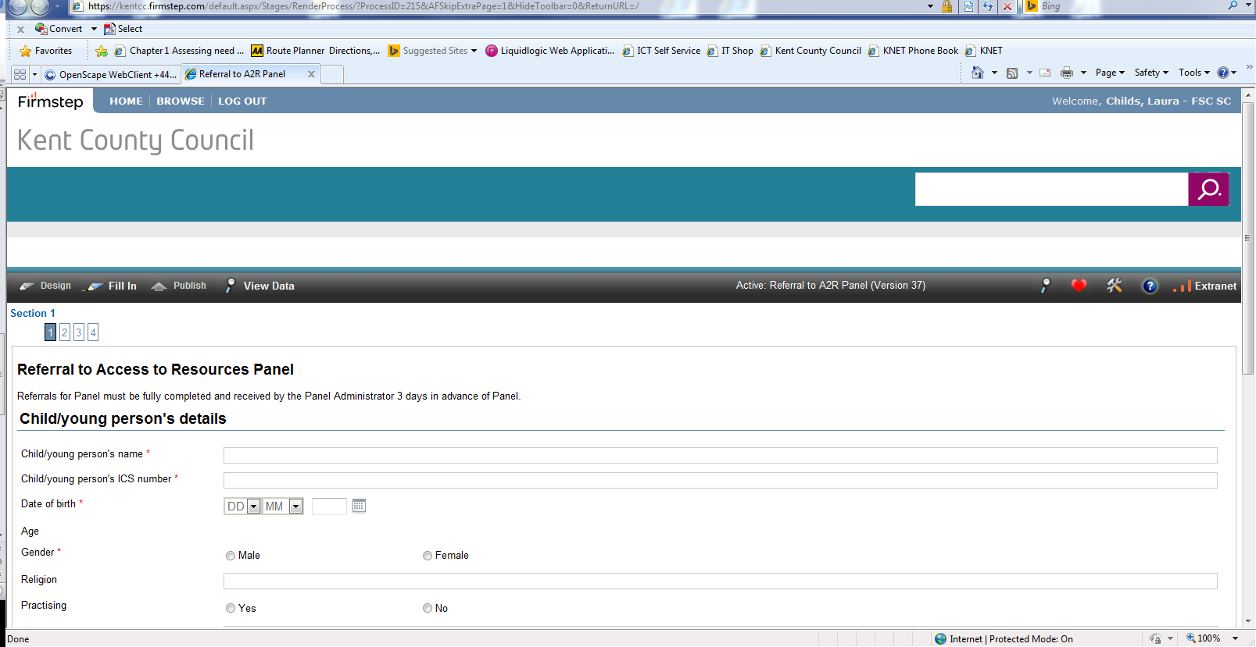
This is the form that SW will complete to submit a referral.
To access all the forms as the administrator, you need to click on ‘View Data’ at the top. Which will take you to this screen:
Then click on ‘Set’, which will take you to a list –
This page shows all the referrals (in pages of 10 at a time) which have been started on your areas system.
From the left :
The date the form was started – The SW submitting the form, Reference number and then a delete button.
If a referral has been through all stages – decision has been submitted, there will also be a date in the ‘Date completed’ column.

If you click on one of the dates to the left, it initiates a box at the bottom, which shows each stage that has completed for that referral –

You can then click on ‘View all data’ at the bottom, which takes you to the referral.
To extract an excel spreadsheet for viewing all the data, click on ‘CSV’ (Small blue button next to set) and another box will pop up -
Select the option to ‘view (Main)’ – this will open an excel spreadsheet, which you can filter, hide columns etc.

Tips –
- If an ‘out of office’ email is received into the generic mailbox, this will be from a TM or SM, therefore, it may need the link re-sending to alternative person for approval. This can be arranged with Kristie Lawton in Communications Team.
- Kristie can also override a TM or SM approval if required (with TM or SM approval to do so).
- A ref number is created whenever someone goes into the system. Therefore there will be a record of a referral when it saved and again when they have finished and submitted the form. It is worth deleting them when you know they are blank / incomplete and you have received the most recent (hope this makes sense!)

CONTACT :
Laura Childs 03000 410 527 for general queries
Kristie Lawton (Communications Team) for technical issues – 01622 694043 – Kristie is able to log into a pc and view your screen with you (same as ICT) which is often helpful.

