- Every effort should be made to resolve issues informally. Where this is not possible, in order to discharge their responsibilities in relation to the child, the IRO following discussions with their line manager, should initiative the formal Practice Alert process.

- In some cases, it may be appropriate to begin the process at a different stage for example, if the social worker or the team manager do not have the authority/ remit to implement the decision, the process should start with the manager with the appropriate authority/responsibility.

- Practice Alerts may be raised in the review meeting or outside of the review i.e. following an IRO mid- way review.

- If the matter is not responded to within 10 working days (can be sooner depending the circumstance), the IRO should consider taking formal action and progress to stage 1 of the IRO practice Alert process. See Liberi guidance.

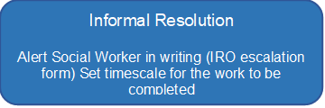
Not resolved
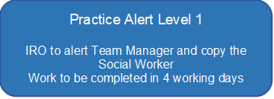

Not resolved

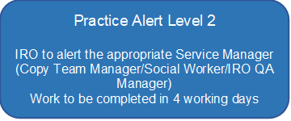
Not resolved
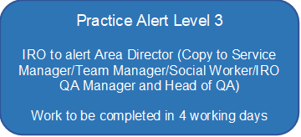
Not resolved
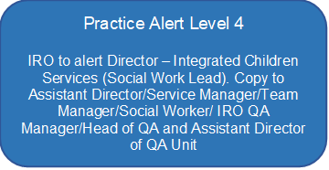
Not resolved
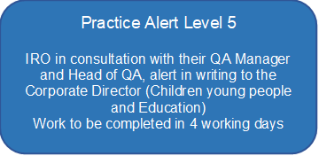
Not resolved
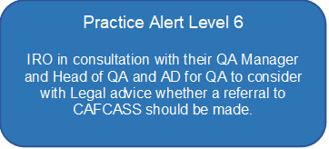
Not resolved

- The timescales at each stage of the Practice Alert process is guidance. In exceptional cases, where it would be beneficial to a successful resolution, IRO’s in agreement with their line manager can call a ‘time out’ from the formal alert process. This might involve waiting until a required person becomes involved to undertake work or the child and/or the family need time to make a decision. The key issue is applying the Practice Alert process to make this as effective as possible in resolving an issue that is getting in the way of the child’s needs being met and their care plan progressed in a timely manner.

- Where concerns relate to external agencies concerns should be raised by letter.

