C:\Documents and Settings\bwoodward\Local Settings\Temporary Internet Files\Content.IE5\A31JTJAY\MC900440203[1].wmf

[](http://www.google.co.uk/url?sa=i&rct=j&q=&esrc=s&frm=1&source=images&cd=&docid=Jui3oIy7g6SfVM&tbnid=7a7cqw-SYf5eaM:&ved=0CAUQjRw&url=http://www.northgatearinso-reward.co.uk/case_study/13_gloucestershire_county_council&ei=hpBzUvLlEOfA0QWqr4HQDQ&bvm=bv.55819444,d.d2k&psig=AFQjCNHT6JT9XRBcuxUTB1xnhtePCYuJaQ&ust=1383391741327478)

My Journey

­­

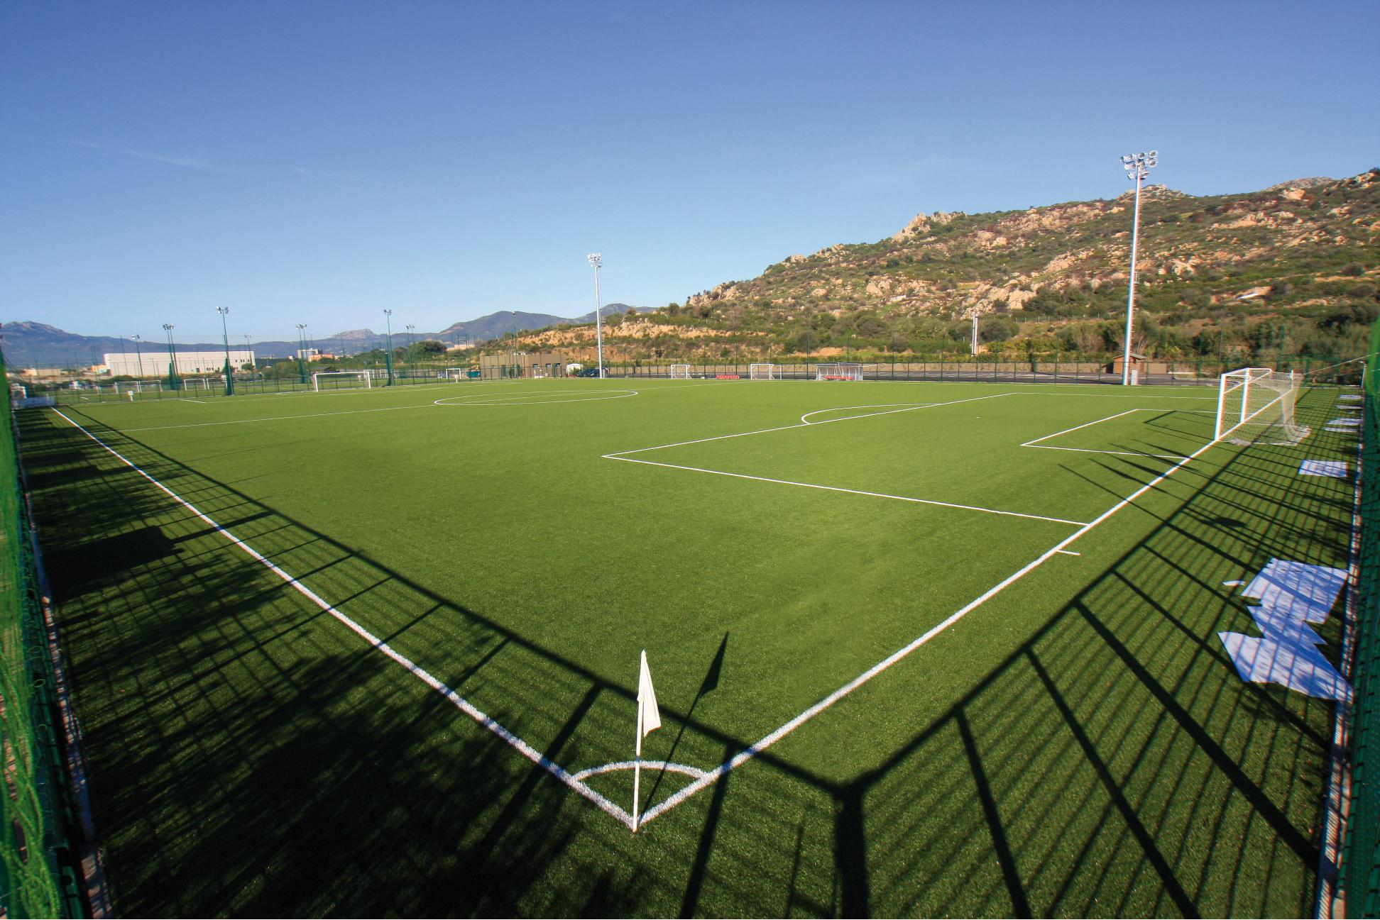

My one page profile

Things that are important to me?

What do people like about me?

What I like about my life.

If I had one wish, it would be:

What makes me sad or worried?

C:\Documents and Settings\bwoodward\Local Settings\Temporary Internet Files\Content.IE5\ZADD51CW\MC900440167[1].wmf

People helping me

C:\Documents and Settings\bwoodward\Local Settings\Temporary Internet Files\Content.IE5\C0EAL8O3\MC900440201[1].wmf

Who is going to help and when?

How is it going to happen?

What needs to change?

My Journey

People that are important to me

C:\Documents and Settings\bwoodward\Local Settings\Temporary Internet Files\Content.IE5\B8OZU2BL\MC900440215[1].wmf

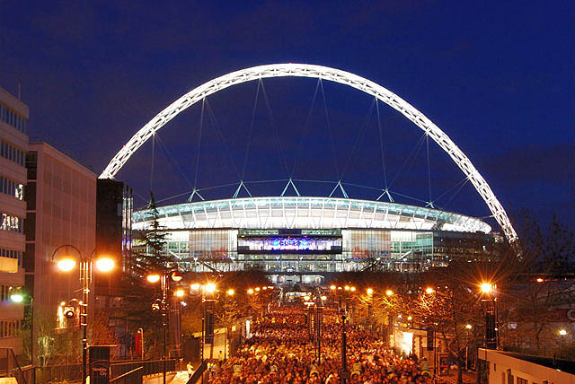



MY road – what has changed?

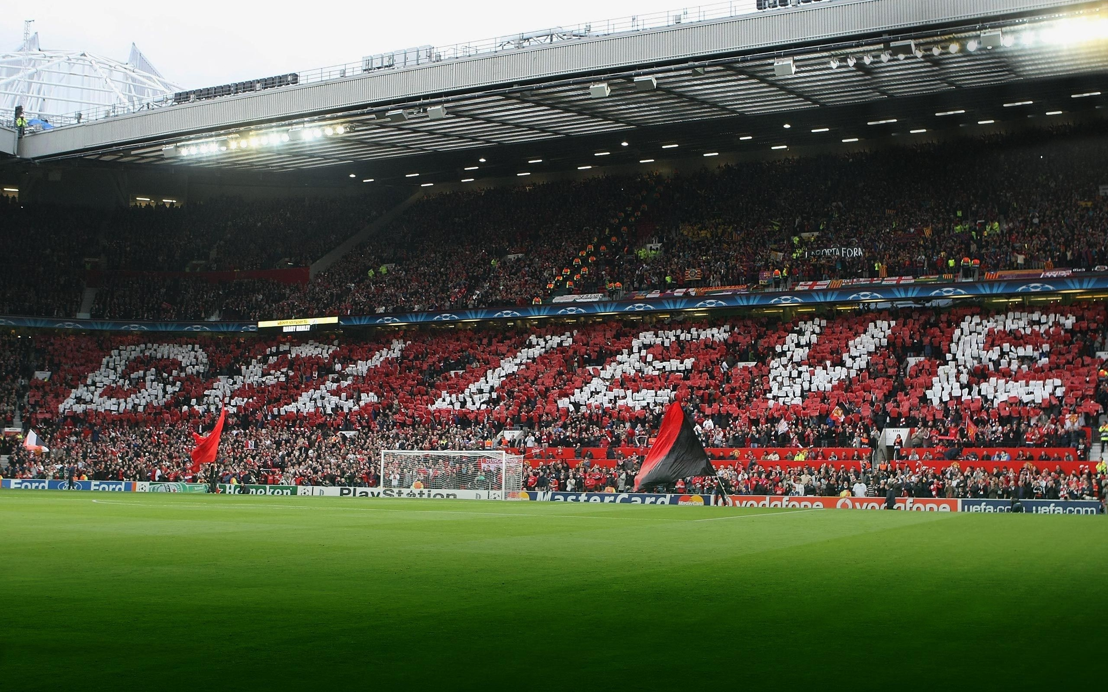





What didn’t help?

What helped?



