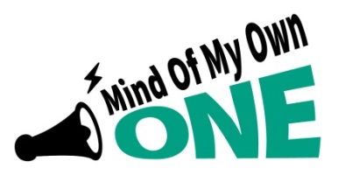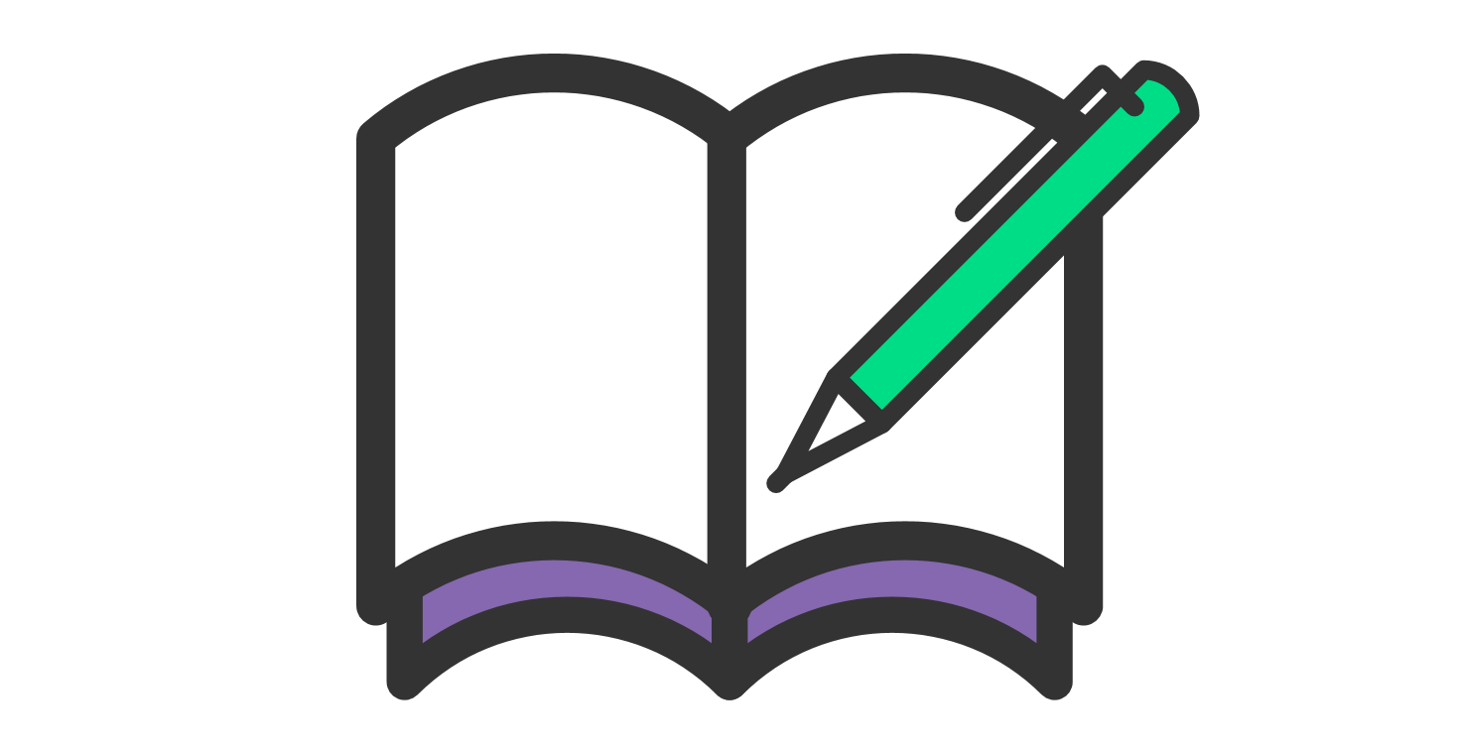
‘My Education’ for Personal Education Plan (PEP) Meetings
Information for Social Workers supporting a child or young person in care
The Mind of My Own One App has a new scenario called ‘My Education’
It can be used for Personal Education Plan (PEP) meetings or for a child/ young person to tell their worker about various areas of their education.
Please can you support children and young people to use this and send to Virtual School be
for their PEP meeting

A Message from Em, Ambassador
“Children and young people should use the Mind of My Own One App as it’s vital for their education so that their views, wishes and can be heard. It’s important because PEP meetings can be overwhelming with so many professionals being there. Mind of My Own gives the child / young person the opportunity to say what’s going on for them. Without Mind of My Own you may never get their views. USE, USE,USE the One App! “

What you need to do
- Get them signed up with the One App or ask Foster Carers to get them to sign up
Watch this to find out more - https://vimeo.com/400294861
- Ask them to complete ‘ My Education’ on the One App
- Ask them to send it to ‘Virtual School Teacher’ or ‘Education Adviser’ (options given)

Do you support a child with disabilities or a child where English isn’t their first language?
‘Recite me’ is available on the One App for children / young people to use it in their own language (there are over 100 different languages available) and this translates into English. It also makes the One App more accessible for those with disabilities, including sight loss and dyslexia. For more information click on the link
Watch this to find out more - https://vimeo.com/400240488
https://mindofmyown.org.uk/recite-me/

For more information contact the Participation Team – cypvoice@gloucestershire.gov.uk

