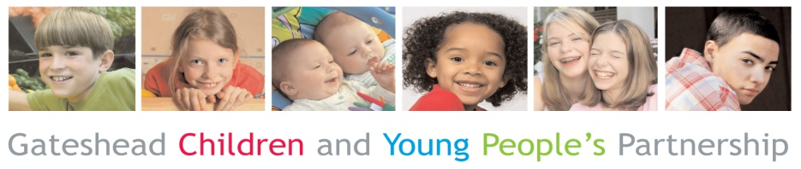
Gateshead CAF Support Plan
Gateshead Children’s Trust

Date of Review

Details of Children with in the family
 | Child 1 |  | Child 2 |  | Child 3 |  | Child 4 |  | Child 5 |  | Child 6 |  | Child 7 |  | Child 8
First Name
Surname
Date of Birth
Sex | M☐ | F☐ | M☐ | F☐ | M☐ | F☐ | M☐ | F☐ | M☐ | F☐ | M☐ | F☐ | M☐ | F☐ | M☐ | F☐
Ethnicity
Religion
1st Language
Disability
P Number Office use only

Address

Postcode
Telephone Number

Details of Parents / Carers

 | Parent / Carer |  |  | Parent / Carer |  |  | Parent / Carer |  |  | Parent / Carer
First Name
Surname
Date of birth
Relationship
Do they have Parental Responsibility | Y ☐ | N ☐ |  | Y☐ | N☐ |  | Y ☐ | N ☐ |  | Y ☐ | N ☐
Address if different from above
Religion
1st Language
Disability
P Number
Office use only

Details of Lead Practitioner

Name of person (LP) | Role | Organisation | Address | Telephone Number | Email | Present at review

Team Around the Family

Name | Role | Organisation | Address | Telephone Number | Email | Present at review

Review Progress and add any additional assessment information (include voice of the child)

For the first TAF refer to the “Analysis, Conclusion & Next steps section” from the CAF assessment.
For subsequent TAF’s refer to the last CAF Support Plan
Action | Why are we doing this? | Who will do this? | By When | Which longer term outcome is this contributing to:  (Please choose from the drop down box or refer to guidance overleaf if handwritten) |  |  | Progress  Newly Identified =0  None =1  Limited =2  Some =3  Significant =4  Resolved =5
 |  |  |  | Childs Development Needs | Parenting | Family  and environmental
 |  |  |  | Choose an item | Choose an item | Choose an item | Choose an item.
Review Progress & Goals

 |  |  |  | Choose an item | Choose an item | Choose an item | Choose an item.
Review Progress & Goals

 |  |  |  | Choose an item | Choose an item | Choose an item | Choose an item.
Review Progress & Goals

 |  |  |  | Choose an item | Choose an item | Choose an item | Choose an item.
Review Progress & Goals

 |  |  |  | Choose an item | Choose an item | Choose an item | Choose an item.
Review Progress & Goals

Action | Why are we doing this? | Who will do this? | By When | Which longer term outcome is this contributing to:  (Please choose from the drop down box or refer to guidance overleaf if handwritten) |  |  | Progress  Newly Identified =0  None =1  Limited =2  Some =3  Significant =4  Resolved =5
 |  |  |  | Childs Development Needs | Parenting | Family  and environmental
 |  |  |  | Choose an item | Choose an item | Choose an item | Choose an item.
Review Progress & Goals

 |  |  |  | Choose an item | Choose an item | Choose an item | Choose an item.
Review Progress & Goals

 |  |  |  | Choose an item | Choose an item | Choose an item | Choose an item.
Review Progress & Goals

 |  |  |  | Choose an item | Choose an item | Choose an item | Choose an item.
Review Progress & Goals

 |  |  |  | Choose an item | Choose an item | Choose an item | Choose an item.
Review Progress & Goals

Can the CAF be closed?

Yes ☐ | No ☐
Reason for Closure  (Please choose from the drop down box or refer to guidance overleaf if handwritten) | Date of Next Review
All Needs Met | Time of Next Review
Any other comments | Location for Next Review

Child or young person’s comment on the review and actions identified

Parent or carer’s comment on the review and actions identified
I understand the information that is recorded on this form and that it will be stored and shared for the purpose of providing services to
☐ Me
☐ Infants, children or young people named in this assessment for whom I am a parent or carer

I agree to the sharing of information, as agreed in order to provide appropriate services |  | ☐ Yes ☐ No
If ‘No’, please give details of the people / services you do not want this information shared with, then sign below.
Young Person | Date | Signed Copy on File ☐  Please tick to confirm you have a signed copy on file if sending electrically
Parent / Carer | Date
Parent / Carer | Date
Lead Practitioner | Date
Copy to Child, Young Person or Family, copy to practitioner and copy (for secure storage) to: CAF Team, Early Help Hub, Gateshead Council,
Civic Centre, Regent Street, Gateshead, Tyne and Wear, NE8 1HH
Tel - (0191) 433 2764 Fax - (0191) 490 1168
E-mail – CAF@gateshead.gov.uk or CAF@gateshead.gcsx.gov.uk

Please use relevant letter to indicate “longer term outcome” in support plan overleaf

Childs Development needs | Parenting | Family and environmental
A – Improved development (young children) | L – Improved parenting ability | T – Improved Social engagement
B – Improved child /young person’s physical health | M – Reduction in safeguarding issues | U – Improved home conditions
C – Improved child/young person’s mental health | N – Improved adult physical health | V – Housing
D – Improved family relationships | O – Improved adult mental health | W – Reduction in debt
E – Improved behaviour | P – Reduction in adult substance misuse (drugs / alcohol) | X – Reduction in adult anti social behaviour / crime
F – Improved attendance at school or training | Q – Reduction in domestic abuse
G – Improved educational attainment | R – Reduction in the need for high cost services
H – Reduction in anti social behaviour /youth crime | S – Employment
I – Improved sexual health incl Teenage Pregnancy
J – Reduction in caring responsibilities (young carer)
K – Reduction in child / young person’s substance misuse (drugs / alcohol)

Reason for Closure

- All Needs Met
- Family Declined following TAF Intervention
- Moved Out of Area – Closed
- Moved Out of Area – Transferred to new LA
- Transferred to Statutory Social Worker
- Transferred to Disabled Children’s Team
- Transferred to Education Health Care Plan (EHCP met need)
- Transferred to YOT Statutory – Single service

