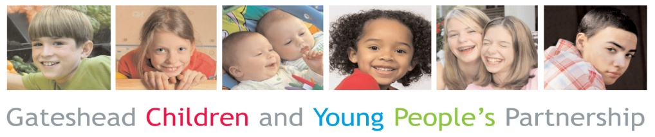
Gateshead CAF Form
Gateshead Children’s Trust
Common Assessment Framework (CAF) for children and young people and their families

Date of Assessment

Details of Children with in the family
 | Child 1 |  | Child 2 |  | Child 3 |  | Child 4 |  | Child 5 |  | Child 6 |  | Child 7 |  | Child 8
First Name
Surname
Date of Birth
Sex | M☐ | F☐ | M☐ | F☐ | M☐ | F☐ | M☐ | F☐ | M☐ | F☐ | M☐ | F☐ | M☐ | F☐ | M☐ | F☐
Ethnicity
Religion
1st Language
Disability
P Number Office use only

Address

Postcode
Telephone Number

Details of Parents / Carers

 | Parent / Carer |  |  | Parent / Carer |  |  | Parent / Carer |  |  | Parent / Carer
First Name
Surname
Date of birth
Relationship
Do they have Parental Responsibility | Y ☐ | N ☐ |  | Y☐ | N☐ |  | Y ☐ | N ☐ |  | Y ☐ | N ☐
Address if different from above
Religion
1st Language
Disability
P Number
Office use only
Current family & home situation
(e.g. family structure and who the child lives with and doesn’t live with, including siblings, other significant adults etc.)

Details of person undertaking assessment

Name of person (LP) | Role | Organisation | Address | Telephone Number | Email

Other professionals involved with the family

 | Name | Role | Organisation | Address | Telephone Number | Email
Educational Provision
Educational Provision
Educational Provision
GP

Why is this assessment needed
(Presenting issues)

Assessment Guidance
The CAF assessment features analysis supported by the 4 domains of the assessment framework
- Child Developmental Needs
- Parenting Capacity
- Family and Environment
- Risk analysis and Evaluation

Guidance
The CAF assessment should identify the support needs of the family and determine which services need to be involved in and contribute to the Team Around the Family Support Plan.

Assessment of Child’s Development Needs

- Health
- Education (including their understanding, reasoning and problem solving, their participation in education or training / employment, their aspirations and their progress / achievement in learning)
- Emotional & behavioural development
- Identity (including self esteem & self image)
- Family and social relationships
- Social presentation
- Their self care abilities and skills

Needs, issues, concerns

Strengths

Assessment of Parenting Capacity

- Ability to provide basic care
- Ability to ensure the child is safe
- Ability to give and demonstrate emotional warmth
- Ability to provide appropriate stimulation
- Ability to provide appropriate guidance and boundaries
- Ability to provide stability and security

Needs, issues, concerns

Strengths

Assessment of Family and Environmental Factors

- Who’s who and significant in or to the family
- The community and community resources
- The family’s social integration in the community
- The family’s income, employment and housing
- The extended family network
- The family’s history and how they function as a family

Needs, issues, concerns

Strengths

The Assessment of Risk

With reference to the 3 previous domains this section should outline the probable impact on the child/ren, now and in the future, if their identified needs are not addressed.

What is going wrong?  What are the dangers? | What is the potential impact on the child/ren?  What will happen if nothing changes?

Conclusions and Analysis

This should be a clear summary of the key issues and pressing needs as currently identified, written in simple jargon free language.

This section should also outline what the family and child/ren would like to change. What are the family goals?

Next Steps
Action |  | Who will be doing this? |  | By when?

Have you arranged a Team Around the Family (TAF) meeting?
(1st TAF meeting should be arranged within 20 working days of this assessment)

Yes ☐ | Date | Time | Location
No ☐ | Reason
Child or Young Person’s view of the assessment and identified goals
Does this capture your views and give a way forward?

Parent or Carer’s view of the assessment and identified goals
Does this capture your views and give a way forward?

Consent for information storage and information sharing

I understand the information that is recorded on this form and that it will be stored and shared for the purpose of providing services to

☐ | Me | ☐ | Or Infants, children or young people named in this assessment for whom I am a parent or carer

I agree to the sharing of information, as agreed in order to provide appropriate services | Yes ☐ | NO ☐
If ‘No’, please give details of the people / services you do not want this information shared with.

Please sign below
Young Person |  |  |  |  |  |  |  |  |  |  | Name |  |  |  |  |  |  | Date
Parent / Carer |  |  |  |  |  |  |  |  |  |  | Name |  |  |  |  |  |  | Date
Parent / Carer |  |  |  |  |  |  |  |  |  |  | Name |  |  |  |  |  |  | Date
Lead Practitioner |  |  |  |  |  |  |  |  |  |  | Name |  |  |  |  |  |  | Date
Signed Copy on file ☐ |  |  |  |  |  |  |  | Please tick to confirm there is a signed copy on file if sending electronically
Copy to Child, Young Person or Family, copy to practitioner and copy (for secure storage) to:
CAF Team, Early Help Hub, Gateshead Council, Civic Centre, Regent Street, Gateshead,
Tyne and Wear, NE8 1HH

Tel - (0191) 433 2764 Fax - (0191) 490 1168
E-mail - CAF@gateshead.gov.uk
Secure E-mail - CAF@gateshead.gcsx.gov.uk

