TITLE: | PLAGIARISM

1 | Purpose
 | There are three main forms of plagiarism and students (staff and foster carers studying for qualifications) are required to avoid them (or any other form of cheating).
2 | Scope
 | All staff and foster carers undergoing training.
3 | References
- Presenting as one’s own work that which has been written by someone else.
It is an ‘academic’ offence for a student/foster carer to use another persons’ work and to submit it with the intent that it should be taken as his or her own.
- Making use of other students’/foster carers ideas without acknowledgement.
Co-operative working is commendable practice and discussion with others is not discouraged but you must develop and present your own ideas and rationales.
- Making use of published material without acknowledgement.
All sources from which material and ideas have been consciously drawn must be referenced. A short quotation should be indicated by quotation marks.
4 | Definitions
 | None
5 | Action
 |  |  |  |  | Person Responsible
 |  | What happens if I am suspected of plagiarism?  Any assessor who believes that any student/foster carer may have breached the plagiarism ‘regulations’ will immediately refer the piece/pieces of work and their concerns to the Independent Verifier. |  |  | Assessor
 |  | If the Independent Verifier is satisfied that plagiarism has occurred a penalty up to the failure of the whole qualification may be imposed.  The issue will be reported to the awarding body (see below). |  |  | IV
 |  | The case will be reported to the Human Resources Department where it will become subject to Families@FamilyCare’s disciplinary procedure. |  |  | HR

Our Quality assurance Requirements
“Awarding bodies require centres to appoint assessors to carry out assessments. Assessors will be responsible and accountable for ensuring the validity, AUTHENTICITY and sufficiency of evidence produced by candidates”.
Where plagiarism is suspected the Internal Quality Assessor’s will examine the issues and the awarding body will be informed.
“An awarding body must inform the regulatory authorities whenever it finds that certificates may be invalid and agree the appropriate action with the regulatory authorities. NVQ certificates are in principle deemed invalid in the following circumstances:
“The evidence assessed is not the candidates own work”

6 | Documentation
 | None

Signed:
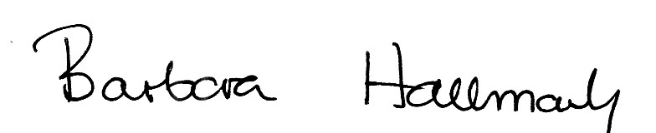

Laura Phillips - Training Co-ordinator

Date: 7 July 2016

Note: This policy is reviewed on an annual basis. Related procedure/guidance documents are reviewed in light of changes in legislation or work practices. Error reporting systems are in place enabling staff to highlight errors or make suggestions as to how documents may be improved.

