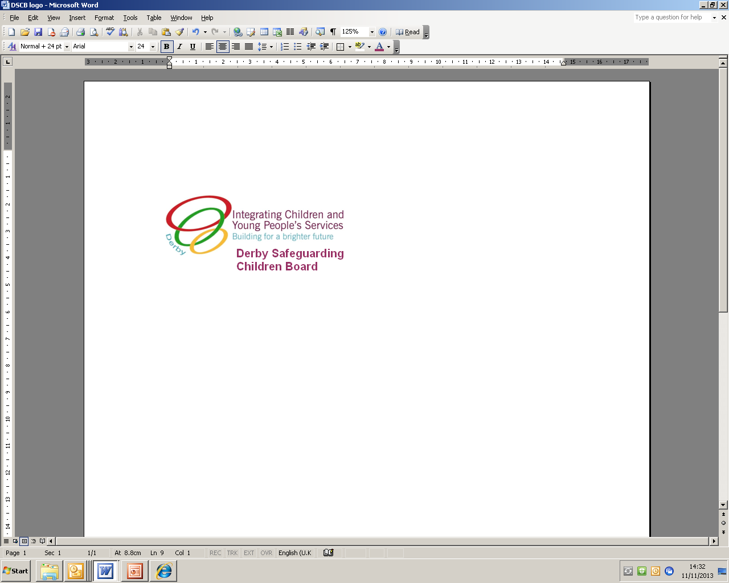

**Early Help Pre-assessment Checklist and Request for Support**

This checklist has been designed to identify and document low level needs or to help practitioners to decide if an early help assessment (EHA) is needed. For further information about the EHA process please see [www.derbyscb.org.uk](http://www.derbyscb.org.uk) or [www.derbyshirescb.org.uk](http://www.derbyshirescb.org.uk).

|  |
| --- |
| **Section 1: Your family household** |

**Child's details**

|  |  |  |  |  |  |  |
| --- | --- | --- | --- | --- | --- | --- |
| **Name**: | | | | **Any other surname/s: If yes please note:** | | |
| **DOB / EDD** | **Gender**  Female  Male | | **Ethnicity** | | **Disabilities** | **Religion** |
| **Address:** | | | | | | |
| **Postcode:** | | **Telephone:** | | | | |
| **Who has parental responsibility for this child?** | | | | | | |

**Details of parents or carers**

|  |  |  |  |  |  |  |
| --- | --- | --- | --- | --- | --- | --- |
| **Name** | **DOB** | **Gender** | **Ethnicity** | **Disability** | **Religion** | **Relationship to child** |
|  |  |  |  |  |  |  |

**Details of other household members, including siblings, and any other significant adults living in household or elsewhere**

|  |  |  |  |  |  |
| --- | --- | --- | --- | --- | --- |
| **Name** | **DOB /**  **age** | **Gender** | **Ethnicity** | **Disability** | **Relationship to child / address if different** |
|  |  |  |  |  |  |
|  |  |  |  |  |  |
|  |  |  |  |  |  |
|  |  |  |  |  |  |
|  |  |  |  |  |  |
|  |  |  |  |  |  |

**Communication needs (including language) of any of the children or adults above**

|  |
| --- |
|  |

|  |  |  |  |  |  |  |
| --- | --- | --- | --- | --- | --- | --- |
| **Section 2: Details of practitioner completing the form** | | | | | | |
| **Name:** | | **Role:** | | **Agency:** | | |
| **Address:** | | | | | | |
| **Telephone number:** | | | | | | |
| **Signature:** | | | | | **Date:** | |
| **Section 3: Family support Are there any other agencies involved? If so who? e.g. midwife, health visitor, nursery / school, GP, voluntary sector** | | | | | | |
| **Name** | **Role/Agency** | | **Work Address** | | | **Phone Number** |
|  |  | |  | | |  |
|  |  | |  | | |  |
|  |  | |  | | |  |
|  |  | |  | | |  |
|  |  | |  | | |  |

|  |
| --- |
| **Section 4: Checklist** |

|  |  |  |  |
| --- | --- | --- | --- |
| **Key safety issue** | **Yes** | **No** | **N/A** |
| ***Are there working smoke alarms on each floor of the property?*** |  |  |  |
| ***Safe sleep arrangements*** |  |  |  |
| ***Don't shake your baby advice*** |  |  |  |
| ***Home safety*** |  |  |  |
| ***Safe storage of harmful substances*** |  |  |  |
| **See DSCB website** [**www.derbyscb.org.uk**](http://www.derbyscb.org.uk) **Family Safety Advice guidance to aid completion of this section** | | | |

**🞟 Has an early help assessment been started?** Yes  No

**🞟 Has an early help assessment been completed?** Yes  No

|  |  |  |
| --- | --- | --- |
| **If "YES", details of lead professional or if no lead professional details of the assessment author:** | | |
| **Name:** | **Role:** | **Agency:** |
| **Address:** | | |
| **Telephone number:** | | |
| **Signature:** | | **Date:** |
| ***IF THERE IS AN EARLY HELP ASSESSMENT, PLEASE ATTACH AND DO NOT COMPLETE SECTION 4 a to d*** | | |

**If there is no early help assessment and no plan to currently initiate one, please complete the next section.**

**🞟 Are there any low level or emerging needs in the following areas?**

**a. Child's profile and story** Yes  No  Not sure *Child/young person's development*, *physical and emotional health, learning and behavioural development, family and relationships. Please note any strengths as well the child's wishes and feelings.*

|  |
| --- |
|  |

**b. Parents / Carers** **and how they look after the children** Yes  No  Not sure *Parenting skills, basic* care, *guidance & boundaries, emotional warmth and stability whilst ensuring safety .* Please n*ote views of parents, any strengths and attendance at parenting programmes.*

|  |
| --- |
|  |

**c. Family, home, community and support networks** Yes  No  Not sure

*Family history and relationships, wider family, housing and finances, useful resources available in the locality. Please note any strengths.*

|  |
| --- |
|  |

**d. Summary and conclusions / What does this mean for the child and family?**

|  |
| --- |
|  |

|  |
| --- |
| **Section 5: Next Steps** |

**🞟 Can you or someone else from your agency, and the family provide the support needed?**

Yes  No

*Please complete own agency action plan, or suggested single agency action plan (attached on page 4).*

**🞟 If you answered "No" to the question above, or if it is not clear what support is needed, please complete an early help assessment. The name of the person who will complete the early help assessment is:**

**🞟Does the child or family require support from another agency?** Yes  No

*If yes, please complete the following and ensure that the family have consented for information to be shared (see below) before sending the completed form to the relevant agency.* ***If the family is likely to require multi agency support you must take steps to progress an early help assessment****.*

|  |  |  |
| --- | --- | --- |
| **What support is required?** | **Which service is being requested?** | **What outcomes would you & the child and family wish to achieve?** |
|  |  |  |
|  |  |  |

**🞟 Any issues regarding the above request?** For example*, access to home, communication issues, car parking, any risks (conflict in family, domestic abuse, pets).*

|  |
| --- |
| **I understand the reasons for information sharing which has been explained to me and I consent to the sharing of this information to the named agencies listed below:** |
|  |

|  |  |  |
| --- | --- | --- |
| **Child/Young Person's name:** | **Signature:** | **Date:** |
| **Parent/Carer name:** | **Signature:** | **Date:** |
| **Parent/Carer name:** | **Signature:** | **Date:** |

|  |
| --- |
| **Single Agency Action Plan** |

|  |  |  |  |  |
| --- | --- | --- | --- | --- |
| **What do we want to achieve?** | **How are we going to do it?** | **Who? (family member, extended family, friend, practitioner, other)** | **By when?** | **Date completed** |
|  |  |  |  |  |
|  |  |  |  |  |
|  |  |  |  |  |

**Child / young person's views on the identified actions**

|  |
| --- |
|  |

**Parent's / carer's views on the identified actions**

|  |
| --- |
|  |

|  |  |
| --- | --- |
| **Agreed review date for plan:** |  |

|  |  |  |
| --- | --- | --- |
| * Child/Young Person's name: | Signature: | Date: |
| * Parent’s name: | Signature: | Date: |
| * Practitioner's name: | Signature: | Date: |

**Plan Review**

**🞟 Did the plan make a difference?**

**🞟 Does anything else need to happen? Please specify:**

**🞟 What are the child and family's view of the services received?**