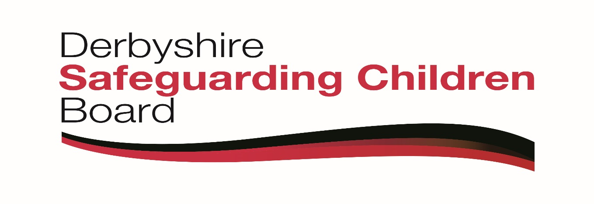

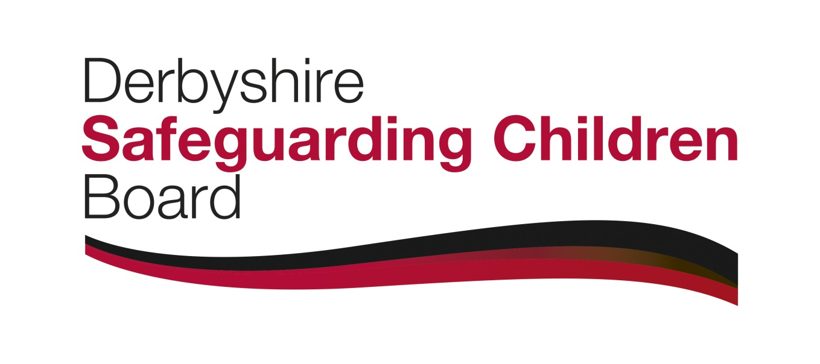
Derbyshire Safeguarding Children Board

Neglect Strategy

Version Control

Version | Author/s | Amendments | Signed off by | Date | Review Date
1. | Maureen Evans  Principal Practitioner Early Help |  |  | 28/02/2017
2 | Maureen Evans  Principal Practitioner Early Help | Edit of strategy including Childs Voice, Family Resilience. | DSCB  27/03/2017 | 10/3/2017 | 27/3/2020
3 | Maureen Evans  Principal Practitioner Early Help | Public Health amendments | DSCB  16/11/2017 | 16/11/2017 | 15/09/2020

1 Role of LSCBs in safeguarding children from neglect

1.1 LSCBs should:

- Monitor the quality of practice in relation to neglect across early help, child in need and child protection interventions
- Enable services; police and social work services working with families where there is domestic abuse; and services for adults with learning difficulties, to work effectively together to assess and agree plans for children who experience neglect

- Provide quality specialist training on the recognition and management of parental non-compliance and disguised compliance for front line practitioners and managers

- Enable access to contemporary research and best practice in working with neglect

- Ensure all staff are aware of their duty to escalate concerns when they consider that a child is not appropriately protected and/or is suffering from neglect, and that all agencies have appropriate escalation policies and procedures, including a procedure for challenging the decisions of children’s social care services where cases are not accepted for assessment or child protection investigation.

2 Definition of neglect

2.1 There are two statutory definitions of neglect: one for criminal and one for civil purposes.

- Neglect is a criminal offence under the Children and Young Persons Act 1933 where it is defined as failure "to provide adequate food, clothing, medical aid or lodging for [a child], or if, having been unable otherwise to provide such food, clothing, medical aid or lodging, he has failed to take steps to procure it to be provided"

- The civil definition of neglect which is used in child and family law is set out in the Children Act 1989 as part of the test of 'significant harm' to a child. This is expanded upon in Working Together 2015 statutory guidance which describes neglect as:

“the persistent failure to meet a child's basic physical and/or psychological needs, likely to result in the serious impairment of the child's health or development. Neglect may occur during pregnancy as a result of maternal substance abuse. Once a child is born, neglect may involve a parent or carer failing to provide adequate food, clothing and shelter (including exclusion from home or abandonment); protect a child from physical and emotional harm or danger; ensure adequate supervision (including the use of inadequate care-givers); or ensure access to appropriate medical care or treatment. It may also include neglect of, or unresponsiveness to, a child's basic emotional needs.”

3 Impact of neglect

3.1 It is well established that neglect can have a serious impact on a child, particularly if chronic (long term) and including pre-birth. In some situations neglect can be fatal, but generally will affect a child’s health and overall development, having far-reaching implications for the child throughout their life. Neglect in infancy and early childhood is particularly damaging.

4 Aims of this strategy

4.1
• to ensure effective support and education are available to families to prevent neglect occurring
• to ensure neglect of children is identified early in a child’s life and early in the
duration of any concern
• to ensure effective interventions are put in place to enable parents and/or wider family to provide adequate care for their children, where neglect has been identified
• to ensure that in serious cases of neglect, where interventions have been unsuccessful, and children are removed from that environment before long-term damage is done and consideration given to criminal action.
• to enable the DSCB and partner agencies to have a robust understanding of
the extent and impact of neglect in Derbyshire, to allow resources to be directed appropriately

5 Prevention

5.1 Families with children need adequate income through work and/or benefits, decent housing and access to health and education. Central Government, the Local Authority, Public Health and CCGs and others all have responsibilities for enabling access to these, including accessible information & guidance. Services should work towards increasing family and community resilience to prevent the impact of neglect on children.

5.2 Most parents will rely on their families, communities and friends for advice and guidance on caring for their children. Support will also be available to parents through universal and targeted services, to enable them to understand their children’s needs and how to meet them. This includes:

- GP
- Dentist
- 0-19 years Public Health Nursing Services
- Midwifery
- Children’s Centres and Early Years Provision
- Schools
- Voluntary & Community Sector

5.3 Opportunities for identifying indicators of neglect at….
- Routine GP and Dentist visits
- Child health clinics/young people drop-in sessions within schools
- Antenatal clinics and groups
- Community groups and events
- School based activities

5.4 Some groups are more vulnerable than others, e.g. Disabled children, young parents, new migrants to the UK, home educated and those with learning disabilities. Targeted services are available from:

- Derbyshire Children’s Services
- Disabled Children’s Service
- 0-19 Public Health Nursing Service
- Thriving Communities
- Derbyshire Adult & Community Education Service

6 Early Identification of neglect

6.1 Children’s health and development will be assessed ante-nataly by midwifery and at 10-14 days, 6 weeks, 12 months and 2yrs by Health Visitors/School Nursing. Standardised recording tools are used for these assessments to track a child’s growth and development, and identify any problems.

6.2 However, all professionals in contact with children and parents are expected to be alert to indications that a child might be being neglected. This might be apparent in:

• the child’s health, dental hygiene, growth, development, behavior, presentation
• the parents’ issues with mental health, substance misuse, crime, domestic
abuse, etc.
• disclosures by child, parents, neighbours, family
• conditions of home & garden and treatment of pets
• poor school attendance
• non-engagement/was not brought to appointments

6.3 Health and Education staff need to be aware that children may present with problems such as dental decay, obesity, poor concentration, etc which whilst having a medical explanation may equally be indicative of neglect.

6.4 Sometimes a single encounter with a child or their family may raise an immediate and urgent concern, but often neglect only becomes apparent over a period of time. There is a very real risk that professionals can become de-sensitised to neglectful situations, or experience them as normalised in disadvantaged communities, or fail to notice a very gradual decline or falling behind in a child’s growth or development.

6.5 In order to prevent this, professionals will have, and will be expected to use as appropriate to their role:

- training around neglect, parental non/disguised compliance and child development
- “Think Family” training
- regular reflective supervision

6.6 DSCB provides general and specialist courses to help build staff skills, knowledge, value and confidence. DSCB provides multi-agency training pathways to support professionals in recognising and responding to neglect; agency pathways for safeguarding training are available for:

- Childminders
- DCHSFT
- Education settings
- National Probation Service
- Nursery training staff
- Police
- Probation & Rehabilitation Service

Safeguarding courses for all agencies is available. In addition to this, specialist training on Neglect including the use of the Graded Care Profile is offered by DSCB.

6.7 DSCB also promotes the use of assessment processes and tools; these should be used in all situations where there are emerging concerns around neglect:

- Pre- Birth Assessment
- Early Help Assessment
- Social Care Single Assessment
- Chronologies
- Graded Care Profile
- DV Risk Identification Matrix and DASH risk assessment in domestic violence situations

6.8 Professional judgement and supervision should highlight cases where neglect may be an issue, and in all such cases further assessment and use of the above tools will be carried out. The DSCB Threshold Document will then indicate the level of response required to assist the child and their family. Critical to this is the sharing of information between involved professionals, in order to build a complete picture of the child’s world.

- Effective interventions

  - Parents or carers need to be supported, educated and/or challenged to provide good enough care for their children. This should be offered by a range of services at different levels. Universal services need to ensure when supporting parents they also have a child focused approach and understand the child’s experience; hearing and acting on the child’s voice within early interventions is key to effective support for the family.

  - Interventions should be offered at the lowest level, consistent with the level of need and risk. This would typically mean that where universal or targeted services have been insufficient to help a family, a referral is made to Starting Point
  - A good assessment is key to identifying the contributory factors and therefore the services and interventions needed; this may be an Early Help assessment or Social Care single assessment. A chronology will be a critical part of this, to include the historical context of a current concern – how many times has this happened before? How effective and sustainable have interventions been? – to establish the impact on the child and future plans. Assessment tools as above, and especially the Graded Care Profile should be used and always including the child’s voice.

  - The Local Authority Early Help Safeguarding Service has an overarching framework ‘The Stronger Families Safer Children Operating Model’ which is strength based and underpinned by Systemic Practice, and provides a framework for family support. Within the Stronger Families Safer Children Model, ensuring the child’s voice is heard and understanding their day to day experience and impact of this on their life’s journey is pivotal to the analysis and assessment of risk. Targeted services, such as early help Local Authority Multi Agency Teams (MAT) or safeguarding (Social Care), depending on the level of concern, require important contributions from adult and health services.

7.5 Specialist assessments may also be needed and should be commissioned promptly, to inform future work. This may include adult learning disability, adult mental health, paediatric, including where a child has a disability, etc.

7.6 Working in partnership with parents is important, so that they will fully engage in the services offered and accept responsibility for making things better for their children. This is likely to be more successful and sustainable. Interventions will often need to focus on parents’ needs – e.g. substance misuse, mental ill health – at the same time as addressing their parenting. Approaches adopted around parenting will need to reflect any specific needs of the parents, e.g. learning disability, their age, cultural differences, language and comprehension, etc.

7.7 Most parents will respond positively to help offered in this way. However professionals need to be alert to parents who refuse to engage or where there is “disguised compliance” – i.e. a parent may say the right things but not making the necessary change. There is a risk for professionals in over-identifying with parents and not noticing or challenging repeated non-attendance, cancelled visits, distraction with repeated crises and justification for not carrying out an agreed action. Professionals may also become de-sensitised to the conditions & environment in which a child is living. This professional de sensitisation can also at a community level, which could affect professional judgement. All of these risks need to be continuously reviewed in practice supervision and within QA audits.

7.8 Alternatively, professionals need to be alert to the risks of developing over- dependency, where services have effectively taken over part of the parenting role and families have lost their self-sufficiency. This situation is not sustainable and is disempowering for parents. Professionals should always work towards increasing family resilience to cope with future challenges within their family and community networks.

7.9 Once neglect is identified and appropriate safeguarding plans are in place, it is important to continuously monitor the impact on the child, to ensure any intervention is having the necessary effect. Any timescale for improvement will be appropriate to the age and circumstance of the child – the younger the child and the more serious the concern, the quicker any improvement needs to be. These timeframes need to be clearly identified at the outset with clear contingency plans so that parents and professionals are aware.

7.10 Individual agencies will need to have safeguarding processes in place, which adhere to DSCB policy; to monitor work with children identified as neglected or at risk of neglect. Local Authority and DSCB procedures should be followed for all work at levels of early help, child in need and child protection to ensure:

• assessments and investigations are carried out in a timely way
• there is good partnership working across children’s and adults services with
information shared appropriately
• clear plans are in place with clear expected outcomes and actions for family and professionals
• interventions are appropriate and effective
• there are regular reviews

7.11 There is a risk of drift and delay in work with neglect; where insufficient progress is made within the child’s timeframe, the work should be promptly escalated to a higher level. The Local Authority requires each case to be discussed in supervision at least twice in each review period, to ensure work is progressed robustly. An independent chair to review the work with a family can be very helpful in identifying when this is necessary.

7.12 DSCB has an Escalation Policy which is used by staff where they have concerns about the response or (in) action by another agency. Child Protection Managers, Social Care managers will also highlight cases where insufficient progress is being made, recommending advice be taken with regard to alternative care arrangements.

8 Legal action

8.1 In serious cases of neglect, where there is, or risk of, significant harm, a strategy meeting will be held in line with DSCB procedures. This will include consideration of any legal action by the Police or Local Authority.

8.2 The Police will need to consider the need for a criminal investigation and possible prosecution for criminal neglect.

8.3 Rarely, the Local Authority will need to consider the need for an Emergency Protection Order where there are immediate risks to “life and limb”. More commonly there will have been a period whilst services have been offered to a family and insufficient progress made within the child’s timeframe. In these circumstances consideration will be needed with regard to discussing alternative family care arrangements, voluntary accommodation or issuing care proceedings, to secure the care of the child outside the current neglectful care.

8.4 Decisions around care proceedings are made by Local Authority Edge of Care panels, with a legal adviser, to ensure consistency in the application of threshold.

8.5 In such cases the Local Authority and partners will be able to present the range of assessments undertaken in relation to child and parents, can evidence the work undertaken with the family by all agencies and can demonstrate the cumulative impact on the child (or likely impact for an unborn baby or very young child). The Court will expect all this information to be available at the point of issue in neglect cases.

9 Strategic oversight of neglect

9.1 Neglect is more common in families and communities living with disadvantage and deprivation, and it is important that current limited resources are targeted at the most deprived communities.

9.2 The health and wellbeing of children in Derbyshire is mixed compared with the
England average. Average figures can mask differences between individuals and communities, for example, families who are comfortably off and others who are struggling financially and possibly struggling to secure a job.

There is also contrast in housing conditions across the county with good quality homes and others whose homes are damp, cold or unsafe. Evidence suggests overall housing in Derbyshire is in a poorer condition compared to England. In Derbyshire 17% of children live in families that are income deprived and have poor living environments.

Derbyshire has welcomed families as recent arrivals to the UK via the Syrian refugee scheme and other families have recently arrived from countries experiencing conflict. In Derbyshire 4.2% of children are from minority ethnic groups and these families have a greater likelihood of disadvantage, as well as adjusting to cultural differences.

9.3 Derbyshire Health and Well-being Board, informed by other Boards including the Children’s Partnership Board, Locality Childrens Partnerships and by all partners, has an over-arching responsibility to co-ordinate and plan for the well-being of residents in Derbyshire. This includes children suffering or at risk of neglect.

9.5 Information to support this and other activity across the partnership is available from the Joint Strategic Needs Assessment, which collates a range of data. A combination of Public Health data and the child health profile data, should allow a focusing of activity to prevent and intervene in the neglect of children, and to attempt some measurement of success.

9.6 However, due to the complexity and multi-faceted nature of neglect, and absence of a standardised reporting system, numbers of children living in neglectful circumstances are not fully known. Numbers of children subject to child protection plans will be indicative of overall numbers and can be used to monitor upward or downward trends. Numbers of plans in the different categories are monitored by the Local Authority and DSCB quarterly.

9.7 The child health profile, collated and analysed by Public Health, offers a range of measures which are associated with neglect, e.g. dental caries, hospital admissions for accidents and low birth weights. Tracking changes in these measures will provide some indication of any change in the prevalence of neglect.

9.8 Derbyshire Safeguarding Children Board will review this data annually and will both undertake quality assurance activity, such as multi-agency audits, and receive QA reports from partners. This will enable the Board to monitor the quality of practice in relation to neglect and to challenge partners as necessary.

