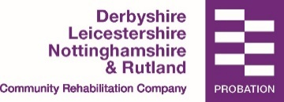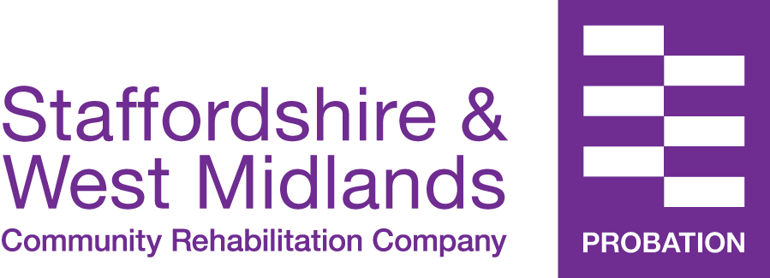
Known Persons Check:
Information Requested By:
Probation Practitioner Name :
Office Address:
Contact Telephone Number:
Contact Email:
Date Information Requested:

Name of Service User
D.O.B
Address

Reasons for Requesting information:
Known Person requests are not completed by default. In line with mandatory Government Safeguarding Procedures, if there is an identified and evidenced risk to a child or other vulnerable person, and/or the nature of the offence committed by the Service User is identified a risk, and/or if information is unknown, a request for safeguarding information is made.

For the appropriate and safe management of this particular case, we would like to know if the children listed below are currently known to your service and if so in what capacity. If the child is known, please could you advise of an allocated Social Worker with their contact details.

If this information is not provided by your organisation, it may lead to a gap in the risk assessment and management of the case and potentially increase the risk of harm to the child/children.

Information Relates to: (please include details of the Children)
Name | D.O.B | Address | Relationship to Child

Has Consent been gained: Yes/No | If No, please state why: Consent is not required due to the evident risk to the child/children. Sharing of this information is permitted in line with the legal basis set out below.
Legal Basis for Sharing of Relevant Information:
This information is requested with regard to the legislative framework set out under Section 11 of the Children Act 2004. This legislation gives the RRP the entitlement to receive any information that is deemed to be pertinent to safeguarding and promoting the welfare of children. It is also in line with Section 115 of the Crime and Disorder Act 1998 ‘where disclosure is necessary or expedient for the purposes of reducing or preventing Crime and Disorder’. This sharing is also in line with Section 45 of The Care Act 2014 This information will not be used for any other reason, it will only be held by RRP until the end of the supervision period and will be held secure under the requirements of the General Data Protection Regulation and Data Protection Bill.

Document Management:

Owner: Information Assurance Manager / CSC
Effective Date:
Review Date:
Document reference: Known Person Request Form: Safeguarding010

Change History Record
Version control | Substantive change narrative | Author of substantive change | Date of substantive change
1.0 | Update in line with GDPR requirements and Safeguarding process | JT | 27/03/2018

Initials key: Jacqui Thompson JT

