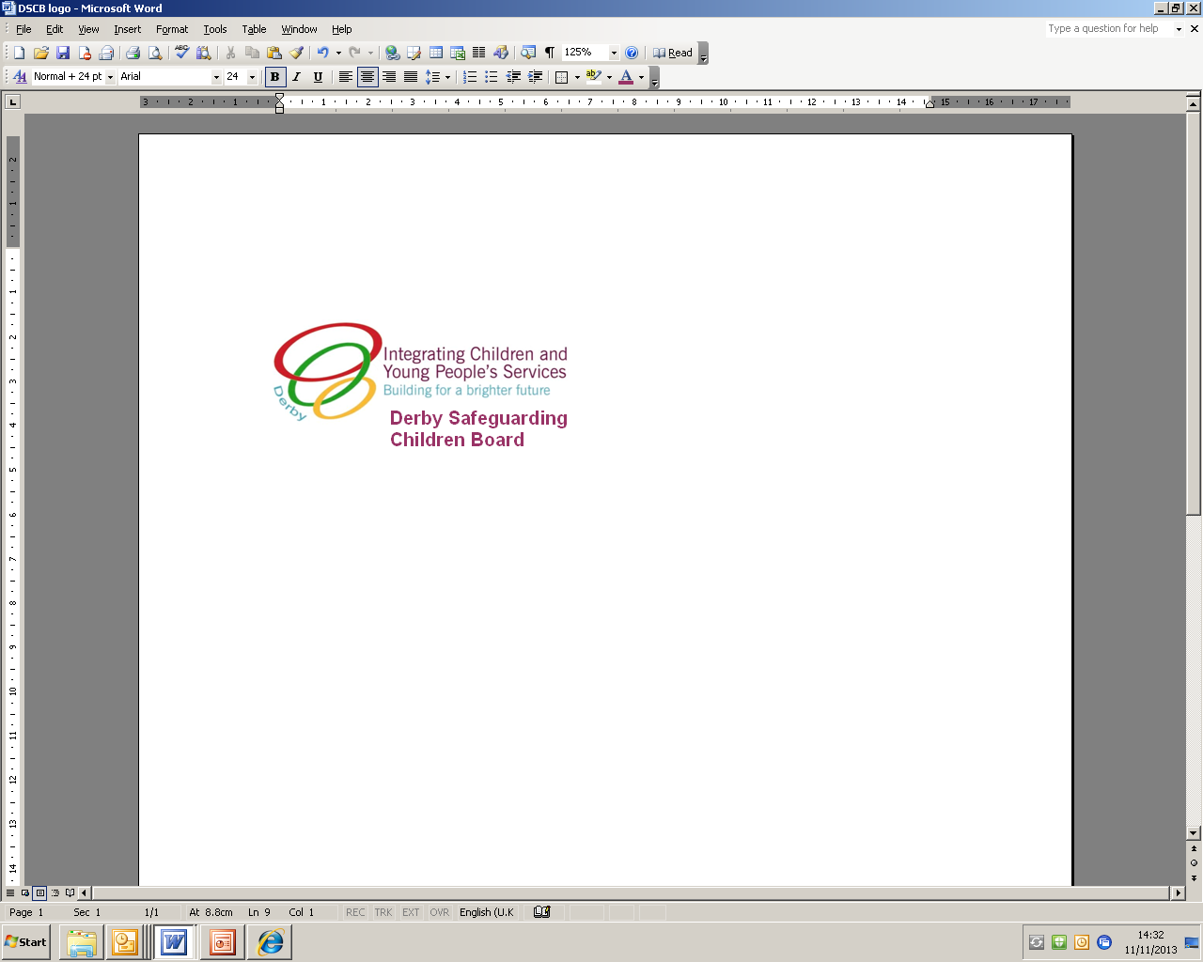

**CRE Information Report Operation Liberty**

**(Note which form of Exploitation you are reporting)**

**Date/Time of report:**

|  |  |  |  |  |  |
| --- | --- | --- | --- | --- | --- |
| **Name:** |  | | | | |
| **Post/Job Title:** |  | | | | |
| **Agency:** |  | | | | |
| **Contact details:** |  | | | | |
| **Witnessed Incident?** |  | Member of Public? |  | Practitioner? |  |

**Are you reporting the information as a third party?**

If so, details of witness, if known:

**Would they be willing to engage with the Police?**

|  |
| --- |
| ***Please provide information about specific events/incidents. Include as much detail as possible (where known) regarding name's / descriptions / nicknames / vehicle details / addresses / risks i.e. weapons. Do not use abbreviations.***  ***Date/time/location and details of incident:***  ***Alleged offender(s)(if known):***  ***Details of other persons present at incident (if known):***  *(Please use one form for each victim)**Note: Use this space to report an incident even if this* ***does******not*** *relate to a victim.*  ***Victim (if known):***       ***DOB:*** |
| ***Name(s) and contact details of persons/professionals this information has been shared with:*** |
| **Send all referrals to the Police Referral Unit: email**  [RiskandReferralUnit@Derbyshire.PNN.Police.UK](mailto:RiskandReferralUnit@Derbyshire.PNN.Police.UK)  **PLEASE NOTE THIS IS NOT A REFERRAL FORM TO CHILDREN'S SOCIAL CARE**  If you believe there are serious/complex needs or child protection concerns you must make a referral to Children’s Social Care as per DSCBs’ [safeguarding procedures](https://derbyshirescbs.proceduresonline.com/p_making_ref_soc_care.html). If the child is already known to Social Care you **must** also send a copy to their Social Worker or MAT Worker. |

## Guidance on Completing the CRE Information Report Operation Liberty

The Information Report Operation Liberty Form offers a multi-agency system of sharing information with Derbyshire Police to aid keeping children safe.

This form should be used to provide details of any concerns about people who pose a risk to a child, any known location where children are at risk of exploitation and any concerns about a child’s circumstances, that makes them vulnerable to exploitation. The form should be used primarily to share information about the person/s or place/s that poses a risk to the child/ren, not to discuss the child’s behaviours. The information can also include low level, soft ‘whisperings’ and ‘gut feelings’, something that does not sit well with you or your co-workers but has nowhere else to go.

Prior to completing the form, practitioners should seek advice and support from their agency CRE champion (Derby), Single Point of Contact (Derbyshire), Senior Practitioner or Manager. Advice and support can also be sought from in Derby a Child Protection Manager telephone 01332 642376 (Derby) or in Derbyshire the Child Protection Manager for Vulnerable Children (CPM-VC) telephone 01629 532834.

Please refer to the CRE Risk Assessment and for the types of exploitation covered in the CRE Strategy e.g. sexual exploitation, criminal exploitation, county lines, debt and trafficking.

You must also share it with any other practitioner's involved with the child. If they are known to Children's Service's you must send a copy of the form to the child’s Social Worker or Children's Practitioner who will analyse your data and upload onto the child’s file.

**If the information is about serious/complex needs or child protection concerns about a child, a referral must also be made to Children’s Social Care.** Please see DSCBs’ Safeguarding Children procedures, [Making a Referral to Social Care](https://derbyshirescbs.proceduresonline.com/p_making_ref_soc_care.html).

Please ensure that the information is accurate, current and that it is factual and not opinions.

Also ensure that full names and details of victims and where alleged perpetrators are provided. If you are unsure of the information then make checks before completing the form and sending it to the Police Referral Unit. If the information is unreliable or you are uncertain about the content, you may wish to arrange a multi-agency meeting before completing and submission of the Information Report Form.

**NEVER assume someone else has passed on the information you have. Duplicate information is better than none.**