Caldecott Fostering

Foster Carer Professional Development Plan

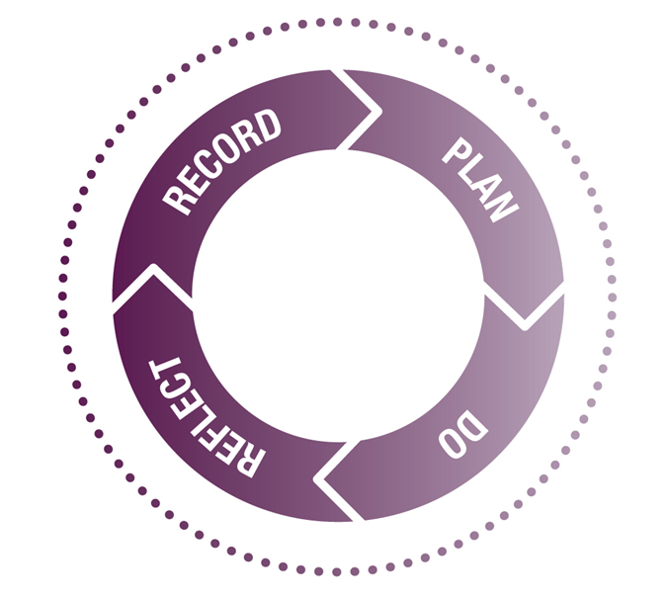

Foster Carer: |  | SSW:
Learning and Development Outcomes:
Foster Carers have a hugely important role providing care to vulnerable children with diverse needs. Caldecott Fostering is committed to ensuring all Foster Carers have the right support and learning opportunities to undertake their role in caring for these children to the highest standards.
It is important that families have access to training that:
- Is child-specific
- Is in line with their approval
- Meets regulatory expectations
- Builds on skills and interests
- Prepares them for looking after future children

This plan will help you and your Supervising Social Worker to identify and keep track of your training and development. You will be able to think about what you need to further enhance and update your knowledge and skills for fostering or meet the specific needs of individual children. The plan is also an opportunity to celebrate achievements and provide feedback on the training offered at Caldecott Fostering.
In your first year you should have completed your TSD portfolio which ensures that you are reaching the National Minimum Standards for Fostering. As a professional Foster Carer, you are always required to be working within the Fostering Standards (listed below). Your Supervising Social Worker will base their assessment of your capacity to foster on a continuous basis against these Standards, even after completion of your TSD Portfolio. Your plan will be reviewed jointly by yourself and your Supervising Social Worker every year alongside your Annual Home Review and on a continual basis through supervision. However, it can and should be updated at any point, such as:
- Following any significant event
- When a new child or young person is moving into your home
- When a Child Safety Plan is updated
- Following an allegation or concern

Each Foster Carer is expected to have their own PDP and is required, as a minimum, to evidence completion of all mandatory training and refresher courses. Those refresher courses marked with an * will be refreshed on a needs-led basis and in discussion with your Supervising Social Worker. Individual foster carer reflective logs should be completed on Charms following each training or development event and discussed with your Supervising Social Worker in supervision. Please also refer to the FAQs for foster carers.

Identifying your Learning & Development needs
What do you need to do?
What skills or knowledge would you like to improve?
What will you be able to do more effectively if you develop these skills or knowledge?
How will you be able to demonstrate this?

How do you prefer to learn?
What type of activities will help you learn the new skills / knowledge?
How will you be able to practise using the new skills / knowledge?
What support will you need to use the new skills / knowledge?

What do you need to do / know?

How do you prefer to learn?

How will you measure your progress?

What have you achieved?
What have you achieved?
To what extent have you achieved your learning objectives?
What can you do differently?
What difference has that made to your role?
What else do you need to learn or practise?
What additional support do you need?
How will you measure your progress?
When will you start?
How will you review what you’ve learnt?
How will you apply the learning to your role?
Who will be able to give you feedback to help you review your progress?
How will you measure your progress?

References: Fostering and adoption learning resources, How to guide for individuals, Research in Practice.
Setting SMART learning objectives

Specific | - What do you need to know, be able to do or improve?  - What will be your time scale?
Measurable | - What will you know or be able to do differently?  - How will you be able to demonstrate this?  - How will you be able to measure your progress?
Achievable | - Is the objective feasible in the timescale?
Relevant | - How will this skill / knowledge help you in your role as a foster Carer? What aspects of your role will it improve / support?
Time - frame | - Include clear milestones and review dates

References
Adapted from Fostering and adoption learning resources, How to guide for individuals, Research in Practice.

National Minimum Standards for Fostering

- Standard 1 - Promoting the wishes, feelings and views of children
- Standard 2 - Promoting a positive identity, potential and valuing diversity through individualised care.
- Standard 3 - Promoting positive behaviour and relationships
- Standard 4 - Safeguarding Children
- Standard 5 – Children Missing from Care
- Standard 6 - Promoting Good Health and Wellbeing
- Standard 7 - Leisure Activities
- Standard 8 - Educational Attainment
- Standard 9 - Promoting and Supporting Contact
- Standard 10 - Providing a suitable physical environment for the foster child
- Standard 11 - Preparation for a placement
- Standard 12 – Independence
FOSTER CARER PROFESSIONAL DEVELOPMENT PLAN - REVIEW AND ACTION PLAN

Name of foster carer |  |  | Date of approval
Date PDP commenced |  |  | Date PDP reviewed/updated and reason for update (i.e. new child/young person, significant event, changing needs of a child, foster carer review etc)
Initial Pre-approval Training |  |  |  | Date completed
Skills to Foster
Safeguarding Children
Health and Safety – Fostering
Equality and Diversity
Safe Administration of Medication
Safer Caring – Fostering
Initial Post-approval Training |  |  |  | Date Completed
Caldecott Fostering Induction
TSDS workbook (to be completed within the first year of approval)
Mandatory Training Record
Course |  | Date Completed |  |  | Mandatory Refresher Course |  | Refresher Due Date
Safeguarding Children |  |  |  |  | Annual refresher
Health and Safety – Fostering |  |  |  |  | 3-yearly refresher
Equality and Diversity |  |  |  |  | 3-yearly refresher
Safe Administration of Medication |  |  |  |  | 3-yearly refresher
Safer Caring – Fostering |  |  |  |  | 3-yearly refresher
Good Recording Practice |  |  |  |  | N/A*
Thinking Therapeutically |  |  |  |  | N/A*
Attachment |  |  |  |  | N/A*
First Aid Caring for Children |  |  |  |  | 3-yearly refresher
PMCB/De-escalation |  |  |  |  | 2-yearly refresher
Child Sexual Exploitation |  |  |  |  | 3-yearly refresher
Online Safety & Data Protection |  |  |  |  | Annual refresher
Gangs and County Lines |  |  |  |  | N/A*
Radicalisation |  |  |  |  | 3-yearly refresher
Trafficking |  |  |  |  | N/A*
Female Genital Mutilation (FGM) |  |  |  |  | N/A*
Compassion Fatigue |  |  |  |  | N/A*
Allegations and Safe Caring |  |  |  |  | N/A*
Self-Harming Behaviours Fostering |  |  |  |  | N/A*
Missing From Care |  |  |  |  | 3-yearly refresher
Health and Nutrition |  |  |  |  | N/A*
LGBTQ+ |  |  |  |  | N/A*
Cultural Competency |  |  |  |  | N/A*
Through the Child’s Eyes (Care Experienced Voice) |  |  |  |  | N/A*
* Please refer to the Foster Carer Training Programme for expectations of timings for completion of the above courses across the first 18 months of approval. Please note that all of the above training is needs led and the timing of training or additional refresher training may be dependent on the specific needs of a child and/or foster carer or following certain events*

INDIVIDUAL FOSTER CARER TRAINING RECORD

Log Individual Foster Carer Training Record here and update each year

Training completed in line with:  (Note training undertaken in each category and date completed in this column) | Mandatory Training (see above): | NMS (see above): | Child-specific (as per matching/stay overs/safety plans etc.): | In line with their approval (as per Panel/ADM recommendations and approval) in preparation for future fostering | Building on skills and interests

FOSTER CARER PROFESSIONAL DEVELOPMENT PLAN - REFLECTION & EVALUATION  To be completed by Foster Carer(s) ‘Reflective Log’ | DATE OF COMPLETION/UPDATE:  XX/XX/XXXX
- What training or learning have you carried out this year? (This can include reading, conferences, TSDs, professional discussions as well as formal training)

- How has this helped you achieve more for the children you care for and supported your continuous professional development?

- What are you key learning highlights from the last year?

- We value you your feedback and comments on the Learning and Development programme. What is your evaluation of the training and development opportunities over the last 12 months (areas of strength and areas for development?) Do you have any suggestions for future courses?

- Are there any outstanding tasks from your previous PDP?

- How are they going to be addressed?

SUPERVISING SOCIAL WORKER ANALYSIS – consider the foster carer’s strengths, skill, knowledge and application of training to practice including Relational Model of Care
LOOKING AHEAD - FOSTER CARER PROFESSIONAL DEVELOPMENT PLAN - TRAINING REQUIRED ACTION PLAN

Action Plan for Continued Professional Development
To be discussed and completed with the Supervising Social Worker
Identified Learning Need
What skills or knowledge are needed to develop or maintain current practice? Are there any gaps that need addressing? Consider outstanding training, identified mandatory training/refresher training, NMS, child specific training, matching and any recommendations from Panel or ADM approval recommendations – (transfer to action plan below)
What support may you need to achieve this?

What benefit will this have to your fostering practice?
Please consider the needs of children in your care (as agreed in the care plan/safety plan/matching form etc).
Actions to be Taken
How will this training/learning need be met?
Timeframe
When will the agreed actions be completed?
Are there any barriers to achieving the training identified? How could they be overcome?

Do you have any additional learning needs? Does the training match your learning style? Consider specific barriers to learning/learning styles and what additional support may be required or how training can be delivered to meet individual needs
What support will be required?

AGREED TRANING ACTION PLAN

Identified Training in line with:  (Note training required under each category including mandatory/refresher training with timescales for completion) | Name of Course/Learning Activity | Deadline for completion
Mandatory/Refresher Training (see above)

National Minimum Standards (see above)
Child-specific (as per matching/stay overs/safety plans etc.):
In line with approval (as per Panel/ADM recommendations and approval) in preparation for future fostering
Building on skills and interests
Supervising social workers are expected to ensure that this PDP demonstrates that the foster carer has or will be provided with all the required training to meet the needs of the children living in the household, as per Caldecott Fostering’s mandatory courses, as per the NMS expectations and in line with the foster carers’ approval and so that they are prepared for future children who may come to live with them. You should also consider any specific learning needs or learning styles of the foster carer in this PDP. Your signature on this document is your sign off that this document ensures this has or will be completed with SMART actions.

Completed PDP to be uploaded to Charms and digitally signed by supervising social worker and foster carer.

