www.bexley.gov.uk
Permanence Panel Protocol and Terms of Reference

Date of publication: May 2018  Date for review: May 2019 | Responsible Manager:  Jo Cross
Electronic file location:
Associated statutory guidance and regulations:
Children Act 1989, Children and Social Work Act 2017, Children and Families Act 2014, Adoption and Children Act 2002, and Care Planning Regulations 2010.
Local documents:
Bexley Tri-X Policy – Children’s Social Care Resource and Care Panel
Key Objectives (including Signs of Safety principles to apply)
This policy separates the current amalgamated functions of the Resource and Care Panel into its separate functions. Part of this purpose was to avoid possible conflicts between focusing on good care planning for a child without the sometimes conflicting focus of resource allocation or availability. Resource implications does not negate a child’s need for the support and thus having a separate focus on each helps senior managers decide if other avenues for the support a child or family needs can be accessed in another manner. Also, good care planning does not always have an additional resource component for consideration.
The referral form to this panel will mirror the SoS framework currently used by the Case Management Review panel and referral to Legal Planning Meeting and is also mirrored in the Resource Panel policy to follow.
This final draft has been approved by SMT on 17 April 2018 with amendments recommended and now included.
Detailed advice:
The creation of this protocol will require the following amendments to existing policies on Tri-X:
4.1.2 Decision to Look After and Care Planning
Related Chapters Amend to read: “Children’s Social Care Resource Panel; Children’s Social Care Permanence Panel Protocol and Terms of Reference”
1.4 Actions Required After a Decision to Look After is Made
Insert after the second paragraph to read: “Where children become looked after, a decision to present the care plan for endorsement must be made in line with the Permanence Panel Protocol.”
4.1.3 Ceasing to Look After a Child
2.2 Decision Making
Amend current clause to read: “Where a child has been Looked After for 20 working days or more, the decision to cease looking after the child should not be put into effect until it has been endorsed by the Permanence Panel and approved by the Nominated Officer.
4.2.1 Placements with Parents Amend to read: “Placements with Parents or Carers”
1.3 Recommending the Plan
Amend current clause to read: “The recommendations of the Looked After Review (and Child Protection Review Conference where applicable) will then be sent to the Permanence Panel and Nominated Officer, together with the Care Plan and proposed Placement Plan and a written report covering the following:
1.4 Approval of the Placement
Amend current clause to read: The placement can only be made after the endorsement of the Permanence Panel and approval of the Nominated Officer has been given and the Placement Plan prepared, except as set out in Section 2, Immediate Placements.

Permanence Panel Protocol and Terms of Reference

Children’s Services

Implemented: May 2018 Due for Review: May 2019

Table of Contents

Achieving permanence for children 3
Permanence panel referral and decision making flowchart 4
Purpose of protocol 5
Purpose of permanence panel 6
Referral process for panel 8
Panel process and agenda 9
Outcomes and decision making 10

Appendices

Appendix A Referral form for permanence panel 12

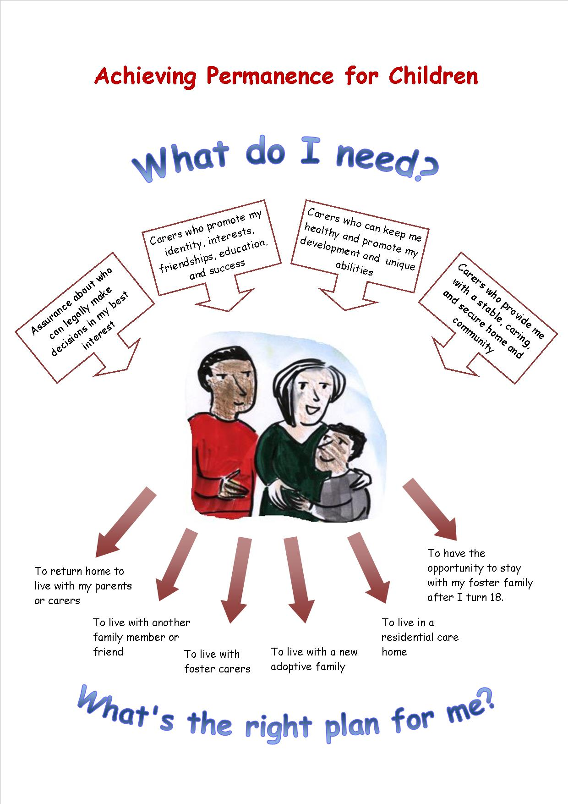

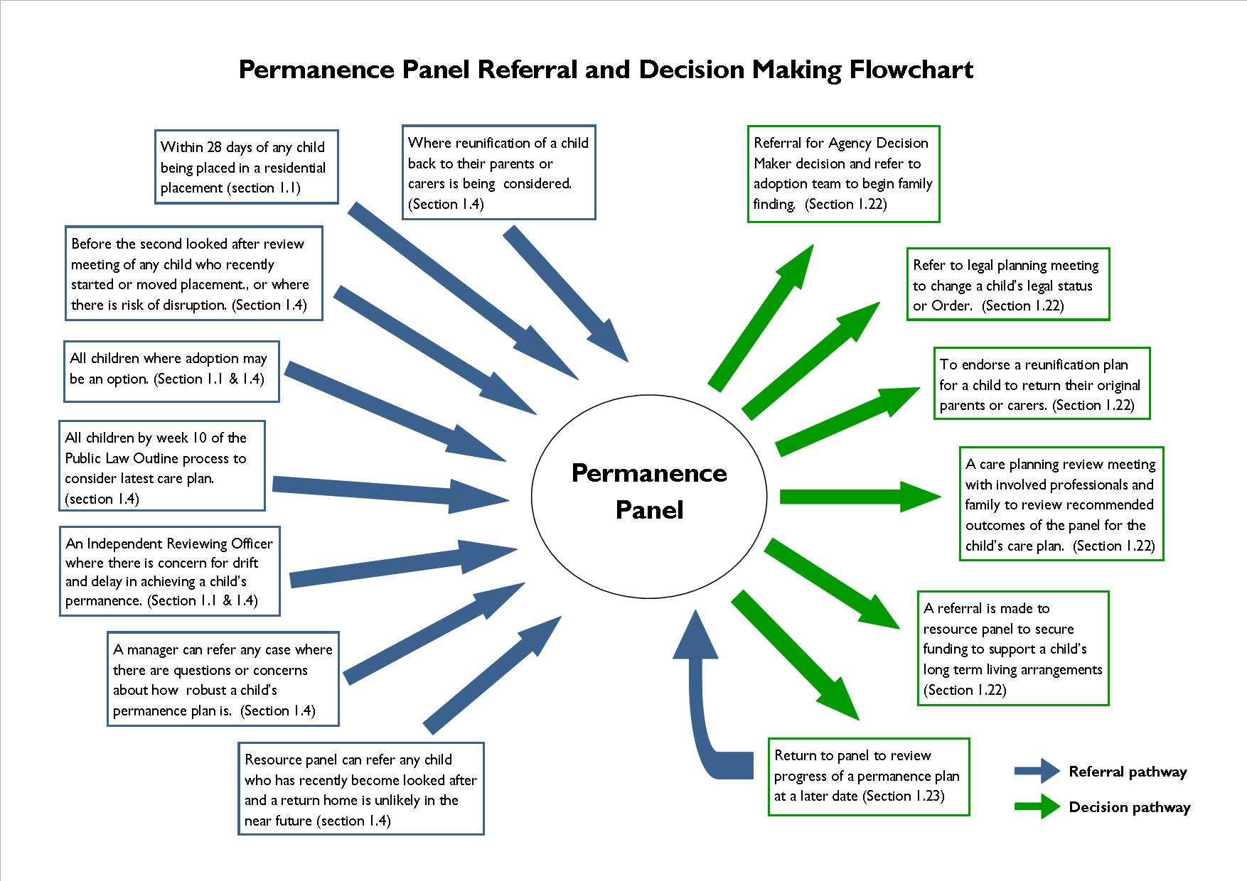

Purpose of Protocol

Bexley Children’s Services believes that all our children and young people should live with carers who love, support, care for and respect them and who will do so through their childhood into adolescence and adulthood.

Guidance published by the DfE (2014) defines permanence as:
“The framework of emotional permanence (attachment), physical permanence (stability) and legal permanence (the carer has parental responsibility for the child) which gives a child a sense of security, continuity, commitment and identity. The objective of permanence is to ensure that children have a secure, stable and loving family to support them through childhood and beyond. Permanence provides an underpinning framework for all social work with children and their families; from family support through to adoption. This can include situations where the Local authority and birth parents share parental responsibility (PR) but where the carer has made a long term commitment to the child”.

Similarly the Care Inquiry In 2013 found that permanence for children means:
“Security, stability, love and a strong sense of identity and belonging” They found that this was not necessarily connected to legal status and that no one route to permanence was better than another.

The Council supports permanence through a range of options including a return to birth parents or placement with extended family or friends. Where this is not appropriate or possible we seek suitable permanent, family based placements through adoption, special guardianship or long term fostering. Where necessary some older young people will find permanence and security through good residential care and we recognise that some young people will thrive, achieve and make a positive transition to adulthood through this provision.

Using the Signs of Safety framework we always try to secure a permanent future with either the birth family or the wider family network. To do so we are committed to using Family Network Meetings with families when children become looked after and supporting families to utilise their own strengths and resources to develop effective safety plans so that children can return home as soon as it is practicable for them to do so. We recognise that this is not always possible, or may not be achievable within the child’s timeframe and as such we will seek suitable alternatives wherever necessary, working with the family and young person to effect permanence in a child centred, fair and transparent manner.

We know that every child or young person is different and so each must have their own permanence plan agreed by the time of their second looked after review, including those young people for whom residential care is the most appropriate option.

Whatever the plan that is agreed the seven Corporate Parenting principles of the Children and Social Work Act 2017 will apply. These are:
- To act in the best interests, and promote the physical and mental health and well being, of children and young people,
- To encourage children and young people to express their views, wishes, and feelings,
- To take into account the views, wishes and feelings of children and young people,
- To help children and young people gain access to, and make the best use of, services provided by the local authority and its relevant partners,
- To promote high aspirations, and seek to secure the best outcomes, for those children and young people,
- For those children and young people to be safe, and for stability in their home lives, relationships, and education or work,
- To prepare children and young people for adulthood and independent living.

This protocol clarifies how we will support permanence for all of the children we work with, where this is being sought away from birth family or friends. It further specifies the decision making process where required.

This protocol must be read in conjunction with the following policy areas on Tri-x:
- Section 4 – Looked After Children
- Section 5 – Fostering and Adoption

Purpose of Permanence Panel

  - The purpose of the permanence panel is to:

- Help Bexley carry out its corporate parenting responsibilities to children in its care within the spirit and meaning of the seven principles outlined in the Children and Social Work Act (2017)
- Support the implementation of timely and positive long term, stable care plans and placements for all children in care based on their individual assessed needs
- Ensure that Bexley is ambitious in seeking legal permanence for all children and that adoption is pursued for all children, regardless of their age, unless there is clear evidence to suggest that this is not in the child’s best interest
- Avoid drift and delay when securing long term permanent placements for children with the most suitable carer. This can include adoption, Connected Persons, Special Guardians, foster carers, and residential placements
- Agree residential placements as permanent living arrangements where there is an up to date assessment and care plan indicating this is in a young person’s best interests and will allow them to flourish. Young people should be encouraged to let panel know their views about the placement. The Independent Reviewing Officer (IRO) must be in agreement with the plan for long term care in a residential unit.) These cases must be placed before permanence panel within 28 days of the placement commencing for review and monitoring.. Such a change of plan will be formally recorded on Liquid Logic
- Review any child or young person referred to it by the allocated IRO or any other interested professional if they are concerned that suitable permanence options are not being robustly explored for a child or young person
- Refer children or young people and set timescales of when permanence plan review meetings should take place for them
- Consider those care plans where the plan is a change away from adoption and make recommendations before the change is considered at adoption panel
- Consider sibling together/apart assessments and agree plans for separation of siblings following a review of all the relevant assessments and care plans
- Ensure that the presenting practitioner and team have always explored how we can work in partnership with the family network to secure permanence for children within their family and their wider network. This will include reviewing whether family network meetings have been utilised and whether any of the other reunification processes available have been sourced. This will include but is not limited to joint work with the Staying Together team, a referral to the MST/FFT programme and work with the looked after service reunification service.
  - Quorate for the panel will be the chair and at least two additional panel members. Panel members should not exceed eight for any given meeting.

  - Panel members must declare any involvement or pre-existing knowledge of a case being presented in the meeting.

  - The Permanence panel will review children in the following circumstances:

- Legal planning meetings (LPM) will refer all cases where care proceedings have been initiated and adoption may be an outcome
- A permanence planning meeting will be convened for all children and young people who become looked after within 4 weeks. The panel chair will then refer all children to the permanence panel to ensure there is robust planning activity for all children looked after
- Independent Reviewing Officers (IROs) can refer children where they believe there has been drift in the decision making and permanency planning processes for a child or young person. Where this happens the IRO is expected to complete the referral to panel in conjunction with the allocated social worker, detailing why they have referred the child and where they believe there has been drift and delay
- Before the second looked after child review meeting of any child who has recently begun or changed living arrangements
- Where there is a likelihood of a placement breakdown or disruption
- Any child who is subject of care proceedings, by week 10 the panel must review their latest care plan
- A senior manager can request that the panel undertake a review of a child’s permanence planning to assure themselves that this planning is robust, timely and in the child’s best interest
- Resource panel can refer to Permanence Panel any child or young person where they have recently become looked after and a return home is not believed to be possible or viable in the near future
- When considering the reunification of a chid back to their parents or carers
- Any Social Care team manager can refer a child or young person for review if it is believed that permanence planning has been poor and that there is a risk a child may suffer drift and delay in finding a long term, loving and stable care environment

Referral Process for Panel

  - Any child or young person who meets the criteria under Section 1.4 can be referred to permanence panel. Referrals will be made using the form contained in Appendix A and can be accessed under forms on Liquid Logic (not yet available so hard copy to be completed and uploaded into documents).

  - All referrals must be completed and submitted to the panel administrator at least three working days before the panel date. Any late submissions or those submitted incorrectly may be deferred to another panel date in order to be properly submitted and considered.

  - Panel members are expected to read all referrals and come to panel prepared with questions and comments.

  - Referrals should be succinct and contain just enough information for the panel to have an understanding of the significant events in a child or young person’s life and to inform discussions and key recommendations. It should not unnecessarily cut and paste complete reports or previous information on file. Additional reports should not be submitted along with a referral form unless the chair gives agreement.

  - Referrals must equally justify the recommendations or decisions being sought by the panel and set out why this is believed to be in the child or young person’s best interest. It must also justify the anticipated cost implications, both short and long term.

  - The chair will decide which cases are properly prepared or are given priority to be heard at any given panel.

Panel Process and Agenda

  - The panel will be chaired by a Children’s Social Care head of service. The chair is responsible for facilitating discussions in a timely, respectful and focused manner using the agenda set out in Section 1.13 below. Given the importance of securing permanence for children, only a head of service can chair the panel. The Head of Service for Looked After Children and Permanence is the substantive chair and the Head of Service for Workforce Development and Quality Assurance is vice chair. In the event neither is available, the Team Manager for Adoption should discuss with the Deputy Director whether the panel should go ahead.

  - The panel will meet every fortnight and its members will include:

- One children’s service manager at team or service manager level representing adoption, fostering, placements, independent reviewing service, and looked after children (Cannot be a manager referring a case to panel)
- One Signs of Safety champion practitioner
- A legal representative
- Other relevant professionals by invitation of the chair

  - The agenda for the panel will be as follows:

- Purpose of panel
- Statement of conduct and confidentiality
- Introductions
- Review of previous recommendations and decisions
- Case presentations (should be a maximum of five per panel)
- Review of panel recommendations and decisions
- Any other business
- Next date and adjournment

1.14 The agenda for case presentations will be as follows:

- Social worker or team manager gives brief case summary and what they are seeking from panel (5 mins max)
- Chair opens discussion from panel members (10-15 mins max)
- Chair summarises discussion and recommendations or decisions made (5 mins max)

  - In order for panel to proceed in a timely and focused manner it requires panel members to come prepared having read all referrals prior. It also requires social workers and team managers to complete referrals properly, in time, and presented in a succinct and focused way.

  - The statement of conduct and confidentiality reads:

The panel will proceed in a respectful manner. This means language or actions that are offensive or discriminatory are not tolerated. Please turn your phones to silent and excuse yourself if you need to take an urgent call. The panel and its chair aim for the meeting to provide constructive feedback and considered recommendations.

Information shared is confidential and is not to be discussed outside this meeting without proper consent or purpose to do so. Panel reports must be confidentially shredded and minutes from the meeting securely stored in accordance with the Data Protection Act.

  - Panel members are expected to support the chair in ensuring the meeting takes place in accordance with the agenda and statement of conduct and confidentiality.

  - The meeting will be coordinated and minuted by a business support administrator. All referrals to panel are to be emailed no later than three working days before to the meeting administrator.

  - Due to time constraints the chair may have to bring an end to discussions, prioritise which cases are heard at panel, and designate cases to be tabled for another panel meeting.

Outcomes and Decision Making

  - When reaching recommendations and decisions the chair should solicit the views of all panel members. Any panel member can request their view be recorded in the minutes.

  - The chair will normally concur with the majority view of the panel members in reaching panel recommendations and decisions. Where the chair makes recommendations or decisions against the view of the panel, the dissenting views will be recorded.

  - Where the panel has concerns about case planning and legal processes it can refer the case back to Case Management Review panel (CMR) for oversight and direction.

  - The panel is able to make the following recommendations and decisions:

- That a multi-agency care planning review meeting with the family takes place within 10 working days to review and revise the child’s current care plan to consider or act upon recommendations or decisions made by the panel
- That a child is referred to the Agency Decision Maker (ADM) for a decision on adoption
- That a referral be made to the adoption team to begin family finding
- That the case proceed to a legal planning meeting to consider changes to a child’s legal and/or care status
- That a referral is made to resource panel to secure funding in support of a child’s long term placement plan
- That a full sibling “together/apart” assessment is completed and thereafter the children referred back to panel
- That more work is undertaken to try and work with the family and their network to enable the child/young person to return home

  - The panel may decide and specify a date when a case must return back to panel to consider changes and progress made on previous recommendations and decisions made.

  - The panel should reserve itself to making recommendations only; leaving responsibility for the detailed child’s planning for the involved family and professional network. Certain decisions may have to be taken where the chair believes the safeguarding of a child from significant harm or concerns of drift and delay warrants.

  - Where there is disagreement between panel members about the decisions made at panel or the case holding team have concerns about the decision made the Deputy Director should be asked to review the decisions made and where the point of concern is. The chair of panel must facilitate the discussion with the Deputy Director, ensuring that there is documentary evidence and relevant attendance at a meeting to review the area of disagreement. This meeting must be organised within 5 working days of the Permanence Panel wherein the permanence plan was heard. The Deputy Director will review the information presented and will agree the appropriate action to be taken on the permanence plan. This meeting will be minuted and the decision circulated to panel within 48 hours. A copy will be uploaded to the liquid logic file as usual.

Appendix A
Part A – To be completed by worker

Permanence Panel Referral

Relevant Family Members (starting with the children and including all carers):

Name | Date of Birth | Relationship to child (or self)

Brief summary of the main issues in the case
(Only write the key events that took place for the child/ren that led to this referral being made)

What recommendations or decisions are you seeking from the panel?
(Think about what the panel can do to help create a better and safer outcome for the child/ren)

Signs of Safety Case Summary

Child/ren’s Name | Date of Birth | Ethnicity | Disability/Special Need | Legal Status

Past Harm | Strengths | Complicating Factors
Future Danger | Signs of Safety | Grey Areas

Danger Statement | Safety Goals

Next Steps
What we want to see be better and safer for the child? | What needs to happen to help make things better and safer for the child? | Who will be responsible? | When will they do it by?

Referral Completed and Authorised by:

Name | Signature | Date

Please note that referrals that are submitted late, incomplete, or unsigned
may be rejected and deferred by the panel.

Part B – To be completed by panel chair

Name of Child/ren | Name of Worker | Team

Permanence Panel Recommendations and Decisions

The panel agreed that:

- ____________________________________________________________________________
- ____________________________________________________________________________
- ____________________________________________________________________________
- ____________________________________________________________________________
- ____________________________________________________________________________
- ____________________________________________________________________________
Care plan review meeting Refer to ADM and adoption Refer to LPM Amend care plan
Refer to Resource Panel Continue current care plan Endorse reunification plan home
Return to panel by: _____________________________

_________________________ ______________________ ______________
Name of Chair Signature Date

