**Professional identifies that a woman has experienced FGM**

**Urgent Safeguarding Contact Number:**

CCG Adults & Children Safeguarding Leads

07867140219 or 07769 886482

Non-pregnant woman in Primary/Secondary Care

Pregnant Woman

* Undertake part 1A of risk assessment
* Refer to Hospital Pathway (see attached) for pregnant women with FGM



* If risk identified refer to Social Care
* Undertake part 1B of the risk assessment
* GP informed if identified in secondary care
* Refer for any surgical treatment required for symptoms from FGM
* Any emotional support required

**Useful Terminology to communicate:-**

* *Have you been closed?*
* *Have you been cut?*
* *Did you have the operation as a child*

If risk identified

Good practice guidance

* Discuss the health complications of FGM and the law in the UK (illegal)
* Signpost to support groups
* Refer for counselling if appropriate
* Give information leaflet
* Notify police with consent if procedure after March 2014
* Refer for treatment if symptomatic
* Document on computer system for easy identification:
  + READ CODE [EMIS FGM K578, Family History of FGM12b], on woman and all children’s notes
  + Document all actions
* Enhanced reporting on HISC by practice (mandatory from October 2015)
  + <https://clinicalaudit.hscic.gov.uk/fgm>

Refer to Social Care

*Countries high risk for FGM includes*:*

*Somalia 98% Dijibouti 93%*

*Mali 89% Seirra Leone 90%*

*Sudan 88% Egypt 91%*

*Guinea 97% Nigeria*

*\*list not exhaustive*

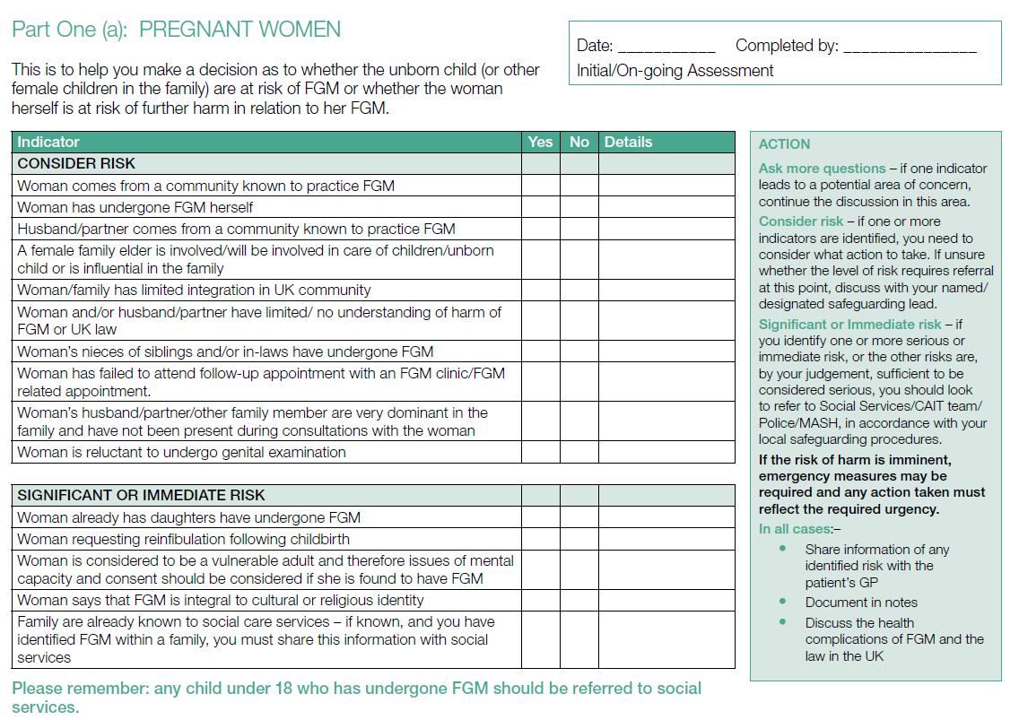

**Patient Details Sticker**

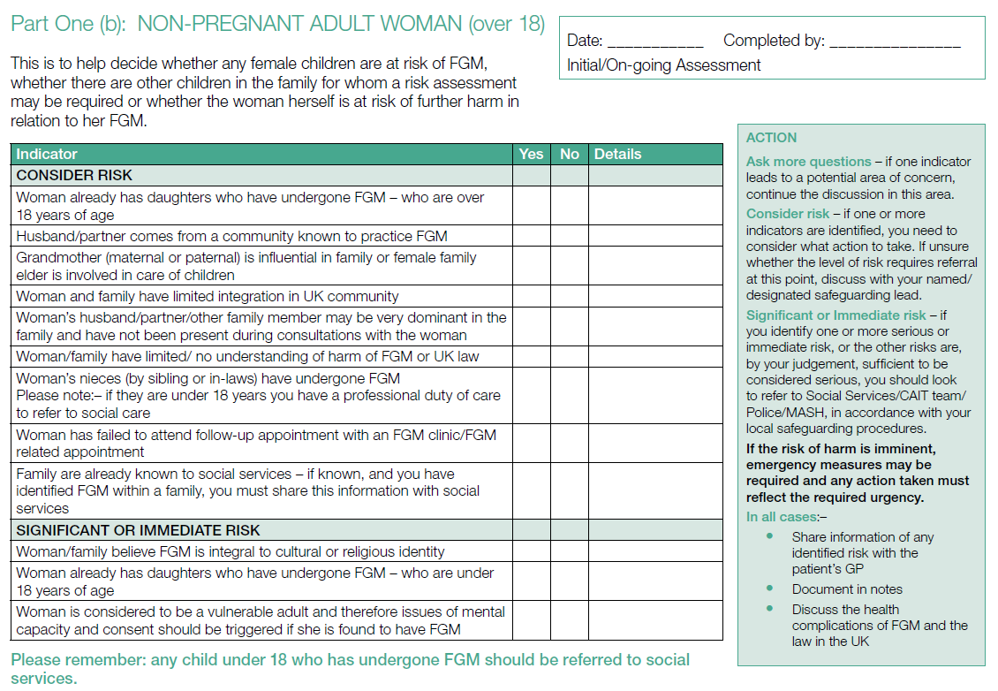

**Patient Details Sticker**